Gender Equity programs conducted

Name of the programme | Date | Name of the Resources Person | Number of students Participated
Skill, Attitude &  Behaviour Development | 21-8-2023 | Mr.Siva Sankar Kantheti,Co-founder of VIRIDUS Social Impact Solutions,Hyderabad | 60
Empowering Youth through Emotional Intelligence | 18-8-2023 | Prof. M L Sai Kumar, IIM, Hyderabad | 210
Guest Lecture on Career Development | 01-02-2024 | Willjavian Dawson, Professor, Suny Polytechnic University, New York, USA | 210
Career Opportunities After Graduation | 13-07-2023 | Mr. Atul Negi, Ims Gate Academy | 56
Goal setting and career opportunities | 10-8-2023 | Mr. Pabba Ramesh | 120

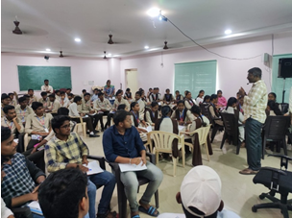 | 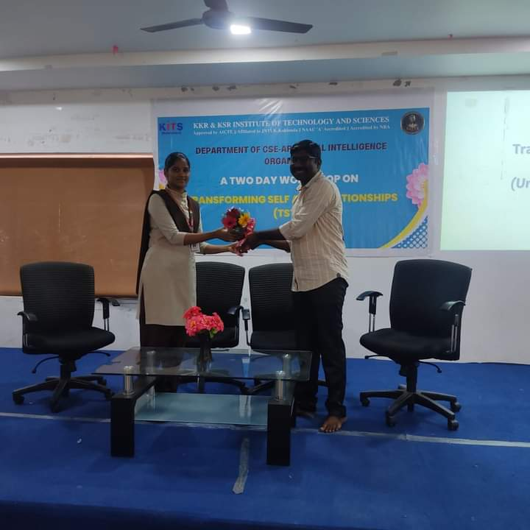
Skill, Attitude & Behaviour Development

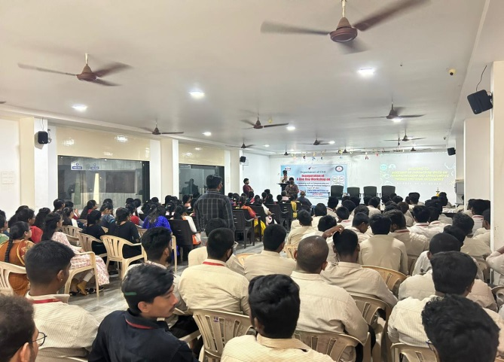 | Empowering Youth through Emotional Intelligence

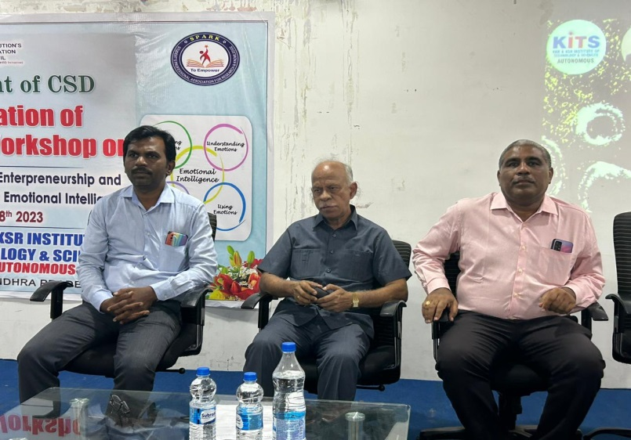 | 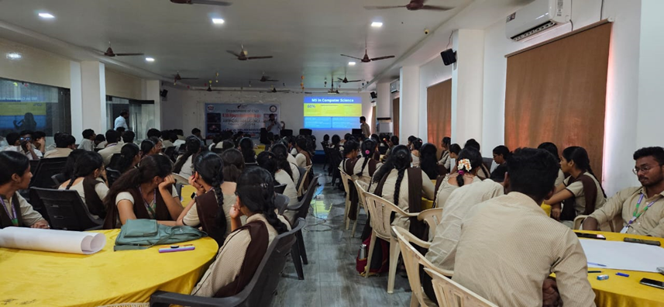
Guest Lecture on Career Development

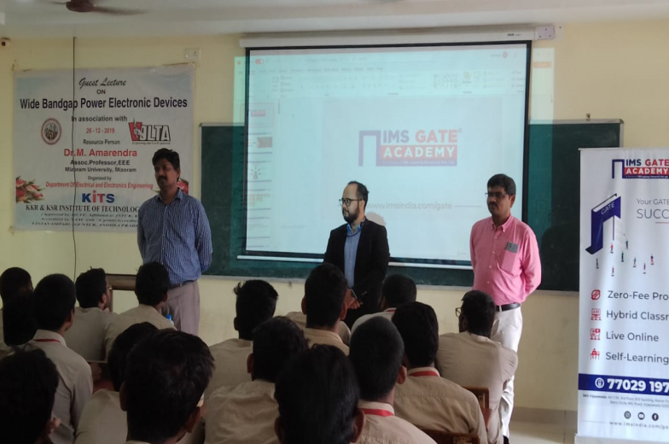 | 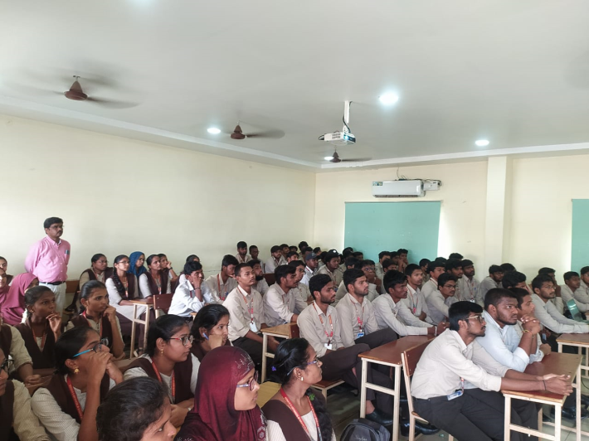

Career Opportunities after Graduation

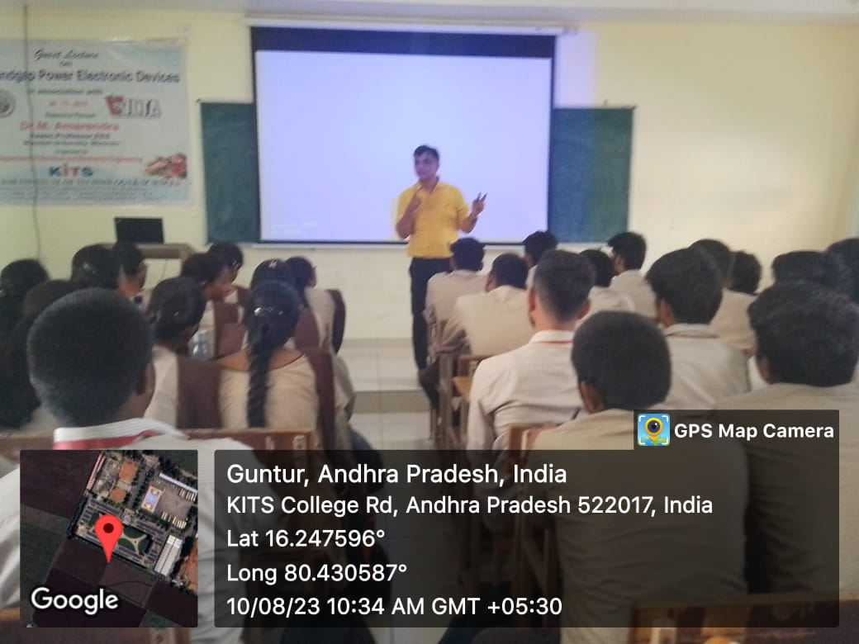 | 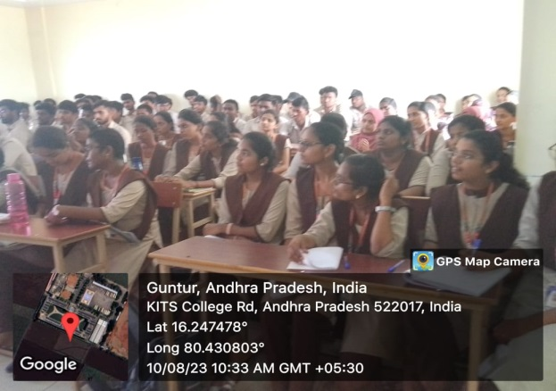
Goal setting and career opportunities

