**KKR&KSR Institute of Technology and Sciences**

**Vinjanampadu, Guntur, Andhra Pradesh-522017**

**Approved by AICTE, New Delhi and Permanent Affiliation from JNTUK, Kakinada**

**Accredited with “A” Grade by NAAC & NBA Accreditation Status for 5 UG (CSE, ECE, EEE, ME, Civil ) Programs**

**DEPARTMENT OF MASTER OF BUSINESS ADMINISTRATION**

**A National Level Webinar on” The Impact of COVID-19 on Indian Education Sector”. (With Special reference to higher education/ Technical education)**

**About the Program/Event:**

A National level one day online webinar was organized by our MBA department, on 6th August 2020 on the topic “The Impact of COVID-19 on Indian Education Sector”. (With Special reference to higher education/ Technical education). The resource person was invited from Sri Krishna Devaraya Institute of Management, Srikrishna Devaraya University-Anantapur. Participants have attended the online sessions across the country. The program has witnessed the overwhelm response from the participants. Registrations have comes from twenty eight states, 2 union territories and from 4 other countries.

**Objective of the Event: FDP**

|  |
| --- |
| The objective of the A National level one day online webinar was Education is responsibility of both the center and state governments as this is mentioned in concurrent list of the Constitution of India. The petrifying and severe impact of pandemic COVID-19 is observed in every sector around the world. Among all, the education sectors of India badly affected by this. It has enforced the world wide lock down creating very bad effect on the students' life. Further, most of the Governments around the world have temporarily closed educational institutions in an attempt to contain the spread of the COVID-19 pandemic. In India too, the government as a part of the nationwide lockdown has closed all educational institutions, as a consequence of which, learners ranging from school going children to postgraduate students, are affected.   * Challenges of higher education system in the era of COVID-19 lockdown * Possibilities for higher education system in the era of COVID-19 pandemic * Future of higher education system after post COVID-19 outbreak * Contemporary issues and perspectives of higher education due to COVID-19 disruption Changing views on the nature of cross-border and transnational higher education in the era of COVID-19 |

**Details of Resource Persons** :

Dr.B.Anitha Kumar,

Professor and HOD

Sri Krishna Devaraya Institute of Management,

Srikrishna Devaraya University-Anantapur

**Venue of the program:**

Goto Webinar App ,

KKR and KSR Institute of Technology,

Guntur, Andhra Pradesh.

**Date & Time of the Event:** 6th August 2020 (10.30AM to 12.00 PM)

**Total no. of participants:** 1037

**Banner and poster of the Event:**

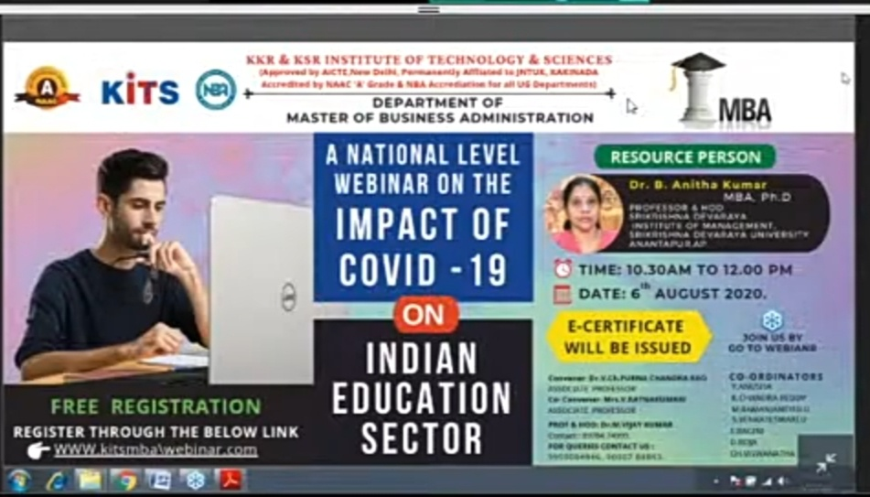

**Registration details: Participants**: 1028+9(MBA Staff)

**Event Photographs**:

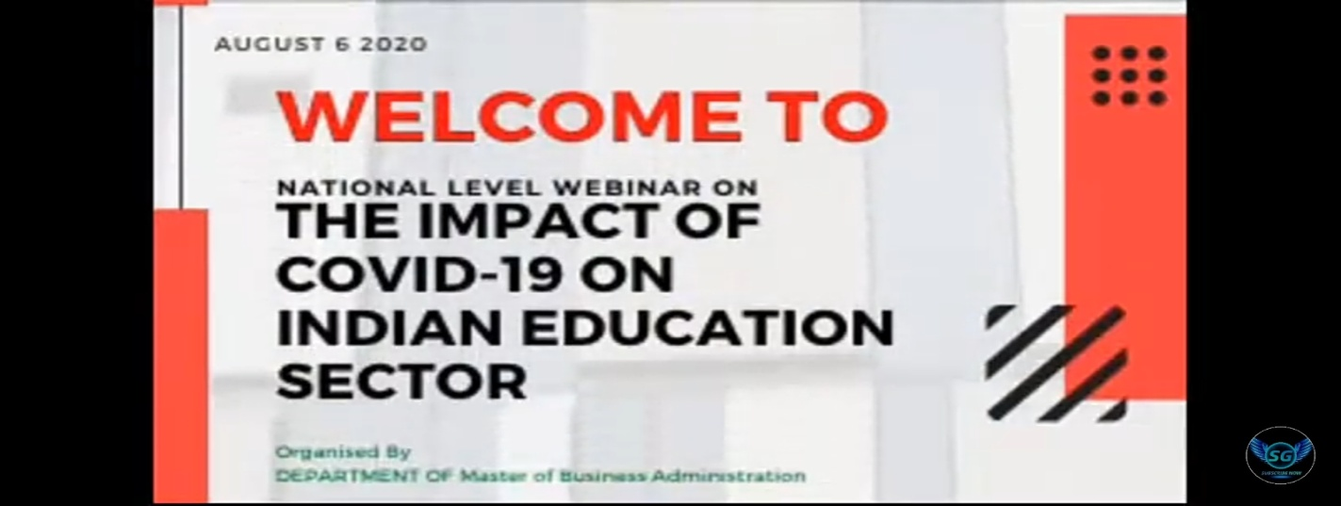

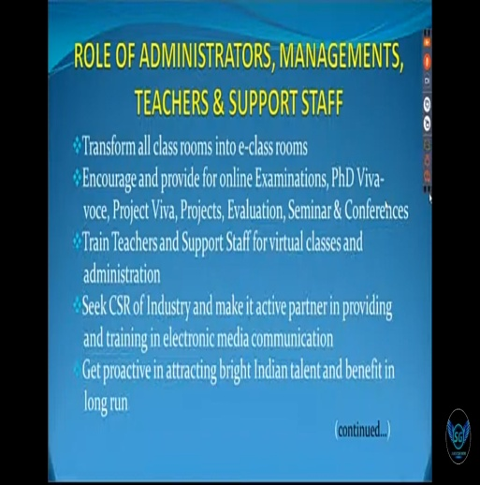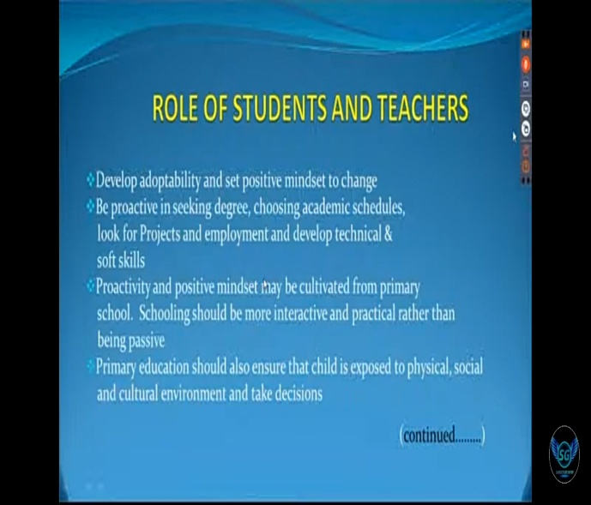



**Feed back on the Program:**

* One of the participant reported Special emphasis was given on the ‘use of technology in the education sector’, an official statement from the government informed. It was discussed to improve the learning outcomes with the use of technology.
* The reports of the participants focused on teaching improvement and the interventions included Time series Predictions, business strategies and skills, Revisiting Marketing strategies, Teaching Strategies of Management Teachers.
* According to Mr. Gopal Krishna, Asst Professor from LENDI college he expired that “Role Of Administrators, Managements, Teachers & Support Staff- was a eye opener the way you explained it made me rethink on my duties”
* Participants reported increased knowledge of educational principles and gains in teaching skills. Where formal tests of knowledge were used, significant gains were shown. Changes in teaching behavior were consistently reported by participants and were also detected by students
* In the view of Ms.L.Lakshmi “The role of students and teachers was explained Cleary and the topic on parents should be counseled to accommodate for their children’s was heart touching. The parents play a main role in the development of their children it’s once again proved. Thank you madam”
* Participants reported role of Students, Teachers and Parents in increasing the knowledge of educational Pattern and gains in teaching skills leads to the upliftments in the new pattern.