DCS Unit-3 Digital Transmission
Multiplexing and T carriers

DIGITAL TRANSMISSION
Pulse Modulation, Pulse code Modulation, Dynamic Range, Signal Voltage –to-Quantization Noise Voltage Ration, Linear Versus Nonlinear PCM Codes, Companding, PCM Line Speed, Delta Modulation PCM and Differential PCM

Digital transmission is the transmittal of digital signals between two or more points in a communications system. The signals can be binary or any other form of discrete-level digital pulses. With digital transmission systems, a physical facility, such as pair of wires, a coaxial cable or an optical fiber cable is required to interconnect the various points within the system.

Digital transmission has several advantages over analog transmission:

- Important advantage is the noise immunity as digital signals are inherently less susceptible than analog signals to interference caused by noise.

- Digital signals are better suited than analog signals for processing and combining using a technique called multiplexing.

- Digital transmission systems are more resistant to analog systems to additive noise because they use signal regeneration rather than signal amplification.

- Digital signals are simpler to measure and evaluate than analog signals.

Disadvantages:

- Transmitting digitally encoded analog signals requires more bandwidth than simply transmitting the original analog signal, which makes it expensive.

- Also conversion of analog signals into digital pulses prior and after transmission requires additional encoding and decoding circuitry.

- Precise time synchronization between the clocks in transmitters and receivers is required in digital transmission

- Digital transmission systems are incompatible with older analog transmission systems.

Pulse Modulation

The process of sampling analog information signals and then converting those samples into discrete pulses and then transporting the pulses from a source to a destination over a physical transmission medium is called Pulse Modulation. Pulse modulation involves communication using a train of recurring pulses. There are four different types of pulse modulation techniques.

Pulse Width Modulation (PWM): The width of a constant amplitude pulse is varied proportional to the amplitude of the analog signal at the time the signal is sampled. It is sometimes called as pulse duration modulation (PDM) or pulse length modulation (PLM). It is very popular in digital circuits because of its easy generation and its applications include voltage regulators and class-D audio amplifiers.

1

DCS Unit-3 Digital Transmission
Multiplexing and T carriers

Pulse Position Modulation (PPM): The position of a constant-width pulse within a prescribed time slot is varied according to the amplitude of the sample of the analog signal. It is commonly used in communications over optic fibers as multipath fading is minimal. It is also used in communications for RC aircraft/cars etc as demodulation is easy allowing a low-cost receiver.
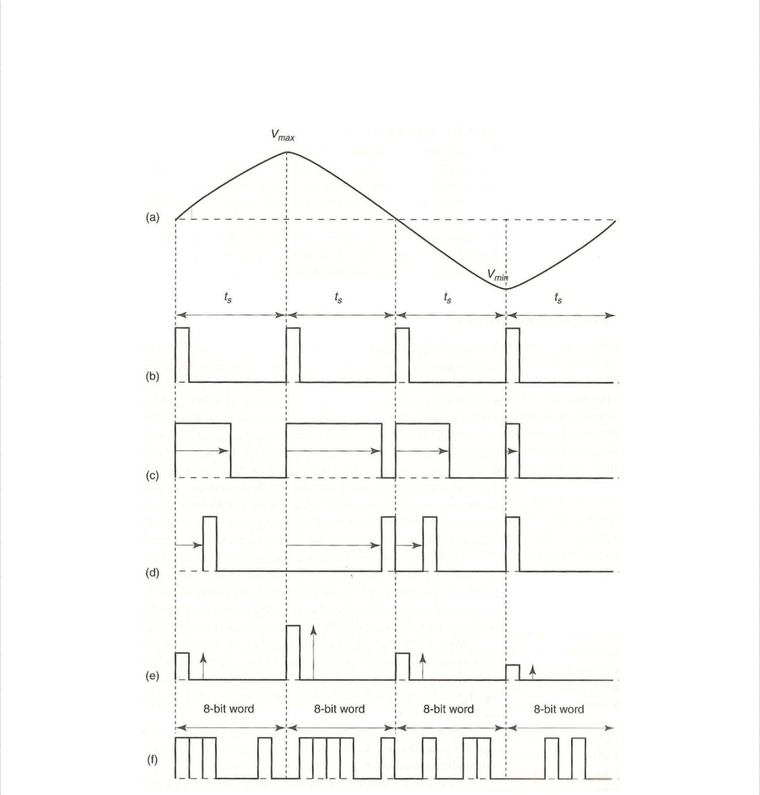

Pulse modulation: (a) analog signal; (b) sample pulse; (c) PWM; (d) PPM; (e) PAM; (f) PCM

Pulse Amplitude Modulation (PAM): The amplitude of a constant width, constant-width, and constant-position is varied according to the amplitude of the sample of the analog signal. It resembles the original analog signal more than the wave forms for PWM or PPM. Telephone modems faster than 300 bits/sec and Ethernet use PAM.

2

DCS Unit-3 Digital Transmission
Multiplexing and T carriers

Pulse Code Modulation (PCM): The analog signal is sampled and then converted to a serial n-bit binary code for transmission. Each code has the same number of bits and requires the same length of time for transmission. Applications include digital audio in computers and CDs.

Pulse Code Modulation

PCM invented by Alex H. Reeves in 1937 is the preferred method of communications within the public switched telephone network because with PCM, it is easy to combine digitized voice and digital data into a single, high-speed digital signal and propagate it over either metallic or optical fiber cables. With PCM, the pulses are of fixed length and fixed amplitude. PCM is a binary system where a pulse of lack of pulse within a prescribed time slot represents either logic 1 or logic 0 conditions.
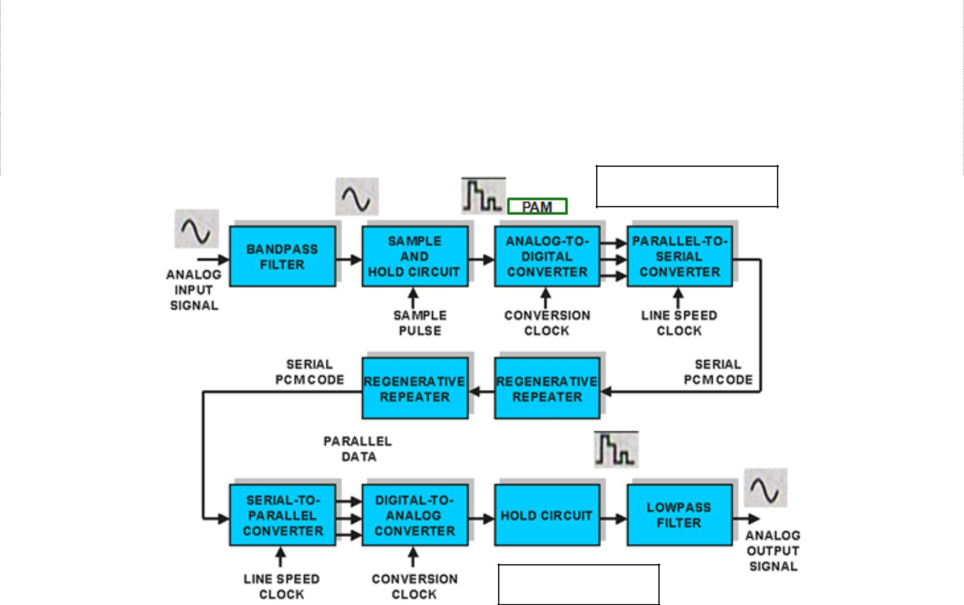

PCM Transmitter

PCM Receiver

The above figure shows a simplified block diagram of a single-channel, simplex PCM system. The bandpass filter limits the frequency of the analog input signal to the standard voice-band frequency range of 300 Hz to 3000 Hz. The sample and hold circuit periodically samples the analog input signal and converts those samples to a multiple PAM signal. The analog-to-digital converter (ADC) converts the PAM samples to parallel PCM codes, which are converted to serial binary data in the parallel-to-serial converter and then outputted into the transmission line as serial digital pulses. Repeaters are placed at prescribed distances to regenerate the digital pulses.

At receiver side, the serial-to-parallel converter converts serial pulses received from the transmission line to parallel PCM codes. The digital-to-analog converter (DAC) converts the parallel PCM codes to multilevel PAM signals. The hold circuit is basically a low pass filter that converts the PAM signals back to its original analog form. An integrated circuit that performs the PCM encoding and decoding functions is called a codec (coder/decoder).

3

DCS Unit-3 | Digital Transmission
 | Multiplexing and T carriers
PCM Sampling

Sampling circuit in a PCM transmitter periodically samples the continually changing analog input voltage and converts those samples to a series of constant amplitude pulses, which can be more easily converted to binary PCM code. Two basic techniques to perform sampling exist.

Natural Sampling: In natural sampling the pulse amplitude takes the shape of the analogue waveform for the period of the sampling pulse. The frequency spectrum of the sampled output is different from that of an ideal sample.
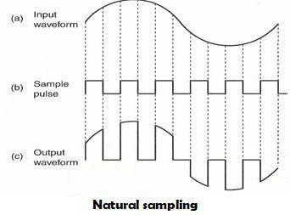

Flat-top sampling: It is accomplished in a sample-and-hold circuit. Its purpose is to periodically sample the continually changing analog input voltage and covert those samples to a series of constant voltage PAM voltage levels. With flat-top sampling, the input voltage is sampled with a narrow pulse and then relatively held constant until next sample is taken.
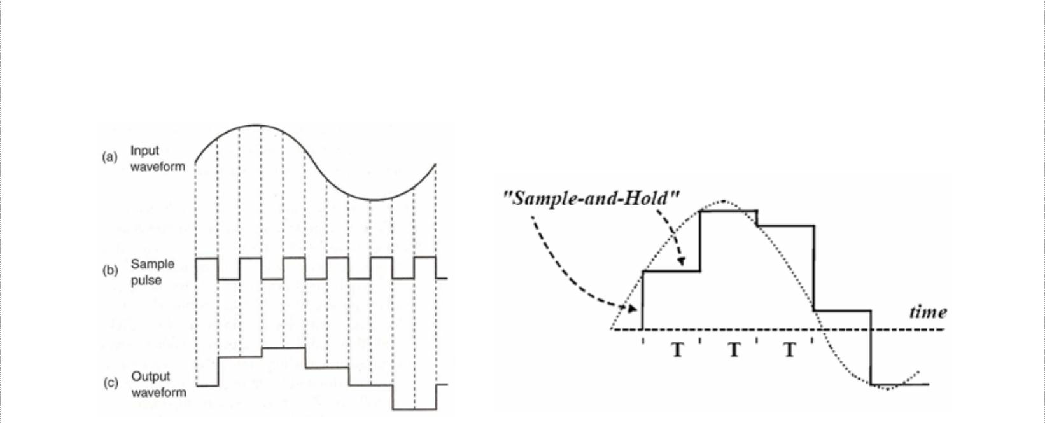

Flat-top sampling

Flat-top sampling introduces less aperture distortion than natural sampling and can operate with a slower analog-to-digital converter.

4

DCS Unit-3 | Digital Transmission
 | Multiplexing and T carriers
Sampling Rate

Nyquist sampling theorem states that for a sample to be reproduced accurately, minimum sampling rate, f_{s} must be twice the higher input frequency, f_{a}. Mathematically, the minimum Nyquist sampling rate, fs is f_{s} ≥ 2 f_{a}, where f_{s} is minimum Nyquist sample rate in hertz and f_{a} is maximum analog input frequency in hertz.

If f_{s} is less than twice f_{a}, i.e. f_{s} < 2 f_{a}, aliasing or foldover distortion occurs. This can be overcome by using anti-aliasing filter before sampling to suppress the component before sampling.
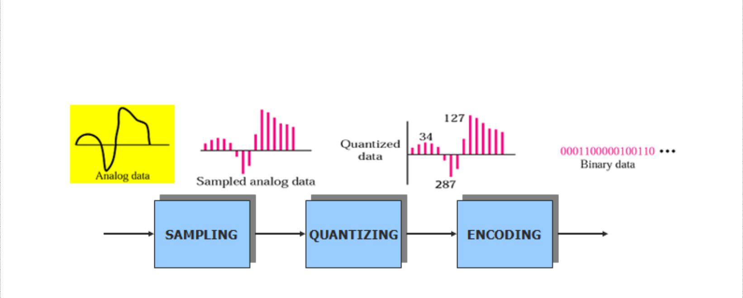

Quantization and the Folded Binary Code

Quantization is the process of converting a continuous range of values into a finite range of discreet values. This is a function of analog-to-digital converters, which create a series of digital values to represent the original analog signal. Quantization is required to convert the analog signal to a PCM code with a limited number of combinations. Taking an example, a sine wave with peak amplitude of 5v, varying between +5V and -5V passing through every amplitude between them. A PCM code could have only eight bits, which equates to only 2⁸ or 256 combinations and to be converted, the sine wave values have to be rounded off.
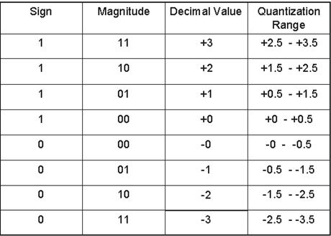

5

DCS Unit-3 Digital Transmission
Multiplexing and T carriers

The above table shows the three bit PCM code, which is a three-bit sign magnitude code with eight possible combinations (four +ve and four –ve). The left most bit is the sign bit (1 = + and 0 = -), and the remaining two right most bits represent magnitude. This type of code is called folded binary code because the codes on the bottom half of the table are an exact mirror image of the codes on the top except for the sign bit. The magnitude difference between adjacent steps is called the quantization interval or quantum (1V for above table). For the above code, the maximum signal magnitude that can be encoded is +3V (111) or -3V (011) and the minimum is +1V (101) or -1V (001). If the magnitude of the sample exceeds the highest quantization interval, overload distortion (peak limiting) occurs.

Assigning PCM codes to absolute magnitudes is called quantizing. The magnitude of a quantum is also called the resolution. It is equal to the voltage of the least significant bit (V_{lsb}) of the PCM code. The smaller the magnitude of a quantum, the better the resolution and the more accurately the quantized signal will resemble the original analog signal.
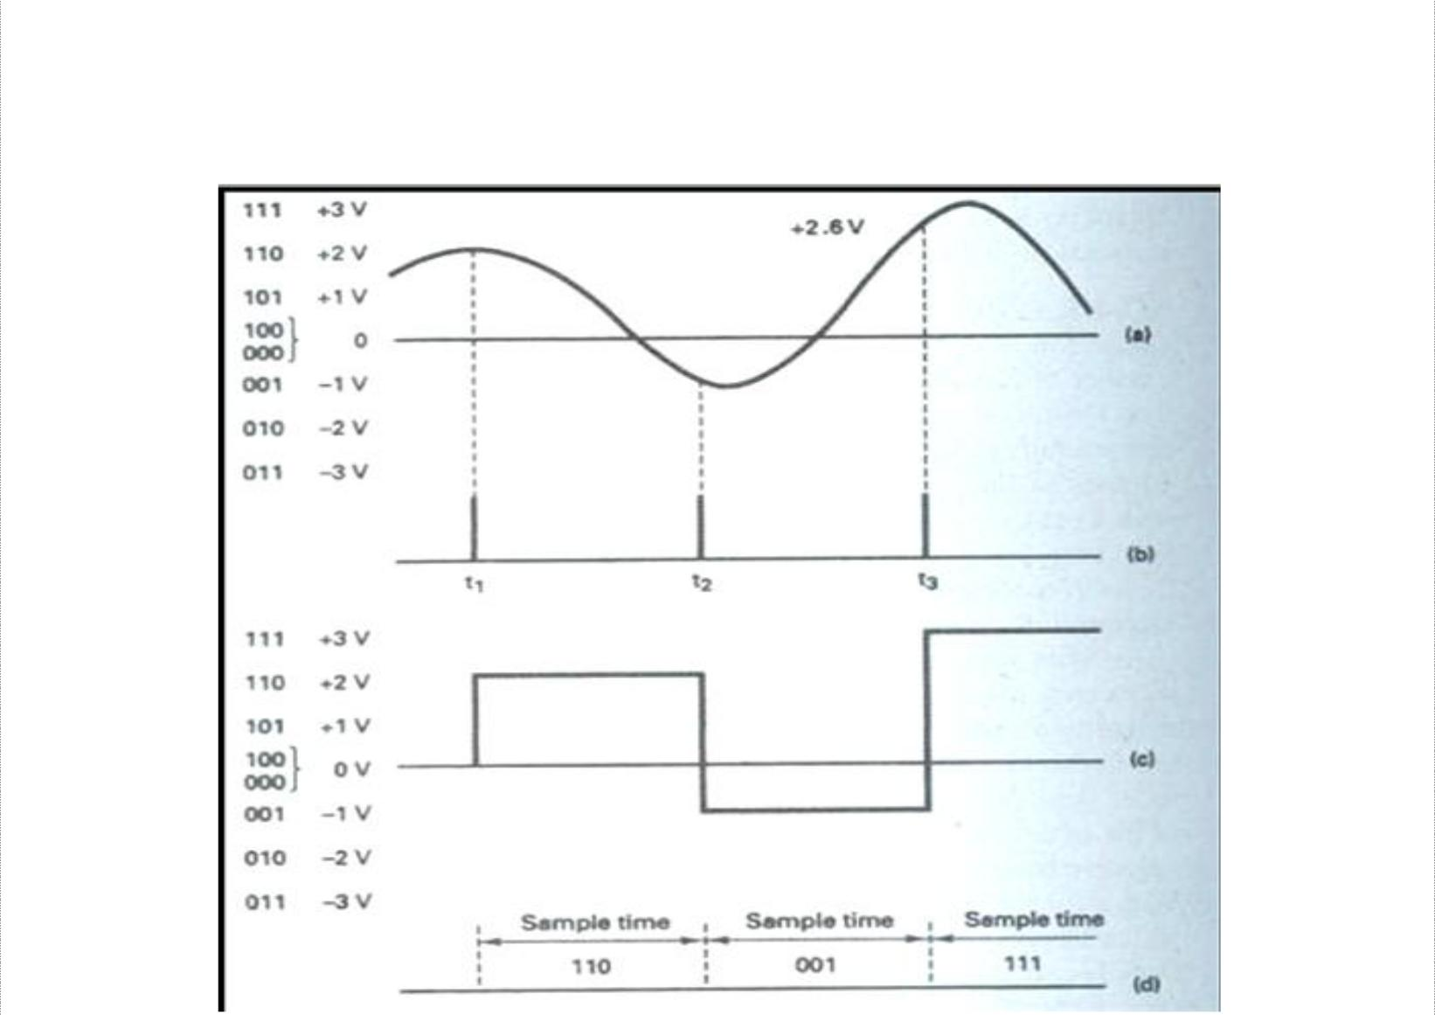

(a) Analog input signal; (b) sample pulse; (c) PAM; (d) PCM code

Each sample voltage is rounded off to the closest available quantization level and then converted to its corresponding PCM code. The PAM signal in the transmitter is essentially the same PAM signal produced in the receiver. So, any round-off errors in the transmitted signal are reproduced when the code is converted back to the analog by the DAC in the receiver. This error is called the quantization error (Qe), which is also quantization noise (Qn). The quantized signal shown above roughly resembles the original input signal as with three-bit PCM code, poor resolution results and only three samples are taken from analog signal.

6

DCS Unit-3 Digital Transmission
Multiplexing and T carriers
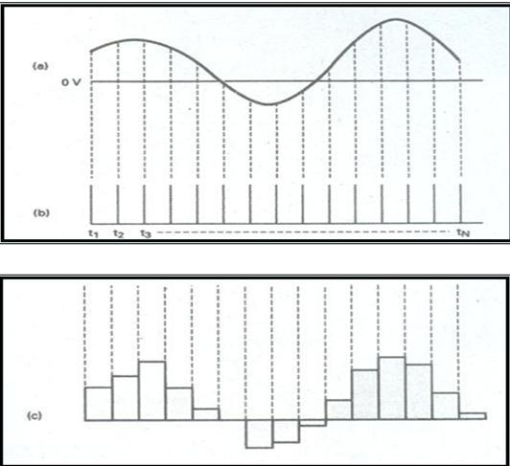

As shown above, the quality of PAM signal can be improved by using a PCM code with more bits, reducing the magnitude of quantum and improving the resolution. Also, the sampling the analog signals at a faster rate increases the quality and the PAM signal
resembles the analog signal closely. Quantization error is given by
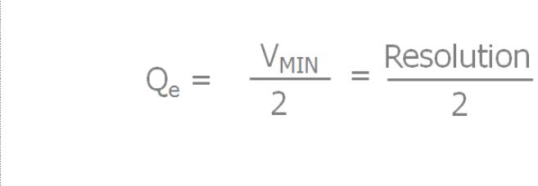

Dynamic Range

It is the ratio of the largest possible magnitude to the smallest possible magnitude (other than 0V) that can be decoded by the digital-to-analog converter in the receiver. Mathematically,

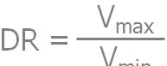, where, DR is dynamic range and V_{min} is the quantum value (resolution) and V_{max} is the maximum voltage magnitude that can be discerned by the receivers DACs. Dynamic range can be expressed in decibels as
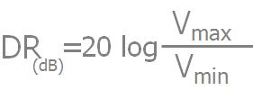
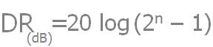

Or , where n is the number of PCM bits.

7

DCS Unit-3 Digital Transmission
Multiplexing and T carriers

Signal Voltage –To-Quantization Noise Voltage Ratio

The maximum quantization noise is half the resolution. Therefore, the worst possible signal voltage-to-quantization noise voltage ratio (SQR) occurs when the input signal is at its minimum amplitude. Mathematically, the worst-case voltage SQR is 2.

For linear PCM codes, the signal power-to-quantizing noise power ratio is determined by the formula:


Where, R is resistance in ohms, v is rms signal voltage in volts, q is quantization interval in volts, v ²/R is average signal power in watts and (q²/12)/R is average quantization noise power in watts.
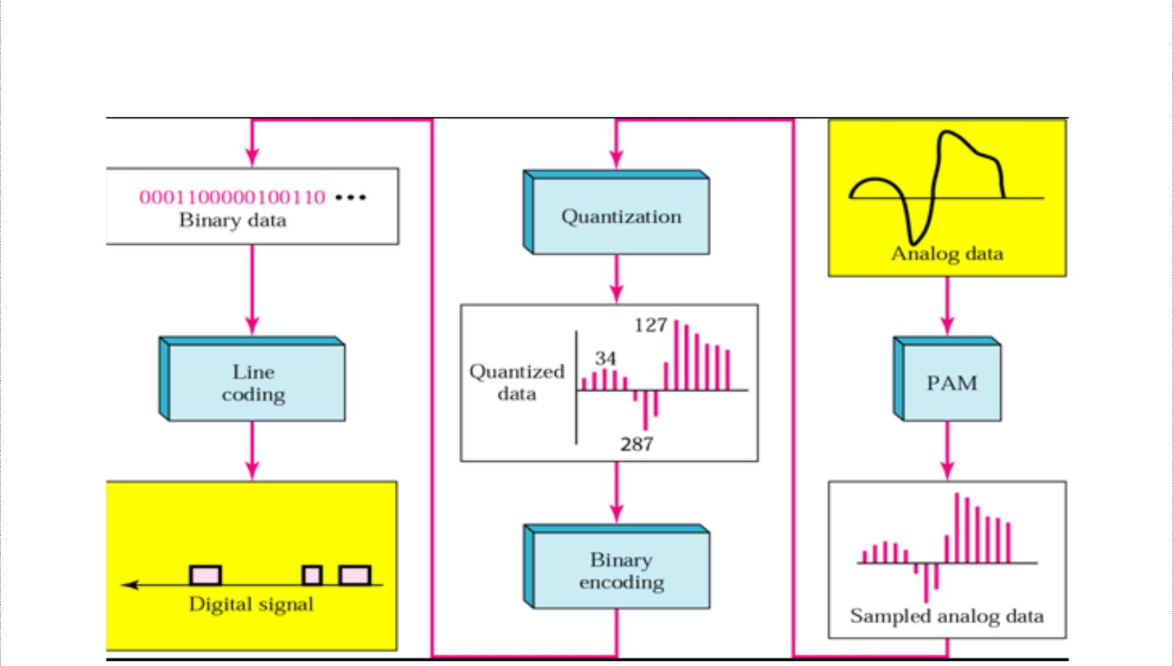

From analog signal to PCM Digital Codes

8

DCS Unit-3 Digital Transmission
Multiplexing and T carriers

Linear versus Nonlinear PCM codes

- Linear codes – magnitude change between any two successive steps in uniform

– Resolution/accuracy is the same for lower and higher amplitude signal
– SQR for low amplitude signal is less than the SQR for higher amplitude signal
- Nonlinear – step size increases with the amplitude of the input signal
– More codes at the bottom
– Distance between successive codes is greater for higher amplitude signals
– Vmax/Vmin is increased
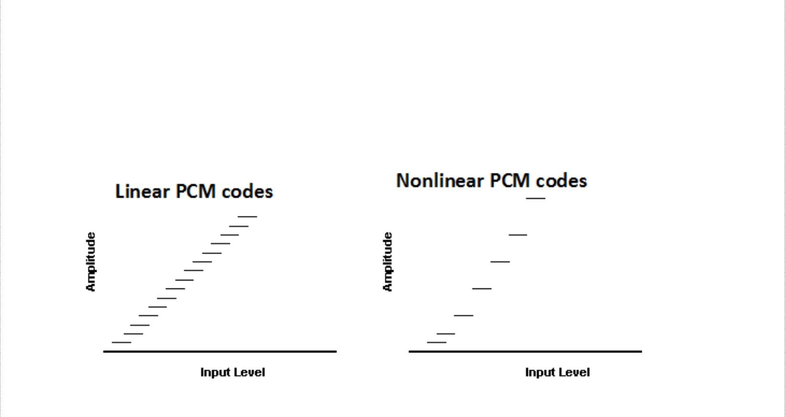

Companding

Companding is the process of compressing and expanding and is a means of increasing the dynamic range of a communications system. Higher-amplitude analog signals are compressed prior to transmission and then expanded in the receiver.
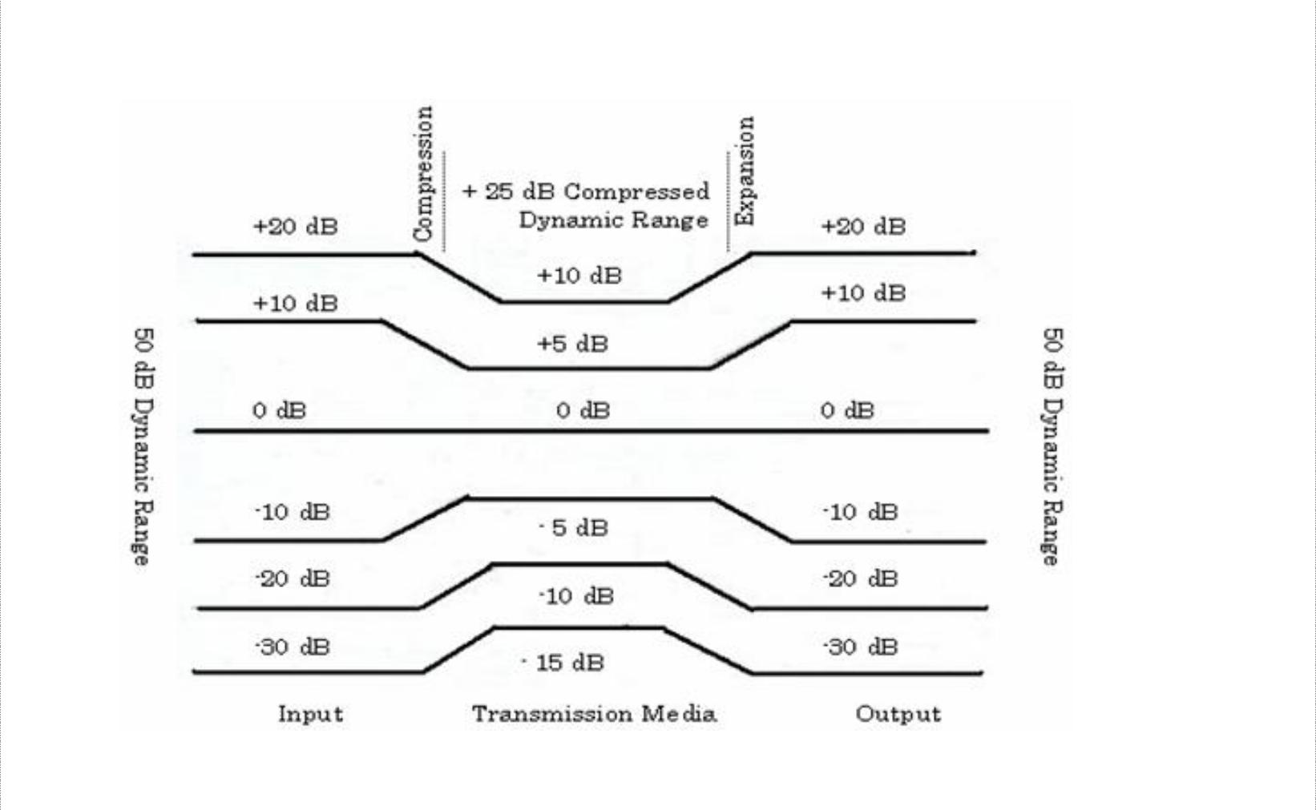

9

DCS Unit-3 Digital Transmission
Multiplexing and T carriers

An analog input signal with a dynamic range of 50dB is compressed to 25dB prior to transmission and then expanded back at the receiver. With PCM, companding may be accomplished using analog or digital techniques.

Analog Companding
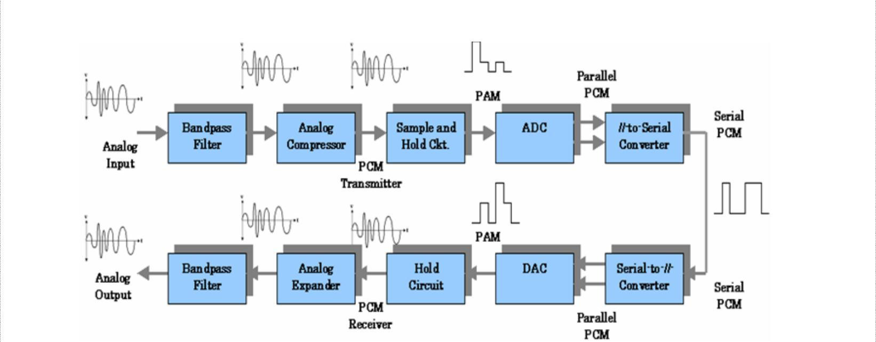

PCM system with analog companding

In the transmitter, the dynamic range of the analog signal is compressed, sampled, and then converted to a linear PCM code. In the receiver, the PCM code is converted to a PAM signal, filtered and then expanded back to its original dynamic range. Two methods of analog companding exist (also called log-PCM codes).

- – Law companding: u-law is a companding scheme used in telephone network to get

more dynamics to the 8 bit samples that is available with linear coding. Compression characteristics for μ – Law is
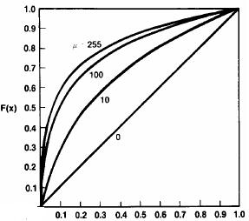

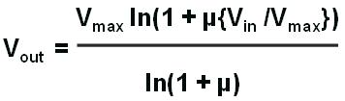,
- – Law Compression characteristics
Where,
V_{max} = maximum uncompressed analog input amplitude (volts)
V_{in} = amplitude of the input signal at particular instant of time (volts)

- = parameter used to define the amount of compression (unitless) V_{out} = compressed output amplitude (volts)

The graph shows the compression curves for several values of µ. The higher the µ, the more compression and also for µ = 0, the graph is linear.

10

DCS Unit-3 Digital Transmission
Multiplexing and T carriers

- – Law: In Europe, the ITU-T has established A-law companding to be used to approximate true logarithmic companding. Compression characteristic for A- law companding is
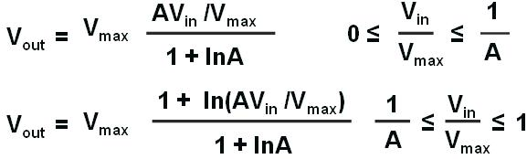

Digital Companding

Digital companding involves compression in the transmitter after the input sample has been converted to a linear PCM code and then expansion in the receiver prior to PCM decoding.
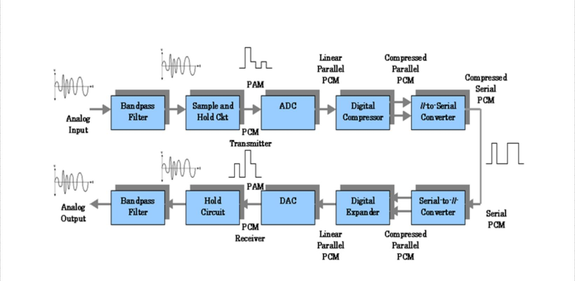

Recent digitally compressed PCM systems use a 12-bit linear PCM code and an eight-bit compressed PCM code. The compression and expansion curves closely resemble analog µ-law curves with a µ = 255.

The following figure shows 12- to eight-bit digital compression curve for positive values only. For negative values, it’s identical but just inverse. Though 16 segments are present, this scheme is called 13-segment compression because the curve for segments +0, +1, -0 and -1 is a straight line.

The digital companding algorithm for a 12-bit linear to eight-bit compressed code is quite simple and the compressed code consists of a sign bit, a three-bit segment identifier, and a five-bit magnitude code which specifies the quantization interval within the specified segment.

11

DCS Unit-3 Digital Transmission
Multiplexing and T carriers
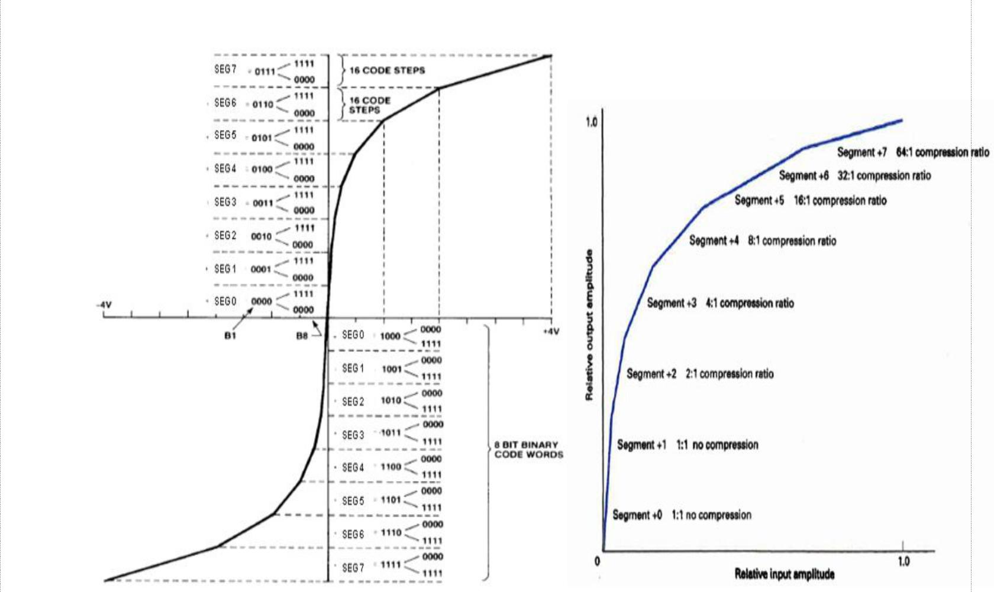

13 Segment Scale µ- 255 compression characteristics
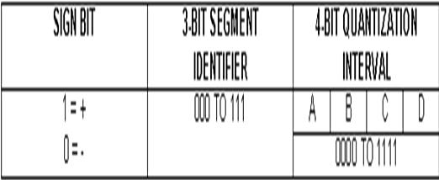

Eight bit µ- 255 compressed code format
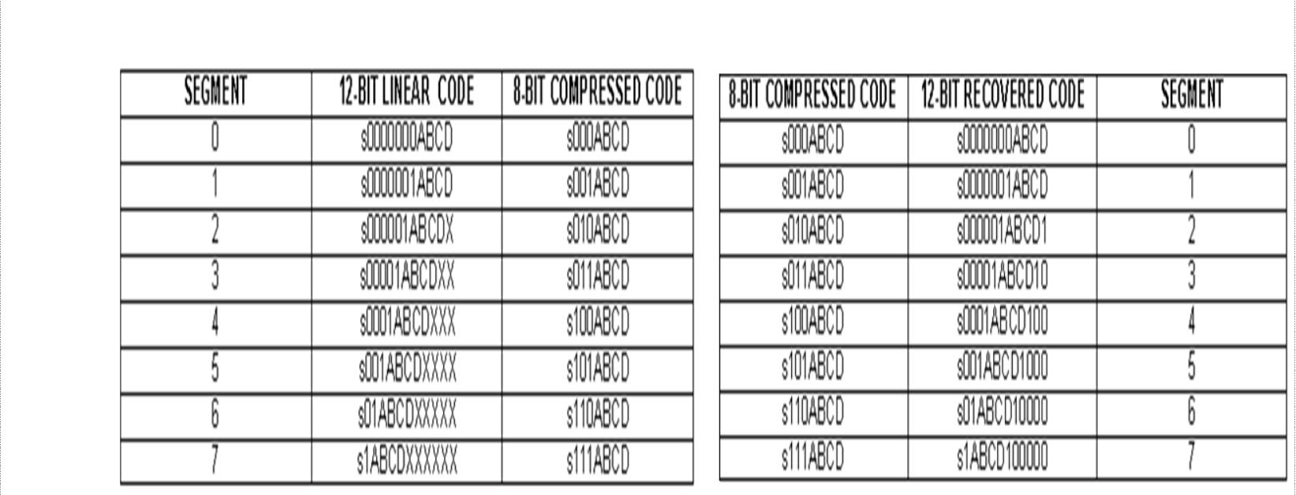

µ- 255 encoding and decoding table

12

DCS Unit-3 Digital Transmission
Multiplexing and T carriers

In the encoding table shown above, the bit positions designated with an X are truncated during compression and thereafter lost. Bits designated by A, B,C, D along with the sign bit are transmitted as is. The analog signal is sampled and converted to a linear 12-bit sign-magnitude code. The sign bit is transferred directly to an eight-bit compressed code. The segment number in the eight-bit code is determined by counting the number of leading 0’s in the 11-bit magnitude portion of the linear code beginning with the most-significant bit and then subtracting the number of leading 0s from 7, which is the segment number. The segment number is converted to a three-bit binary number and inserted into the eight-bit compressed code as the segment identifier. The four magnitude bits (A, B, C, D) represent the quantization interval and are submitted into the least-significant four bits of the eight-bit compressed code.
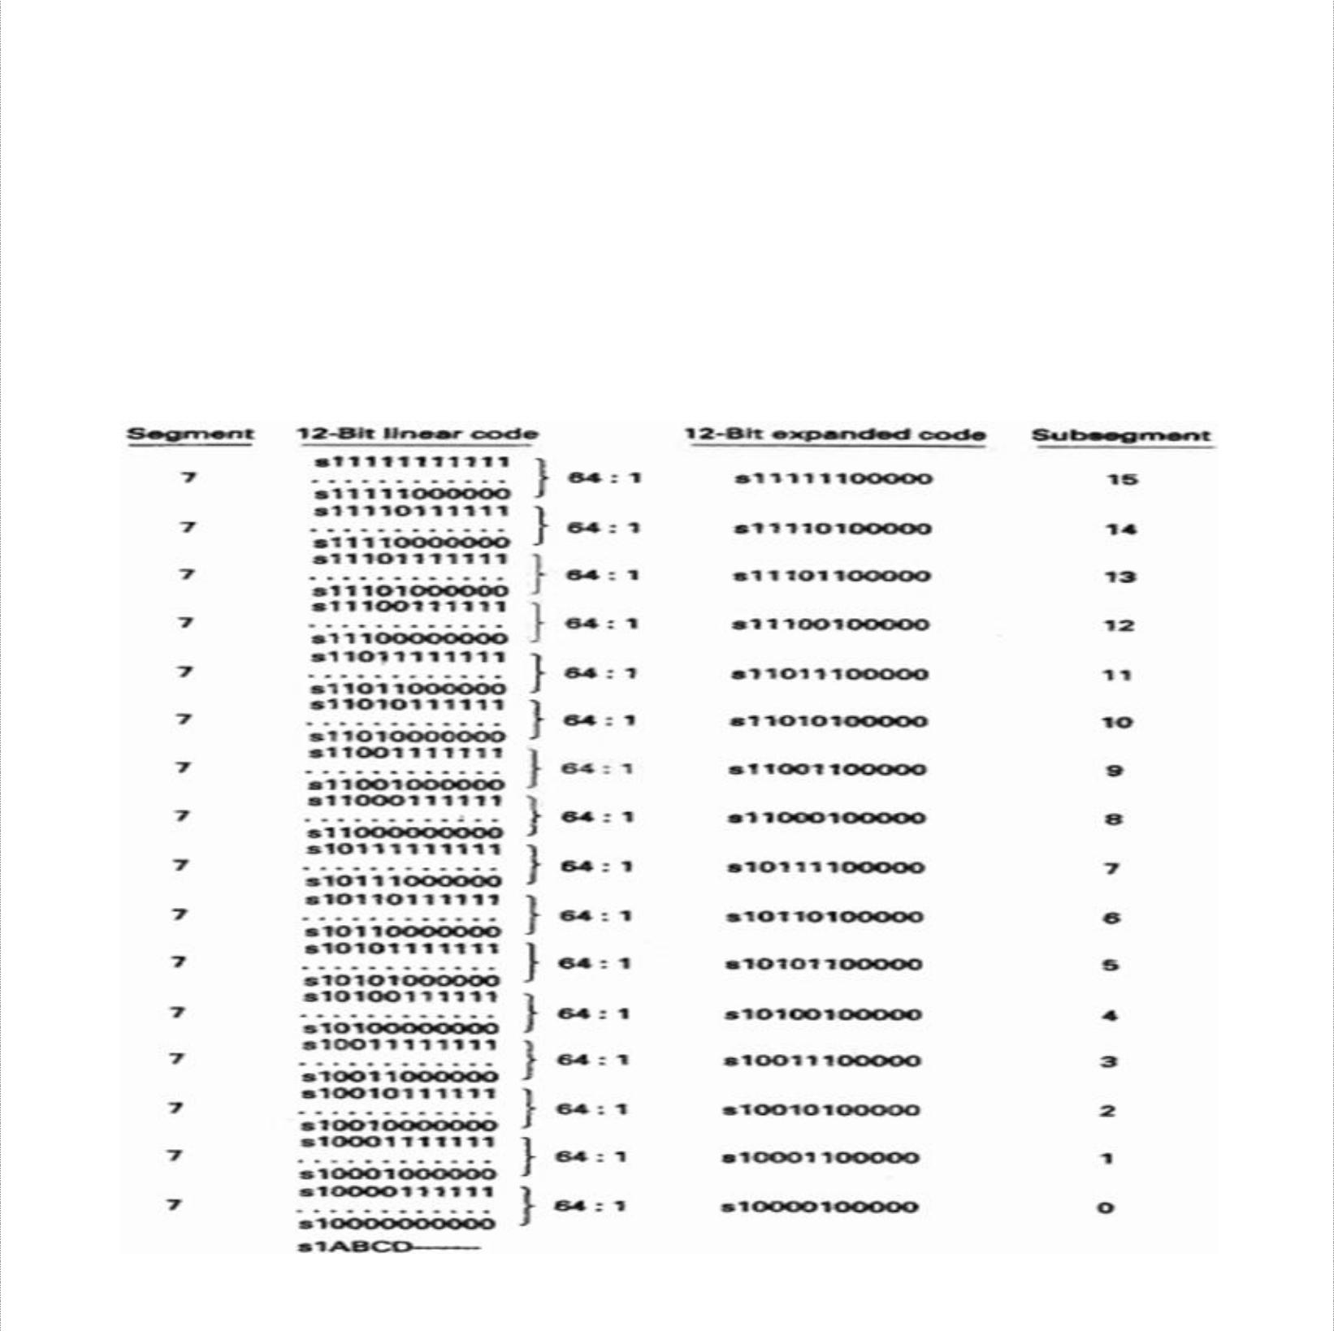

Segments 2 through 7 are subdivided into smaller subsegments. Each segment consists of 16 subsegments corresponding to the 16 conditions possible for bits A, B,C and D (0000 – 1111). In segment 2, there are two codes per subsegment and in segment 3, there are four. The number of codes per subsegment doubles with each subsequent segment. So, in segment 7, each subsegment has 64 codes. In the decoder, the most significant of the truncated bits is reinserted as logic 1. The remaining truncated bits are reinserted as 0s. This minimizes the magnitude of error introduced by compression and expansion process.

13

DCS Unit-3 | Digital Transmission
 | Multiplexing and T carriers
Digital Compression Error

The magnitude of the compression error is not the same for all samples. However, the maximum percentage is the same in each segment (other than segments 0 and 1, where there is no compression error), which is calculated using:
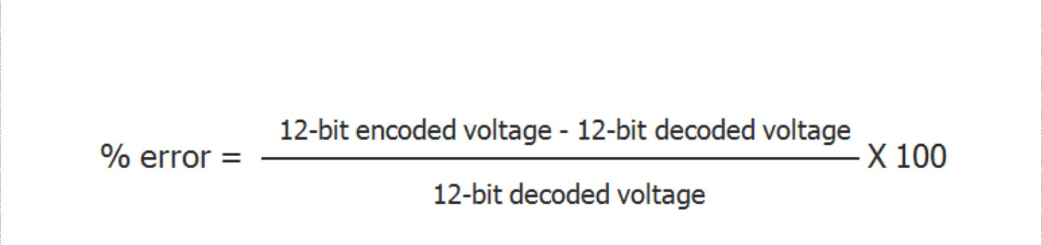

Every function performed by a PCM encoder and decoder is now accomplished with a single integrated-circuit chip called codec. Some of the most recent developed codecs are called combo chips, as they include an antialiasing (band-pass) filter, a sample-and-hold circuit, and an ADC in transaction and a DAC, a hold circuit, and a band pass filter in the receive section.

PCM Line Speed

Line speed is the data rate at which serial PCM bits are clocked out of the PCM encoder onto the transmission line. Line speed is dependent on the sample rate and the number of bits in the compressed PCM code. Mathematically, it is:


, where

Line speed is the transmission rate in bits per second, samples/second is sample rate (f_{s}) and bits/sample is number of bits in the compressed PCM code.

Delta Modulation PCM and Differential PCM

Delta modulation PCM uses a single-bit PCM code to achieve digital transmission of analog signals. Here, only a single bit is transmitted, which simply indicates whether the present sample is larger or smaller in magnitude than the previous sample. If the current sample is larger in magnitude than a previous sample, a logic 1 is transmitted and if its smaller, logic 0 is transmitted.

Differential pulse code modulation (DPCM) takes advantage of the sample-to-sample redundancies in typical speech waveforms. With DPCM, a binary code proportional to the difference in the amplitude of two successive samples is transmitted rather than a binary code of an actual sample. As the range of sample differences is less than the range of individual sample amplitudes, fewer bits are required for DPCM than for conventional PCM.

14

DCS Unit-3 Digital Transmission
Multiplexing and T carriers

MULTIPLEXING AND T CARRIERS
Time- Division Multiplexing, T1 Digital Carrier System, North American Digital Multiplexing Hierarchy, Digital Line Encoding, T Carrier systems, European Time- Division Multiplexing, Statistical Time – Division Multiplexing, Frame Synchronization, Frequency-Division Multiplexing, Wavelength- Division Multiplexing, Synchronous Optical Network

Multiplexing is the transmission of information from more than one source to more than one destination over the same transmission medium. Multiplexing is accomplished in various domains such as space, time, phase, frequency and wavelength.

Time Division Multiplexing

With TDM system, transmission from multiple sources occurs on the same transmission medium but not at the same time. Transmission from various sources is interleaved in time domain. The two basic forms of TDM are: Synchronous TDM (STDM) and Asynchronous (or) Statistical TDM (STATDM)
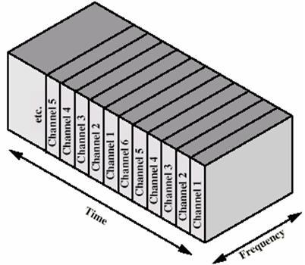

In synchronous TDM, time slot ‘x’ is assigned to user m alone and cannot be used by any other user or other device. T-1 and ISDN telephone lines are common examples of synchronous time division multiplexing. Asynchronous TDM networks assign time slots only when they are to be used and delete them when they are idle. STATDM is used in high density and high traffic applications.

With PCM-TDM system, two or more voice channels are sampled, converted to PCM codes, and then time-division multiplexed onto a single metallic or optical fiber cable.
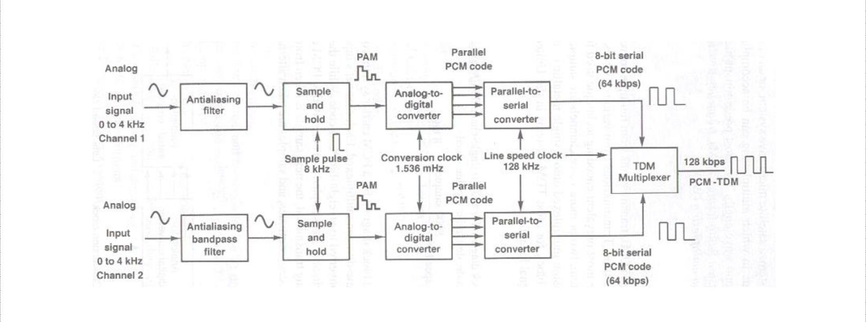

15

DCS Unit-3 Digital Transmission
Multiplexing and T carriers

The above figure shows a block diagram for a PCM carrier system comprised of two DS-0 channels that have been time-division multiplexed. Each channel’s input is alternately sampled at an 8-kHz rte and converted to an eight-bit PCM code. While the PCM code for channel-1 is being transmitted, channel-2 is sampled and converted to PCM code. When its turn for channel-2’s PCM code to be transmitted, the next sample is taken from channel-1 and converted to PCM code. This is a continuous process.
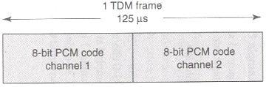

The multiplexer is simply an electronically controlled digital switch with two inputs and one output. One eight-bit PCM code from each channel is called a TDM frame and the time it takes to transmit one TDM frame is called frame time and it is equal to reciprocal of sample rate. The above figure shows the frame allocation for a two channel PCM system. The PCM code for each channel occupies a fixed time slot within the total TDM frame.
DS-hierarchy 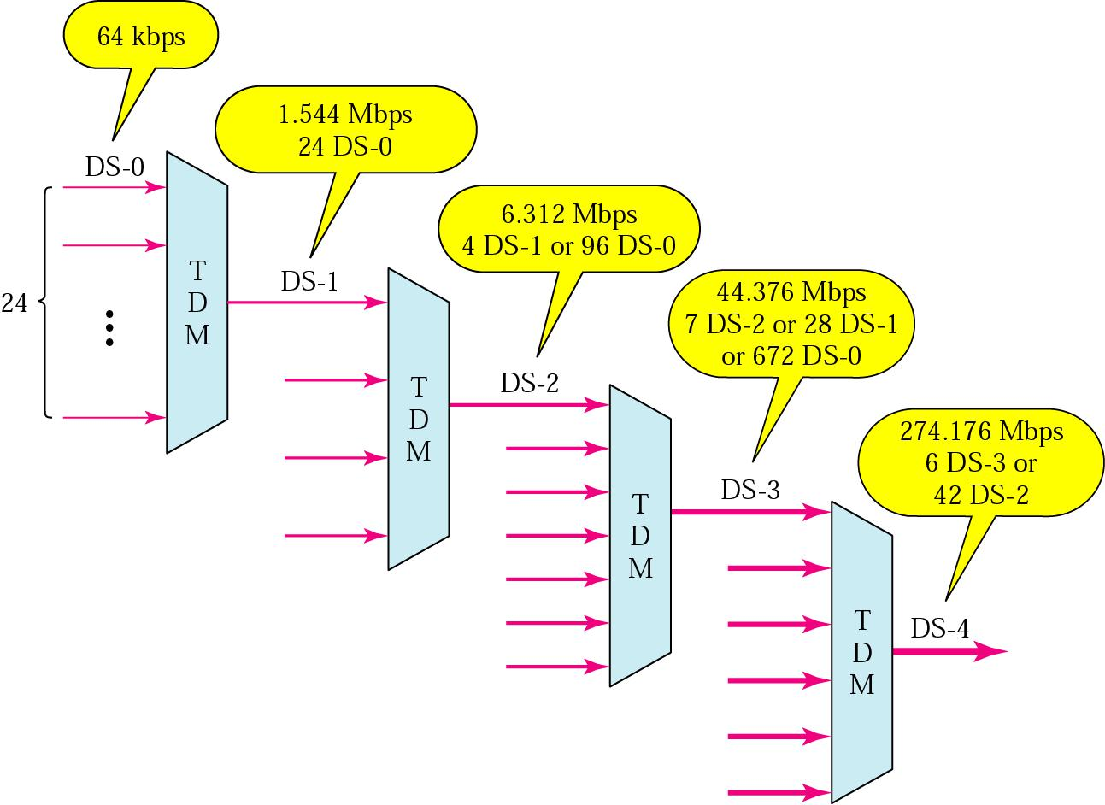

T1 Digital Carrier System

A digital carrier system is a communications system that uses digital pulse rather than analog signals to encode information. The following figure shows a block diagram of for the Bell system T1 digital carrier system, which is the North American telephone standard.
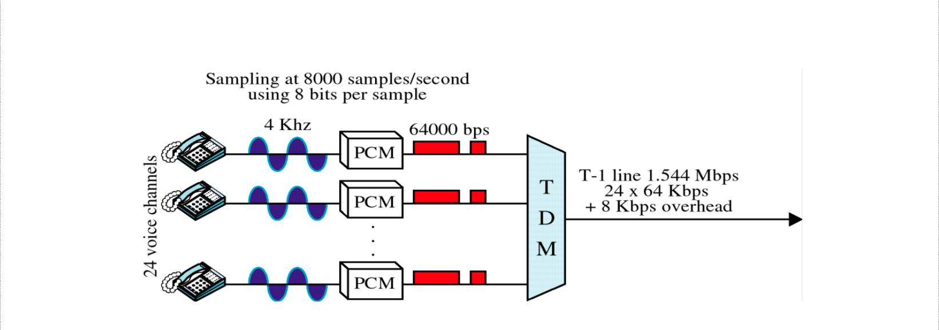

16

DCS Unit-3 Digital Transmission
Multiplexing and T carriers
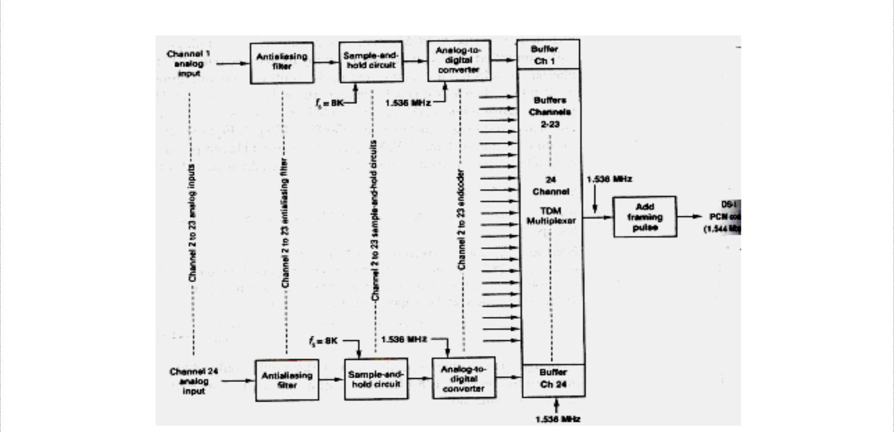

A T1 carrier system time division multiplexes PCM encoded samples from 24 voice band channels for transmission over a single metallic wire pair or a fiber optic cable. The multiplexer has 24 independent inputs and one time-division multiplexed output. The 24 PCM output signals are sequentially selected and connected through the multiplexer to the transmission line. To become a T1 carrier, the system has to be line encoded and placed on special conditioned cables called T1 lines.

A transmitting portion of a Channel Bank digitally encodes the 24 analog channels, adds signalling information into each channel, and multiplexes the digital stream onto the transmission medium. The receiving portion reverses the process. Each of the 24 channels contains an eight-bit PCM code and is sampled 8000 times a second. Each channel is sampled at the same rate, but may not be at the same time. The line speed is calculated as:
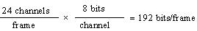=> 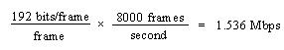

Later, an additional bit called the framing bit is added to each frame. The framing bit occurs once per frame and is recovered at the receiver and its main purpose is to maintain frame and sample synchronization between TDM transmitter and receiver.
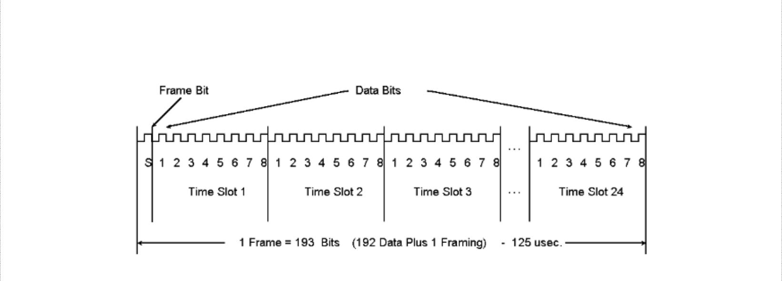

As a result of this extra bit, each frame now contains 193 bits and the line speed for a T1 digital carrier system is 1.544 Mbps. { 193 bits × 8000 frames = 1.544 Mbps}

17

DCS Unit-3 | Digital Transmission
 | Multiplexing and T carriers
D-Type Channel Banks

D type Channel Bank refers to the terms used in T1 technology. Channel Bank defines the type of formatting that is required for transmission on T1 trunk. The purpose of a Channel Bank in the telephone company is to form the foundation of multiplexing and demultiplexing the 24 voice channels (DS0). D type Channel Bank is one of the types of Channel Bank which is used for digital signals. There are five kinds of Channel Banks that are used in the System: D1, D2, D3, D4, and DCT (Digital Carrier Trunk).

Earlier T1 carrier systems used D1 digital channel banks (PCM encoders) with a seven-bit magnitude-only PCM code, analog companding and a µ = 100. Modern versions use digital companded, eight-bit sign magnitude-compressed PCM codes with a µ = 255.

Superframe TDM Format

The 8-kbps signalling rate used with the early digital channel banks was excessive for signaling on standard telephone voice circuits. Therefore, with modern channel banks, a signaling bit is substituted only into the least-significant bit (LSB) of every sixth frame. Hence, five of every six frames have eight-bit resolution, while one in every six frames (the signaling frame) has only seven-bit resolution.

Because only every sixth frame includes a signaling bit, it is necessary that all the frames be numbered so that the receiver knows when to extract the signaling bit. Also, because signaling is accomplished with a two-bit binary word, it is necessary to identify the most- and least-significant bits (MSB and LSB, respectively) of the signaling word. A Superframe format was devised as shown below.
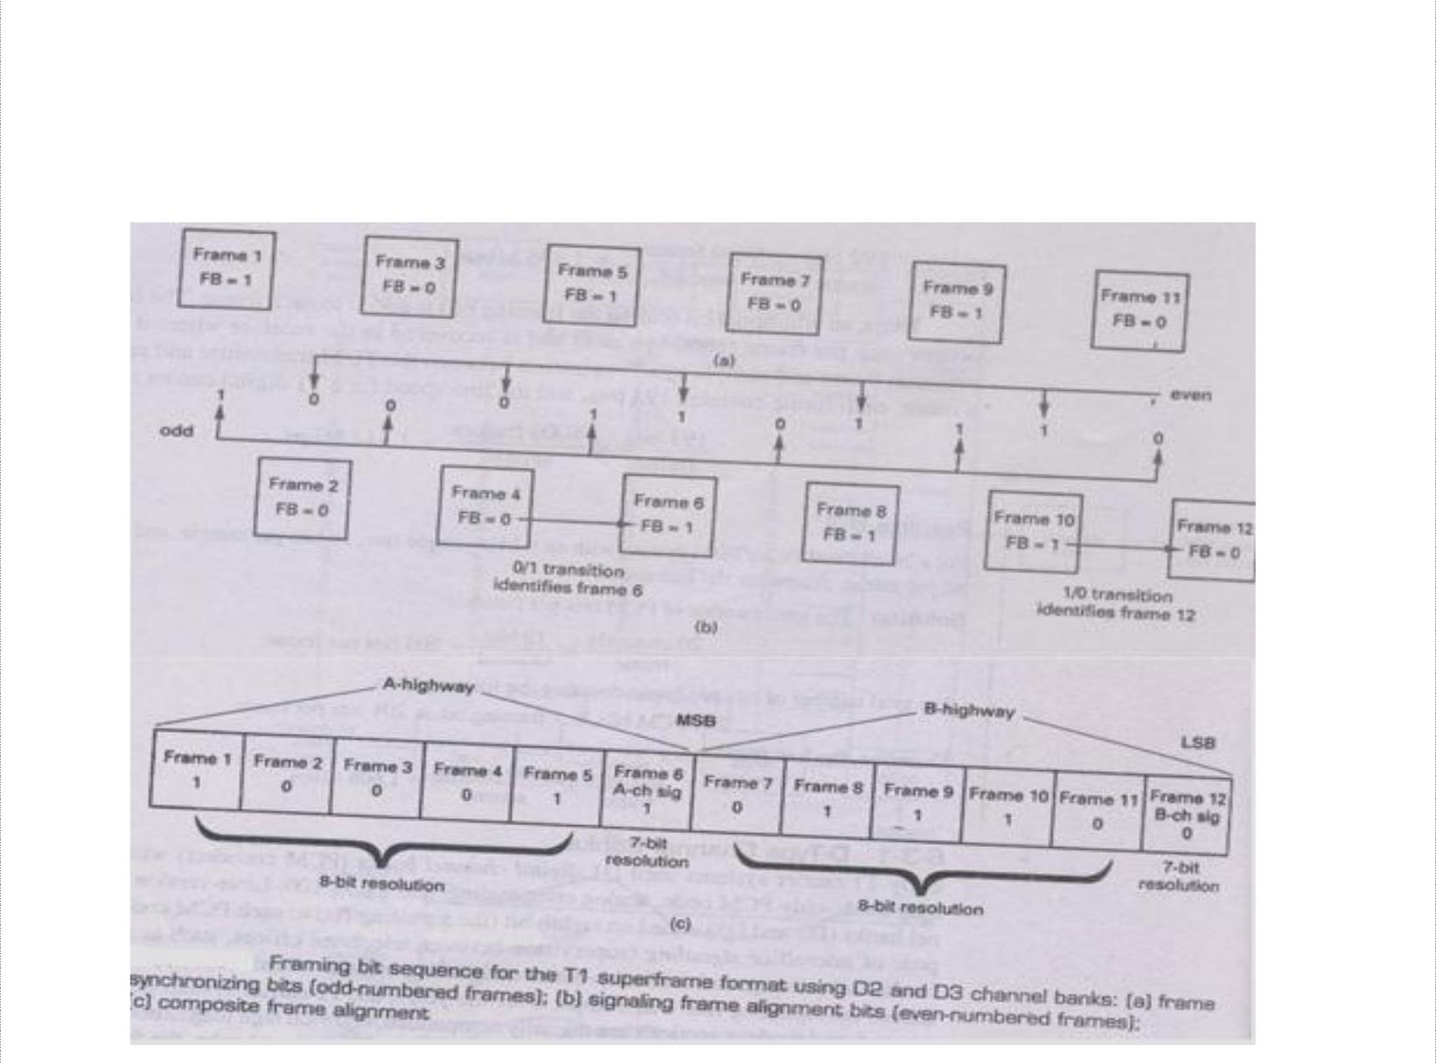

18

DCS Unit-3 Digital Transmission
Multiplexing and T carriers

Within each super- frame are 12 consecutively numbered frames (1 to12). The signaling bits are substituted in frames 6 and 12, the MSB into frame 6, and the LSB into frame 12. Frames1to 6 are called the A highway, with frame 6 designated the A channel signaling frame. Frames 7 to 12 are called the B high way, with frame 12 designated the B channel signaling frame. Therefore, in addition to identifying the signaling frames, the sixth and twelfth frames must also be positively identified. To identify frames 6 and 12, a different framing bit sequence is used for the odd- and even-numbered frames. The odd frames (frames 1, 3, 5, 7, 9, and 11) have an alternating 1/0) pattern, and the even frames (frames 2, 4, 6, 8, 10, and 12) have a 00 1110repetitive pattern. As a result, the combined framing bit pattern is 1000 11011100. The odd numbered frames are used for frame and sample Synchronization and the even-numbered frames are used to identify the A and B channel signaling frames (frames 6 and 12). Frame 6 is identified by a 0/1 transition in the framing bit between frames 4 and 6. Frame 12 is identified by a 1/0 transition in the framing bit between frames 10 and 12.

D4 channel banks time-division multiplex 48 voice-band telephone channels and operate at a transmission rate of 3.152 Mbps, which is slightly more than twice the line speed for 24-channel D1, D2, or D3 channel banks because with D4 channel banks, rather than transmitting a single framing bit with each frame, a 10-bit frame synchronization pattern is used.

Line speed is calculated as: total no of bits is 8 bits/channel × 48 channels = 384 bits/frame An additional 10 bits are added for frame: so 394 bits/frame. Therefore, line speed of DS-1C system is 394×8000 = 3.152 Mbps

Extended Superframe Format

In telecommunication, an Extended Super Frame (ESF) is a T1 framing standard, sometimes called D5 framing because it was first used in the D5 Channel Bank, invented in the 1980s. It requires less frequent synchronization than the earlier superframe or D-4 format, and provides on-line, real-time testing of circuit capability and operating condition.

In ESF, a superframe is 24 frames long, and the 193rd bit of each frame is used as framing bit. Only 6 of the 24 framing bits are used for frame synchronization. Frame synchronization bits occur in frames 4, 8, 12, 16, 20 and 24 and have a bit sequence of 001011. Six additional framing bits in frames 1, 5, 9, 13, 17, and 21 are used for an error-detection code called CRC-6 (cyclic redundancy checking). The 12 remaining framing bits provide for a management channel called the facilities data link (FDL). FDL bits occur in frames 2, 3, 6, 7, 10, 11, 14, 15, 18, 19, 22, and 23.

The extended superframe format supports a four-bit signaling word with signaling bits provided in the second least-significant bit of each channel during every sixth frame. The signaling bit in frame 6 is called the A bit, in frame 12 is called the B bit, in frame 18 is C bit and in frame 24 is called D bit. These signaling streams are sometimes called the A, B, C and D signaling channels (or signaling highways).

19

DCS Unit-3 | Digital Transmission
 | Multiplexing and T carriers
Fractional T Carrier Service

Fractional T carrier emerged because standard T1 earners provide a higher capacity (i.e., higher bit rate) than most users require. Fractional T1 systems distribute the channels (i.e., bits) in a standard T1 system among more than one user, allowing several subscribers to share one T1line. Bit rates offered with fractional T1 carrier systems are 64kbps (1 channel), 128 kbps (2 channels), 256 kbps (4 channels), 384 kbps (6 channels), 512 kbps (8 channels), and 768 kbps (12 channels), with 384 kbps (1/4 T1) and 768 kbps (1/2 T1) being the most common. The minimum data rate necessary to propagate video information is 384 kbps.
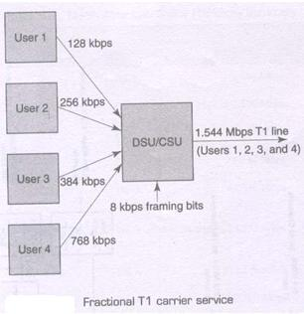

The above figure shows four subscribers combining their transmissions in a special unit called a data service unit/channel service unit (DSU/CSU). A DSU/CSU is a digital interface that provides the physical connection to a digital carrier network. User 1 is allocated 128 kbps, user 2 - 256 kbps, user 3 - 384 kbps, and user 4 - 768 kbps for a total of 1.536 kbps (8 kbps is reserved for the framing bit).

20

DCS Unit-3 Digital Transmission
Multiplexing and T carriers

North American Digital Multiplexing hierarchy
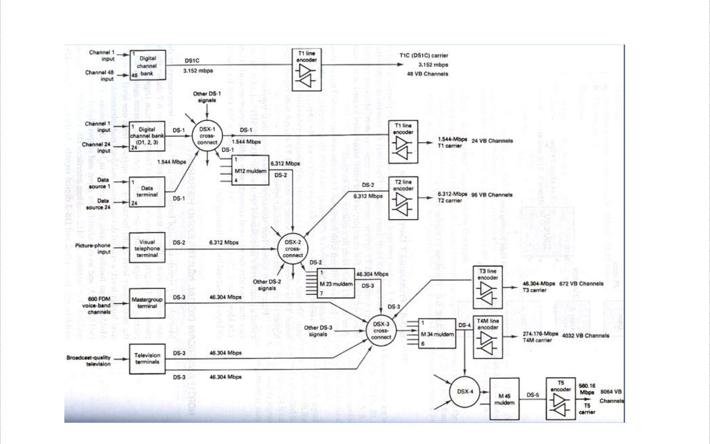

The above figure shows the American Telephone and Telegraph Company’s (AT&T’s) North American Digital Hierarchy for multiplexing digital signals into a single higher-speed pulse stream suitable for transmission on the next higher level of the hierarchy. A special device called muldem (multiplexers/demultiplexer) is used to upgrade from one level in the hierarchy to the next-higher level. They handle bit-rate conversions in both directions and are designated as M12, M23 etc. which identifies the respective input and output digital signals. As shown, an M12 muldem interfaces DS-1 and DS-2 digital signals. Also DS-1 signals can be further multiplexed or line encoded and placed on specially conditioned cables called T1 lines.

Digital signals are routed at central locations called digital cross-connects (DSX), which are convenient for making patchable interconnections and routine maintenance and troubleshooting. Each digital signal (i.e. DS-1, DS-2, etc) has its own digital switch (DSX-1, DSX-2…).

Digital Line Encoding

It involves converting standard logic levels to a form more suitable for telephone line transmission. Six factors must be considered

Transmission voltages and DC component: Transmission voltages or levels can be categorized as being either unipolar (UP) or bipolar (BP). Unipolar transmission involves the transmission of only a single nonzero voltage level (either +ve or –ve for logic 1 and a 0 V for

21

DCS Unit-3 Digital Transmission
Multiplexing and T carriers

logic 0). In bipolar transmission, two nonzero voltages are involved (+ve voltage for logic 1 and equal –ve voltage for logic 0).

Duty cycle: The duty cycle of a binary pulse can be used to categorize the type of transmission. If the binary pulse is maintained for the entire bit time, this is called nonreturn to zero (NRZ). If the active time of the binary pulse is less than 100% of the bit time, it’s called return to zero (RZ). Unipolar and Bipolar transmission voltages can be combined with either RZ or NRZ in several ways to achieve a particular line-encoding scheme. Alternate mark inversion (AMI) scheme involves two nonzero voltage levels (-V and +V) but both polarities represent logic 1s and 0V represents logic 0
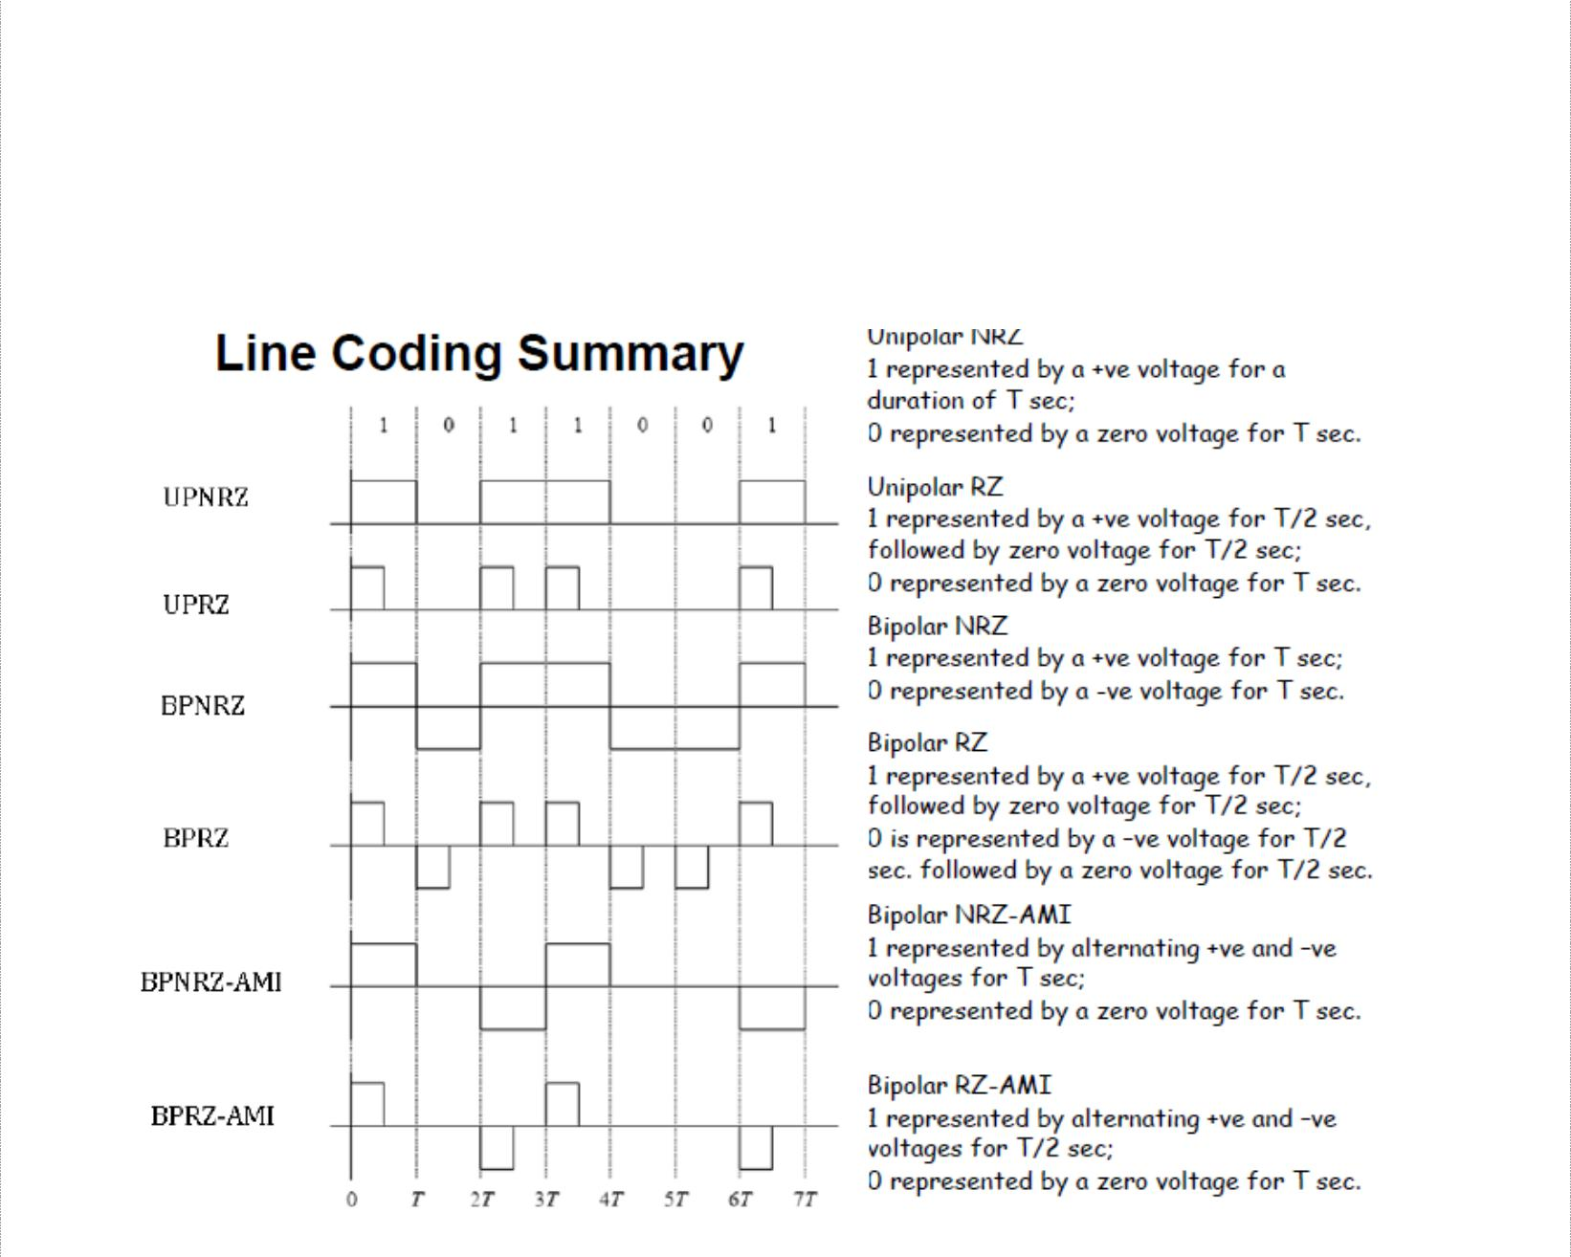

With NRZ encoding, a long string of either logic 1 or logic 0’s produces a condition in which a receiver may lose its amplitude reference for discrimination between received 1’s and 0’s. This condition is called dc wandering.

Bandwidth Requirements: The minimum bandwidth required to propagate a line-encoded digital signal is determined by the highest fundamental frequency, which is in turn determined by the worst-case (fastest transition) binary sequence. For, UPNRZ and BPNRZ the worst-case is alternating 1/0 sequence making the highest fundamental frequency one-half of the bit rate (fb/2). With BPRZ, it occurs for successive logic 1’s and 0’s making the minimum bandwidth equal to bitrate fb. With BPRZ-AMI, the worst-case condition is two or more consecutive logic 1’s, and minimum bandwidth is one-half of bitrate (fb/2).

22

DCS Unit-3 Digital Transmission
Multiplexing and T carriers

Clock and framing bit recovery: To maintain clock and framing bit synchronization, there must be sufficient transitions in the data waveform. Among all, BPRZ is the best encoding scheme for clock recovery as a transition occurs in each position regardless of whether the bit is a 1 or 0.

Error detection: With UPNRZ, BPNRZ, UPRZ, and BPRZ encoding, there is no way to determine if the received data have errors. However, with BPRZ-AMJ encoding, an error in any bit will cause a bipolar violation (BPV—the reception of two or more consecutive logic is with the same polarity). Therefore, BPRZ-AMI has a built-in error-detection mechanism. T carriers use BPRZ-AMI, with +3V and —3 V representing logic 1 and 0 V representing a logic 0.

Digital Biphase: Digital biphase (sometimes called the Manchester code or diphase) is a popular type of line encoding that produces a strong timing component for clock recovery and does not dc wandering. Biphase is a form of BPRZ encoding that uses one cycle of a square wave at 0⁰ phase to represent a logic 1 and one cycle of a square wave at 180⁰ phase to represent a logic 0.
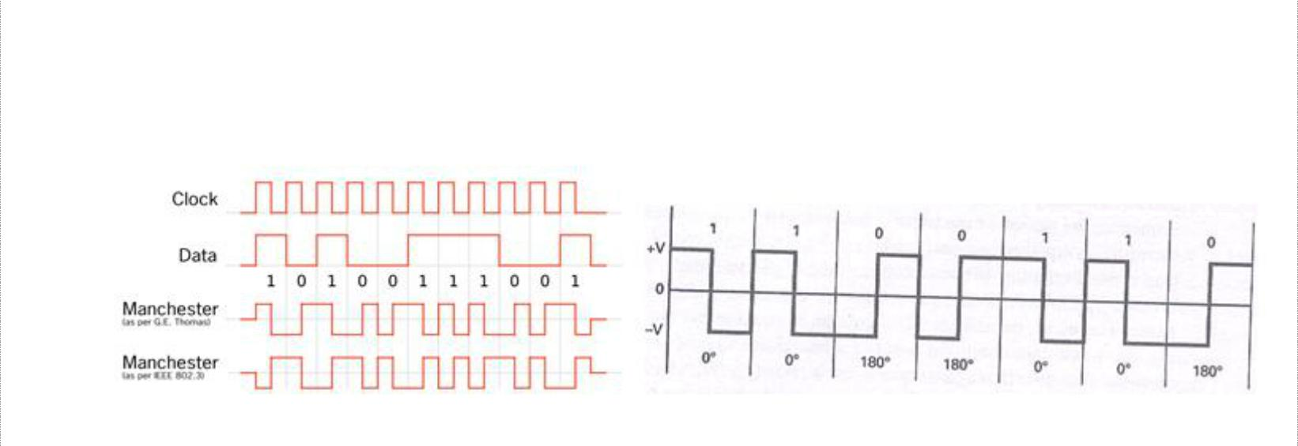

Manchester codes always have a transition at the middle of each bit period, and depending on the state of the signal, may have a transition at the beginning of the period as well. In addition, assuming equal probability of 1s and 0s, the average dc voltage is 0 V. and there is no dc wandering. A disadvantage of biphase is that it contains no means of error detection.

T Carrier Systems

- carriers are used for the transmission of PCM-encoded time-division multiplexed digital signals. Digital signals deteriorate as they propagate along a cable and regenerative repeaters are placed at periodic intervals. It has three functional blocks: an amplifier/equalizer, a timing clock recovery circuit, and the regenerator itself. The amplifier/equalizer filters and shapes the incoming digital signal and raises its power level so that the regenerator circuit can make a pulse-no pulse decision.
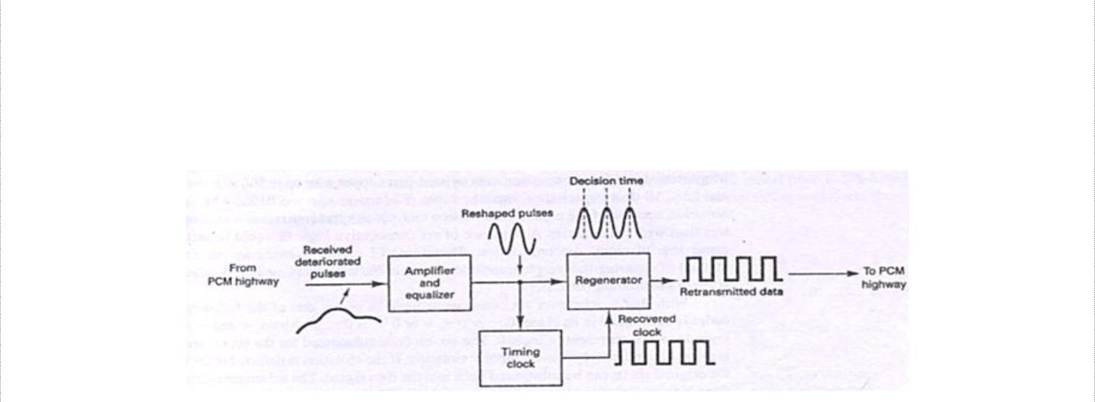

23

DCS Unit-3 Digital Transmission
Multiplexing and T carriers

The timing clock recovery circuit reproduces the clocking information from the received data and provides the proper timing information to the regenerator so that samples can be made at the optimum time, minimizing the chance of an error occurring. A regenerative repeater is simply a threshold detector that compares the sampled voltage received to a reference level and determines whether the bit is logic 1 or logic 0. Spacing of repeaters is designed to maintain an adequate signal-to-noise ratio for error-free performance.

T1 Carrier System

T1 carrier systems were designed to combine PCM and TDM techniques for the transmission of 24 64-kbps channels with each channel capable of carrying digitally encoded voiceband telephone signals or data. The transmission bit rate (line speed) for a T1 carrier is 1.544 Mbps. Using TDM, T1 divides this bandwidth into 24 individual DS-0 channels, sampling each channel 8000 times per second. Thus 8 × 8000 samples per second give each of the 24 DS-0 channels a data rate of 64kbps. All 24 DS-0 channels combined has a data rate of 1.544 Mbps; this digital signal level is called DS-1. Therefore T1 lines are sometimes referred to as DS-1 lines.

Alternate mark inversion (AMI) is the type of line coding used for T1 lines. Electrically, the signal transmitted on a T1 line is a bipolar, return-to-zero (RZ) signal. This simply means that each logical 1 bit is transmitted as a positive or a negative pulse, after which the line voltage always returns to zero. A logical 0 bit is transmitted as a zero voltage on the line. This format is known as AMI because each logical 1 bit (pulse or mark) is of opposite polarity from the previous one.
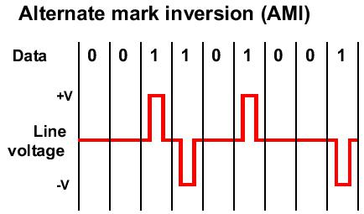

One additional benefit of the AMI bipolar format is that it permits detection of line errors. If a line problem causes a pulse to be deleted or an unintended pulse to be transmitted, two consecutive pulses with the same polarity on the line will result, called a bipolar violation (BPV).

With modern T1 carriers, a technique called binary eight zero substitution (B8ZS) is used to ensure that sufficient transitions occur in the data to maintain clock synchronization. Here, whenever eight consecutive 0s are encountered, one of two special patterns is substituted for the eight 0s, either +-0-+000 or -+0+-000. The + and – represent bipolar logic 1 conditions and a 0 indicates a logic 0 condition.

24

DCS Unit-3 Digital Transmission
Multiplexing and T carriers
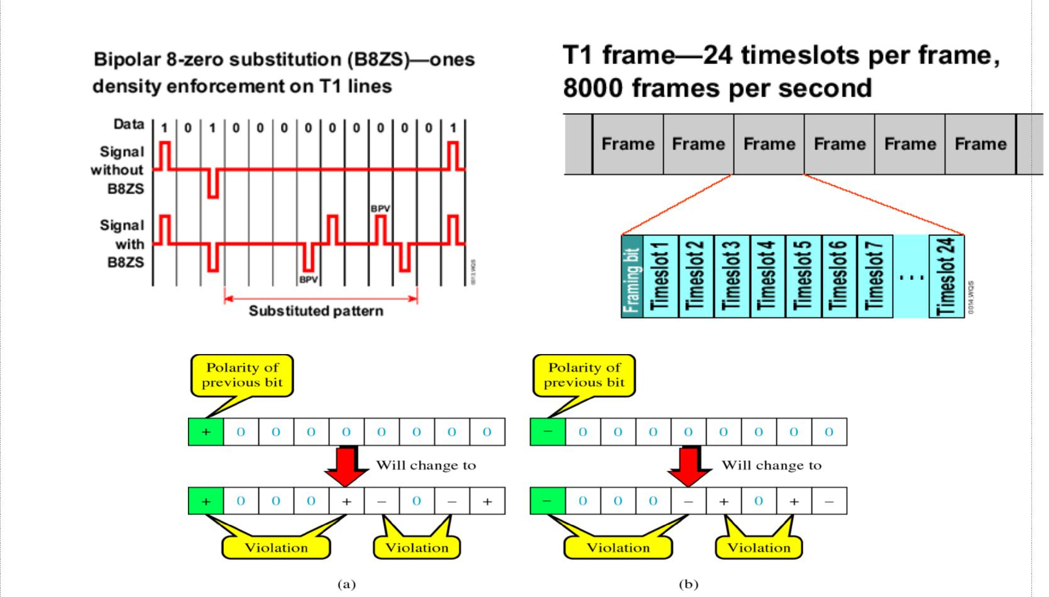

The eight-bit pattern substituted for the eight consecutive 0s is the one that purposely induces bipolar violations in the fourth and seventh bit positions. This code is then interpreted at the remote end of the connection. A full 1.544 Mbps T1 line contains 24 fractional T1 lines (abbreviated as FT1), each with a bandwidth of 64 kbps.

Some of the limitations of T1 services are: They are very expensive, installation cost is also very high and some case improper utilization of bandwidth.

T2 Carrier System

T2 carriers time-division multiplex 96 64-kbps voice or data channels into a single 6.312 Mbps data signal for transmission over twisted-pair copper wire upto 500 miles over a special LOCAP (low capacitance) metallic cable. Higher transmission rates make clock synchronization even more critical. So, an alternative method called binary six zero substitution (B6ZS) is used to ensure that ample transitions occur in the data.

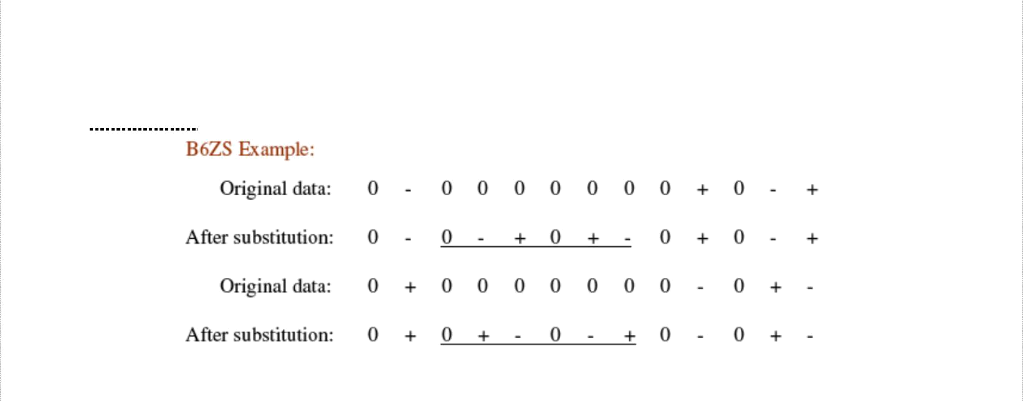

Whenever six consecutive logic 0s occur, either 0-+0+- or 0+-0-+ is substituted, and this code is selected to create a bipolar violations in the second and fourth bits of the substituted patterns.

25

DCS Unit-3 Digital Transmission
Multiplexing and T carriers

T3 Carrier System

T3 carriers time-division multiplex 672 64-kbps voice or data channels for transmission over a single 3A-RDS coaxial cable. The transmission bit rate is 44.736 Mbps and coding technique used with T3 carriers is binary three zero substitution (B3ZS).

T4M Carrier System

T4M carriers time division multiplex 4032 64-kbps voice or data channels for transmitting over a single T4M coaxial cable upto 500 miles. The transmission rate is very high (274.16 kbps) making substituting patterns impractical. They transmit scrambled unipolar NRZ digital signals.

T5 Carrier System

T5 carriers time-division multiplex 8064 64-kbps voice or data channels and transmits them at 560.16 Mbps over a single coaxial cable.

European Time-Division Multiplexing

In Europe, a different version of T carrier lines is used called E lines. With the basic E1 system, a 125µs frame is divided into 32 equal time slots. Time slot 0 is used for a frame alignment pattern and for an alarm channel. Time slot 17 is used for a common signalling channel (CSC). The signalling for all 30 voice-band channels is accomplished on the common signalling channel. Consequently, 30 voice-band channels are time-division multiplexed into each E1 frame. Every slot has eight bits. So the number of bits per frame is given as:
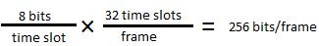

And the line speed can be given as 256 bits/frame × 8000 frames/second = 2.408 Mbps

Statistical Time Division Multiplexing

Statistical time division multiplexing, is one method for transmitting several types of data simultaneously across a single transmission cable or line. STA-TDM is often used for managing data being transmitted via a local area network (LAN) or a wide area network (WAN). A statistical TDM multiplexer exploits the natural breaks in transmissions by dynamically allocating time slots on a demand basis. As like synchronous TDM system, a statistical mux has a finite number of low-speed data input lines with one high-speed multiplexed data output line, and each input line has its own digital encoder and buffer. With the statistical mux, there are n input lines and k time slots available (k >n). The multiplexer scans the input buffers, collecting data until a frame is filled, at which time the frame is transmitted. On the receiving end, the demultiplexer removes the data from the time slots and distributes to their appropriate output buffers. Statistical multiplexers require

26

DCS Unit-3 Digital Transmission
Multiplexing and T carriers

low data rate than synchronous multiplexers. Also, they can support more users operating at the same transmission rate.
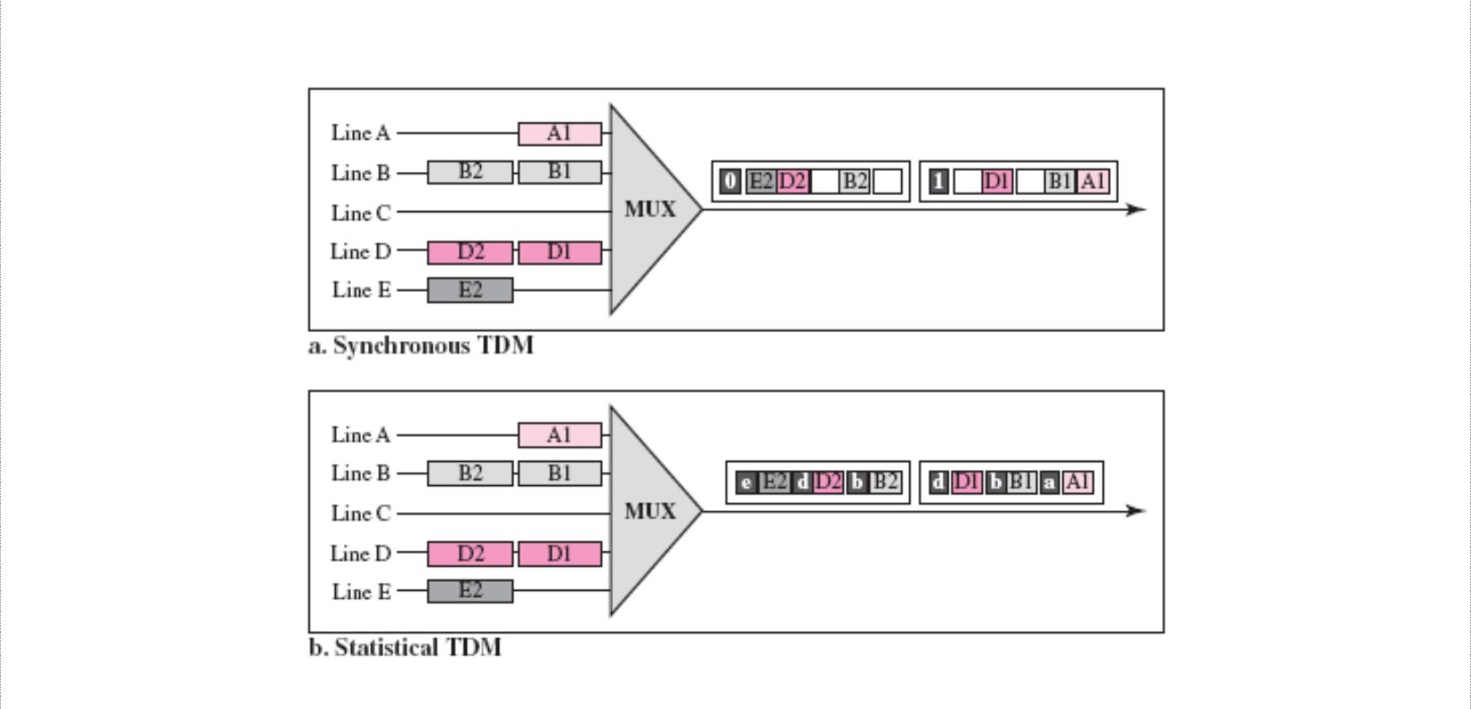

With Statistical multiplexing, control bits must be included in the frame. The following figure shows the overall frame format for a statistical TDM multiplexer.
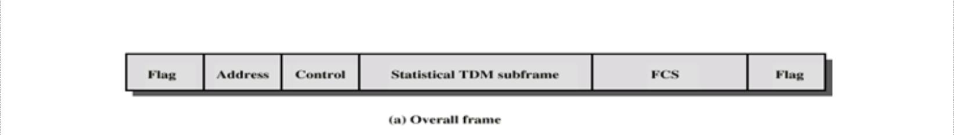

The frame includes a beginning flag and ending flag to indicate the start and end of frame, an address field that indicates the transmitting device, a control field, a statistical TDM subframe, and a frame check sequence field (FCS), which provides error detection.
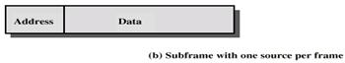

The above figure shows the frame when only one data source is transmitting. The transmitting devise is identified in the address field. The data field is variable and this scheme works well in times of light loads, but inefficient for heavy loads.
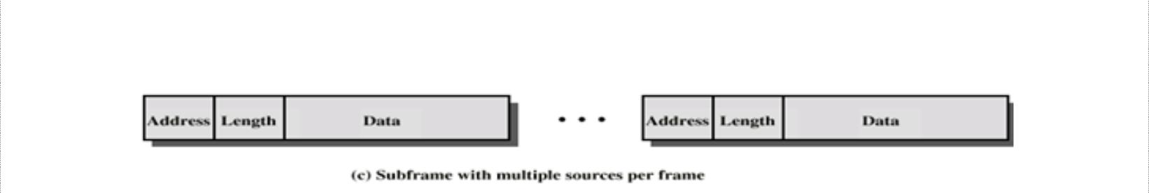

The above figure shows a way to improve efficiency by allowing more than one data source to be included within a single frame.

27

DCS Unit-3 Digital Transmission
Multiplexing and T carriers

Frame Synchronization

With TDM systems, it is important not only that a frame has to be identified, but also individual timeslots within the frame be identified. There are several methods used to establish frame synchronization, including added digit, robbed digit, added channel, statistical and unique coding. Considerable amount of overhead is added to transmission to achieve frame synchronization.
- Added-Digit Framing: - T1 carriers using D1, D2 or D3 channel banks use added-digit framing. A special framing digit (framing pulse) is added to each frame. The

maximum average synchronization time is given by Synchronization time = 2NT = 2N²t_{b}

Where N is number of bits per frame and T is frame period of Nt_{b} and t_{b} is bit time.
- Robbed-Digit Framing: - Added-digit framing is inefficient when a short frame is

used in the case of single-channel PCM systems. As an alternative, the least significant bit of every n^{th} frame is replaced with a framing bit. This process is called robbed-digit framing and it does not interrupt transmission, but instead periodically replaces information bits with forced data errors to maintain frame synchronization.

- Added-Channel Framing: - It is essentially same as added-digit framing except that

digits are added in groups or words instead of as individual bits. The average number of bits to acquire frame synchronization using added-channel framing is N²/2(2^{K} – 1), where N is number of bits per frame and K is number of bits in the synchronizing word.

- Statistical Framing: - Here no robbing or adding digits is done. As a signal that has a centrally peaked amplitude distribution generates a high probability of logic 1 in the second digit, the second digit of a given channel can be used for the framing bit.

- Unique-Line Code Framing: - Some property of the framing bit is different from the data bits. The framing bit is either made higher or lower in amplitude or with a different time duration. The advantage is that synchronization is immediate and automatic. The disadvantage is additional processing requirements necessary to generate and recognize the unique bit.

Frequency Division Multiplexing

Assignment of non-overlapping frequency ranges to each “user” or signal on a medium, such that all signals are transmitted at the same time, each using different frequencies. FDM is used for combining many relative narrowband sources into a single wideband channel, such as in public telephone systems. Essentially FDM is taking a given bandwidth and subdividing it into narrow segments with each segment carrying different information. FDM is an analog multiplexing scheme.

28

DCS Unit-3 Digital Transmission
Multiplexing and T carriers
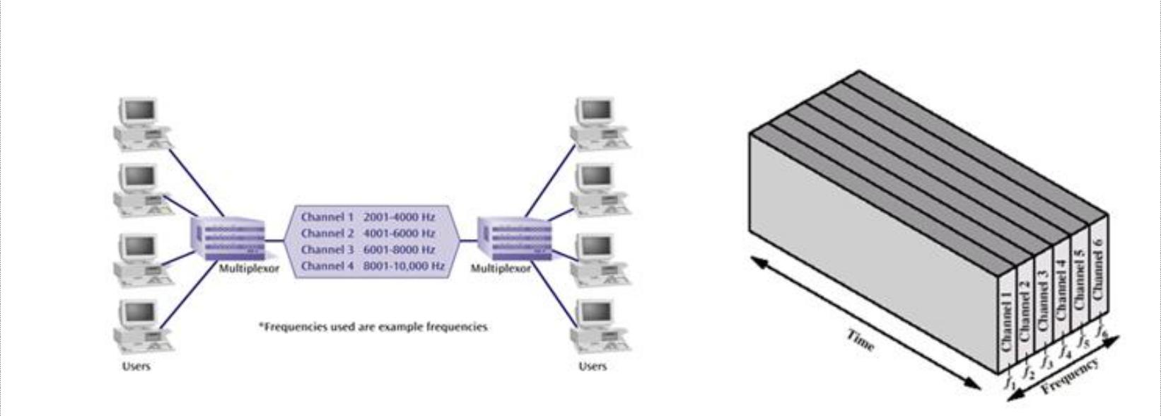

In the above figure-b, five signal sources are fed into a multiplexer that modulates each signal onto a different frequency (f₁, f₂, f₃, f₄ , f₅). To prevent interference, the channels are separated by guard bands, which are unused portions of the spectrum. With FDM, each user has its own modulating circuitry, a transmitter, a receiver and a demodulator. The channel is common to all users. Since each transmitter is using a carrier of a different frequency, there is no interference unless the sidebands or carriers are incorrectly assigned and therefore overlap. AM, FM and cable TV broadcasting are most common examples of FDM where each station uses a different frequency band.

Advantages of FDM:

- In FDM system, users can be added to the system by simply adding another pair of transmitter modulator and receiver demodulators.

- FDM system support full duplex information flow which is required by most of the applications
- Noise problem for analog communication has less effect.

Disadvantages of FDM:

- The initial cost is high, which includes the cable between the two ends and associated connectors for the cable.
- One users problem can sometimes affect others
- Each user requires a precise carrier frequency.

Wavelength-Division Multiplexing

WDM involves transmission of multiple digital signals using several wavelengths without their interfering with one another. This technology enables many optical signals to be transmitted simultaneously by a single fiber cable. It is also referred to as wave-division multiplexing.

WDM is accomplished by modulating injection laser diodes, which are transmitting highly concentrated light waves at different wavelengths (i.e. at different optical frequencies). Therefore WDM is coupling light at two or more discrete wavelengths into and out of an optical fiber. Each wavelength is capable of carrying vast amounts of information in either analog or digital form, and the information can already be time- or frequency-division multiplexed.

29

DCS Unit-3 Digital Transmission
Multiplexing and T carriers
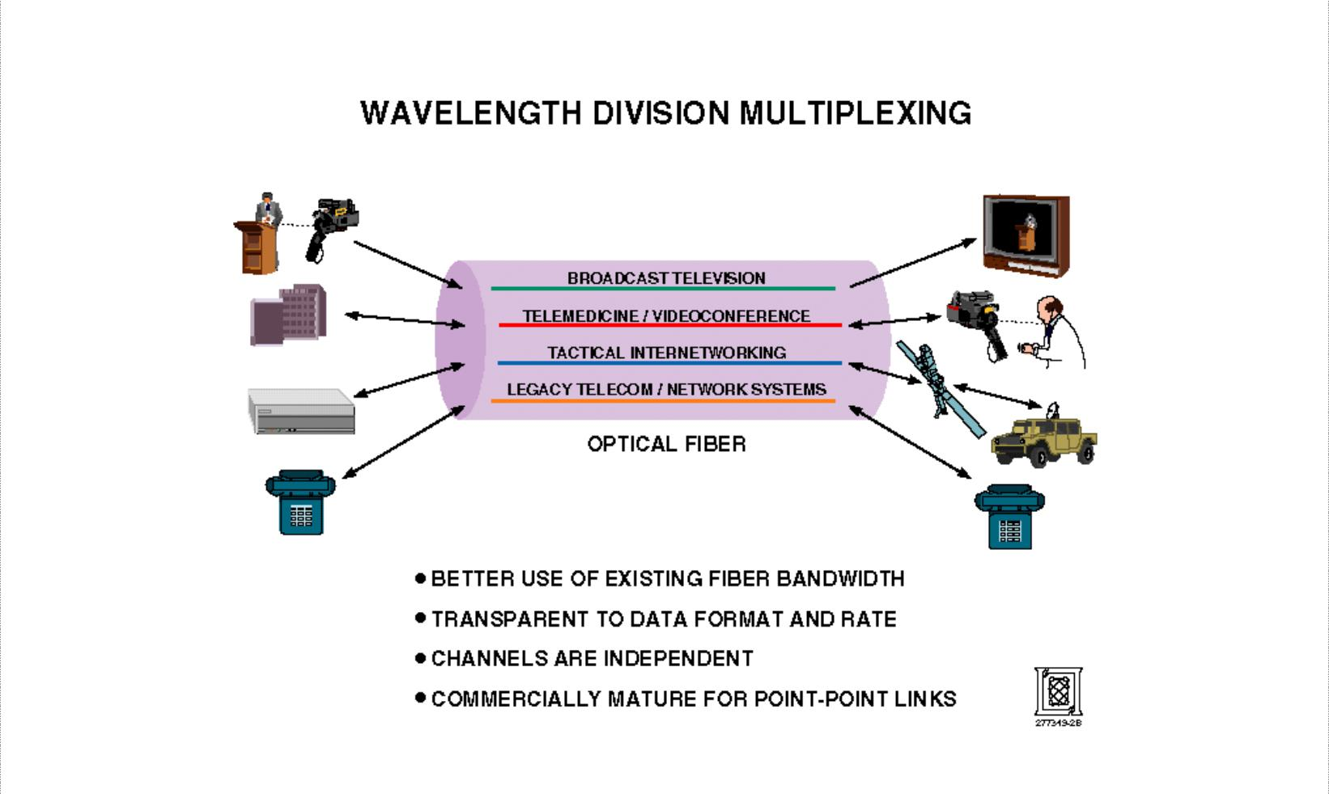

Advantages of WDM:
- Enhanced capacity as full-duplex transmission is also possible with a single fiber.
- WDM is inherently easier to reconfigure (i.e. adding of removing channels)

- Usage of optical components makes it simpler, more reliable and often less costly Disadvantages of WDM:

- Signals cannot be placed so close in the wavelength spectrum that they interfere with each other.

- The overall signal strength should be approximately the same for each wavelength which may not be possible.

- Light waves carrying WDM are limited to a two-point circuit or a combination of many two-point circuits that can go only where the cable goes.

Dense wavelength division multiplexing (DWDM) is a fiber-optic transmission technique that employs light wavelengths to transmit data parallel-by-bit or serial-by-character.
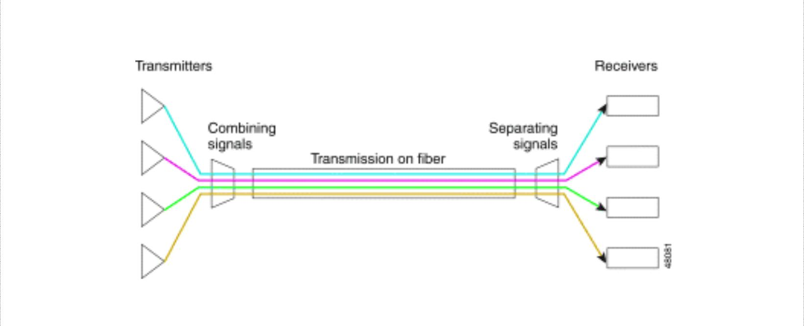

30

DCS Unit-3 Digital Transmission
Multiplexing and T carriers

Advantages:
- Protocol & Bit Rate independence
- Increased overall capacity at much lower cost
  - Current fiber plant investment can be optimized by a factor of at least 32

- Transparency

  - Physical layer architecture → supports both TDM and data formats such as ATM, Gigabit Ethernet, etc.

- Scalability

  - Utilize abundance of dark fibers in metropolitan areas and enterprise networks Disadvantages:

- Dispersion
  - Chromatic dispersion

  - Polarization mode dispersion

- Attenuation
  - Intrinsic: Scattering, Absorption, etc.

  - Extrinsic: Manufacturing Stress, Environment, etc.

- Four wave mixing
  - Non-linear nature of refractive index of optical fiber

  - Limits channel capacity of the DWDM System
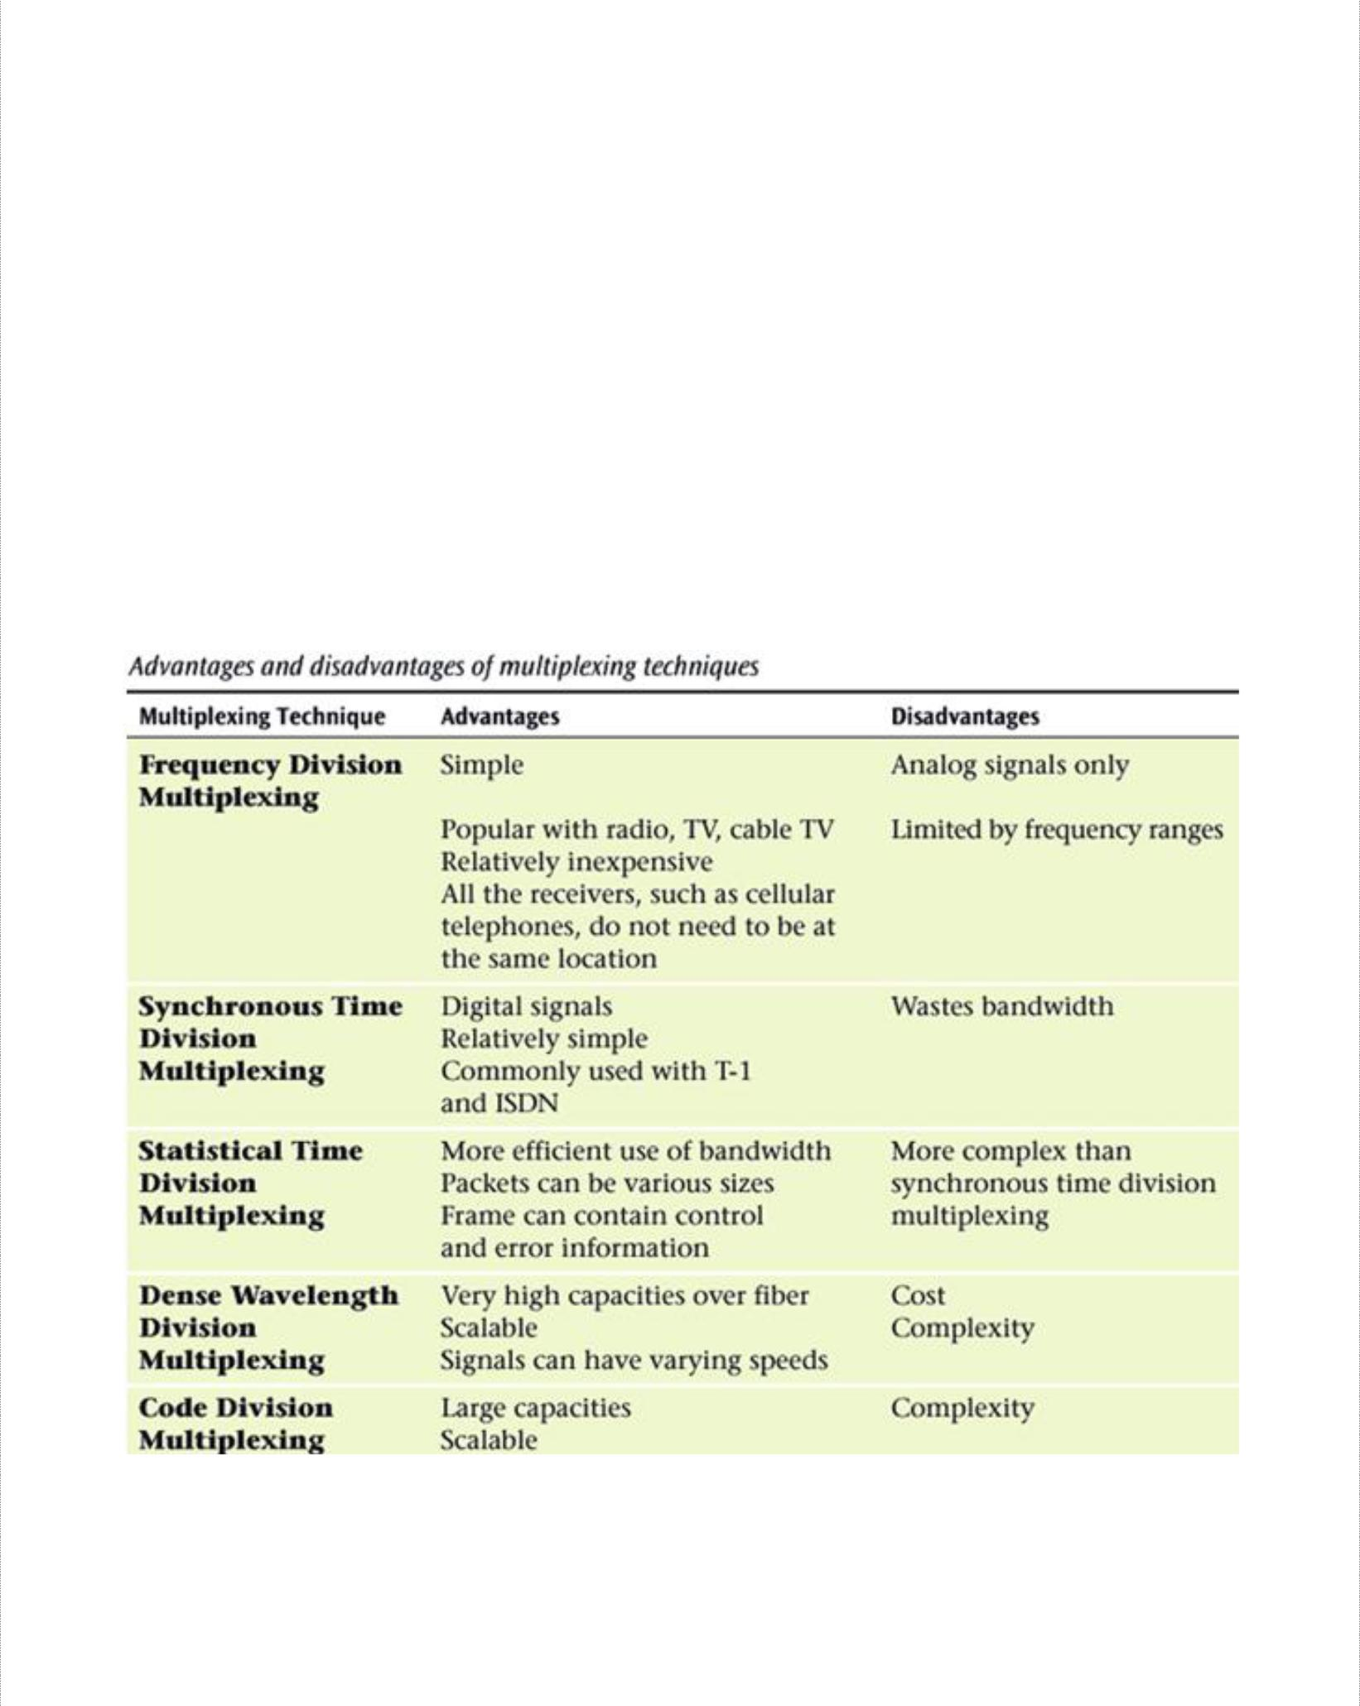

31

DCS Unit-3 Digital Transmission
Multiplexing and T carriers

Synchronous Optical Network (SONET)

The synchronous optical network is a multiplexing system similar to conventional time-division multiplexing except SONET was developed to be used with optical fibers. SONET is the name for a standard family of interfaces for high speed optical links. These start at 51.84 Mbps, which is referred to as synchronous transport level 1 (STS-1). It is comprised of 28 DS-1 signals. Each DS-1 signal is equivalent to a single 24-channel T1 digital carrier system. With STS-1, it is possible to extract or add individual DS-1 signals with completely disassembling the entire frame. OC-48 is the second level of SONET multiplexing. It has a transmission bit rate of 2.48Gbps.

SONET Applications:
- High speed backbone networks
- Basic architecture for B-ISDN
- Basic architecture for ATM
- High speed optical networks for data communications.

32

DCS Unit-3 |  | Digital Transmission
 |  | Multiplexing and T carriers
 | Asst Questions

  - a) What is a T carrier system? What is a fractional T carrier system? Describe in detail, the various T carrier systems.

      - Compare WDM and DWDM and also list the advantages and disadvantages of WDM.

- a) What do you understand by companding?? Compare analog and digital companding

    - What is SQR and give its relationship to resolution, dynamic range and maximum no of bits in a PCM code.

  - a) What is the difference between FDMA, TDMA and CDMA
      - What is line speed and how is it determined?

  - a) What is superframe and extended superframe TDM format? Explain with an example.

      - What is frame synchronization and how it is achieved in PCM-TDM system.

33

