DCS Unit-4 Wireless Communication Systems

WIRELESS COMMUNICATIONS SYSTEMS

Electromagnetic Polarization, Rays and Wavefronts, Electromagnetic Radiation, Spherical Wavefront and the Inverse Square Law, wave Attenuation and Absorption, Optical Properties of Radio Waves, Terrestrial Propagation of Electromagnetic Waves, Skip Distance, Free-Space Path Loss, Microwave Communications Systems, Satellite Communications Systems

With wireless communication systems, electromagnetic signals are emitted from an antenna, propagate through the earth’s atmosphere (air) or free space (a vacuum), and are then received (captured) by another antenna. Sometimes, it is impractical to interconnect two pieces of equipment physically. So, free space or earth’s atmosphere is often used as the transmission medium. Free space propagation of electromagnetic waves is often called radio-frequency (RF) propagation or simply radio propagation. Wireless communications include terrestrial and satellite microwave radio systems, broadcast radio systems, two-way mobile radio and cellular telephone.

Electromagnetic Polarization

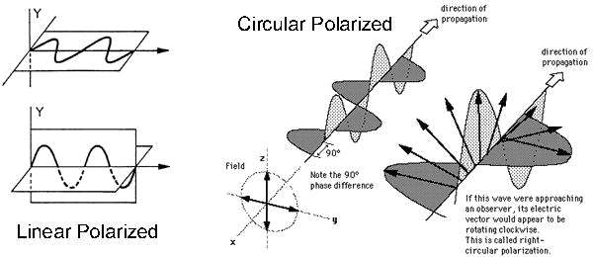

Electromagnetic waves are comprised of an electric and a magnetic field at 90 degrees to each other. The polarization of a plane electromagnetic wave is simply the orientation of the electric field vector in respect to earth’s surface. If the polarization remains constant, it is described as linear polarization. Horizontal and vertical polarizations are two forms of linear polarization. A wave is horizontally polarized if the electric field propagates parallel to the earth’s surface, and the wave is vertically polarized if the electric field propagates perpendicular to the earth’s surface. The wave is described as having circular polarization if the polarization vector rotates 360 degrees, as the wave moves one wavelength through space and the field strength is equal at all angles of polarization. When the field strength varies with changes in polarization, this is described as elliptical polarization. A rotating wave can turn in either direction. If the vector rotates in a clockwise direction, it is right handed, and if the vector rotates in a counter-clockwise direction, it is considered left handed.

1

DCS Unit-4 Wireless Communication Systems

Rays and Wavefronts

Rays and wavefronts are used for analysing electromagnetic waves. A ray is a line drawn along the direction of propagation of an electromagnetic wave. Rays are used to show the relative direction of propagation.

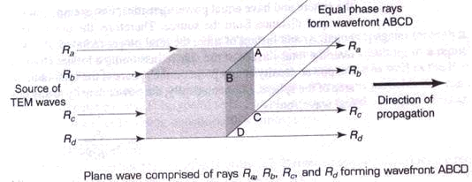

A wavefront shows a surface of constant phase of electromagnetic waves. A wavefront is formed when points of equal phase on rays propagating from the same source are joined together. The above figure shows a wavefront with a surface that is perpendicular to the direction of propagation (rectangle ABCD). When a surface is plane, its wavefront is perpendicular to the direction of propagation. A point source is a single location from which rays propagate equally in all directions (i.e. isotropic source). The wavefront generated from a point source is simply a sphere with radius R and its center located at the point of origin of the waves.

Electromagnetic Radiation

The flow of electromagnetic waves (energy) in the direction of propagation is called electromagnetic radiation. The rate at which energy passes through a given surface area in free space is called power density, usually given in watts per square meter. Mathematically, Power density P = EH, where P is power density (watt/m²), E represents rms electric field intensity (volts/meter) and H represents rms magnetic field intensity (ampere turns/meter).

Spherical Wavefront and Inverse Square Law

A spherical wavefront is obtained by an isotopic radiator. All points at distance R(radius) from the source lie on the surface of the sphere and have equal power densities. At an instance of time, the total power radiated P_{rad} is uniformly distributed over the total surface of the sphere. Therefore, the power density at any point on the sphere is the total radiated power divided by the total area of the sphere and can be given as,
- = P_{rad} / (4πR²)

2

DCS Unit-4 Wireless Communication Systems

The power density becomes smaller as the distance from isotropic source increases. The total radiated power is same. But as the area of the sphere increases in direct proportion to the square of distance from source, the power density is inversely proportional to the square of the distance from the source. This relationship is called inverse square law.

Wave Attenuation and Absorption

When waves propagate through free space, they spread out, resulting in reduction of power density. This is called attenuation loss and it occurs in free space as well as earth’s atmosphere. Earth’s atmosphere contains different particles which absorb electromagnetic energy, causing reduction in power, called as absorption loss. The reduction in power density with increase in distance is equivalent to a power loss and is called wave attenuation. Because it’s due to spherical spreading of wave in space, it is sometimes called space attenuation. Mathematically, wave attenuation is

γ_{A}= 10 log (P₁/P₂), where γ_{A} represent wave attenuation in dB, P₁ is power density at point 1 and P₂ is power density at point 2.

Earth’s atmosphere is not a vacuum and it consists of atoms, molecules of various substances such as gases, liquids and solids, which are quite capable of absorbing EM waves. As the wave propagates, energy is transferred from the wave to the atoms and molecules and this transfer is known as wave absorption and is analogous to I2R power loss. Once absorbed, energy is lost forever and causes reduction in the power density.

Optical Properties of Radio Waves

The free space behaviour of propagation is altered by optical effects such as refraction, reflection, diffraction and interference.

Refraction: Electromagnetic refraction is the change in direction of an electromagnetic wave as it passes obliquely from one medium to another medium with a different density (refractive index).

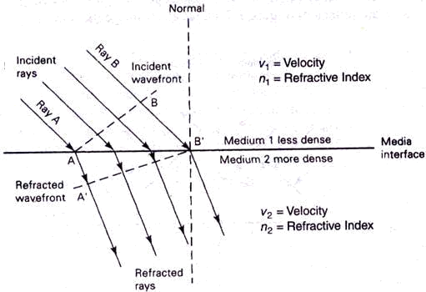

Refraction at a plane boundary between two media

3

DCS Unit-4 Wireless Communication Systems

Whenever a ray passes from a less dense to a more dense medium, it is effectively bent toward the normal (imaginary line drawn perpendicular to the interface at the point of incidence). Conversely, whenever a ray passes from a more dense to a less dense medium, it is effectively bent away from the normal. The angle of incidence is the angle formed between the incident wave and the normal, and the angle of refraction is the angle formed between the refracted wave and the normal. Snell’s law states that,

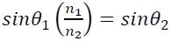

- where θ₁ and θ₂ are angles of incidence and
refraction and n₁ and n₂ are refractive indexes of material1 and material2.

Refraction also occurs when a wavefront propagates in a medium that has a density gradient that is perpendicular to the direction of propagation. The following figure shows wavefront refraction in earth’s atmosphere (which has gradient refractive index).

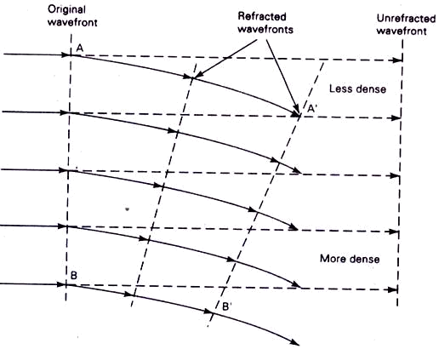

Wavefront refraction in a gradient medium

The medium is more dense near the bottom and less dense near the top (upper atmosphere). Therefore, rays travelling in the upper layers of the atmosphere travel faster than rays travelling near earth’s surface and, consequently, the wavefront tilts downward. The tilting occurs in a gradual fashion as the wave progresses.

Reflection: Electromagnetic wave reflection occurs when an incident wave strikes a boundary of two media and some or all of the incident power does not enter the second material (i.e., they are reflected). The following figure shows electromagnetic wave reflection at a plane boundary between two media.

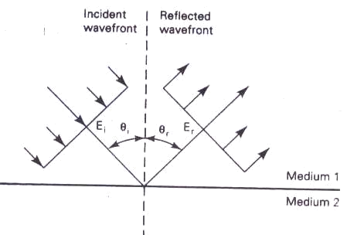

4

DCS Unit-4 Wireless Communication Systems

Because all the reflected waves remain in medium1, angle of reflection equals the angle of incidence (θ_{i} = θ_{r}). The ratio of reflected to incident power is Γ, expressed as
- = P_{r}/P_{i} where Γ is reflection coefficient and Pr and Pi are reflected and incident power.

For perfect conductors, Γ = 1 and all incident power is reflected. Reflection also occurs when the reflective surface is irregular. When an incident wavefront strikes an irregular surface, it is randomly scattered in many directions. Such a condition is called diffuse reflection, whereas reflection from a perfectly smooth surface is called specular (mirror like) reflection.

Diffraction: Diffraction is defined as the modulation or redistribution of energy within a wavefront when a density it passes near the edge of an opaque object. Diffraction is the phenomenon that allows light or radio waves to propagate (peek) around corners. Huygen’s principle states that every point on a given spherical wavefront can be considered as a secondary point source of electromagnetic waves from which other secondary waves (wavelets) are radiated outward. Huygen’s principle is illustrated below.

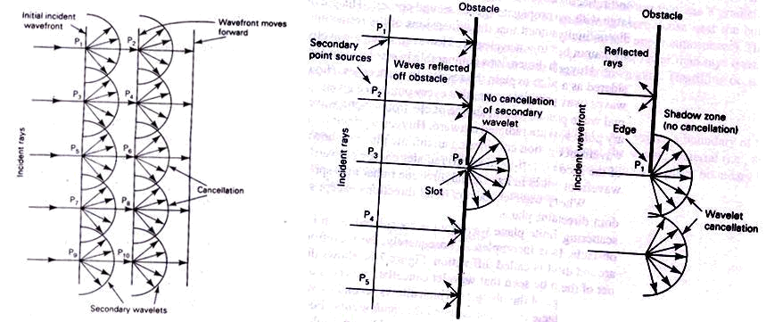

The first figure shows normal wave propagation considering an infinite plane. Each secondary point source (P1, P2 and so on) radiates energy outward in all directions. But, the wavefront continues in its original direction rather than spreading out because cancellation of the secondary wavelets occurs in all directions except straight forward. Therefore, the wavefront remains plane. When a finite plane wavefront is considered, as in second figure, cancellation in random directions is incomplete. So, the wavefront spreads out or scatters. This scattering effect is called diffraction.

The third figure shows diffraction around the edge of an obstacle. It can be seen that wavelet cancellation occurs only partially. Diffraction occurs around the edge of the obstacle, which allows secondary waves to “sneak” around the corner of the obstacle into what is called the shadow zone.

Interference: Radio wave interference occurs when two or more electromagnetic waves combine in such a way that system performance is degraded. Interference, on the other

5

DCS Unit-4 Wireless Communication Systems

hand, is subject to the principle of linear superposition of electromagnetic waves and occurs whenever two or more waves simultaneously occupy the same point in space.

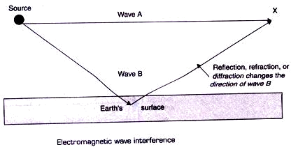

In the above figure, it can be seen that, at point X the two waves occupy the same area in space. However, wave B has travelled a different path than wave A and, therefore, their relative phase angles may be different. If the difference in distance travelled is an odd-integral multiple of one-half wavelength, reinforcement takes place. If the difference is an even-integral multiple of one- half wavelength, total cancellation occurs.

Terrestrial Propagation of Electromagnetic Waves

Electromagnetic waves travelling within earth’s atmosphere are called terrestrial waves and communications between two or more points on earth is called terrestrial radio communications. There are three modes of propagating EM wave within earth’s atmosphere: ground wave propagation, space wave propagation and sky wave propagation.

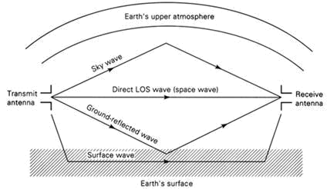

Normal modes of wave propagation

Ground Wave Propagation: Ground waves are the electromagnetic waves that travel along the surface of earth and are also called as surface waves. Ground waves must be vertically polarized and the changing electric field induces voltages in earth’s surface, which cause currents to flow that are very similar to those in a transmission line. Ground waves are attenuated as they propagate because of the presence of resistance and dielectric losses in the earth’s surface. Ground waves propagate best over a surface that is a good conductor, such as salt water and poorly over dry desert areas. Also losses in ground

6

DCS Unit-4 Wireless Communication Systems

waves increase rapidly with frequency, ground wave propagation is limited to frequencies below 2 MHz

The following figure shows ground wave propagation. Because of earth’s gradient density, ground wave propagates around the earth, remaining close to its surface.

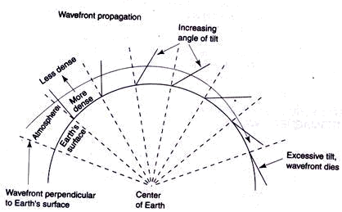

Surface (ground) wave propagation

The frequency and terrain over which the ground wave propagates has to be selected carefully to ensure that the wavefront does not tilt excessively and simply turn over, lie flat on the ground and cease to propagate. Ground wave communication is commonly used for ship-to-ship and ship-to-shore communications, for radio navigation and for maritime mobile communications.

Space Wave Propagation: It includes radiated energy that travels in the lower few miles of earth’s atmosphere. Space wave include both direct and ground reflected waves.

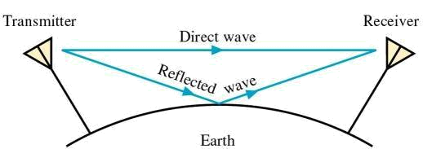

Direct waves travels essentially in a straight line between transmit and receive antennas. And this propagation with direct waves is commonly called line-of-sight (LOS) transmission. Direct space wave propagation is limited by the curvature of the earth. Ground-reflected waves are waves reflected by earth’s surface as they propagate between transmit and receive antennas. The field intensity at the receive antenna depends on the distance between the two antennas (attenuation and absorption) and whether the direct and ground-reflected waves are in phase (interference). The curvature of earth presents a horizon to space wave propagation commonly called the radio horizon. Because the conditions in earth’s lower atmosphere are subject to change, the degree of refraction can vary with time. A special condition called duct propagation occurs when the density of the

7

DCS Unit-4 Wireless Communication Systems

lower atmosphere is such that electromagnetic waves can propagate within the duct for great distances, causing them to propagate around earth following its natural curvature.

Sky Wave Propagation: Electromagnetic waves that are directed above the horizon level are called sky waves. Sky waves are radiated toward the sky, where they are either reflected or refracted back to earth by the ionosphere. Because of this, sky wave propagation is sometimes called ionospheric propagation. The ionosphere is the upper portion of earth’s atmosphere and is located approximately 50km to 400km (31 mi to 248 mi) above earth’s surface. Because of the ionosphere’s non uniform composition and its temperature and density variations, it is stratified. Essentially, three layers make up the ionosphere (the D, E, and F layers) and are shown below:

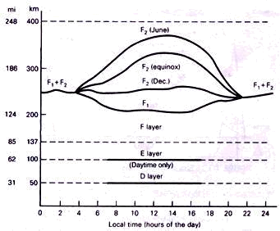

Ionospheric Layers

All three layers of the ionosphere vary in location and in ionization density with the time of day. The ionosphere is most dense during times of maximum sunlight. Because the density and location of the ionosphere vary over time, the effects it has on electromagnetic radio wave propagation also vary.

Skip Distance

The skip distance is the distance from the transmitter to the point where the sky wave first returns to the earth. The skip distance depends on the wave’s frequency and angle of incidence, and the degree of ionization.

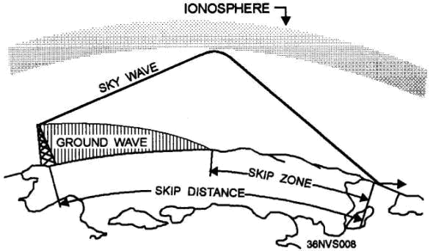

8

DCS Unit-4 Wireless Communication Systems

The SKIP ZONE is a zone of silence between the point where the ground wave becomes too weak for reception and the point where the sky wave is first returned to Earth. The size of the skip zone depends on the extent of the ground wave coverage and the skip distance. When the ground wave coverage is great enough or the skip distance is short enough that no zone of silence occurs, there is no skip zone.

Free-Space Path Loss

In telecommunication, free-space path loss (FSPL) is the loss in signal strength of an electromagnetic wave that would result from a line-of-sight path through free space, with no obstacles nearby to cause reflection or diffraction. With free-space path loss, no electromagnetic energy is actually lost—it merely spreads out as it propagates away from the source resulting in a lower power density. It’s also referred as spreading loss, which occurs simply because of the inverse square law. Spreading loss is a function of distance from the source and the wavelength (frequency) of the electromagnetic wave. Mathematically, free-space path loss is proportional to the square of the distance between the transmitter and receiver, and also proportional to the square of the frequency of the radio signal.

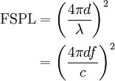

Where:

is the signal wavelength (in metres),
is the signal frequency (in hertz),
is the distance from the transmitter (in metres),

is the speed of light in a vacuum, 2.99792458 × 10⁸ metres per second

For typical radio applications, it is common to find measured in units of MHz and in km, in which case the FSPL equation becomes

Microwave Communication Systems

Microwaves are generally described as electromagnetic waves with frequencies that range from approximately 500 MHz to 300 GHz. Because of their high frequencies, microwaves have relatively short wavelengths. Microwave systems are used for carrying long-distance voice telephone service, metropolitan area networks, wide area networks and the Internet. There are different types of microwave systems operating over distances that vary from 15 miles to 4000 miles in length. Intrastate or feeder service microwave systems are generally classified as short haul because they are used to carry information for relatively short distances, such as between cities within the same state. Long-haul microwave systems are those used to carry information for relatively long-distances, such as

9

DCS Unit-4 Wireless Communication Systems

interstate and backbone route applications. Microwave radio system capacities range from less than 12 voice grade telephone circuits to more than 22,000 voice and data channels.

Advantages of Microwave Radio Communication:

- Radio systems do not require a right-of-way acquisition between stations.
- Each station requires the purchase or lease of only a small area of land.

- Because of their high operating frequencies, microwave radio systems can carry large quantities of information.
- High frequencies mean short wavelengths, which require relatively small antennas

- Radio signals are more easily propagated around physical obstacles, such as water and high mountains.

- Microwave Systems require fewer repeaters for amplification.
- Distances between switching centers are less.
- Underground facilities are minimized.
- Minimum delay times are introduced.
- Minimal crosstalk exists between voice channels.

Disadvantages of Microwave radio systems:

- The electronic circuits used with microwave frequencies are more difficult to analyze.

- Conventional components, such as resistors, inductors, and capacitors, are more difficult to manufacture and implement at microwave frequencies.
- Microwave components are more expensive.
- Transistor transit time is a problem with microwave devices.
- Signal amplification is more difficult with microwave frequencies.

Microwave Radio Link

The following figure shows a simplex microwave radio link. The transmitter includes a modulator, mixer, and microwave generator and several stages of amplification and filtering.

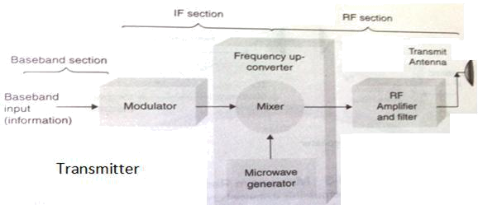

The modulator may perform frequency modulation or some form of digital modulation such as PSK or QAM. The output of modulator is an intermediate frequency (IF) carrier that has been modulated or encoded by the baseband input signal. The baseband signal is simply the

10

DCS Unit-4 Wireless Communication Systems

information. The mixer and microwave generator (oscillator) combine to perform frequency up-conversion through nonlinear mixing. The up-converter is to translate IF frequencies to RF microwave frequencies.

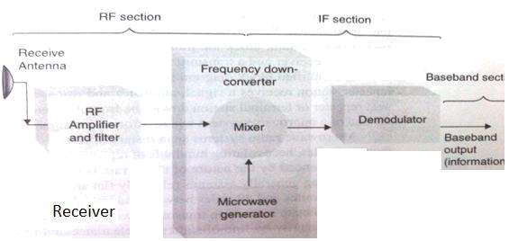

The receiver consists of a radio-frequency (RF) amplifier, a frequency down-converter and a demodulator. The RF amplifier and filter increase the received signal level so that the down-converter can convert the RF signals to IF signals. The demodulator can be for FM, PSK or QAM. The output of demodulator is the original baseband (information) signals.

Microwave Radio Repeaters

With systems longer than 40 miles or when geographical obstructions block the transmission path, repeaters are needed. A microwave repeater is a receiver and transmitter placed back to back in the system.

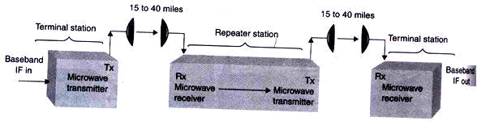

The repeater station receives a signal, amplifies and reshapes it, and then retransmits it to the next repeater or terminal station down line from it. A terminal station is simply a station at the end of a microwave system where information signals originate and terminate.

Satellite Communication Systems

A satellite is a celestial body that orbits around a planet. In other terms, a satellite is a space vehicle launched by humans that orbits earth or another celestial body. Communication satellites are manmade satellites that orbit earth, providing a multitude of communications services to a wide variety of consumers, including military, governmental, private and commercial subscribers. The main purpose of communications satellite is to

11

DCS Unit-4 Wireless Communication Systems

relay signals between two or more earth stations. A satellite repeater is called a transponder, and a satellite may have many transponders. Transmissions to and from satellites are categorized as either bus or payload. The bus includes control mechanisms that support the payload operation. The payload is the actual user information. Satellites utilize many of the same frequency bands as terrestrial microwave radio systems.

Satellite Elevation Categories

Satellites are generally classified as having a low earth orbit (LEO), medium earth orbit (MEO), or geosynchronous earth orbit (GEO).

- LEO satellites operate in the 1.0 GHz to 2.5 GHz frequency range. Main advantage is that the path loss between earth stations and space vehicles is much lower thereby resulting in lower transmit powers, smaller antennas and less weight. Example is Motorola’s satellite-based mobile telephone system, Iridium.

- MEO satellites operate in the 1.2 GHz to 1.67 GHz frequency band and orbit between

6000 miles and 12,000 miles above earth. Example is DOD’s satellite based global positioning system, NAVSTAR.

- Geosynchronous or geostationary satellites operate primarily in the 2 GHz to 18 GHz frequency spectrum with orbits 22,300 miles above the earth’s surface. They orbit in a circular pattern with an angular velocity equal to that of earth and have an orbital time of approx 24 hours (i.e. same as earth).

Satellite Orbits and Orbital Patterns

Satellites are classified as either synchronous or nonsynchronous. Synchronous satellites orbit earth above the equator with the same angular velocity as earth and therefore appear to be stationary and remain in the same location with respect to a given point on earth. Nonsynchronous satellites rotate around earth in circular or elliptical pattern as shown below.

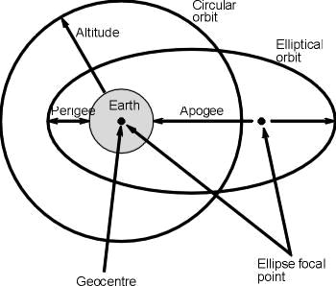

In circular orbit, the speed or rotation is constant. With elliptical orbits, the velocity of a satellite is greatest when satellite is closest to earth. The point in an elliptical orbit farthest from earth is called the apogee, and the point on the orbit closest to earth is called perigee. If satellite rotation is in the same direction as earth’s rotation with angular velocity greater than that of earth, the orbit is called prograde or posigrade orbit. If it’s in opposite direction with angular velocity less than that of earth, then it’s called a retrograde orbit. Nonsynchronous satellites revolve around in a prograde orbit, resulting in change of position continuously in respect to a fixed position on earth. So expensive and complicated tracking equipment is needed to locate and lock the antennas onto the satellite track.

12

DCS Unit-4 Wireless Communication Systems

Out of infinite number of orbital paths possible, only three are used for communication satellites: inclined, equatorial, or polar. When satellites orbit the Earth, either in a circular or elliptical orbit, the satellite orbit forms a plane that passes through the centre of gravity called geocentre of the Earth.

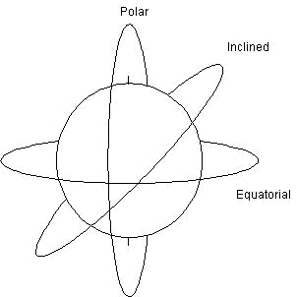

Inclined orbits are virtually all orbits except those that travel directly above the equator or directly above the North and South Poles.

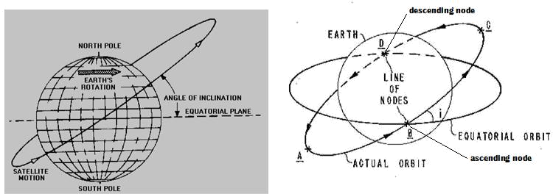

The angle of inclination is the angle between the earth’s equatorial plane and the orbital plane of a satellite measured counter clockwise at the point in the orbit where it crosses the equatorial plane from south to north and this point is called ascending node. If it’s passing from north to south, it is called descending node. Angles of inclination vary between 0 degrees and 90 degrees. The line joining both these nodes through the center of earth is called line of nodes.

An equatorial orbit is when the satellite rotates in an orbit directly above the equator, usually in a circular path. With an equatorial orbit, the angle of inclination is 0 degrees. All geosynchronous satellites are in equatorial orbits. A polar orbit is when the satellite rotates in a path that takes it over the North and South Poles in an orbital pattern that is perpendicular to the equatorial plane. The angle of inclination of a satellite in a polar orbit is nearly 90 degrees. 100% of earth’s surface can be covered with a single satellite in a polar orbit. Satellites in polar orbits rotate around earth in a longitudinal orbit while earth is rotating on its axis in a latitudinal rotation.

13

DCS Unit-4 Wireless Communication Systems

Geosynchronous Satellites

Also referred to as geostationary, it refers to the movement of communications satellites where the satellite circles the globe over the equator, in a movement that is synchronized with the earth's rotation. Because of this synchronization, the satellite appears to be stationary, and they also offer continuous operation in the area of visibility. Geosynchronous orbits are circular. There is only one geosynchronous earth orbit, which is occupied by a large number of satellites.

Geosynchronous orbit requirements: The most important requirement is that the orbit must have a 0-degree angle of elevation. They also must orbit in the same direction as earth’s rotation with the same angular velocity. Using Kepler’s third law, it can be shown that geosynchronous satellites must revolve around earth in a circular pattern 42,164 km from the center of the earth. The circumference of a geosynchronous satellite orbit is

C = 2 π (42,164km) = 264,790 km, and the velocity (v) is v = 264,790 km/24hr = 6840 mph

Clarke orbit: Synonymous with geostationary orbit. It is so-named because noted author Arthur C. Clarke was the first person to realize that this orbit would be useful for communication satellites. The Clarke orbit meets the concise setoff specifications for geosynchronous satellite orbits: (1) be located directly above the equator, (2) travel in the same direction as earth’s rotation with a velocity of 6840 mph, (3) have an altitude of 22,300 miles above earth and (4) complete one revolution in 24 hours

Geosynchronous satellite advantages and disadvantages:

Some of the advantages are,

- Geosynchronous satellites remain almost stationary in respect to a given earth station; therefore, expensive tracking equipment is not required at the earth stations.

- Geosynchronous satellites are available to all earth stations within their shadow 100% of the time. The shadow of a satellite includes all the earth stations that have a line-of-sight path to the satellite.

- Switching from one geosynchronous satellite to another as they orbit overhead is not necessary. Consequently, there are no transmission breaks due to switching times

Disadvantages are;

- An obvious disadvantage of geosynchronous satellites is they require sophisticated and heavy propulsion devices on board to keep them in a fixed orbit.

- High-altitude geosynchronous satellites introduce much longer propagation delays. The roundtrip propagation delay between two earth stations through a geosynchronous satellite is typically between 500 ms and 600 ms.

- Geosynchronous satellites require higher transmit power levels and more sensitive receivers because of the longer distances and greater path losses.

- High precision spacemanship is required to place a geosynchronous satellite into orbit and to keep it there.

14

DCS Unit-4 Wireless Communication Systems

Satellite Look Angles

Two angles have to be determined to ensure the earth station antenna is pointed directly at the satellite: the azimuth and the elevation angle. Both of them together are referred to as look angles. With geosynchronous satellites, the look angles of earth station antennas need to be adjusted only once, as the satellite will remain in a given position permanently except for minor variations. The pint on the surface of earth directly below the satellite is used to identify its location is called the subsatellite point (SSP) and for geosynchronous satellites, SSP must fall on the equator.

Satellite Antenna Radiation Patterns: Footprints

The geographical representation of the area on earth illuminated by the radiation from a satellite’s antenna is called a footprint or sometimes a footprint map. In essence, a footprint of a satellite is the area on earth’s surface that the satellite can receive from or transmit to. The shape of a satellite’s footprint depends on the satellite’s orbital path, height, and the type of antenna used. The higher the satellite, the more of the earth’s surface it can cover.

The radiation pattern from a satellite’s antenna is sometimes called a beam. The smallest and most directive beam is called a spot beam, followed by zonal beams, hemispherical beams, and earth (global) beams.

Satellite Multiple-Accessing Arrangements

Satellite multiple accessing implies that more than one user has access to one or more transponders within a satellite’s bandwidth allocation. The three most commonly used multiple accessing arrangements are frequency division multiple accessing (FDMA), time-division multiple accessing (TDMA) and code-division multiple accessing (CDMA).

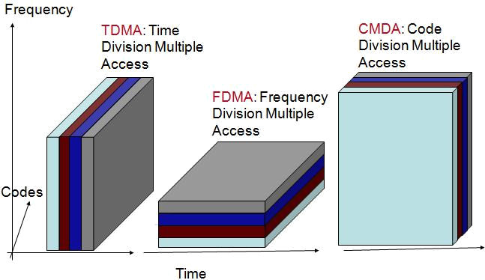

15

DCS Unit-4 Wireless Communication Systems

Frequency division multiple accessing: FDMA is a method of multiple accessing where a given RF bandwidth is divided into smaller frequency bands called subdivisions. FDMA transmissions are separated in the frequency domain and must share the total available transponder bandwidth as well as total transponder power. A control mechanism is used to ensure that two or more earth stations do not transmit in the same subdivision at the same time. Essentially, the control mechanism designates a receive station for each of the subdivisions. Thus, with FDMA, transmission can occur from more than one station at the same time, but the transmitting stations must share the allocated power, and no two stations can utilize the same bandwidth.

Time-division multiple accessing: TDMA is the predominant multiple-accessing method used today. TDMA is a method of time-division multiplexing digitally modulated carriers between participating earth stations within a satellite network using a common satellite transponder. With TDMA, each earth stat ion transmits a short burst of information during a specific time slot within a TDMA frame. The bursts must be synchronized so that each station’s burst arrives at the satellite at a different time, thus avoiding a collision with another station’s carrier. TDMA transmissions are separated in the tune domain, and with TDMA, the entire transponder bandwidth and power are used for each transmission but for only a prescribed interval of time. Thus, with TDMA, transmission cannot occur from more than one station at the same time. However, the transmitting station can use all the allocated power and the entire bandwidth during its assigned time slot.

Code-division multiple accessing: CDMA is based on the use of modulation technique known as spread spectrum. Users are separated both by frequency and time.

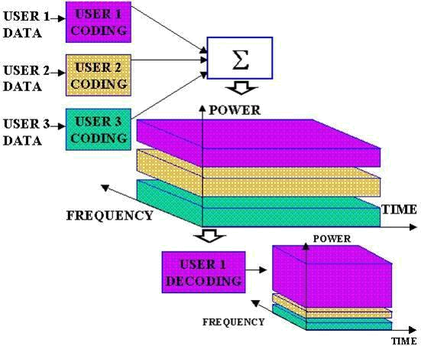

Because there are no limitations on bandwidth, CDMA is sometimes referred to as spread-spectrum multiple accessing (SSMA). With CDMA, all earth stations transmit within the same frequency band and, for all practical purposes, have no limitations on when they may transmit or on which carrier frequency. Thus, with CDMA, the entire satellite transponder bandwidth is used by all stations on a continuous basis. Signal separation is accomplished with envelope encryption/decryption techniques

16

DCS Unit-4 Wireless Communication Systems

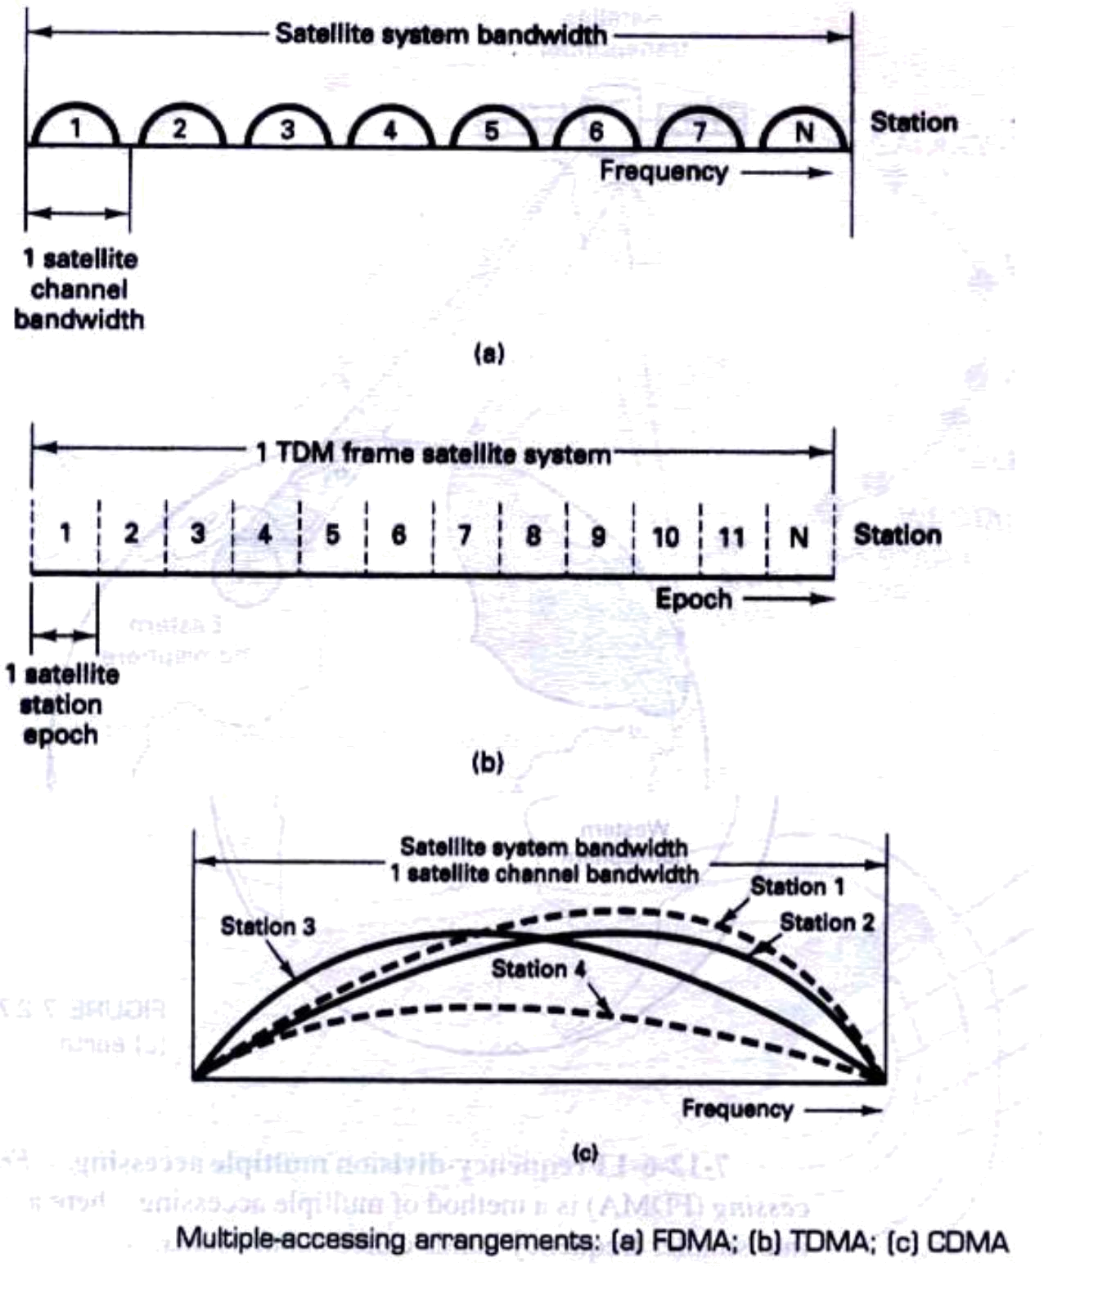

Comparison: In both FDMA and TDMA, only one subscriber at a time is assigned to a channel. No other conversion can access this channel until the subscriber’s call is finished or until that original call to be handed off to a different channel by the system. Voice data tends to be burst in nature. So much of the time, no data is being sent over the channel. This inefficiency tends to limit the capacity of the system. The above drawbacks are overcome in this third technique in which the users are spread across both frequency and time in the same channel. This is a hybrid combination of FDMA and TDMA. For example, frequency hopping may be employed to ensure during each successive time slot, the frequency bands assigned to the users are recorded in random manner. An important advantage of CDMA over FDMA and TDMA is that it can provide for secure communication.

17

DCS Unit-4 Wireless Communication Systems

Assignment Questions

- What is a radio wave? What are the optical properties of radio waves? Explain all the details of how they relate to radio wave propagation?

- What is meant by a free space path loss of an electromagnetic wave? Give the mathematical equation in decibel form. Determine, in dB, the free space path loss for a frequency of 6 GHz travelling a distance of 50 km.

- What are the three modes of terrestrial propagation of electromagnetic waves? Explain.

- What is a satellite multiple accessing arrangement? List and describe, in detail with neat diagrams, the three forms of satellite multiple accessing arrangements.

- Explain the term skip distance, satellite footprint and give the advantages of geosynchronous satellites

- List the advantages and disadvantages of microwave communications over cable transmission facilities.

- Compare FDMA, TDMA and CDMA

18

