DCS Unit-6 Cellular Telephone Systems

CELLULAR TELEPHONE SYSTEMS
First- Generation Analog Cellular Telephone, Personal Communications system, Second-Generation Cellular Telephone Systems, N-AMPS, Digital Cellular Telephone, Interim Standard, North American Cellular and PCS Summary, Global system for Mobile Communications, Personal Communications Satellite System

Introduction

Cellular system was developed to provide mobile telephony: telephone access “anytime, anywhere.” Cellular telephony is a system-level concept, which replaces a single high power transmitter with a large number of low-power transmitters for communication between any two devices over a large geographic area. Primary goal of the cellular telephone network is to provide wireless communication between two moving devices, called mobile stations or between one mobile unit and a stationary unit, commonly referred to as land-line unit. To accommodate a large number of users over a large geographic area, the cellular telephone system uses a large number of low-power wireless transmitters to create cells. Variable power levels allow cells to be sized according to subscriber density and demand within a particular region.

A cell is a basic geographic unit of a cellular system. The term cellular comes from the honeycomb shape of the areas into which a coverage region is divided. Cells are base stations transmitting over small geographic areas that are represented as hexagons. As mobile users travel from cell to cell, their conversations are handed off between cells. Channels (frequencies) used in one cell can be reused in another cell some distance away, which allows communication by a large number stations using a limited number of radio frequencies. To summarize, the basic concept of reuse allows a fixed number of channels to serve an arbitrarily large number of users. A cluster is a group of cells and no channels are reused within a cluster.

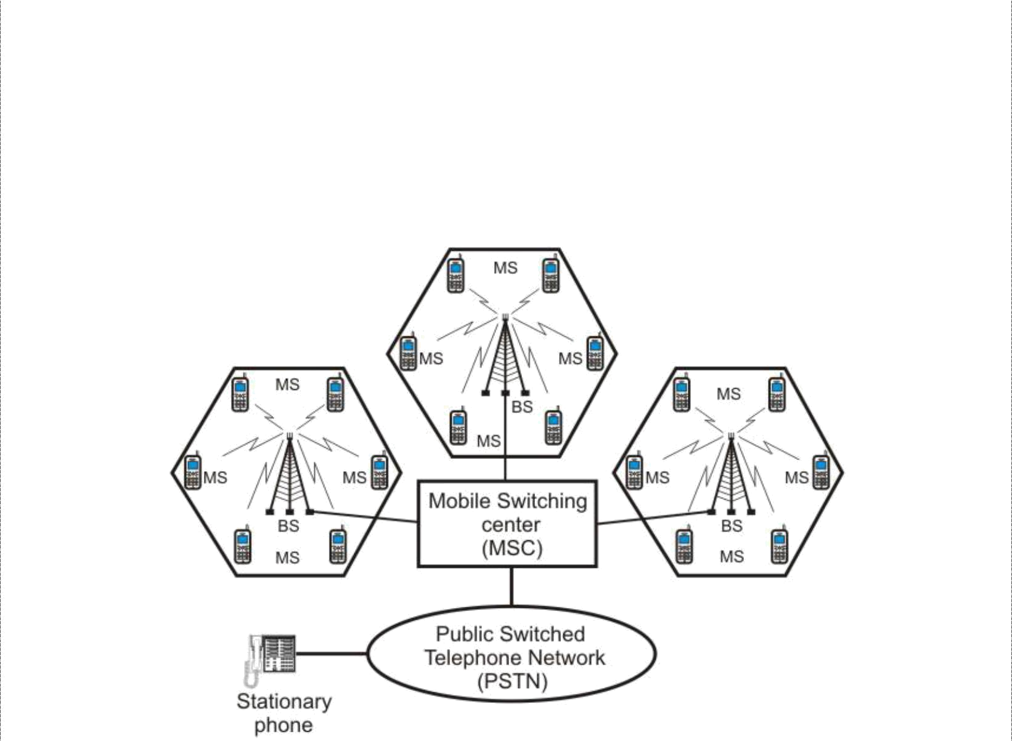

Schematic diagram of a cellular telephone system

1

DCS Unit-6 Cellular Telephone Systems

As shown above, a cellular system comprises of the following basic components:

- Mobile Stations (MS): Mobile handsets, which is used by an user to communicate with another user

- Cell: Each cellular service area is divided into small regions called cell (5 to 20 Km)
- Base Stations (BS): Each cell contains an antenna, which is controlled by a small office.

- Mobile Switching Center (MSC): Each base station is controlled by a switching office, called mobile switching center

Frequency reuse is the process in which the same set of frequencies (channels) can be allocated to more than one cell, provided the cells are separated by sufficient distance. The figure shows a geographic cellular radio coverage area containing three groups of cells called clusters. Each cluster has seven cells in it, and all cells are assigned the same number of full-duplex cellular telephone channels. Cells with the same letter use the same set of channel frequencies. A, B, C, D, E, F and G denote the seven sets of frequencies.
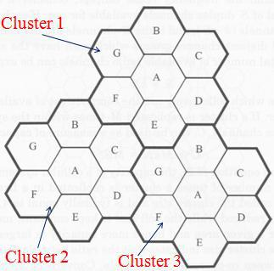

Handoff: At any instant, each mobile station is logically in a cell and under the control of the cell’s base station. When a mobile station moves out of a cell, the base station notices the MS’s signal fading away and requests all the neighbouring BSs to report the strength they are receiving. The BS then transfers ownership to the cell getting the strongest signal and the MSC changes the channel carrying the call. The process is called handoff. There are two types of handoff; Hard Handoff and Soft Handoff. In a hard handoff, which was used in the early systems, a MS communicates with one BS. As a MS moves from cell A to cell B, the communication between the MS and base station of cell A is first broken before communication is started between the MS and the base station of B. As a consequence, the transition is not smooth. Hard handoff is often called as break before-make. Hard handoffs are intended to be instantaneous in order to minimize the disruption to the call. A hard handoff is perceived by network engineers as an event during the call. For smooth transition from one cell (say A) to another (say B), an MS continues to talk to both A and B. As the MS moves from cell A to cell B, at some point the communication is broken with the old base station of cell A. This is known as soft handoff (also called as make before break). A soft handoff may involve using connections to more than two cells, e.g. connections to three, four or more cells can be maintained by one phone at the same time. Softer handoffs are possible when the cells involved in the handoff have a single cell site.

2

DCS Unit-6 Cellular Telephone Systems

First Generation Analog Cellular Telephone

AMPS (Advanced Mobile Telephone System) was invented at Bell Labs and initially deployed in the U.S. in the early 1980's. The frequencies allocated to AMPS by the Federal Communications Commission (FCC) range between 824 to 849 MHz in reverse channels (mobile to base) and 869 to 894 MHz in forward channels (base to mobile). Simultaneous transmission in both directions in a transmission mode is called full duplex (FDX) or simply duplexing. Frequency-division duplexing (FDD) is used with AMPS and occurs when two distinct frequency bands are provided to each user. A special device called duplexer is used in each mobile unit and base station to allow simultaneous transmission and reception on duplex channels. Transmissions from base stations to mobile units are called forward links, whereas transmissions from mobile units to base stations are called reverse links. In 1989, the FCC added an additional 10-MHz frequency spectrum to the original 40-MHz band, which increased the simplex channels to a total of 832 (416 full duplex).
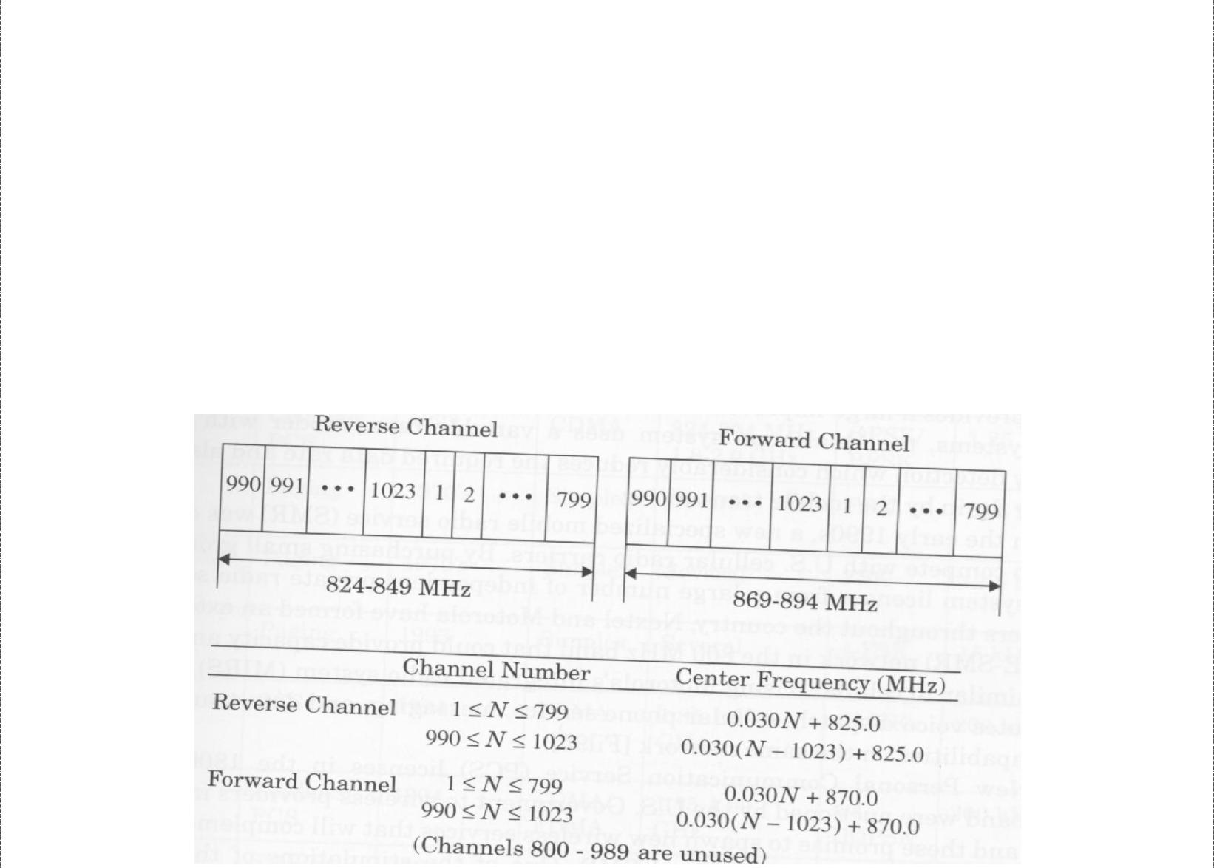

Complete AMPS Frequency spectrum

The 832 channels are divided into four categories:

- Control (base to mobile) to manage the system.

- Paging (base to mobile) to alert mobile users to calls for them.

- Access (bidirectional) for call setup and channel assignment.

- Data (bidirectional) for voice, fax, or data.

Each physical channel is 30 kHz wide and is dedicated to a single mobile station for the duration of the call while the mobile is in the current cell. Each call uses a dedicated forward channel paired with a dedicated reverse channel at a 45 MHz offset. Some of the channel pairs (21 of them) are used for control purposes in the AMPS environment. Analog frequency modulation (FM) with 8 kHz deviation is used in the traffic channels, which convey voice conversations. Binary frequency shift keying (FSK) at 10 kbps-a digital modulation technique-is used in the control channels used for signalling.

3

DCS Unit-6 Cellular Telephone Systems

AMPS Identification Codes: The AMPS system uses several identification codes for

each mobile unit. The mobile identification number (MIN) is a 34-bit binary code, which is the programmed handset phone number used to call the subscriber. This programmed identifier is associated with the subscriber and is stored in erasable non-volatile memory in the handset. The second identifier is the electronic serial number (ESN), which is a manufactured characteristic of the mobile unit. This identifier is permanent and associated with the physical equipment. It is 32 bits in length, with the first 8 bits identifying the manufacturer. The third identification code is four bit station class mark (SCM), which indicates whether the terminal has access to all 832 channels or not. The SCM also specifies the maximum radiated power for the unit. The system identifier (SID) is a 15-bit binary code issued by the FCC to an operating company when it issues a license to provide AMPS cellular service to an area. Local operating companies assign a tow-bit digital color code (DCC) and a supervisory audio tone (SAT) to each of their base stations to help the mobile units distinguish one base station from a neighbouring base station.

AMPS Control Channels: Control channels are used in cellular telephone systems to enable mobile units to communicate with the cellular network through base stations and are used for call origination, call termination, and to obtain system information. With AMPS system, voice channels are analog FM, while control channels are digital and employ FSK. Base stations broadcast on the forward control channel (FCC) and listen on the reverse control channel (RCC). All AMPS base stations continuously transmit FSK data on the FCC so that idle cellular telephones can maintain a lock on the strongest FCC regardless of their location. A subscriber’s unit must be locked on an FCC before it can originate or receive calls.

Personal Communications System

The FCC defines PCS mobile telephone as “a family of mobile or portable radio communications services, which provides services to individuals and business and is integrated with a variety of competing networks”. PCS is North American implementation of the European GSM standard. Differences between PCS systems and standard cellular telephone systems generally include but are certainly not limited to the following:

- smaller cell size, (2) all digital and (3) additional features. Cellular systems generally classified as PCS include IS-136 TDMA, GSM and IS-95 CDMA.

The fundamental concept of PCS is to assign each mobile unit a PTN that is stored in a database on the SS7 common signalling network. The database keeps track of where mobile units are. When a call is placed for a mobile unit, the SS7 artificial intelligence network determines where the call should be directed. The PCS network is similar to

4

DCS Unit-6 Cellular Telephone Systems

D-AMPS system in that the MTSO stores three essential-databases: home location register, visitor location register, and equipment identification registry.

The HLR is a database that stores information about the user, including home subscription information and also the supplementary services like call waiting, call hold, call forwarding etc subscribed by the user. The VLR stores information about subscribers in a particular MTSO serving area, such as whether the unit is on or off and whether any of the supplementary services are activated or deactivated. The EIR stores information pertaining to the identification and type of equipment that exists in the mobile unit. The EIR also helps the network identify stolen or fraudulent mobile units.

Some of the services offered by PCS systems are:

- Available mode: It allows all calls to pass through the network to the subscriber except for a minimal number of telephone numbers that can be blocked.

- Screen mode: It is PCS equivalent to caller ID. The calling party’s name appears on the mobile units display allowing users to screen calls. Unanswered calls are automatically forwarded to a forwarding destination specified by the subscriber.

- Private mode: Here, all calls except those specified by the subscriber are automatically forwarded to a forwarding destination without ringing the subscriber’s handset.

- Unavailable mode: no calls are allowed to pass through to the subscriber. So, all calls are automatically forwarded to a forwarding destination.

The primary disadvantage of PCS is network cost. Employing small cells requires using more base stations, which equates to more transceivers, antennas, and trunk circuits. PCS networks rely extensively on the SS7 signalling network for interconnecting to other telephone networks and databases.

N-AMPS

Narrowband Advanced Mobile Phone Service (NAMPS) is an improved version of AMPS systems. NAMPS is a cellular call-handling system that uses digital signalling techniques to split the existing 30 kHz wideband voice channels into three 10 kHz narrowband voice channels. Each 10-KHz subchannel is capable of handling its own calls. The result is three times more voice channel capacity than the traditional AMPS system provides.

With narrow bandwidths, voice channels are more vulnerable to interference than standard AMPS channels and would require a higher frequency reuse factor. This is compensated for, with the addition of an interference avoidance scheme called Mobile Reported Interference (MRI), which uses voice companding to provide synthetic voice channel quieting. NAMPS cellular phones are manufactured for dual mode operation, and they are compatible with traditional AMPS systems. N-AMPS systems use standard AMPS

5

DCS Unit-6 Cellular Telephone Systems

control channels for call setup and termination. N-AMPS mobile units are capable of utilizing four types of handoffs: wide channel to wide channel (30 kHz to 30 kHz), wide channel to narrow channel (30 kHz to 10 kHz), narrow channel to narrow channel (10 kHz to 10 kHz) and narrow channel to wide channel (10 kHz to 30 kHz). To conclude, with N-AMPS, user capacity can be expanded by subdividing existing channels (band splitting), partitioning cells into smaller subcells (cell splitting), and modifying antenna radiation patterns (sectoring).

Digital Cellular Telephone

With the rapidly expanding customer base while working with unchanged allocated frequency spectrum, it was a growing problem for the cellular companies. Digital cellular telephone systems have several inherent advantages over analog cellular telephone systems, including better utilization of bandwidth, more privacy and incorporation of error detection and correction. Consequently, the United States Digital Cellular (USDC) system was designed and developed with the intent of supporting a higher user density within a fixed-bandwidth frequency spectrum. Cellular telephone systems that use digital modulation, such as USDC, are called digital cellular. USDC cellular systems comply with IS-54, which specifies dual-mode operation and backward compatibility with standard AMPS and because of this reason, they are also known as Digital AMPS (D-AMPS or DAMPS). The USDC system has an additional frequency band in the 1.9 GHz that is not compatible with AMPS frequency allocation.

Time-Division Multiple Accessing


USDC uses time-division multiple accessing (TDMA) as well as FDMA. However, TDMA allows more than one mobile unit to use a channel at the same time by further dividing transmissions within each cellular channel into time slots, one for each mobile unit using that channel. Unlike AMPS FDMA systems, with USDC TDMA systems, mobile-unit subscribers can only hold a channel while they are actually talking on it. During pauses or other normal breaks in a conversation, users must relinquish their channel so that other mobile units can use it. This time sharing technique significantly increases the capacity of a system, allowing more mobile-unit subscribers to use a system at virtually the same time within a geographical area.

A USDC TDMA transmission frame consist of six equal-duration time slots enabling each 30-kHz AMPS channel to support three full-rate or six half-rate users. Hence USDC offers as much as six times the channel capacity as AMPS. The advantages of digital TDMA multiple-accessing systems over analog AMPS FDMA systems are given below:

- Time domain multiple accessing allows for a threefold to sixfold increase in the number of mobile subscribers using a single cellular channel.

6

DCS Unit-6 Cellular Telephone Systems

- Digital signals are much easier to process than analog signals as most of the modern modulation techniques are developed to be used in a digital environment.

- Digital signals (bits) can be easily encrypted and decrypted, safeguarding against eavesdropping.

- The entire telephone system is compatible with other digital formats, such as those used in computers and computer networks.

- Digital systems inherently provide a quieter (less noisy) environment than their analog counterparts.

EIA/TIA Interim Standard 54


In 1990, the Electronics Industries Association and Telecommunications Industry Association (EIA/TIA) standardized the dual-mode USDC/AMPS system as Interim Standard 54 (IS-54), Cellular Dual Mode Subscriber Equipment. Using IS-54, a cellular telephone carrier could convert any or all of its existing analog channels to digital. To achieve dual-mode operation, IS-54 provides digital control channels and both analog and digital voice channels. Dual-mode mobile units can operate in either the digital or the analog mode for voice and access the system with the standard AMPS digital control channel. IS-54 specifies a 48.6 kbps rate per 30-kHz voice channel divided among three simultaneous users. Each user is allocated 13 kbps, and the remaining 9.6 kbps is used for timing and control overhead.

USDC Control Channels and IS-136.2


The IS-54 USDC standard specifies the same 42 primary control channels as AMPS and 42 additional control channels called secondary control channels. So USDC offers twice as many control channels as AMPS and is therefore capable of providing twice the capacity of control traffic within a given market area. To maintain compatibility with existing AMPS cellular telephone systems, the primary forward and reverse control channels in USDC cellular systems use the same signalling techniques and modulation scheme (FSK) as AMPS. However, a new standard IS-136.2 replaces FSK with π/4 DQPSK modulation for the 42 dedicated USDC secondary control channels, allowing digital mobile units to operate entirely in the digital domain. The IS-136.2 standard is called North American- Time Division Multiple Accessing (NA-TDMA). IS 136 was developed to provide a host of new features and services. An additional “sleep mode” which conserves power is also provided.

The IS-54 standard specifies three types of channels: analog control channels, analog voice channels, and a 10-kbps binary FSK digital control channel (DCCH). The IS-136 standard provides the above three channels and an additional one: a digital control channel with a signalling rate of 48.6 kbps on USDC-only control channels. The new digital control channel includes several logical channels with different functions, including the random access channel (RACH), the SMS point-to-point, paging, and access response channel (SPACH); the broadcast control channel (BCCH) and the shared channel feedback (SCF) channel.

7

DCS Unit-6 Cellular Telephone Systems

- RACH: It is a unidirectional channel used by mobile units to request access to the cellular telephone system.

- SPACH: It is used to transmit information from base to specific mobile station and information transmitted on SPACH channel includes three separate logical subchannels: SMS point-to-point messages, paging messages, and access response messages.

- BCCH: It is an acronym referring to the F-BCCH, E-BCCH and S-BCCH. The fast broadcast channel (F-BCCH) broadcasts digital control channel (DCCH) structure parameters. Mobile units use F-BCCH information when initially accessing the system to determine the beginning and ending of each logical channel in the DCCH frame. The extended broadcast control channel (E-BCCH) carries information about neighbouring analog and TDMA cells and optional messages, such as emergency information, time and date messaging etc. The SMS broadcast channel (S-BCCH) is a logical channel used for sending short messages to individual mobile units.

- SCF: It is used to support random access channel operation by providing information about which time slots the mobile unit can use for access attempts and also if a mobile unit’s previous RACH transmission was successfully received.

USDC Digital Voice Channel


Like AMPS, each USDC voice channel is assigned a 30-kHz bandwidth on both the forward and the reverse link. With USDC, each channel can support as many as three full-rate mobile users simultaneously by using digital modulation and a TDMA format called North American Digital Cellular (NADC). Each radio-frequency voice channel in the total AMPS FDMA frequency band consists of one 40-ms TDMA frame comprised of six time slots containing 324 bits each. The average cost per subscriber per base station equipment is lower with TDMA since each base station transceiver can be shared by upto six users at a time.
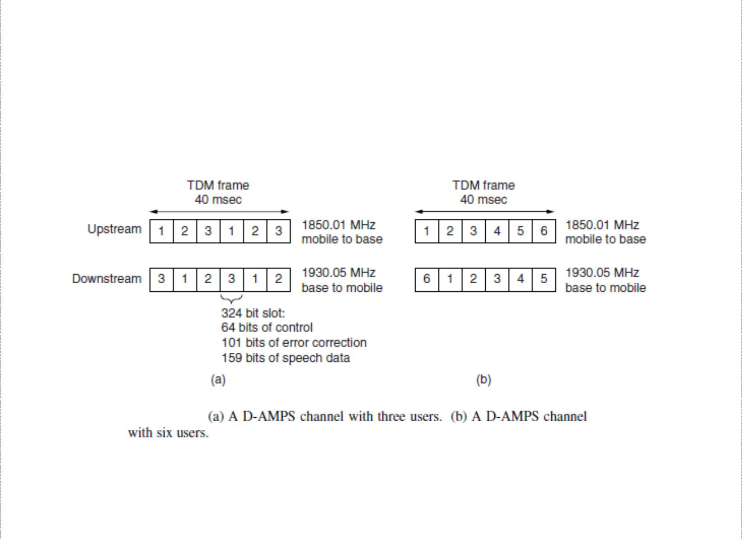

8

DCS Unit-6 Cellular Telephone Systems

E-TDMA: General Motors Corporation implemented a TDMA scheme called E-TDMA {Extended or Enhanced TDMA}, which incorporates six half-rate users transmitting at half the bit rate of standard USDC TDMA systems. E-TDMA systems also incorporate digital speech interpolation (DSI) to dynamically assign more than one user to a time slot, deleting silence on the calls. Consequently E-TDMA can handle approximately 12 times the user traffic as standard AMPS systems and four times that of systems complying with IS-54.

Each time slot in every USDC voice-channel frame contains four data channels-three for control and one for digitized voice and user data. The full-duplex digital traffic channel (DTC) carries digitized voice information and consists of a reverse digital traffic channel (RDTC) and a forward digital traffic channel (FDTC) that carry digitized speech information or user data. The three supervisory channels are given below:

- Coded digital verification color code (CDVCC): Its purpose is to provide co-channel identification similar to the SAT signal transmitted in the AMPS system. It is a 12 bit message transmitted in every time slot.

- Slow associated control channel (SACCH): It is a signalling channel for transmission of control and supervision messages between the digital mobile unit and the base station while the mobile unit is involved with a call. It is also used by the mobile unit to report signal strength measurements of neighbouring base stations, so when needed the base station can initiate a mobile-assisted handoff (MAHO).

- Fast associated control channel (FACCH): It is a second signalling channel for transmission of control and specialized supervision and traffic messages between the base station and the mobile units. It is a blank-and-burst type of transmission than when transmitted replaces digitized speech information with control and supervision messages within a subscriber’s time slot.

USDC Digital modulation scheme


To achieve a transmission bit rate of 48.6 kbps in a 30-kHz AMPS voice channel, a bandwidth (spectral) efficiency of 1.62 bps/Hz is required, binary FSK is incapable. USDC voice and control channels use a symmetrical differential, phase-shift keying technique known as π/4 DQPSK or π/4 differential quadriphase shift keying, which offers several advantages such as improved co-channel rejection and bandwidth efficiency. In π/4 DQPSK modulator, data bits are split into two parallel channels that produce a specific phase shift in the analog carrier, and since there are four possible bit pairs, there are four possible phase shifts using a quadrature I/Q modulator and the four phase changes are π/4, - π/4, 3 π/4 and -3 π/4, which define eight possible carrier phases. Using pulse shaping with π/4 DQPSK allows for the simultaneous transmission of three separate 48.6-kbps speech signals in a 30-kHz bandwidth.

9

DCS Unit-6 Cellular Telephone Systems

Interim Standard 95

Interim Standard 95 (IS-95) is the first CDMA-based digital cellular standard by Qualcomm. The brand name for IS-95 is cdmaOne. IS-95 is also known as TIA-EIA-95. CDMA allows users to differentiate from one another by a unique code rather than a frequency or time assignment and hence has several advantages over TDMA and FDMA cellular systems such as increased capacity, improved performance and reliability. IS-95 is designed to be compatible with existing analog systems (AMPS).

CDMA

IS-95 specifies a direct-sequence, spread spectrum CDMA system and does not follow the channelization principles of traditional cellular radio communications systems. Rather than dividing the allocated frequency spectrum into narrow bandwidth channels, one for each user, information is transmitted (spread) over a very wide frequency spectrum with as many as 20 mobile subscriber units using the same carrier frequency within the same frequency band. IS-95 is not asymmetrical as it specifies a different modulation and spreading technique for the forward (digital QPSK) and reverse (digital OQPSK) channels. On the forward channel, the base station simultaneously transmits user data from all current mobile units in that cell by using different spreading sequences (codes) for each user’s transmissions. A pilot code is transmitted with the user data at a higher power level, thus allowing all mobile units to use coherent detection. On the reverse link, all mobile units respond in an asynchronous manner (i.e. no time or duration limitations) with a constant signal level controlled by the base station. The speech coder used with IS-95 is the Qualcomm 9600-bps Code-Excited Linear Predictive (QCELP) coder. The vocoder converts an 8-kbps compressed data stream to a 9.6 kbps data stream.

Advantages of CDMA:

- Frequency diversity – frequency-dependent transmission impairments have less effect on signal

- Multipath resistance – chipping codes used for CDMA exhibit low cross correlation and low autocorrelation

- Privacy – privacy is inherent since spread spectrum is obtained by use of noise-like signals

- Graceful degradation – system only gradually degrades as more users access the system

Limitations of CDMA

- Self-jamming – arriving transmissions from multiple users not aligned on chip boundaries unless users are perfectly synchronized

- Near-far problem – signals closer to the receiver are received with less attenuation than signals farther away

10

DCS Unit-6 Cellular Telephone Systems

- Soft handoff – requires that the mobile acquires the new cell before it relinquishes the old; this is more complex than hard handoff used in FDMA and TDMA schemes

CDMA frequency and channel allocations

Each IS-95 channel is allocated a 1.25-MHz frequency spectrum for each one-way CDMA communications channel. A single CDMA radio channel takes up the same bandwidth as approximately 42 30-kHz AMPS voice channels. But because of the frequency reuse advantage of CDMA, CDMA offers approximately a 10-to-1 channel advantage over standard analog AMPS and a 3-to-1 advantage over USDC digital AMPS. Each CDMA channel is 1.23 MHz wide with a 1.25 MHz frequency separation between adjacent carriers, producing a 200-kHz guard band between CDMA channels. There are as many as nine CDMA carriers available for A and B band operator in the AMPS frequency spectrum.

For the forward (uplink) channel, subscriber data are encoded using convolutional coding with rate ½, interleaved and spread by one of 64 orthogonal Walsh codes. For the downlink channels, a different spreading strategy is used as each mobile unit’s received signal takes a different transmission path and therefore, arrives at the base station at a different time. A convolutional coding rate of 1/3 is used and long sequences are used to separate the signals from different users on the reverse link (CDMA).

Each mobile unit in a given cell is assigned a unique spreading sequence that ensures near perfect separation among the signals from different subscriber units and allows transmission differentiation between users. All signals in a particular cell are scrambled using a pseudorandom sequence of length 2¹⁵ chips. This reduces radio frequency interference between mobiles in neighbouring cells that may be using the same spreading sequence and provides the desired wideband spectral characteristics. Two commonly used techniques for spreading the spectrum are frequency hopping and direct sequencing.

Frequency-hopping spread spectrum: FH – CDMA is a kind of spread spectrum technology that enables many users to share the same channel by employing a unique hopping pattern to distinguish different users’ transmission. The type of spread spectrum in which the carrier hops randomly from one frequency to another is called FH spread spectrum. A common modulation format for FH system is that of M-ary frequency shift keying (MFSK).the combination is referred to as FH/MFSK.

A major advantage of frequency hopping is that it can be implemented over a much larger frequency band than it is possible to implement DS- spreading, and the band can be non-contiguous. Another major advantage is that frequency hopping provides resistance to multiple – access interference while not requiring power control to prevent near – far problems. The sequence in which the frequencies are selected must be known by both the transmitter and the receiver prior to the beginning of the transmission. Each transmitter in

11

DCS Unit-6 Cellular Telephone Systems

the system has a different hopping sequence to prevent one subscriber from interfering with transmissions from other subscribers using the same radio channel frequency.

Direct-sequence spread spectrum: Here, a high-bit-rate pseudorandom code is added to a low-bit-rate information signal to generate a high-bit-rate pseudorandom signal closely resembling to noise that contains both the original data signal and the pseudorandom code. The code has to known both to the transmitter and the intended receiver. The receiver upon detection of direct-sequence transmission, simply subtracts the pseudorandom signal from the composite receive signal to extract the information data.

Adding a high bit-rate pseudorandom signal to the voice information makes the signal more dominant and less susceptible to interference, allowing lower power transmission and hence, a lower number of transmitters and less expensive receivers.

CDMA Traffic Channels

CDMA traffic channels consist of a downlink (base station to mobile unit) channel and an uplink (mobile station to base station) channel. The downlink traffic channel consists up to 64 channels, including a broadcast channel used for control and traffic channels used to carry subscriber information.

The forward link uses the same frequency spectrum as AMPS (824-849 MHz). Four types of logical channel are present i.e. a pilot, a synchronization, 7 paging, and upto 63 traffic channels. All these channels share the same 1.25-MHz CDMA frequency assignment. The traffic channels are identified by a distinct user-specific long-code sequence, and each access channel is identified by a distinct access channel long-code sequence.
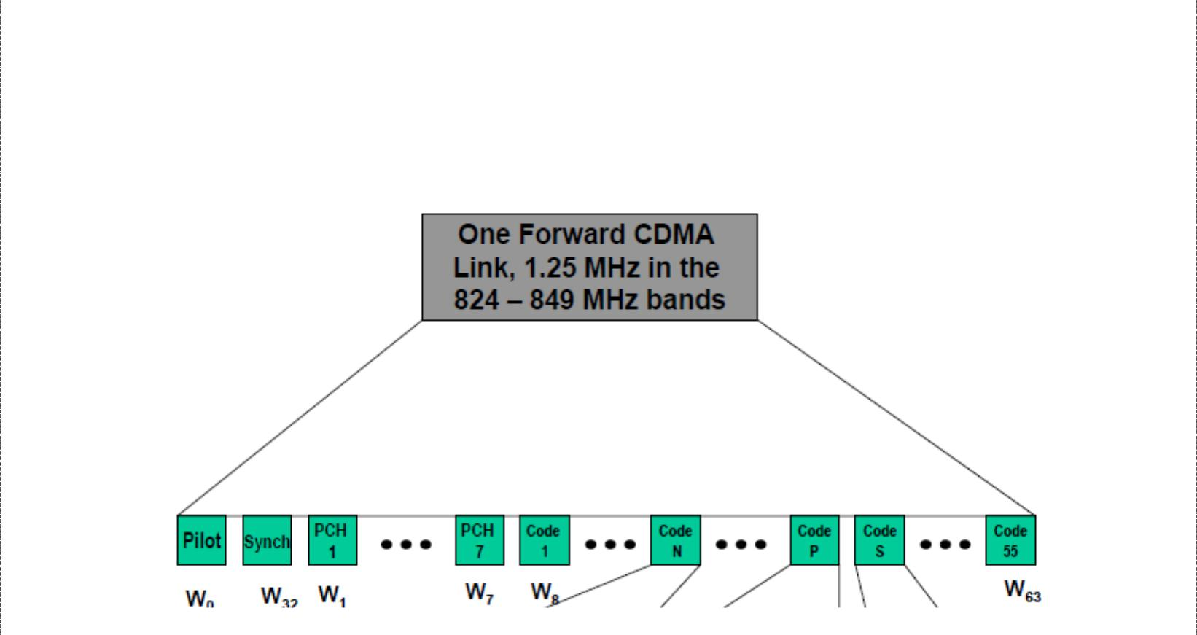

The pilot channel is included in every cell with the purpose of providing a signal for the receiver to use to acquire timing and provide a phase reference for coherent demodulation. It is also used by mobile units to compare signal strengths between base stations to determine when a handoff should be initiated. The pilot contains no information but it is the strongest signal on the forward link, containing at least 20% of the total power

12

DCS Unit-6 Cellular Telephone Systems

on the forward link. The synchronization channel uses a Walsh W32 code and same pseudorandom sequence and phase offset as the pilot channel, allowing it to be demodulated by any receiver that can acquire the pilot signal. The synchronization channel broadcasts synchronization messages to mobile units and operates at 1200 bps. Once the mobile is synchronized with the base station the sync channel is ignored.

The paging channels are used to transmit overhead information (i.e. commands and pages) to the mobile. When a call is being set up the commands and traffic channel assignment are sent on the paging channel. Once a traffic channel is established the paging channel is ignored by the mobile. Paging channels are optional and can range in number between zero and seven. A single 9600-bps pilot channel can typically support about 180 pages per second for a total capacity of 1260 pages per second. Data on the downlink traffic channel are grouped into 20-ms frames. The data are first convolutionally coded and then formatted and interleaved to compensate for differences in the actual data rates. The resulting signal is spread with Walsh code with a long pseudorandom sequence at a rate of 1.2288 Mchips/s.

The uplink radio channel transmitter consists of access channels and upto 62 uplink traffic channels. The access channel is used by the mobile when not assigned to a traffic channel. The access channels is used by the mobile to register with the network, originate calls, respond to pages and commands from the base station, and transmit overhead messages to the base station. Typical access channel messages include acknowledgements and sequence number, mobile identification parameter messages and authentication parameters. The access channel is a random access channel with each channel subscriber uniquely identified by their pseudorandom codes.
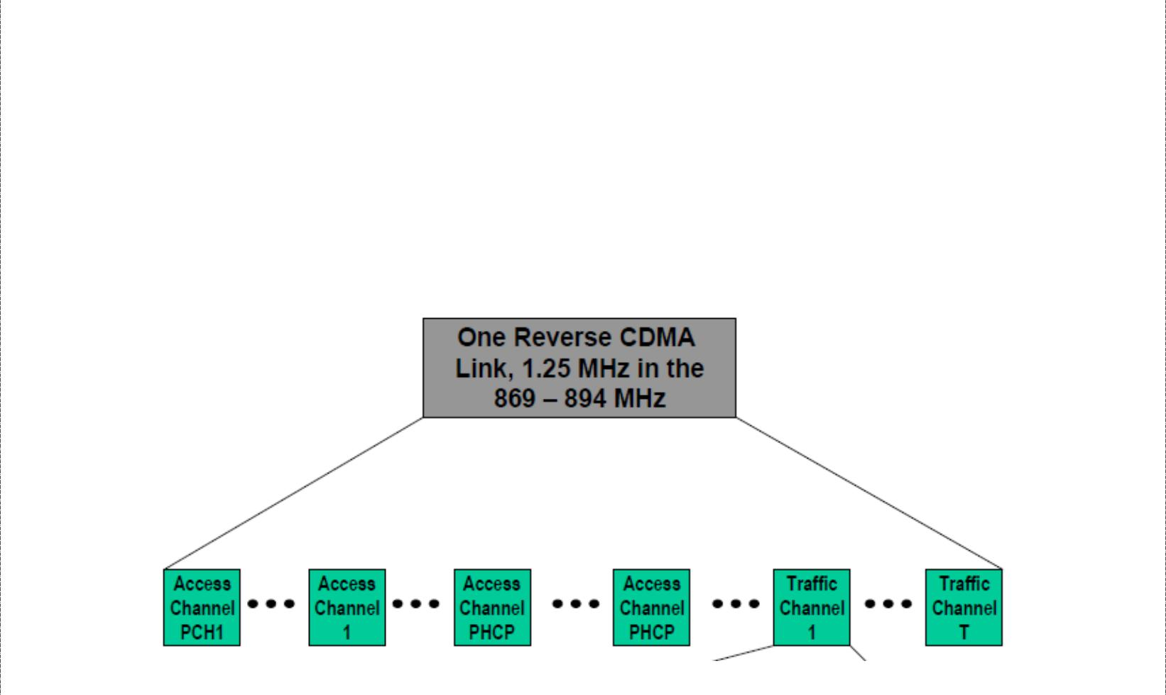

The uplink traffic channel operates at a variable data rate mode, and the access channels operate at a fixed 4800-bps rate. The reverse traffic channel is used when there is a call. Subscriber data on the uplink radio channel transmitter are also grouped into 20-ms frames, convolutionally encoded, block interleaved, modulated by a 64-ary orthogonal modulation and spread prior to transmission.

13

DCS Unit-6 Cellular Telephone Systems

CDMA radiated Power

IS-95 specifies complex procedures for regulating the power transmitted by each mobile unit. The goal is to make all reverse-direction signals within a single CDMA channel arrive at the base station with approximately the same signal strength (±1 dB), which is essential for CDMA operation. As signal paths change continuously with moving units, the mobile units perform power adjustments as many as 800 times per second under the control of the base station. Base stations instruct the mobile units to increase or decrease their transmitted power in 1-dB increments.

When a mobile unit is first turned on, it measures the power of the signal received from the base station. The mobile unit assumes that the signal loss is the same in each direction and adjusts its transmit power on the basis of the power level of the signal it receives from the base station. This process is called open-loop power setting. Mobile units use the following formula to compute their transmit power:

P_{t} dBm = -76 dB - P_{r}
where Pt is transmit power in dBm and Pr is received power in dBm.

With CDMA, rather than limit the maximum transmit power, the minimum and maximum effective isotropic radiated power (EIRP) is specified. The maximum radiated power of base stations is limited to 100 W per 1.23 MHz CDMA channel.

Global System for Mobile Communications

Throughout the evolution of cellular telecommunications, various systems have been developed without the benefit of standardized specifications. This presented many problems directly related to compatibility. GSM standard is intended to address these problems. GSM was the world’s first totally digital cellular telephone system designed to use the services of SS7 signalling and an all-digital data network called integrated services digital network (ISDN) to provide a wide range of network services. GSM is now the world’s most popular standard for new cellular telephone and personal communications equipment.

Advantages of GSM
- Communication: mobile, wireless communication, support for voice and data services

- Total mobility: international access, chip-card enables use of access points of different providers.

- Worldwide connectivity: one number, the network handles every location.

- High capacity: better frequency efficiency, smaller cells, more customers per cell.

- High transmission quality: high audio quality and reliability for wireless, uninterrupted phone calls at higher speeds (e.g., from cars, trains).

14

DCS Unit-6 Cellular Telephone Systems

GSM Services

GSM telephone services are broadly classified into three categories: bearer services, teleservices, and supplementary services. Teleservices are mainly voice services that provide subscribers with the complete capability to communicate with other subscribers. Data services provide the capacity necessary to transmit appropriate data signals between two access points creating an interface to the network. Some of the subscriber services are given below:

- dualtone multifrequency (DTMF): DTMF is a tone signalling scheme used for various control purposes via the telephone network, such as remote control of an answering machine.

- facsimile group III: GSM supports CCITT group 3 facsimile. This enables a GSM connected fax to communicate with any analog fax in the network.

- short message service: A message consisting of 160 alphanumeric characters can be sent to or from a mobile station. If the mobile station is off or not in the coverage area, the message is stored and then offered back ensuring that the message will be received.

- cell broadcast: a message of maximum of 93 characters can be broadcast to all mobile subscribers in a given geographic area. Typical applications include traffic congestion warnings and reports on accidents.

- voice mail: This service is actually an answering machine within the network controlled by the subscriber. Calls can be forwarded to the subscriber’s voice mail box, which can be checked later by the subscriber via a personal code.

- fax mail: with this service, the subscriber can receive fax at any fax machine.

GSM supports a set of supplementary services that can complement and support both telephony and data services. These are defined by GSM and are termed as revenue generating services. Some of them are listed below:

- Call forwarding: It gives the subscriber the ability to forward incoming calls to another number if the called unit is not reachable, not answering, or busy.

- barring of outgoing calls: this service makes it possible for a subscriber to prevent all outgoing calls

- barring of incoming calls: It allows the subscriber to prevent incoming calls either completely or if in roaming

- advise of charge: The AoC service provides the mobile subscriber with an estimate of the call charges.

- call hold: This service enables the subscriber to interrupt an ongoing call and then subsequently re-establish the call.

- call waiting: It allows the mobile subscriber to be notified of an incoming call during a conversation. The subscriber then can answer, reject or ignore the incoming call.

15

DCS Unit-6 Cellular Telephone Systems

- multiparty service: It enables a mobile subscriber to establish a multiparty conversation i.e. a simultaneous communication between three and six users.

- closed user groups: CUG’s are generally comparable to a PBX. They are a group of subscribers who are capable of only calling themselves and certain numbers.

- calling line identification presentation/restriction: these services supply the called party with the integrated services digital network (ISDN) number of the calling party.

GSM architecture

The GSM network is divided into three major systems: the Network Switching Subsystem (NSS), the Base Station Subsystem (BSS) and the Operation and Support System (OSS). The basic GSM elements are shown below:
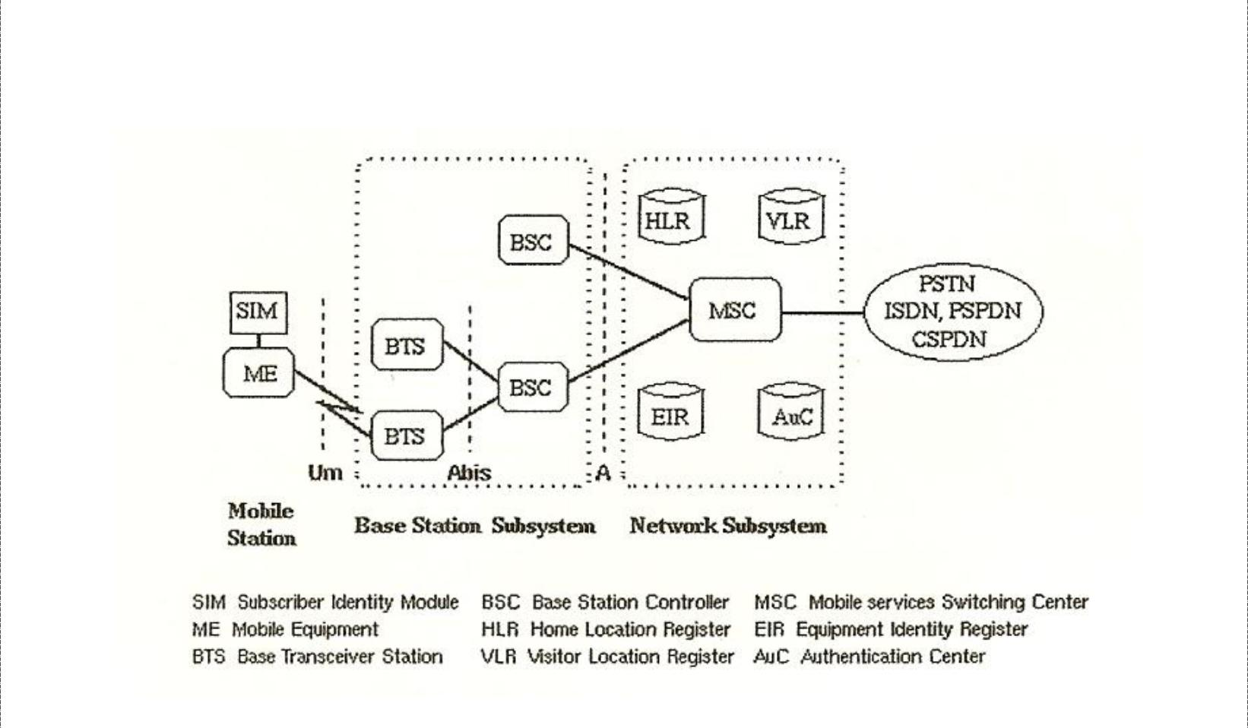

Network Switching Subsystem: The NSS is responsible for performing call processing and subscriber related functions. The switching system includes the following functional units:

- home location register (HLR): It is a database used for storage and management of subscriptions. HLR stores permanent data about subscribers, including a subscribers service profile, location information and activity status. When an individual buys a subscription from the PCS provider, he or she is registered in the HLR of that operator.

- Visitor location register (VLR): It is a database that contains temporary information about subscribers that is needed by the MSC in order to service visiting subscribers. VLR is always integrated with the MSC. When a MS roams into a new MSC area, the VLR connected to that MSC will request data about the mobile station from the HLR. Later if the mobile station needs to make a call, VLR will be having all the information needed for call setup.

16

DCS Unit-6 Cellular Telephone Systems

- Authentication center (AUC): A unit called the AUC provides authentication and encryption parameters that verify the users identity and ensure the confidentiality of each call.

- Equipment identity register (EIR): It is a database that contains information about the identity of mobile equipment that prevents calls from stolen, unauthorized or defective mobile stations.

- Mobile switching center (MSC): The MSC performs the telephony switching functions of the system. It controls calls to and from other telephone and data systems.

Base Station Subsystem (BSS): All radio related functions are performed in the BSS, which is also known as radio subsystem. It provides and manages radio-frequency transmission paths between mobile units and MSC. It consists of many base station controllers (BSC) and base transceiver stations (BTS).

- Base station controllers (BSC): The BSC provides all the control functions and physical links between the MSC and BTS. It is a high capacity switch that provides functions such as handover, cell configuration data, and control of radio frequency (RF) power levels in

BTS. A number of BSC’s are served by and MSC.

- Base transceiver station (BTS): The BTS handles the radio interface to the mobile station. The BTS is the radio equipment (transceivers and antennas) needed to service each cell in the network. A group of BTS’s are controlled by an BSC.

Operation and Support system: The operations and maintenance center (OMC) is connected to all equipment in the switching system and to the BSC. Implementation of OMC is called operation and support system (OSS). The OSS is the functional entity from which the network operator monitors and controls the system. The purpose of OSS is to offer the customer cost-effective support for centralized, regional and local operational and maintenance activities that are required for a GSM network. OSS provides a network overview and allows engineers to monitor, diagnose and troubleshoot every aspect of the GSM network.

The mobile station (MS) consists of the mobile equipment (the terminal) and a smart card called the Subscriber Identity Module (SIM). The SIM provides personal mobility, so that the user can have access to subscribed services irrespective of a specific terminal. By inserting the SIM card into another GSM terminal, the user is able to receive calls at that terminal, make calls from that terminal, and receive other subscribed services.

The mobile equipment is uniquely identified by the International Mobile Equipment Identity (IMEI). The SIM card contains the International Mobile Subscriber Identity (IMSI) used to identify the subscriber to the system, a secret key for authentication, and other information. The IMEI and the IMSI are independent, thereby allowing personal mobility. The SIM card may be protected against unauthorized use by a password or personal identity number.

17

DCS Unit-6 Cellular Telephone Systems

GSM Radio Subsystem

GSM uses two 25-MHz frequency bands that have been set aside for system use in all member companies. The 890 MHz to 915 MHz band is used for mobile unit-to-base station transmissions (reverse link transmissions), and the 935-MHz to 960-MHz frequency band is used for bas station-to-mobile unit transmission (forward link transmission). GSM uses frequency-division duplexing and a combination of TDMA and FDMA techniques to provide base stations simultaneous access to multiple mobile units. The available forward and reverse frequency bands are subdivided into 200-kHz wide voice channels called absolute radio-frequency channel numbers (ARFCN). The ARFCN number designates a forward reverse channel pair with 45-MHz separation between them. Each voice channel is shared among as many as eight mobile units using TDMA.

Each of the ARFCN channel subscribers occupies a unique time slot within the TDMA frame. Radio transmissions in both directions is at a 270.833-kbps rate using binary Gaussian minimum shift keying (GMSK) modulation with an effective channel transmission rate of 33.833 kbps per user.

Personal Communications Satellite System

Personal communications satellite services, however, use low earth orbit (LEO) and medium earth orbit (MEO) satellites that communicate directly with small, low power mobile telephone units. The intention of PCSS mobile telephone is to provide the same features and services offered by traditional, terrestrial cellular telephone providers. PCSS telephones will be able to make or receive calls at anytime, anywhere in the world. The Personal Communication Satellite System (PCSS) is the mother of the Iridium satellite system.

The Iridium System is a satellite-based, wireless personal communications network to permit a wide range of mobile telephone services including voice, data, networking, facsimile, and paging. The iridium uses GSM-based telephony architecture to provide a digitally switched telephone network and global roaming feature is designed in to the system. Each subscriber is assigned a personal phone number and will receive only one bill, no matter in what country or area they use the telephone.

ADVANTAGES
- Less reliance on wire-line networks

- Continuous talk time

- Fewer outages

- Don’t need to be in the in the same footprint as the gateway

18

DCS Unit-6 Cellular Telephone Systems

DISADVANTAGES
- High risk associated with designing, building, and launching satellites.

- High cost for the terrestrial-based networking and interface infrastructure.

- low power, dual mode transceivers are more cumbersome and expensive

APPLICATIONS
  - Fixed cellular telephone service

  - Complementary and back up telephone service in fields of:

    - Manufacturing

    - Military

    - Government

    - Transportation

Comparison between iridium and traditional satellite systems: -

- Iridium is the first mobile satellite to incorporate sophisticated, onboard digital processing on each satellite.

- Entire global coverage by a single wireless network system.

- Only provider of truly global voice and data solutions.

- With this system the subscriber will never listen a message called ”OUT OF COVERAGE

AREA”. This list provides just a few of absolutely inexhaustible list of comparisons.
Appendix diagrams
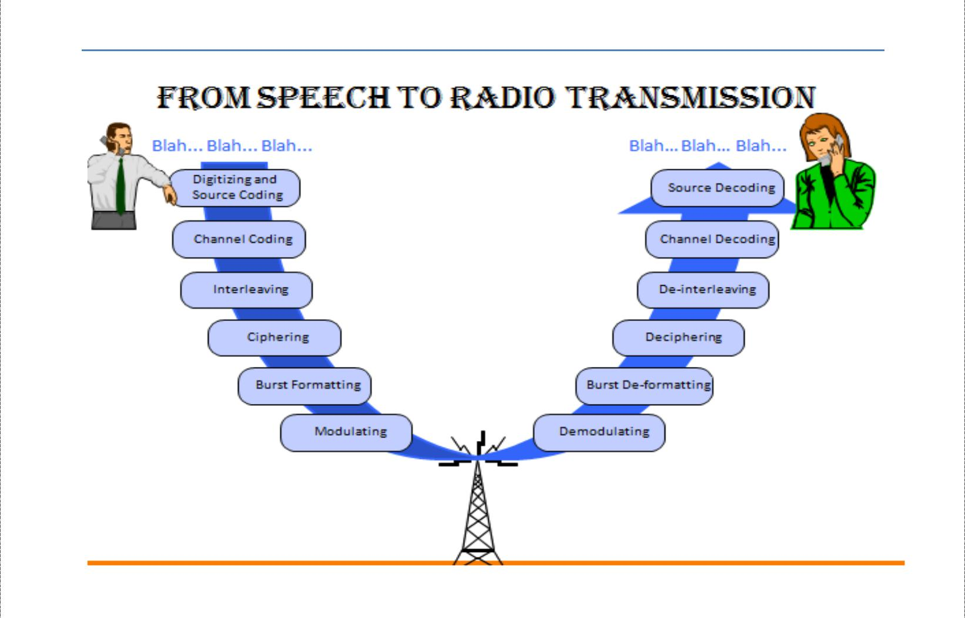

19

DCS Unit-6 Cellular Telephone Systems
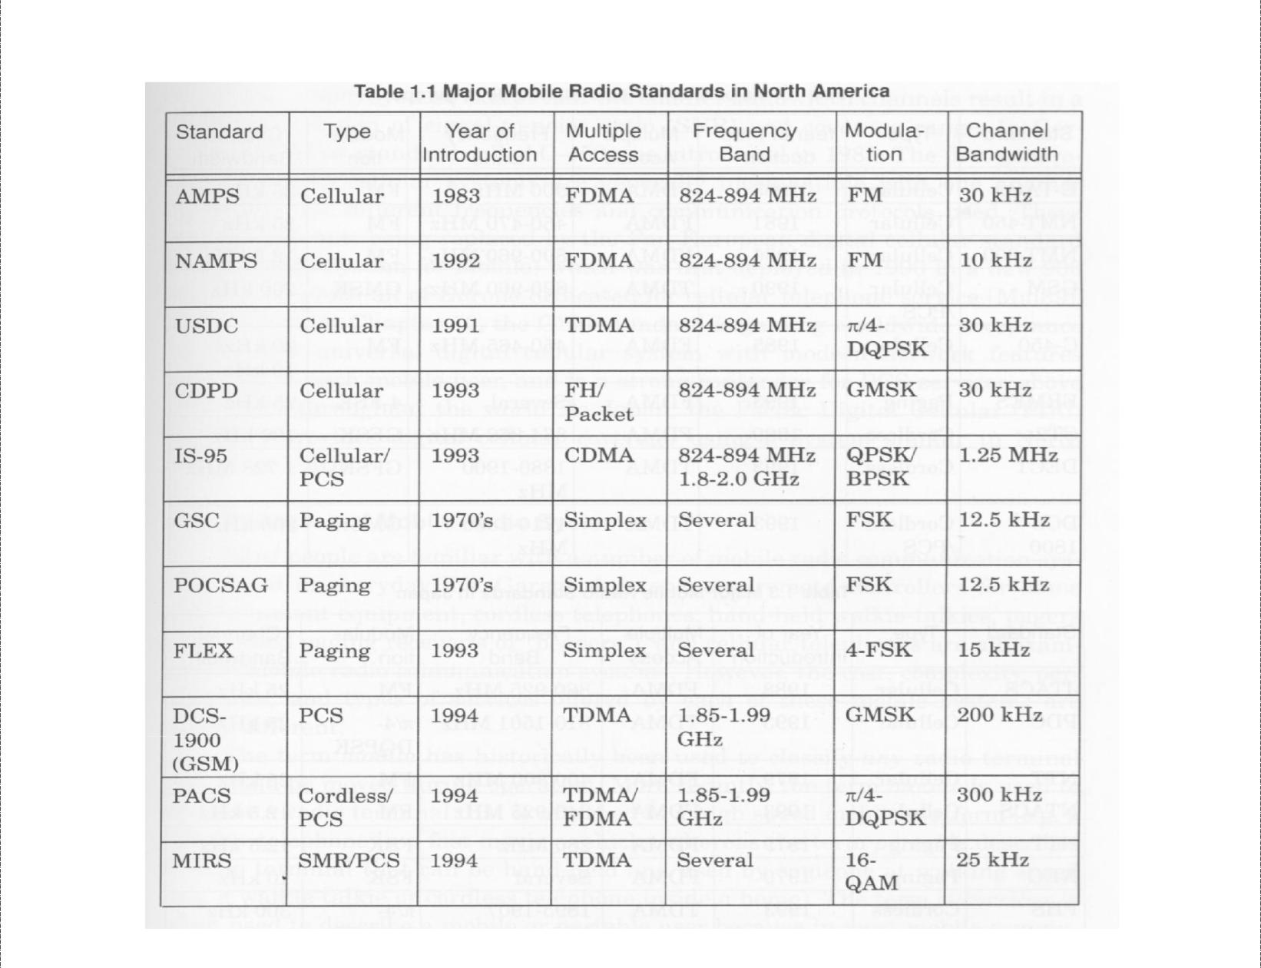

Multiple Accessing Schemes: HOW IT WORKS
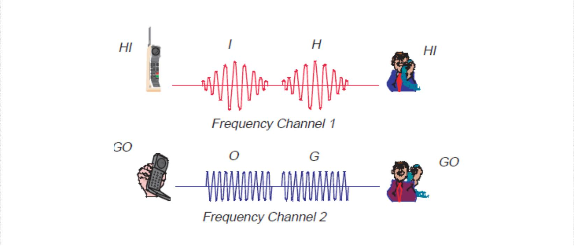

FDMA

20

DCS Unit-6 Cellular Telephone Systems
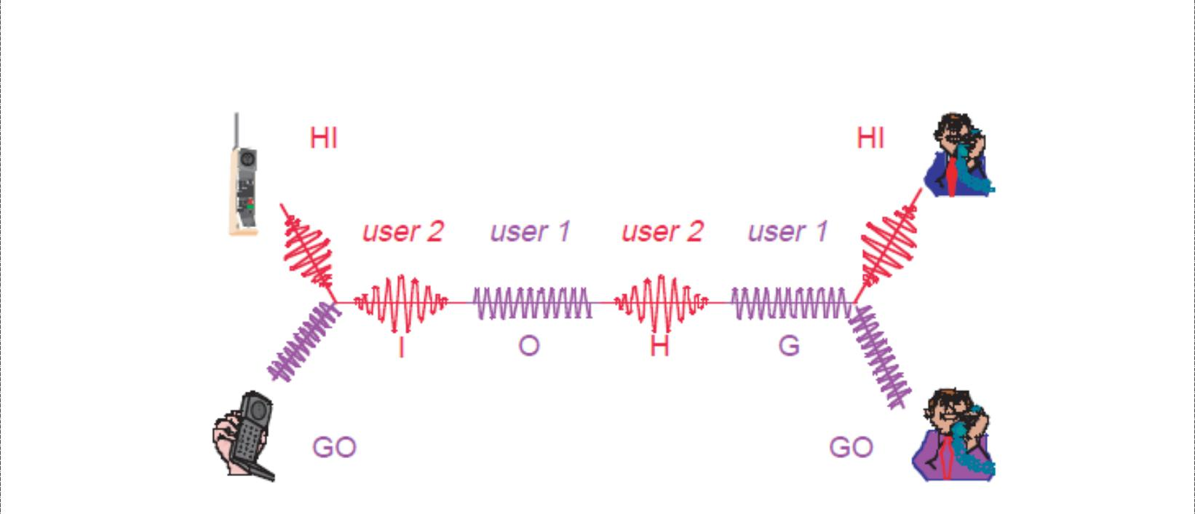

TDMA
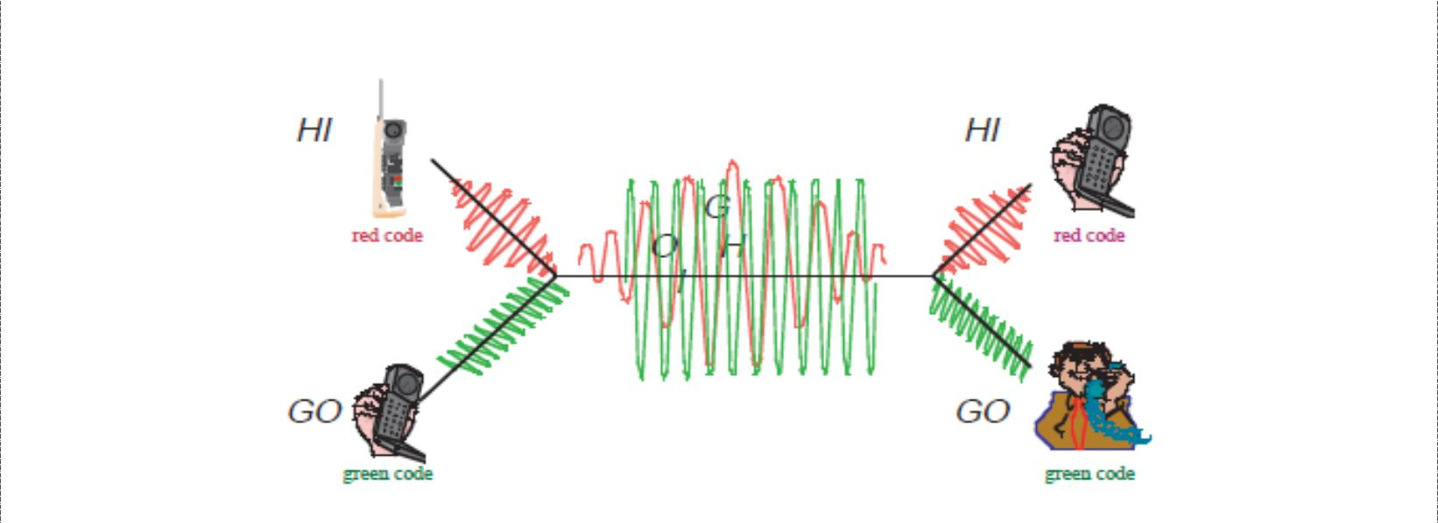

CDMA

21

DCS Unit-6 Cellular Telephone Systems

Assignment Questions

- (a) What is a digital Cellular System? List the advantages of a digital cellular system

  - Explain the classifications of CDMA radiated power. Determine the transmit power for a CDMA mobile unit that is receiving a signal from the base station at -100dB

- (a) What is GSM cellular telephone system? Describe the services offered by GSM

    - What is meant by false handoff? What are the four types of handoff’s possible with N-AMPS? Compare macro cellular system and digital cellular system

- (a) What is N-AMPS cellular telephone system? Explain the operation of N-AMPS cellular telephone system

    - List the basic parameters of GSM and briefly describe the GSM radio system?

- (a) What are the three primary subsystems of GSM? Describe in detail, the GSM system architecture

    - Explain with diagrams the CDMA traffic channels

- (a) Explain the TDMA scheme used with USDC and its advantages
  - what is an interference avoidance scheme

6.(a) Outline the advantages and disadvantages of PCSS over terrestrial cellular telephone systems?
(b) Briefly describe the E-TDMA scheme?

22

