Binary Parallel Adders

 | Subscript i |  | 4 3 2 1 |  |  |  |  |  | Full adder
 | Input carry |  | 0 |  | 1 1 0 |  | Ci |  | Z
 | Augend |  | 1 |  | 0 1 1 |  | Ai |  | X
 | Addend |  | 0 |  | 0 1 1 |  | Bi |  | Y
Sum |  |  | 1 |  | 1 1 0 |  | Si |  | S
Output carry |  |  | 0 |  | 0 1 1 |  | Ci + 1 |  | C

 |  | B4 | A4 |  |  | B3 | A3 |  |  |  | B2 | A2 |  |  |  | B1 | A1
 | C5 |  |  |  | C4 |  |  |  |  |  |  |  |  | C2 |  |  |  |  | C1
 | C5 | FA |  |  | C4 | FA |  |  | C3 |  | FA |  |  | C2 |  | FA
 |  |  |  |  |  | FA |  |  |  |  |  |  |  |  |  |  |  |  | 0

S4 S3 _{S2} S1

4-BIT FULL ADDER

- An n-bit parallel adder requires n full adders

- An IC of 4-bit FA has 14 terminals

- It is an MSI function

- The classical method would require a truth table with 512 entries (9 input variable) (too cumbersome)

 |  |  |  |  |  | Not used
 |  |  |  |  |  | C5 | S1
 |  |  |  |  | A1 |  | S1 |  |  |  | Excess-3
 |  |  |  |  | A2 |  |  |  |  |  | Excess-3
BCD |  |  |  |  | A2 |  | S2 |  |  |  | Excess-3
 |  |  |  |  |  |  |  |  |  |  | Output
 |  |  |  |  | A3 |  |  |  |  |  | Output
INPUT |  |  |  |  | A3 |  | S3
 |  |  |  |  | A4 |  | S4

1
B1

B2

0 | B3
0 | B4 | C1

BCD -to -Excess 3 Code

Converter

D’
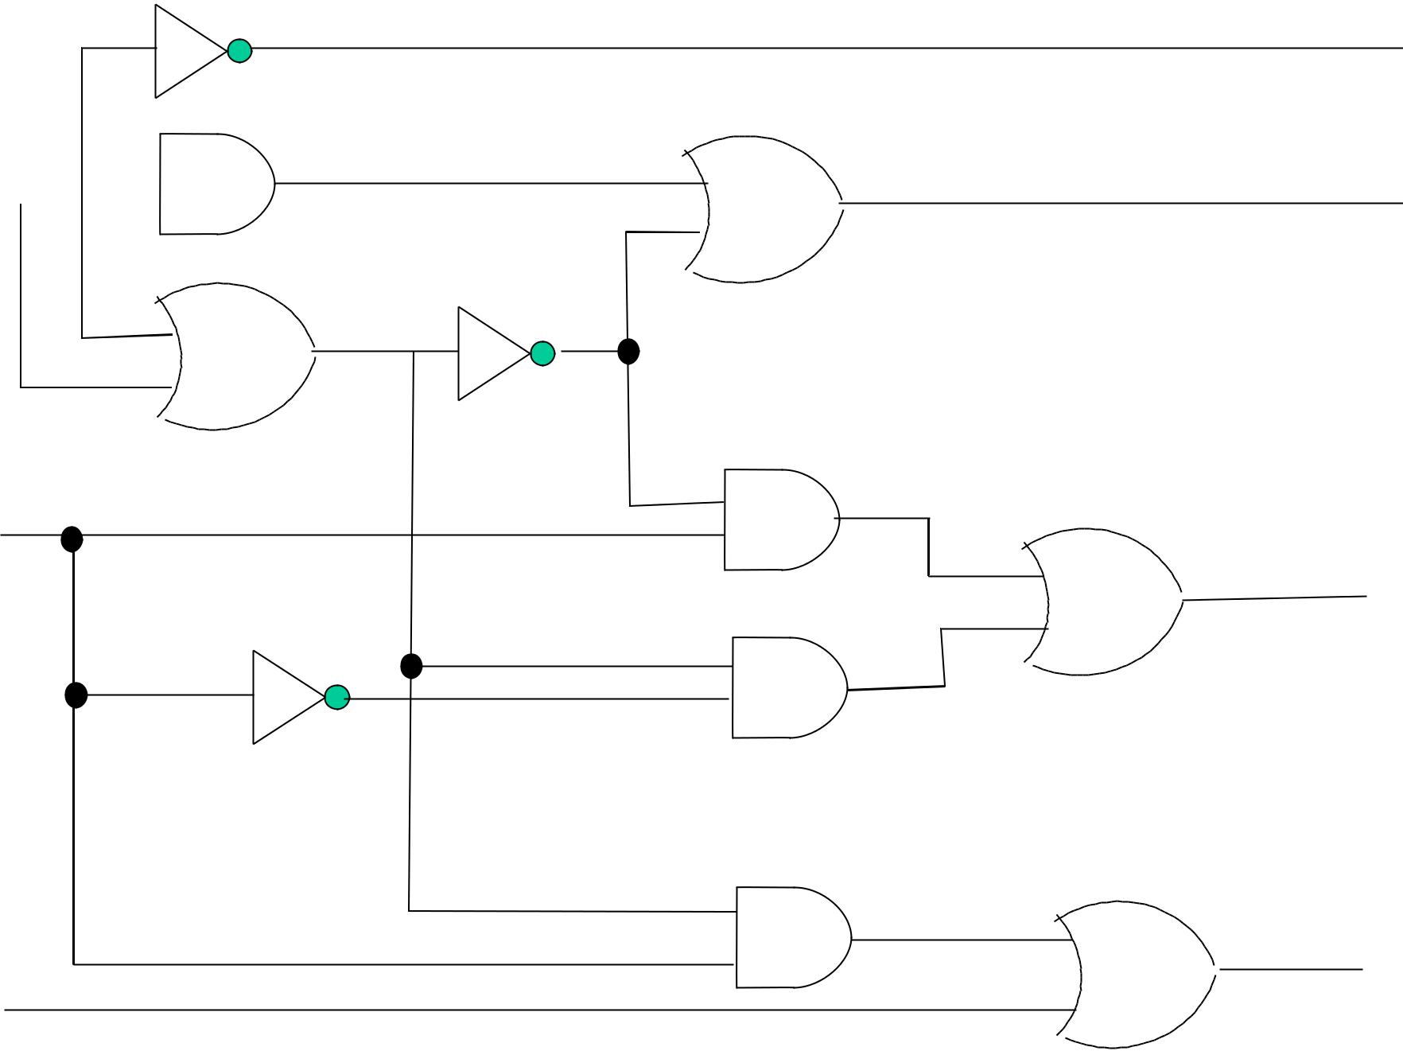

D  CD

C 

(C+D)’

C+D

B

A

Z

Y

X

W
Classical Method

- Truth table for four inputs

- K-maps for four outputs

- Algebraic manipulation of expressions

- Logic diagram using gates 4 x AND gates, 4 x OR gates & 3 x inverters

- Requires 3 IC packages & 14 wire connections (excluding 1/0 connections)

Alternate Design Methods

1 IC package , MS1 function , 5 wire connections (excluding 1/O connections)

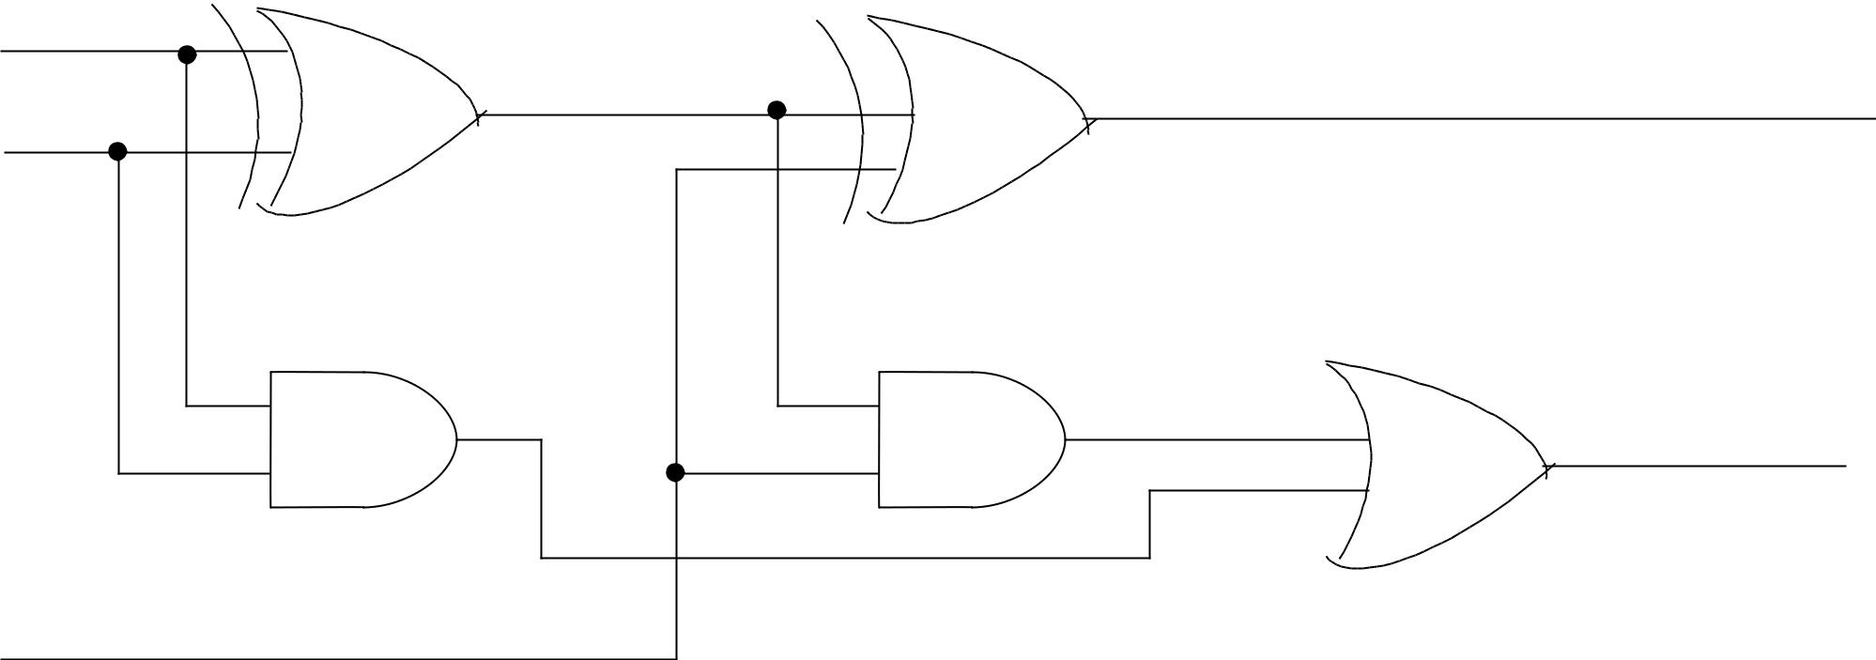

G_{i} | C_{i} + 1

C_{i}

Full Adder Circuit

Pi = Ai Å Bi |  | (Gi |  |  |  | carry generate )
Gi = Ai Bi |  | ( Pi |  |  |  | carry propagate from Ci to Ci + 1)
Si = Pi Å Ci
Ci + 1 = Gi + PiCi
C2 = G1 | + P1C1
C3 = G2 | + P2C2 = G2 + P2 (G1 + P1C1) = G2 +P2G1 + P2P1C1
C4 = G3 | + P3C3 = G3 + P3G2 + P3P2G1 + P3P2P1C1

P₃

G₃

P₂

G2

P₁

G₁
C₁

C₄
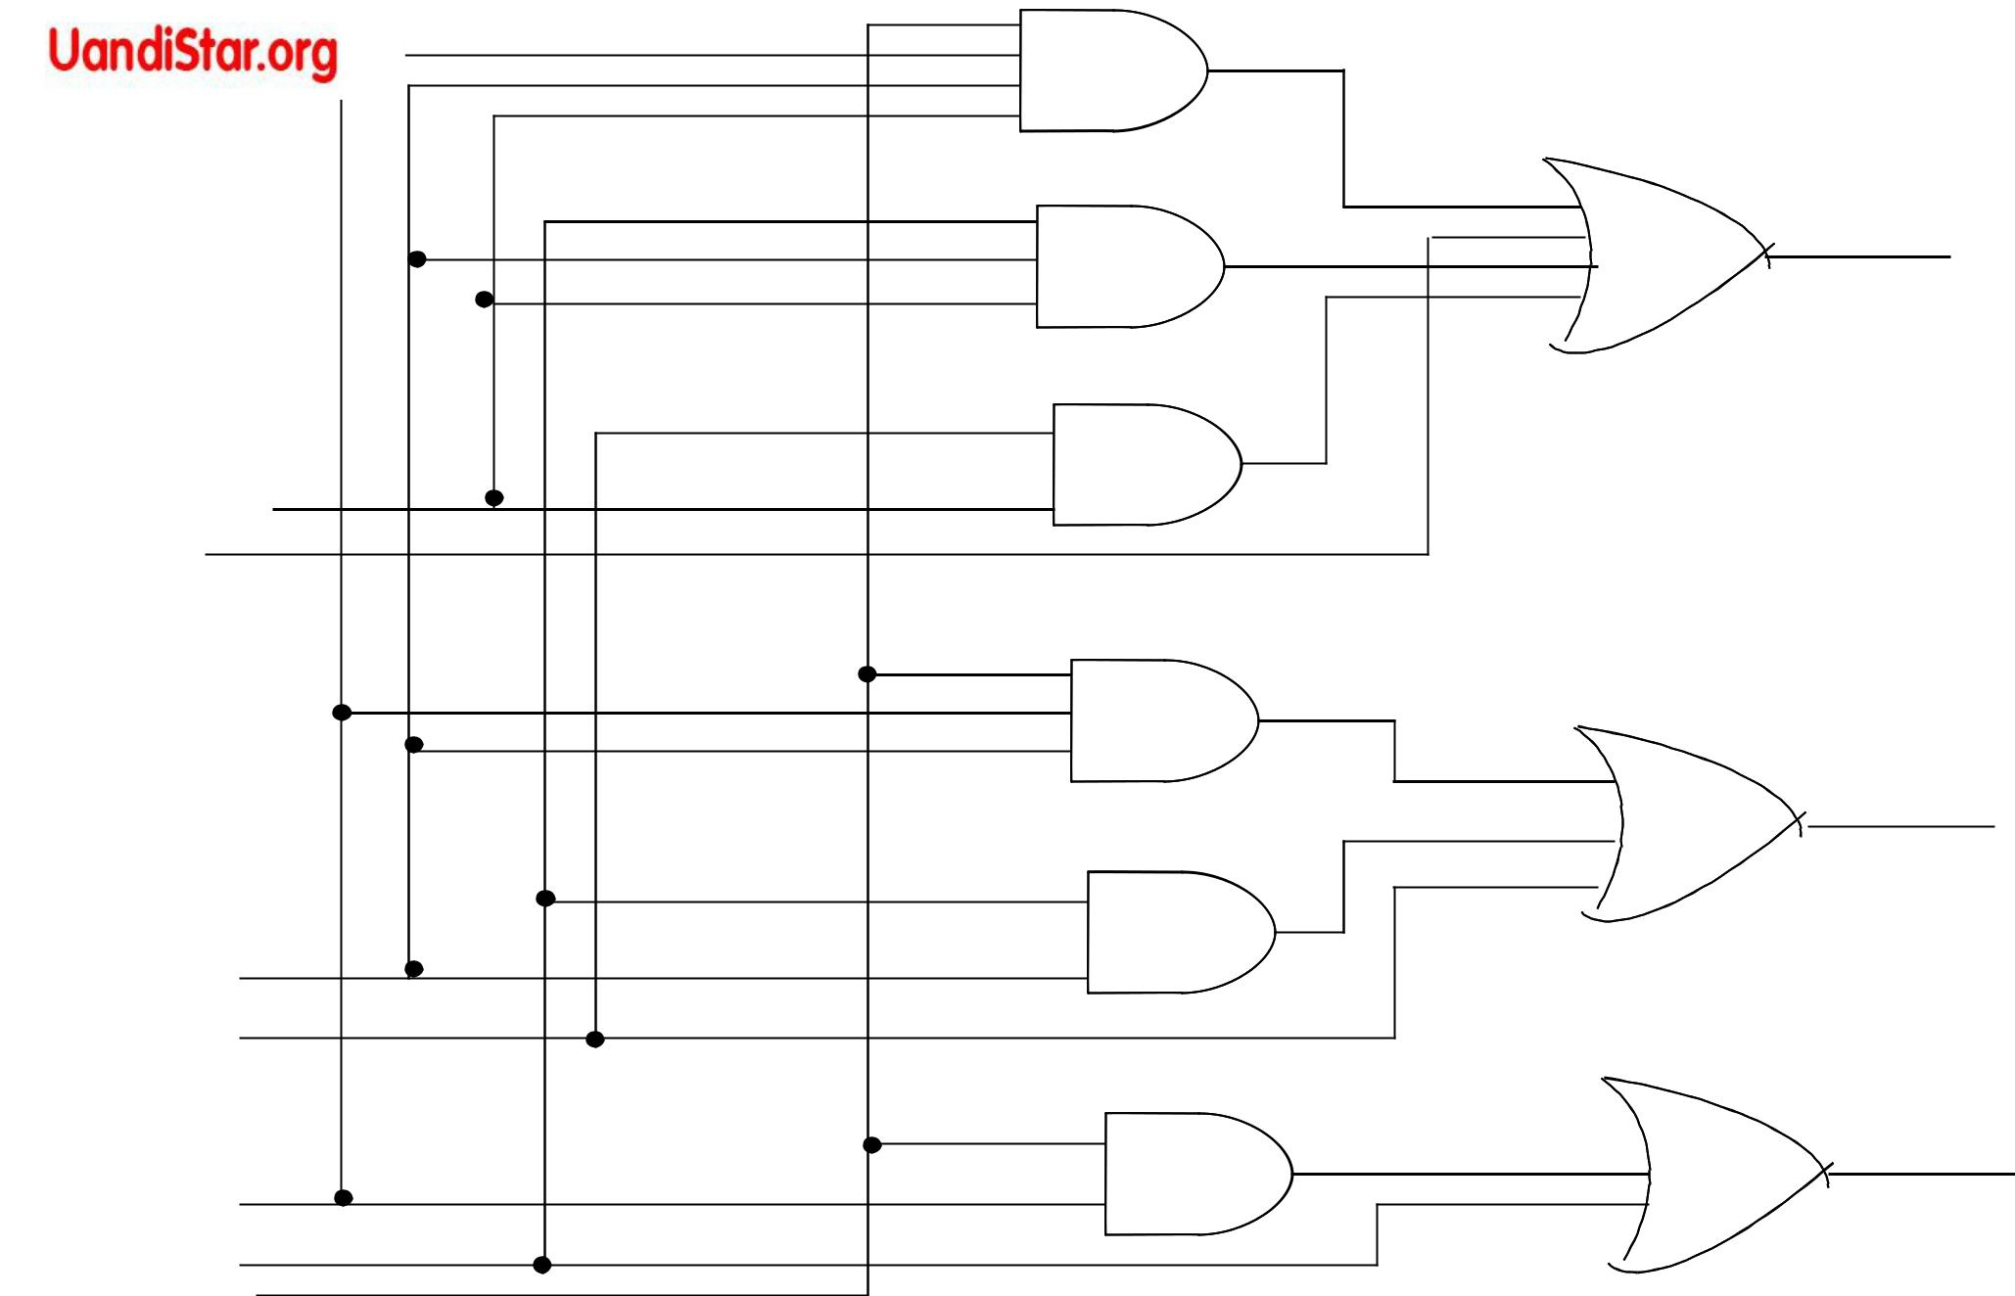

C₃

C₂

Logic diagram of a look - ahead carry generator
C2 = G1 + P1C1

C3 = G2 + P2G1 + P2P1C1

C4 = G3 + P3G2 + P3P2G1 + P3P2P1C1

B4

A4

B3

A3

B2

A2

B1

A1

C1

P4

G4

P3

G3

P2

G2

P1

G1

C1

Look - ahead Carry
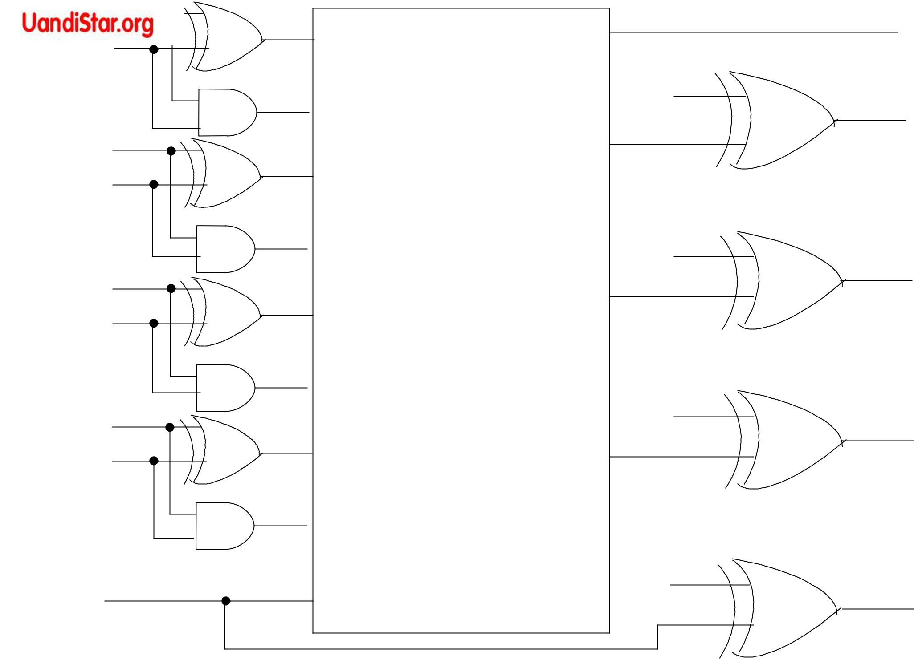
Generator

C5

P4

C4

P3

C3

P2

C2

P1

C5

S4

S3

S2

S1

4-Bits full adders with look - ahead carry

Derivation of a BCD adder

 | Input Binary Sum Output B C D Sum |  |  |  |  |  |  |  |  |  |  |  | Decimal
 | K | Z₈ | Z₄ | Z₂ | Z₁ |  |  |  |  |  |  |  | Decimal
 |  |  |  |  |  |  | C | S₈ | S₄ | S₂ | S₁ |  | Decimal
 | 0 | 0 | 0 | 0 | 0 | 0 |  | 0 | 0 | 0 | 0 |  | 0
 | 0 | 0 | 0 | 0 | 1 | 0 |  | 0 | 0 | 0 | 1 |  | 1
 | 0 | 0 | 0 | 1 | 0 | 0 |  | 0 | 0 | 1 | 0 |  | 2
 | 0 | 0 | 0 | 1 | 1 | 0 |  | 0 | 0 | 1 | 1 |  | 3
 | 0 | 0 | 1 | 0 | 0 | 0 |  | 0 | 1 | 0 | 0 |  | 4
 | 0 | 0 | 1 | 0 | 1 | 0 |  | 0 | 1 | 0 | 1 |  | 5
 | 0 | 0 | 1 | 1 | 0 | 0 |  | 0 | 1 | 1 | 0 |  | 6
 | 0 | 0 | 1 | 1 | 1 | 0 |  | 0 | 1 | 1 | 1 |  | 7
 | 0 | 1 | 0 | 0 | 0 | 0 |  | 1 | 0 | 0 | 0 |  | 8
 | 0 | 1 | 0 | 0 | 1 | 0 |  | 1 | 0 | 0 | 1 |  | 9

K | Z8 | Z4 | Z2 | Z1 | C | S8 | S4 | S2 | S1 | Decimal
0 | 1 | 0 | 1 | 0 | 1 | 0 | 0 | 0 | 0 | 10
0 | 1 | 0 | 1 | 1 | 1 | 0 | 0 | 0 | 1 | 11
0 | 1 | 1 | 0 | 0 | 1 | 0 | 0 | 1 | 0 | 12
0 | 1 | 1 | 0 | 1 | 1 | 0 | 0 | 1 | 1 | 13
0 | 1 | 1 | 1 | 0 | 1 | 0 | 1 | 0 | 0 | 14
0 | 1 | 1 | 1 | 1 | 1 | 0 | 1 | 0 | 1 | 15
1 | 0 | 0 | 0 | 0 | 1 | 0 | 1 | 1 | 0 | 16
1 | 0 | 0 | 0 | 1 | 1 | 0 | 1 | 1 | 1 | 17
1 | 0 | 0 | 1 | 0 | 1 | 1 | 0 | 0 | 0 | 18
1 | 0 | 0 | 1 | 1 | 1 | 1 | 0 | 0 | 1 | 19

C = K + Z8 Z4 + Z8 Z2

Addend Augend

carry out |  | 4-bit binary adder |  |  |  |  | carry in
 |  | K
 |  | Z8 | Z4 | Z2 | Z1
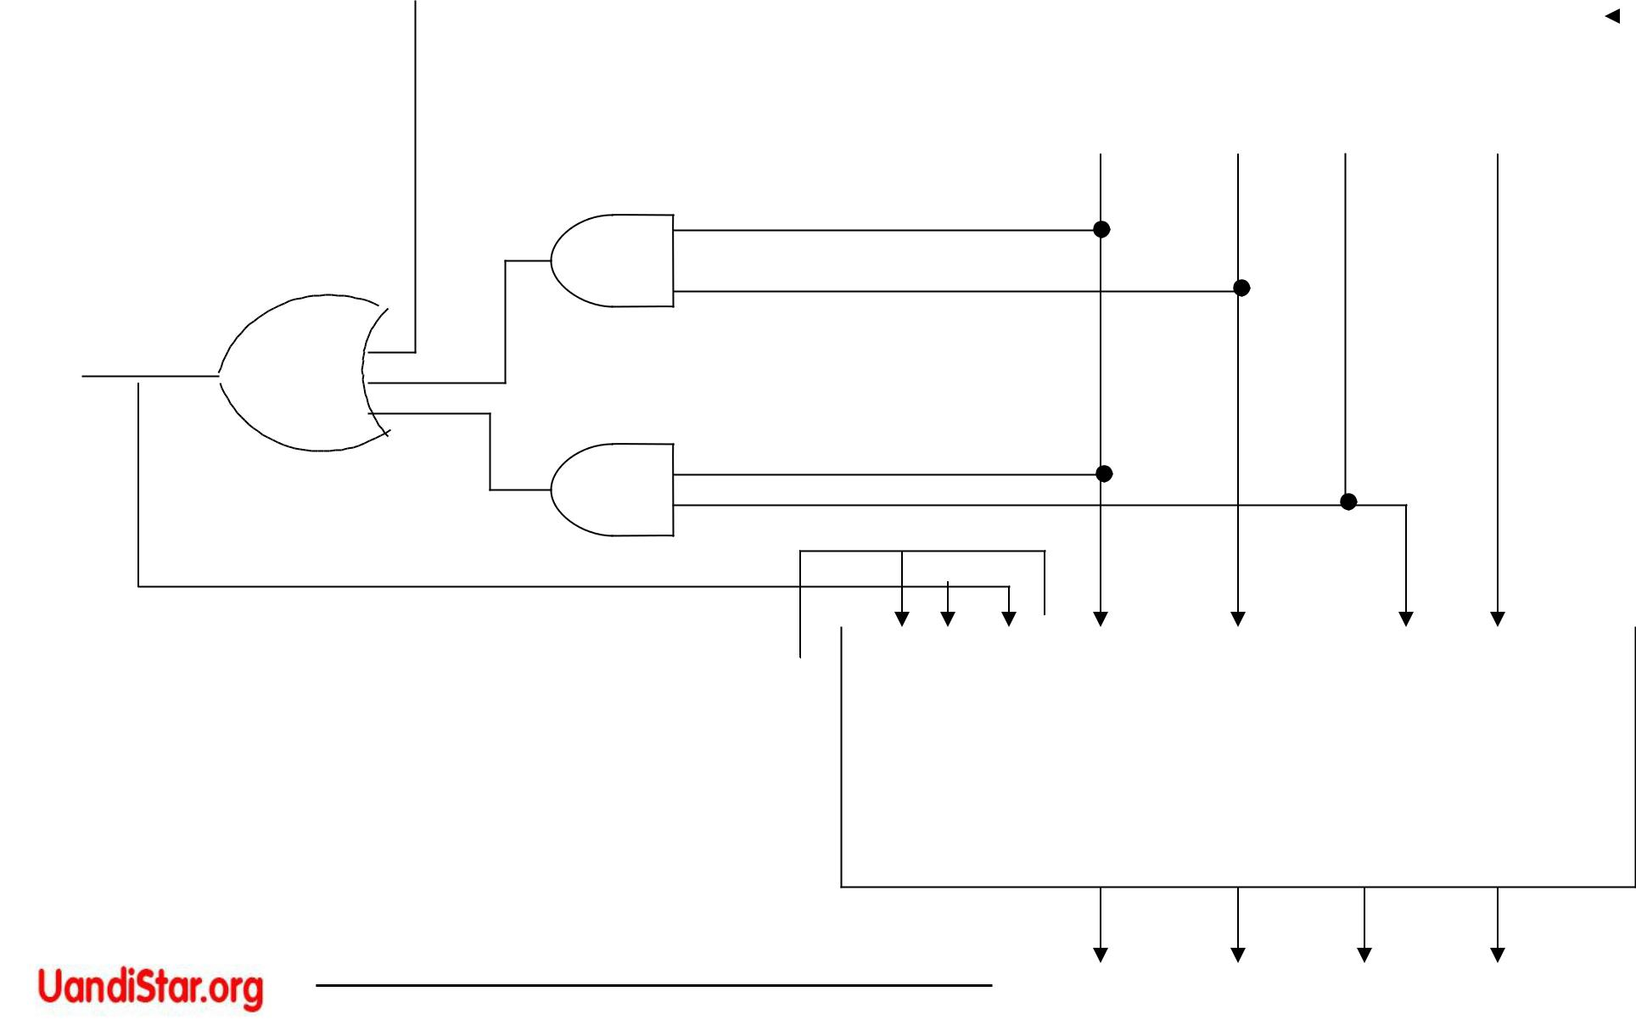

Output

Carry

0
0 |  |  | 0 1 10

4-bit binary adder

BLOCK DIAGRAM OF A BCD ADDER _{S8} _{S4} _{S2} _{S1}
MAGNITUDE COMPARATOR

A = A3 A2 A1 A0

B = B3 B2 B1 B0

Xi = Ai Bi | + Ai’ Bi’ | ( i = 0, 1, 2, 3 )
(A = B) = | x3x2x1x0

(A > B) = A3 B’3 + x3 A2 B’2 + x3 x2 A1B’1+ x3x2x1A0B’0

(A < B) = A’3 B3 + x3 A’2 B2 + x3 x2 A’1B1+x3x2x1A’0B0

A₃

B₃

A₂

B₂

A₁

B₁

x₃
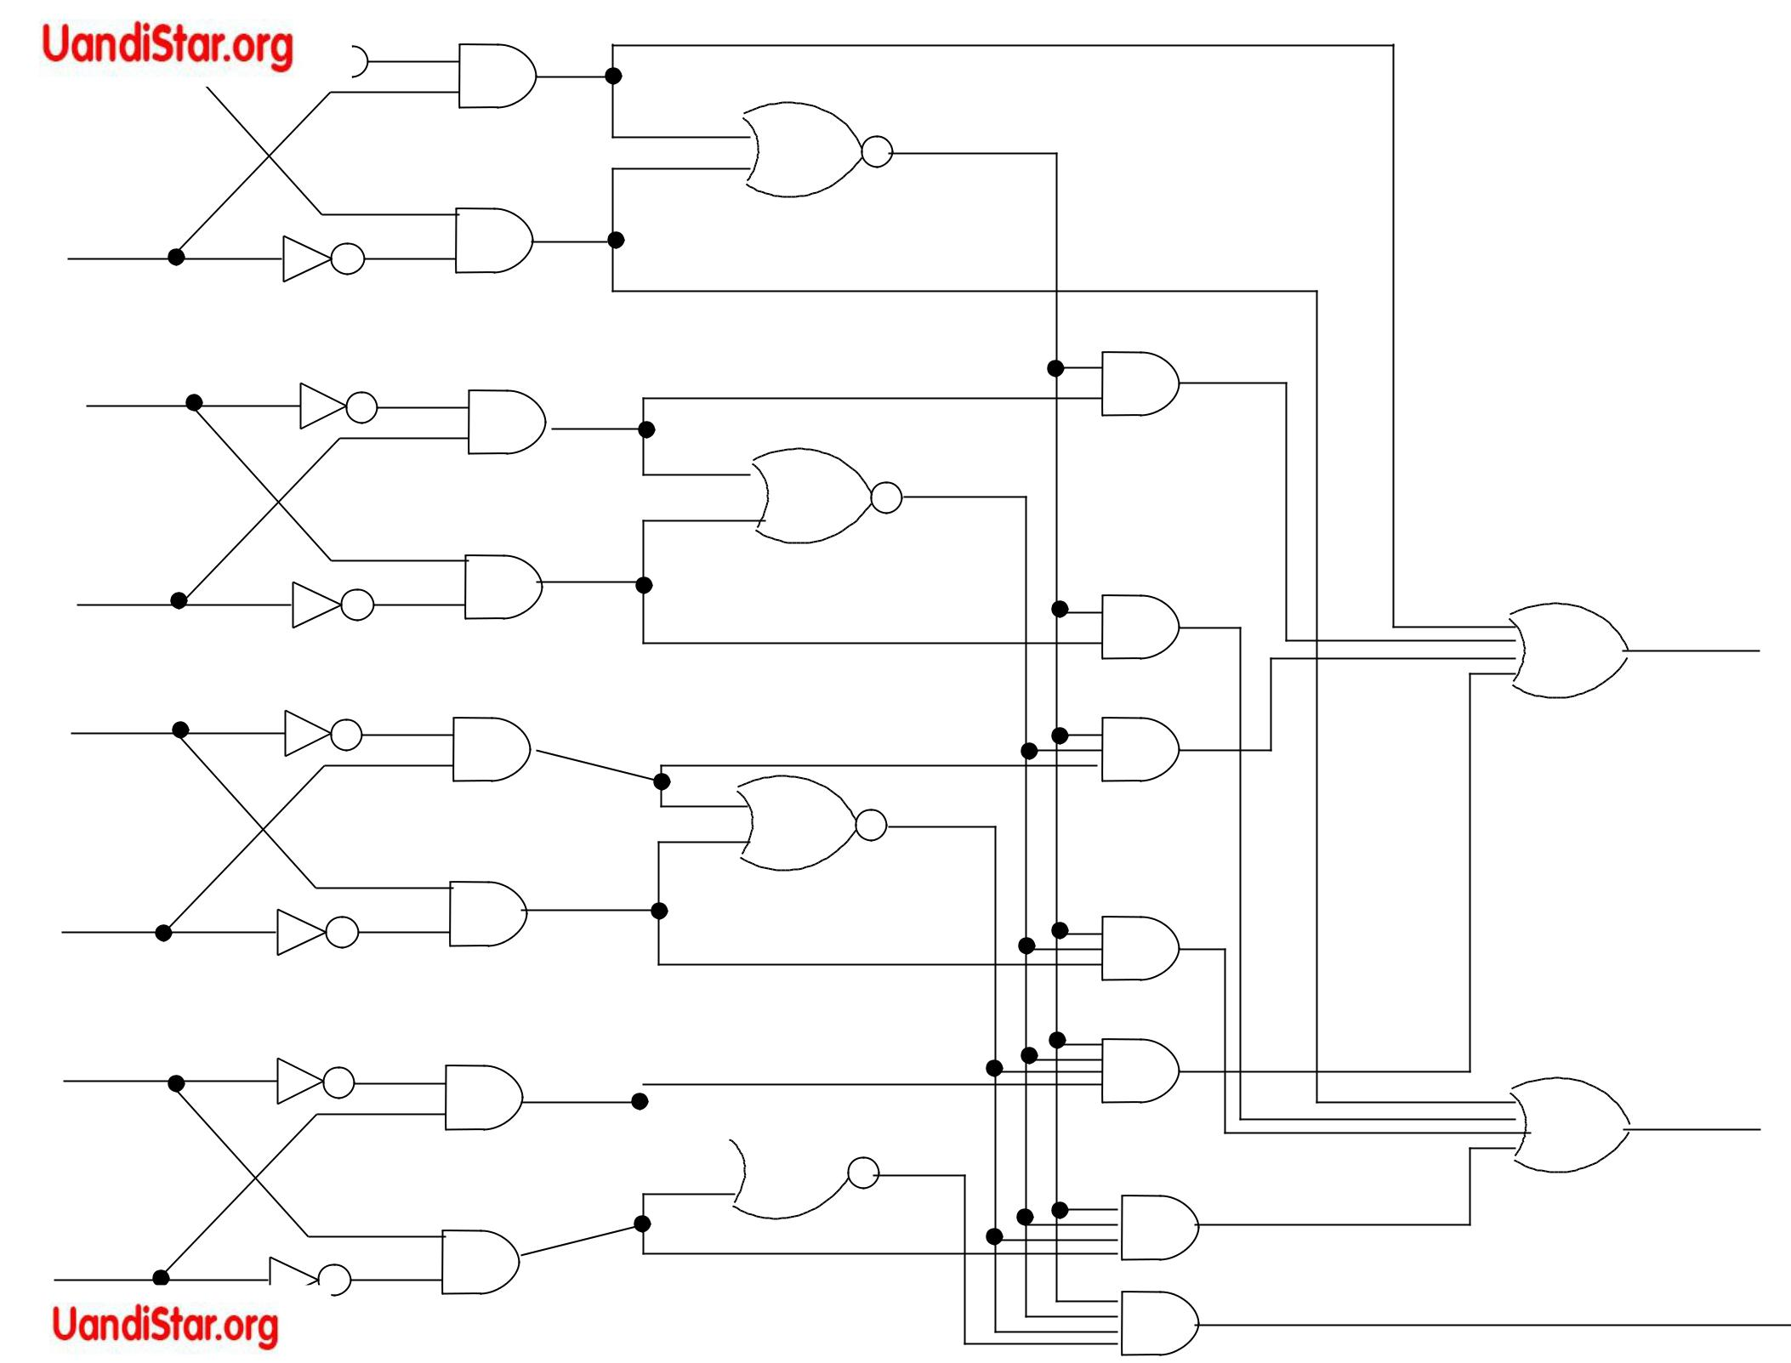

x₂

(A < B)

x₁

A₀

 x₀

(A > B)

B₀

(A = B)

4 bit magnitude comparator

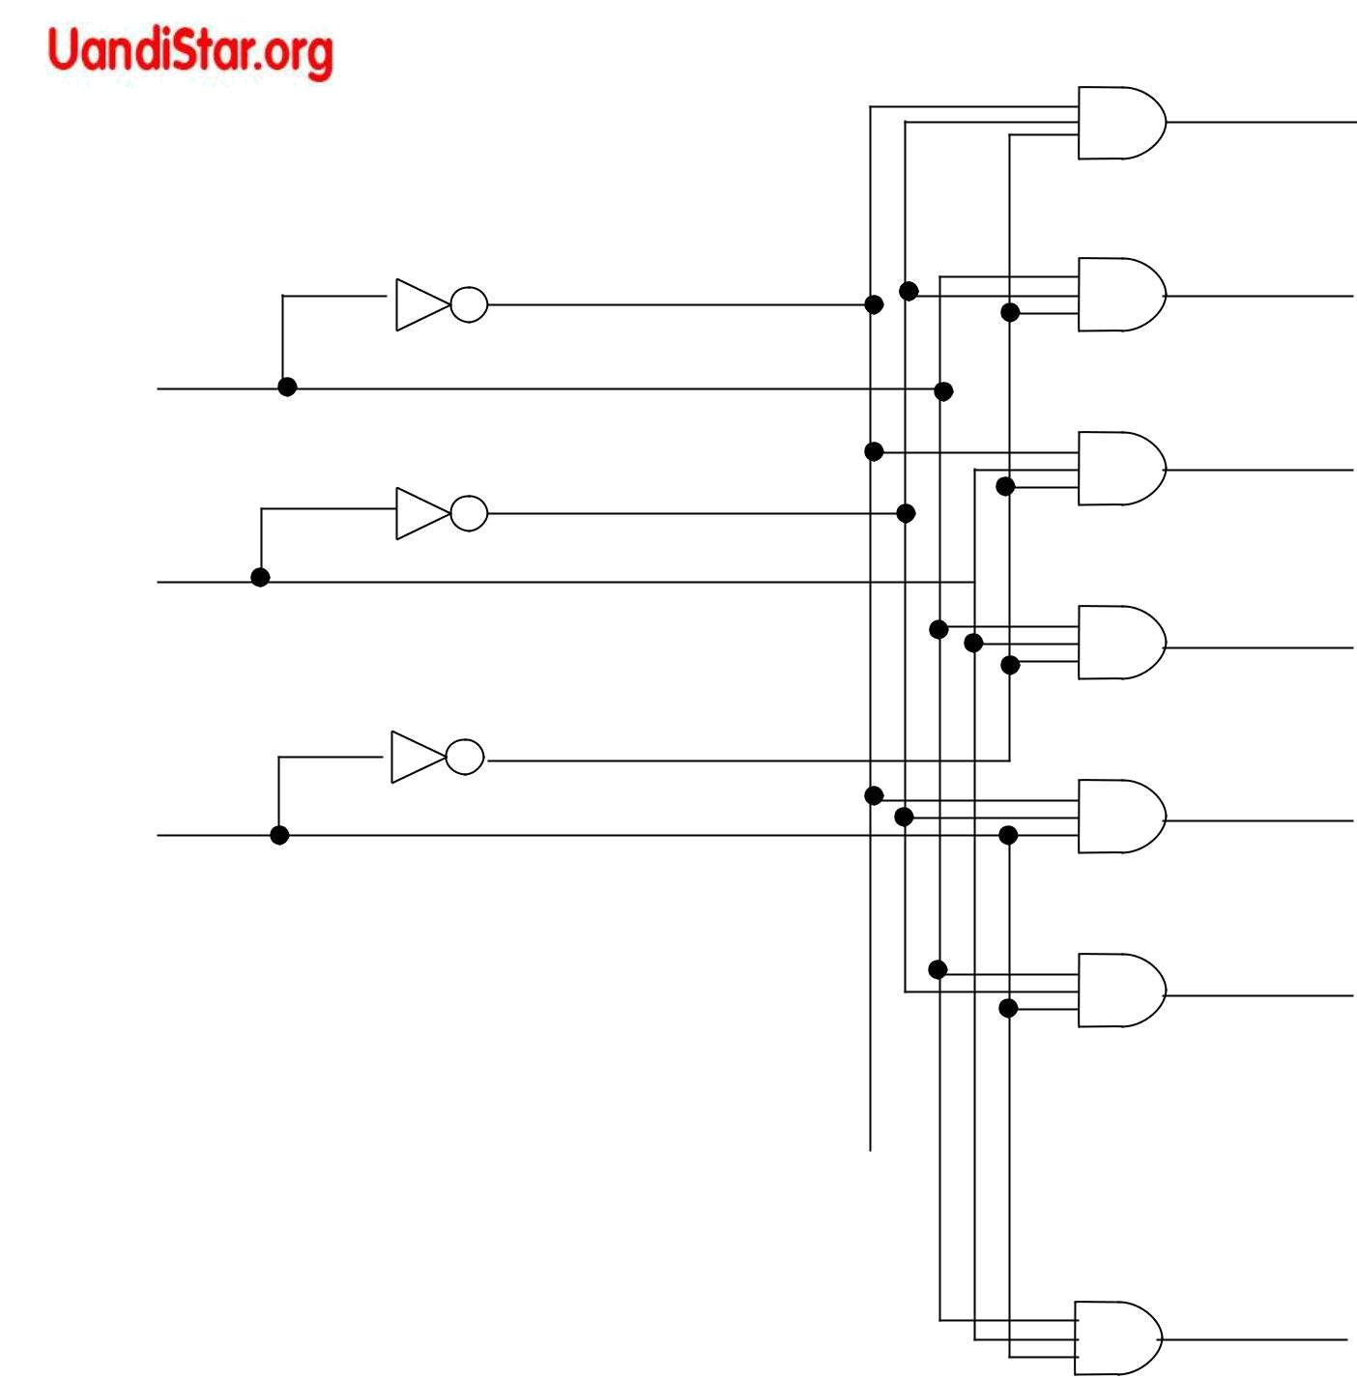

z

y

x

Input lines = n

Output lines = 2n (Maximum)

n – to – m decoder

M ≤ 2n

D0

D1

D2

D3

D4

D5

D6

D7
x’ y’ z’

x’ y’ z

x’ y z’

x’ y z

- y’ z’

- y’ z

- y z’

- y z

A 3 – to – 8 line decoder (Binary – to – Octal application)



Truth table of a 3 – to – 8 line decoder

 | Inputs |  |  |  | Outputs
x y z |  |  | D₀ | D₁ | D₂ | D₃ | D₄ | D₅ | D₆ | D₇
0 | 0 | 0 | 1 | 0 | 0 | 0 | 0 | 0 | 0 | 0
0 | 0 | 1 | 0 | 1 | 0 | 0 | 0 | 0 | 0 | 0
0 | 1 | 0 | 0 | 0 | 1 | 0 | 0 | 0 | 0 | 0
0 | 1 | 1 | 0 | 0 | 0 | 1 | 0 | 0 | 0 | 0
1 | 0 | 0 | 0 | 0 | 0 | 0 | 1 | 0 | 0 | 0
1 | 0 | 1 | 0 | 0 | 0 | 0 | 0 | 1 | 0 | 0
1 | 1 | 0 | 0 | 0 | 0 | 0 | 0 | 0 | 1 | 0
1 | 1 | 1 | 0 | 0 | 0 | 0 | 0 | 0 | 0 | 1
Design a BCD – to – Decimal Decoder

 |  |  |  | y |  |  | D0 | = w’ x’ y’ z’
 | ^{yz}00 01 11 10 |  |  |  |  |  | D0 | = w’ x’ y’ z’
wx |  |  |  |  |  |  | D1 = w’ x’ y’ z
wx |  |  |  |  |  |  | D2 | = x’ y z’
wx |  | D | D | D | D |  | D2 | = x’ y z’
00 |  |  |  |  |  |  | D2 | = x’ y z’
00 |  |  |  |  |  |  | D3 | = x’ y z
 |  | 0 | 1 | 3 | 2 |  | D3 | = x’ y z
01 |  | D₄ | D₅ | D₇ | D₆ | x | D4 | = x y’ z’
01 |  |  |  |  |  |  | D5 | = x y’ z
11 |  | X | X | X | X |  | D6 | = x y z’
11 |  |  |  |  |  |  | D7 = x y z
w
w |  | D₈ | D₉
10 |  | D₈ | D₉ | X | X |  | D8 = w z’
 |  |  |  |  |  |  | D9 | = w z


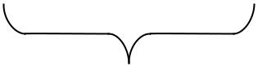
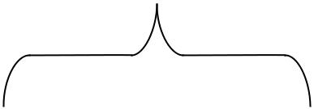

z
Map for simplifying a BCD – to – decimal decoder

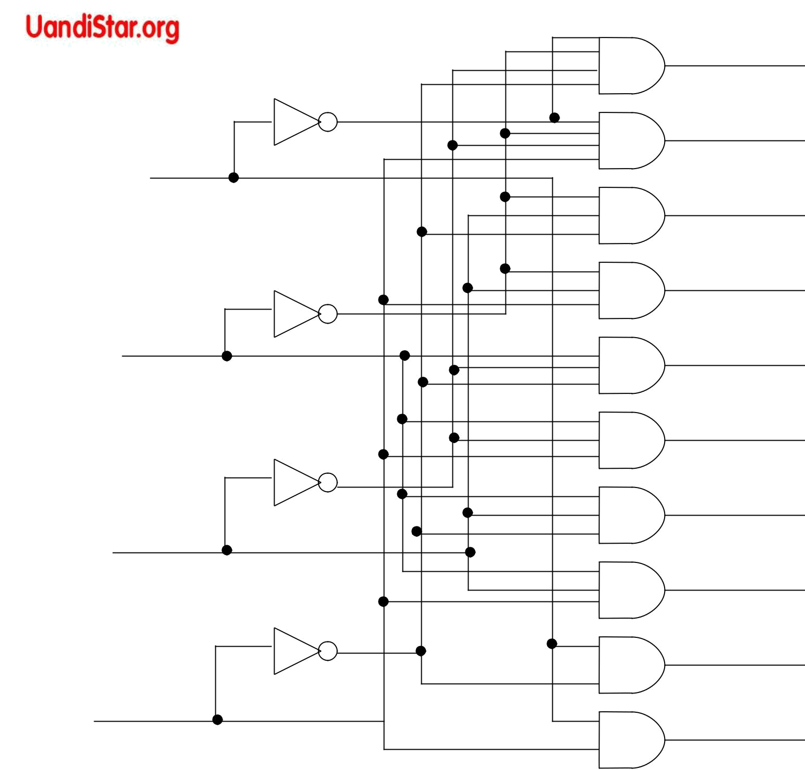

w
D₀ = w’ x’ y’ z’

D₁ = w’ x’ y’ z

D₂ = x’ y z’

D₃ = x’ y z

x | D₄ = x y’ z’

D₅ = x y’ z

D₆ = x y z’

y

z

D₇ = x y z

D₈ = w z’

D₉ = w z

BCD – TO – DECIMAL DECODER ( 4 – LINE TO 10 – LINE)

PARTIAL TRUTH TABLE

 | Inputs |  |  |  |  |  | Outputs
w | x y z |  |  | D₀ | D₁ | D₂ | D₃ | D₄ | D₅ | D₆ | D₇ | D₈ | D₉
1 | 0 | 1 | 0 | 0 | 0 | 1 | 0 | 0 | 0 | 0 | 0 | 1 | 0
1 | 0 | 1 | 1 | 0 | 0 | 0 | 1 | 0 | 0 | 0 | 0 | 0 | 1
1 | 1 | 0 | 0 | 0 | 0 | 0 | 0 | 1 | 0 | 0 | 0 | 1 | 0
1 | 1 | 0 | 1 | 0 | 0 | 0 | 0 | 0 | 1 | 0 | 0 | 0 | 1
1 | 1 | 1 | 0 | 0 | 0 | 0 | 0 | 0 | 0 | 1 | 0 | 1 | 0
1 | 1 | 1 | 1 | 0 | 0 | 0 | 0 | 0 | 0 | 0 | 1 | 0 | 1

x

y

z

2²

21 | 3 x 8
21 | decoder

20

0
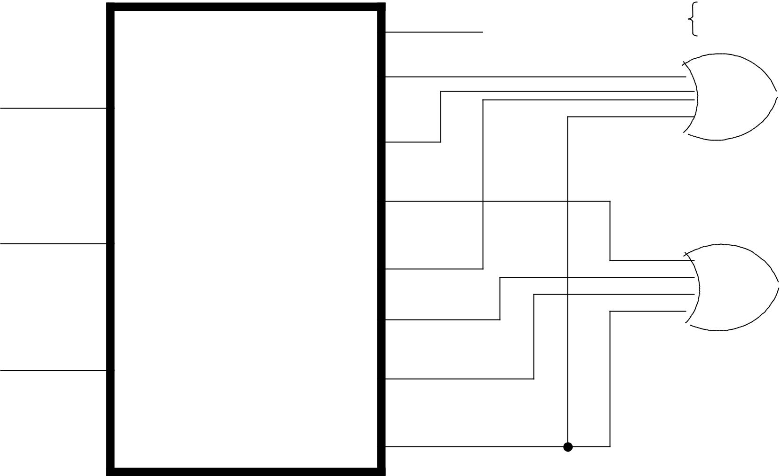

1

2

3

4

5

6

7

S (x, y, z) = | (1, 2, 4, 7)
c (x, y, z) = | (3, 5, 6, 7)

s

c

Implementation of a full adder with a decoder and two OR gates

DEMULTIPLEXERS

- A decoder with an enable input can function as a demultiplexer. It receives information on a single line and transmits this information on one of 2n possible output lines.

- A 2 – to – 4 line decoder with E input is shown

- When E = 0, the circuit operates as a decoder with comlemented outputs.
- The decoder can function as a demultiplexer if E line is taken as a data input line and A & B lines are taken as the selection line.

- 2 decoders (3x8) can be connected to form a larger decoder circuit (4x16)

when:

- = 0, top decoder is inabled (0000 – 0111)

W = 1, bottom decoder is enabled (1000 – 1111)

- Digital function can be easily expanded to accommodate more inputs and outputs by using e lines
Demultiplexer _{(A’ B’ )’ = A + B}
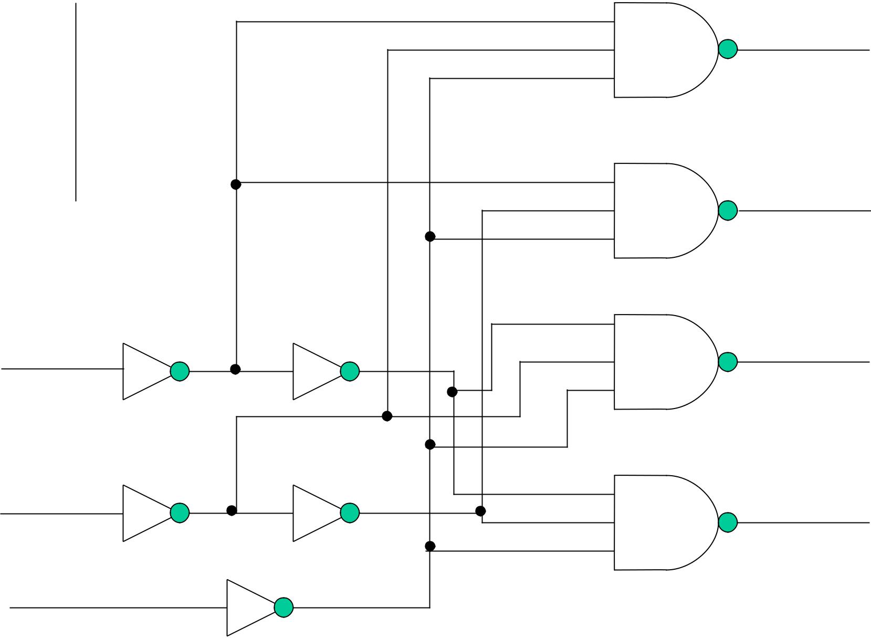

- B

0 0

- 1

- 0

- 1

A

B

E

D₀

(A’ B )’ = A + B’

D₁

(A B’ )’ = A’ + B

D₂

(A B )’ = A’ + B’

D₃

(a) LOGIC DIAGRAM WITH NAND GATES

E | A | B | D0 | D1 | D2 | D3
1 | X | X | 1 | 1 | 1 | 1
0 | 0 | 0 | 0 | 1 | 1 | 1
0 | 0 | 1 | 1 | 0 | 1 | 1
0 | 1 | 0 | 1 | 1 | 0 | 1
0 | 1 | 1 | 1 | 1 | 1 | 0

TRUTH TABLE

A 2 – TO – 4 LINE DECODER WITH ENABLE E INPUT
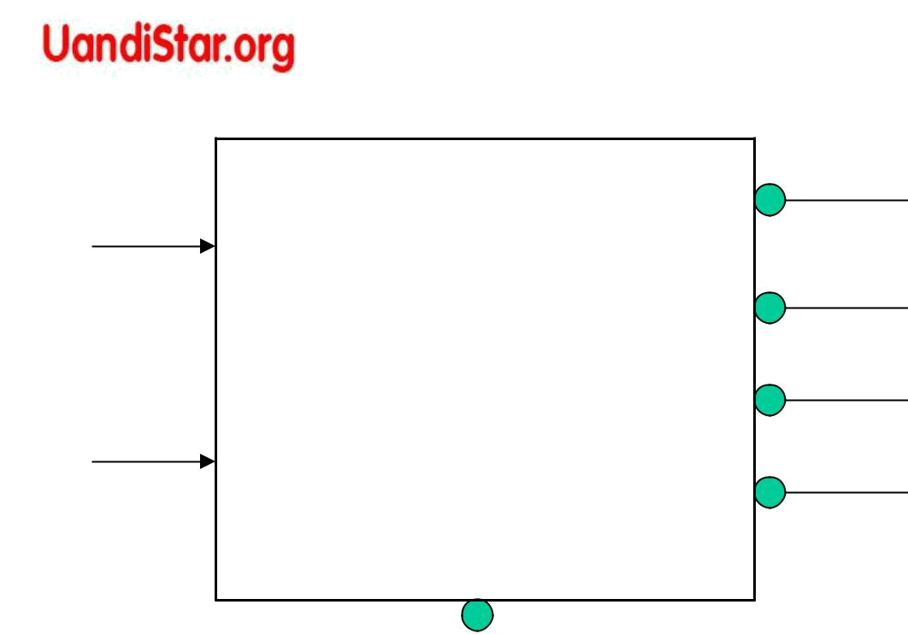
A |  | D₀
A | 2 X 4 | D₁
Inputs | 2 X 4 | D₁
Inputs | Decoder | D₂
B | Decoder | D₂
B |  | D₃

E |  | Input E
Enable

- Decoder with enable can function as demultiplexer

 |  | D₀
1 X 4 |  | D₁
Demultiplexer |  | D₂
 |  | D₃
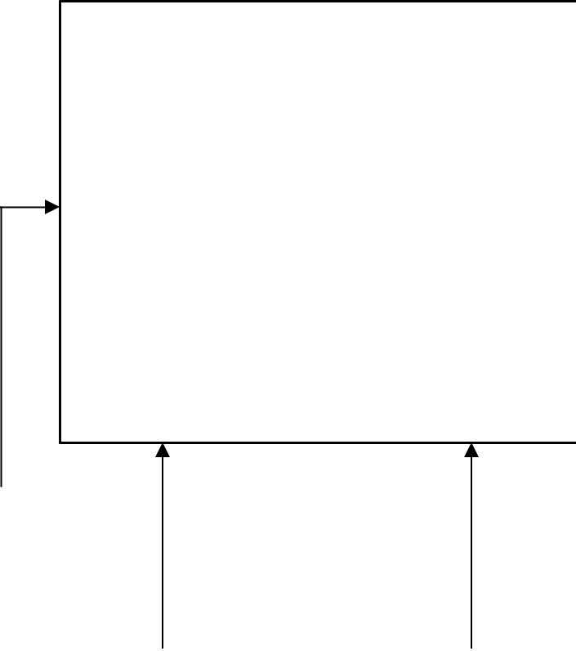

- Select B

(b) Demultiplexer
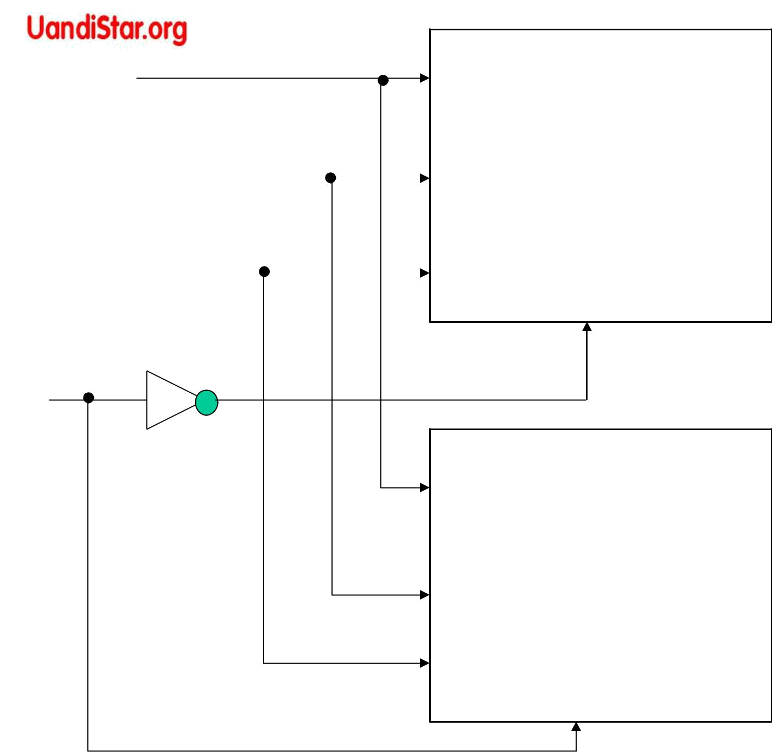
X

y |  | 3 X 8 |  | D0 to D7
y |  | Decoder |  | D0 to D7
y |  | Decoder | 0000 to 0111
z |  | E

W

3 X 8 | D8 to D15
Decoder
Decoder | 1000 to 1111
E

A 4x16 Decoder Constructed with two 3x8 Decoders
ENCODERS

• An encoder produces a reverse operation of a decoder

Input lines | ≤ | 2n
Output lines | = | n

- An octal-to-binary encoder circuit has 8 inputs and 3 outputs.

- Only one input line can be equal to one at any time.

Possible input combinations | = 28 = 256
Meaningful combinations | = | 8
Don’t care conditions | = | 248
- Priority encoder establishes an input priority to ensure that the highest priority input line is encoded.

 | D2
If inputÞ | Þ 1
 | D5



Output

Þ

line D5 is encoded because of higher–priority

- When D₀ is not connected to any OR gate, then binary output is 000.

D0

D1

D2

D3

D4

D5

D6

D7

x = D₄+ D₅ + D₆ + D₇
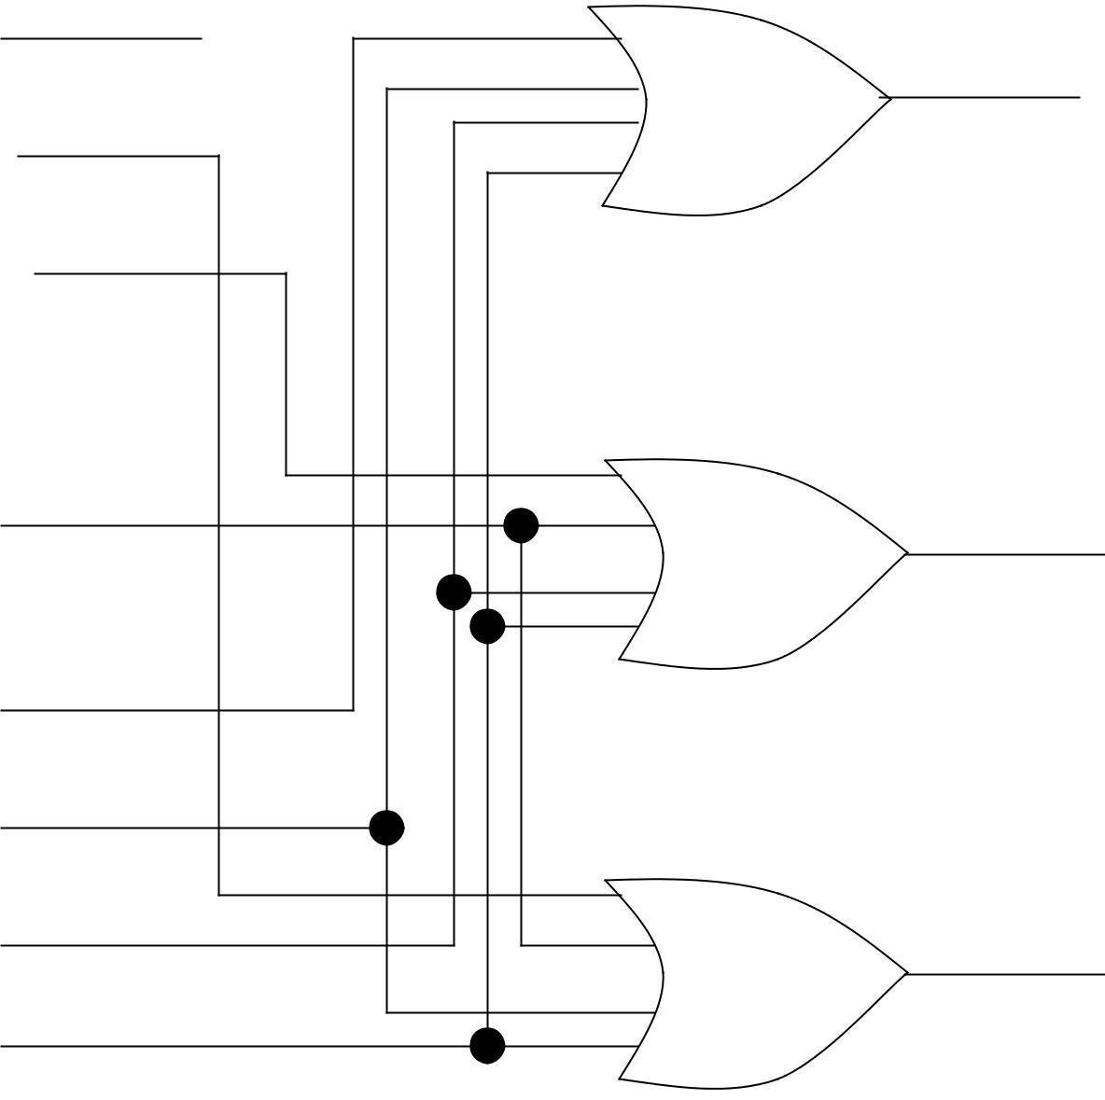

y = D₂+ D₃ + D₆ + D₇

z = D₁+ D₃ + D₅ + D₇

Octal to binary encoder
TRUTH TABLE

 |  |  | INPUTS |  |  | (Octal) |  |  |  | OUTPUTS (binary)
 | ^{D}0 ^{D}1 ^{D}2 ^{D}3 ^{D}4 ^{D}5 ^{D}6 ^{D}7 |  |  |  |  |  |  |  |  | x | y | z
 | 0 1 | 0 | 0 | 0 | 0 |  | 0 | 0 | 0 | 0 | 0 | 0
 | 1 0 | 1 | 0 | 0 | 0 |  | 0 | 0 | 0 | 0 | 0 | 1
 | 2 0 | 0 | 1 | 0 | 0 |  | 0 | 0 | 0 | 0 | 1 | 0
 | 3 0 | 0 | 0 | 1 | 0 |  | 0 | 0 | 0 | 0 | 1 | 1
 | 4 0 | 0 | 0 | 0 | 1 |  | 0 | 0 | 0 | 1 | 0 | 0
 | 5 0 | 0 | 0 | 0 | 0 |  | 1 | 0 | 0 | 1 | 0 | 1
 | 6 0 | 0 | 0 | 0 | 0 |  | 0 | 1 | 0 | 1 | 1 | 0
 | 7 0 | 0 | 0 | 0 | 0 |  | 0 | 0 | 1 | 1 | 1 | 1
Multiplexers

- A digital multiplexer is a combinational circuit that selects binary information from one of many input lines and directs it to a single output line.

input lines = 2n output lines = 1
selection lines = n

- An example of 4-line-to-1-line shows that:

input lines = 2² = 4 (I_{0,} I_{1,} I_{2 &} I₃)

output lines = 1 (Y)

selection lines = 2 (s₀ & s₁)

- A multiplexer is also called a data selector since it selects one of many inputs and steers the binary information to the output line.

- Multiplexer ICs can have an enable input to control the operation of the unit. When E is in disable state, outputs = 0. When E is in enable state, the circuit functions as a normal MUX.

- The E strobe can used to expand two or more ICs (MUXs) to provide a larger number of inputs.
I₀ |  |  |  |  | (a) Logic Diagram
I₁
I₂ |  |  |  |  |  | Y
I₃
 |  |  | A 4-to-1 Line Multiplexer
 | S1 | S₀ | Y |  | inputs
S₁ | 0 | 0 | I₀ |  | 0 | 4 x 1 |  | output
 |  |  |  |  | 1 | 4 x 1 | Y | output
S₀
S₀ | 0 | 1 | I | 1 | 2 | MUX | Y
 | 1 | 0 | I₂ |  | 3 | S₁ S0
 | 1 | 1 | I₃
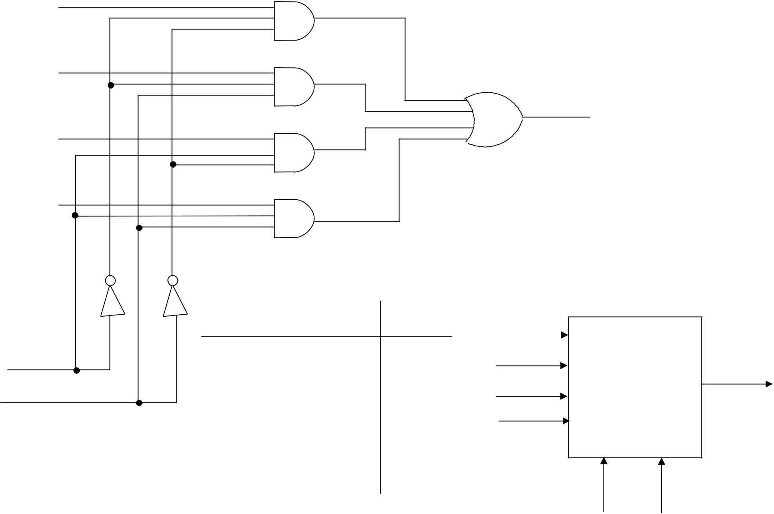

(c) Function Table

Select

(b) Block Diagram

A₁

A₂

A₃

A₄

B₁

B₂

B₃

B₄

S
(Select)

^{E} (Enable)

Y₁
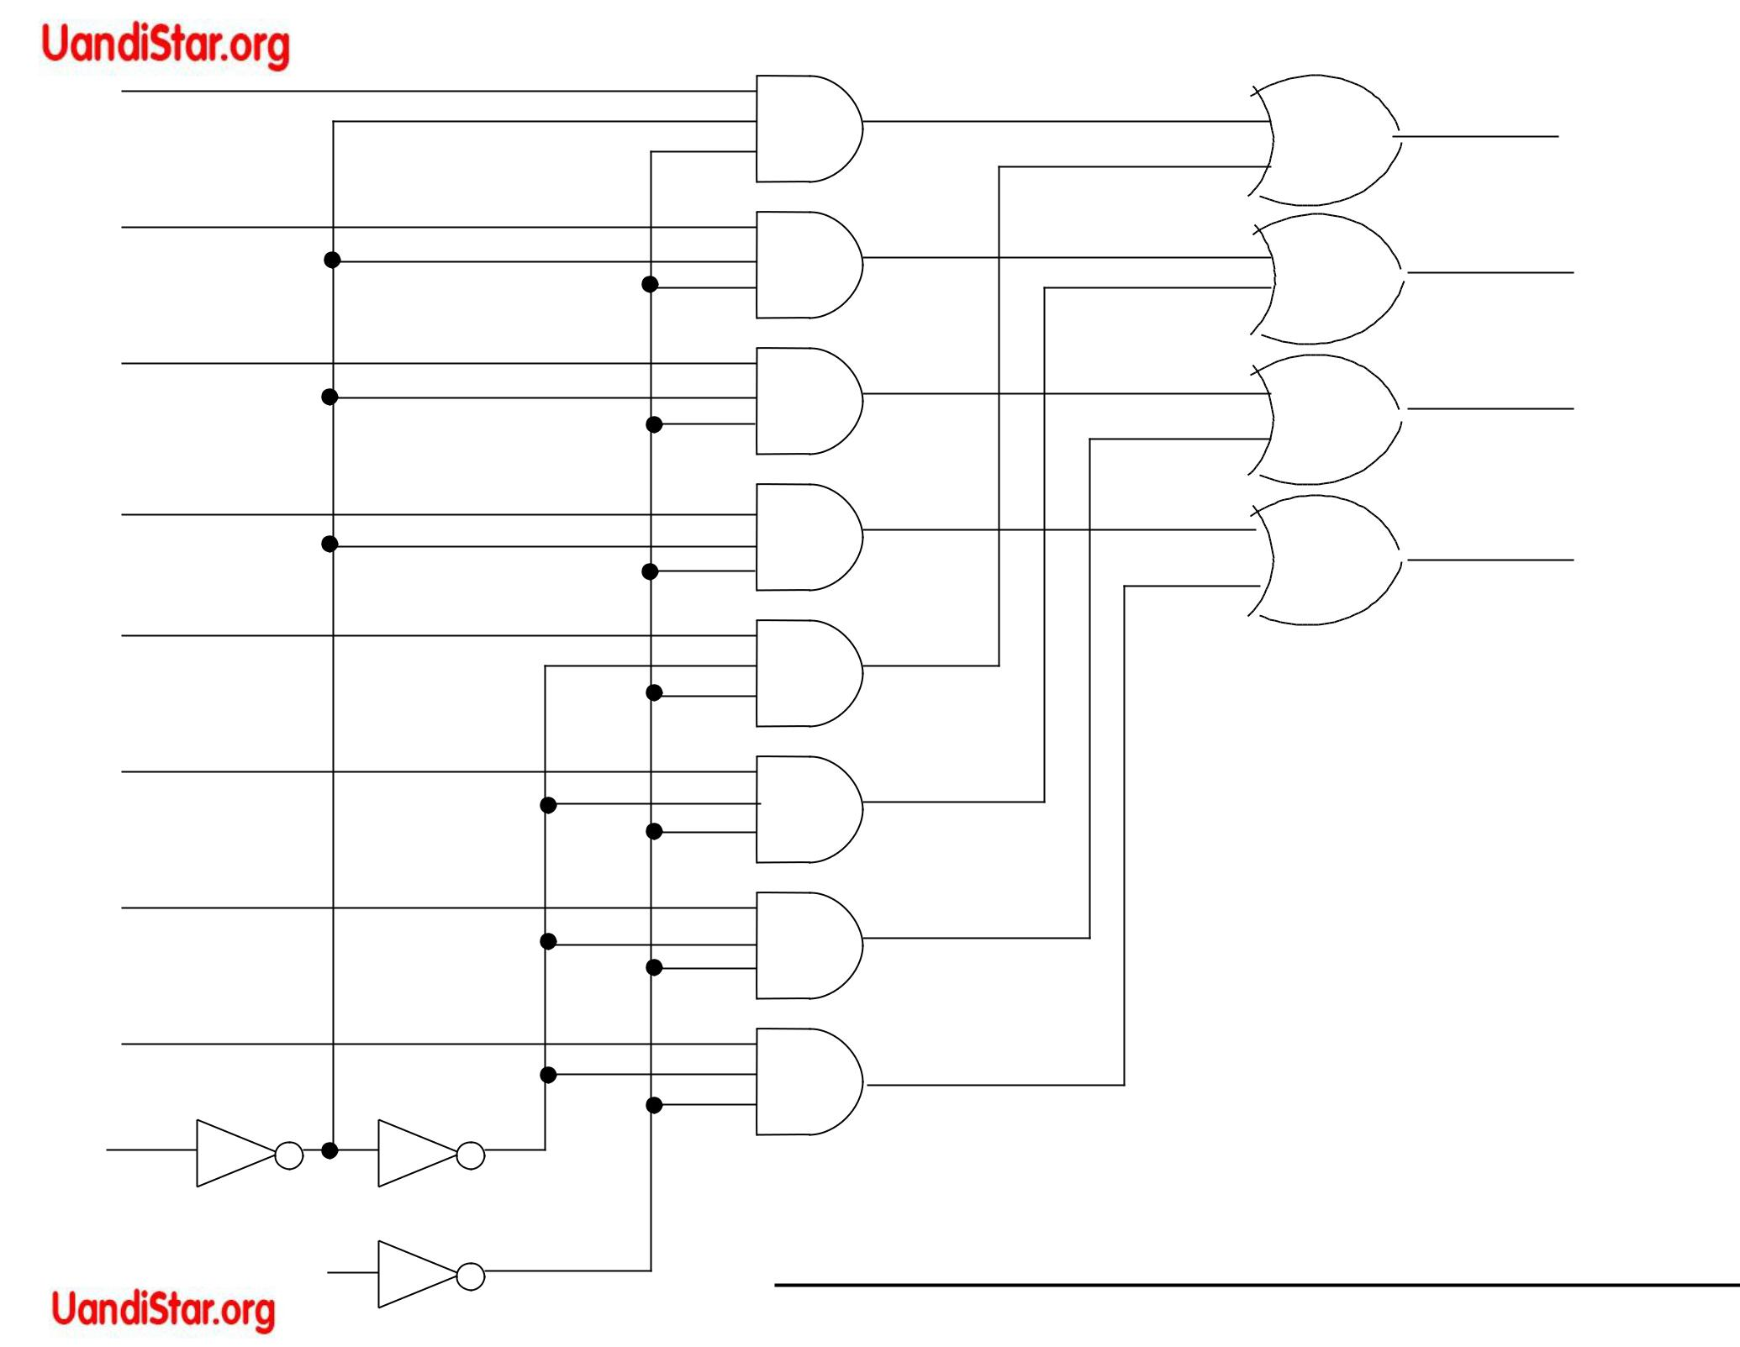

Y₂

Y₃

Y₄

Function Table

E | S | Output Y
1 | X | all 0’s
0 | 0 | Select A
0 | 1 | Select B

Quadruple 2-to-1 Line multiplexer
• |  | Function Table
4 x MUXs
•E = 1, Y ₁ -Y₄ = 0 | E | S |  | Output Y
•
When E = 0, S = 0: | 1 | X |  | all Os
Y₁ = A₁ | 0 | 0 |  | Select A
Y₁ = A₁ | 0 | 1 |  | Select B
Y₂ = A₂ | 0 | 1 |  | Select B
Y₃ = A₃
Y₄ = A₄
•When E = 0, S=1 Þ Y₁ = B₁ ,Y₂=B₂, Y₃=B₃ & Y₄=B₄

Applications:-

•Used for connecting 2 or more sources to a single destination among computer units.

•Used for constructing a common bus system
Boolean Function Implementation
S1 S0

Example :- F(A,B,C)=Σ (1,3,5,6)

0 |  | I₀
1 |  | I₁ | 4 x 1 | Y
A |  |  | 4 x 1 | Y
A |  | I₂ | MUX
A’ |  | I₃ | S₁ | S₀
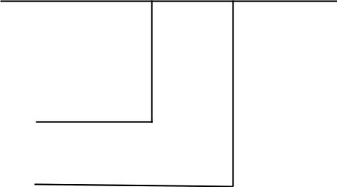

B

C

(c) Multiplexer Implementation
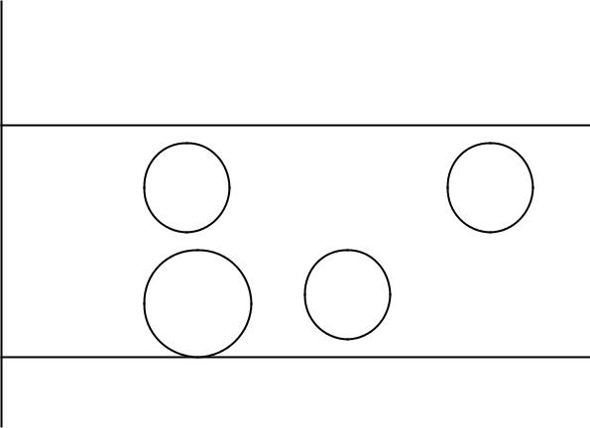

I₀ I₁ I₂ I₃

A’ | ⁰ 1 | 2 | 3
A | 4 | 6 | 7

0 1 A A’

(b)Implementation Table

 |  | Minterm | A | B | C | F
 |  | 0 | 0 | 0 | 0 | 0
F |  | 1 | 0 | 0 | 1 | 1
 |  | 2 | 0 | 1 | 0 | 0
 |  | 3 | 0 | 1 | 1 | 1
 |  | 4 | 1 | 0 | 0 | 0
 |  | 5 | 1 | 0 | 1 | 1
 |  | 6 | 1 | 1 | 0 | 1
 |  | 7 | 1 | 1 | 1 | 0

(a) Truth Table

It is possible to generate any function of n+1 variables with 2n-to-1 Multiplexer

Implementing F(A,B,C)= Σ (1,3,5,6) with a multiplexer

Alternate implementation for F(A,B,C)= Σ (1,3,5,6)

 | I₀ | I₁ | I₂ | I₃ |  | S1 |  | S0
 |  |  |  |  |  |  |  | S0 |  |  | C |  |  |  |  |  |  | I₀
C’ | 0 | 2 | 4 | 6 |  |  | A B |  | C |  | F |  |  |  |  |  |  | I₁ |  | 4 x 1 |  |  | Y |  |  |  | F
 |  |  |  |  |  |  |  |  | C |  | F |  |  |  |  |  |  | I₂ |  |  |  |  | Y
 |  |  |  |  | 0 |  | 0 | 0 | 0 |  | 0 |  |  |  |  |  |  |  |  | MUX
 | 1 | 3 | 5 | 7 | 0 |  | 0 | 0 | 0 |  | 0 |  |  |  |  |  |  | I₃
C |  |  |  |  | 2 | 0 1 |  |  | 0 |  | 0 |  |  |  |  |  |  |  |  | S₁ s0
 |  |  |  |  | 4 |  | 1 | 0 | 0 |  | 0
 | C | C | C | C’ | 4
 |  |  |  |  | 6 |  | 1 | 1 | 0 |  | 0 |  |  |  |  | A
 | (b) Implementation Table |  |  |  | 1 |  | 0 | 0 | 1 |  | 1
 |  |  |  |  | 3 |  | 0 | 1 | 1 |  | 1
 |  |  |  |  | 3 |  | 0 | 1 | 1 |  | 1 |  |  |  |  |  |  |  | B
 |  |  |  |  | 5 |  | 1 | 0 | 1 |  | 1 |  |  |  |  |  |  |  | B
 |  |  |  |  | 5 |  | 1 | 0 | 1 |  | 1 |  |  | (c) | Multiplexer Implementation
 |  |  |  |  | 7 |  | 1 | 1 | 1 |  | 1 |  |  | (c)
 |  |  |  |  | (a) |  | Truth Table

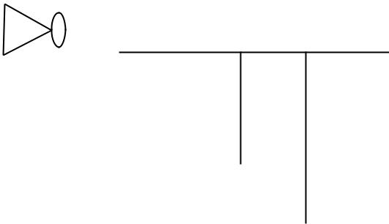

Example:- F(A,B,C,D)= Σ (0,1,3,4,8,9,15)

 |  | 1 |  |  |  |  |  | I₀
 |  | 0 |  |  |  |  |  | I₁
 |  | 0 |  |  |  |  |  | I₂ |  | 8 x 1
 |  |  |  |  |  |  |  | I₃ |  |  |  | Y |  |  | F
 |  |  |  |  |  |  |  |  |  | MUX |  |  |  |  | F
 |  |  |  |  |  |  |  | I₄
 |  |  |  |  |  |  |  | I₅
 |  |  |  |  |  |  |  | I₆ |  | S₁ |  | S₀
 |  |  |  |  |  |  |  | I S2
A
 |  | B |  |  |  |  |  | 7
 |  | C
 |  | D



 |  | S₂ | S₁ | S₀
 | A | B | C | D |  | F
0 | 0 | 0 | 0 | 0 |  | 1
1 | 0 | 0 | 0 | 1 |  | 1
2 | 0 | 0 | 1 | 0 |  | 0
3 | 0 | 0 | 1 | 1 |  | 1
4 | 0 | 1 | 0 | 0 |  | 1
5 | 0 | 1 | 0 | 1 |  | 0
6 | 0 | 1 | 1 | 0 |  | 0
7 | 0 | 1 | 1 | 1 |  | 0
8 | 1 | 0 | 0 | 0 |  | 1
9 | 1 | 0 | 0 | 1 |  | 1
10 | 1 | 0 | 1 | 0 |  | 0
11 | 1 | 0 | 1 | 1 |  | 0
12 | 1 | 1 | 0 | 0 |  | 0
13 | 1 | 1 | 0 | 1 |  | 0
14 | 1 | 1 | 1 | 0 |  | 0
15 | 1 | 1 | 1 | 1 |  | 1

 | I0 | I1 | I2 | I3 | I4 | I5 | I6 | I7
A’
A’ | 0 | 1 | 2 | 3 | 4 | 5 | 6 | 7



A | 8 | 9 | 10 | 11 | 12 | 13 | 14 | 15
 | 1 | 1 | 0 | A’ | A’ | 0 | 0 | A

READ ONLY MEMORY ROM

- ROM is a device that includes both the decoder and the OR gates within a single IC package.

- It is usually used to implement a complex comb. circuit in one IC package and eliminates all interconnecting wires between a decoder and OR gates.

- It is a memory device in which binary information is stored fusing or breaking internal links in order to form required circuit paths.

•If a ROM has:

input lines

= n

output lines

= m

Then:

Distinct Addresses (words) = 2n Total no. of bits stored in ROM = 2n x m (Where m denotes no. of bits per word)

- 32 x 8 ROM means:

– Words = 32 of 8 bits each

– Output lines = 8

– Input lines = 5

– Total bits = 256 (25 x 8)

- Internal construction of a 32 x 4 ROM can be shown using a decoder and four OR gates
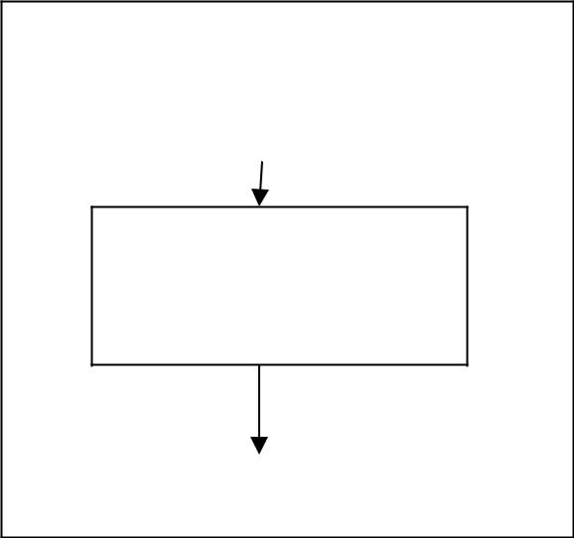

ROM BLOCK DIAGRAM

n inputs

2n x m

ROM

m outputs

INPUTS
ADDRESS

A₀

A₁

A₂

A₃

A₄

INPUTS = 5

WORDS = 32

BITS/WORD = 4

OUTPUTS = 4
Logic Construction of a 32 x 4 ROM


(32words of 4 bits each)

Total bits stored = 32 x 4 = 128

MINTERMS
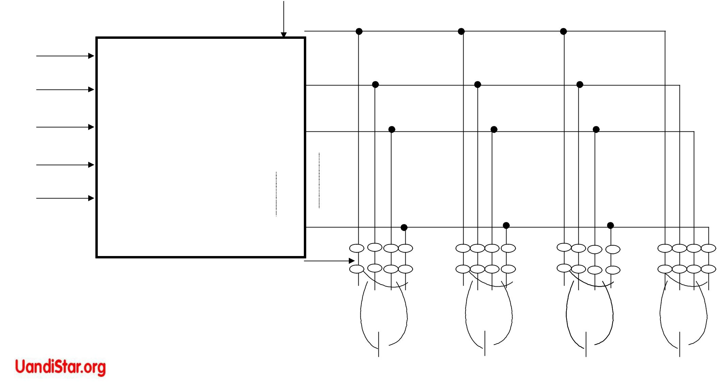

0

1
5 x 32 ₂

decoder

31

128 LINKS

F₁ F₂ F₃ F₄
Combinational Logic Implementation - ROM

- For an n-input, m-output combinational circuit of a 2^{n} x m ROM is needed
- The opening of the links is referred to as programming

- ROM program table gives the information for the required paths in the

ROM

- Example: F₁(A₁, A₀) = Σ (1,2,3)

Truth Table | A₁ | A₀ |  | F₁ | F₂
0 |  | 0 |  | 0 | 1
0 |  | 1 |  | 1 | 0
1 |  | 0 |  | 1 | 1
1 |  | 1 |  | 1 | 0

Combinational circuit implementation with a 4 x 2 ROM is shown:

–With AND –OR gates

–With AND-OR-Inverter gates

A₀ |  |  | 00
 |  | 2 x 4 | 01
 |  | 2 x 4 | 10
 |  | decoder | 10
A₁ |  |  | 11

TRUTH TABLE

A₀ | A₁ | F₁ | F₂
0 | 0 | 0 | 1
0 | 1 | 1 | 0
3 | 0 | 1 | 1
4 | 1 | 1 | 0

ROM with
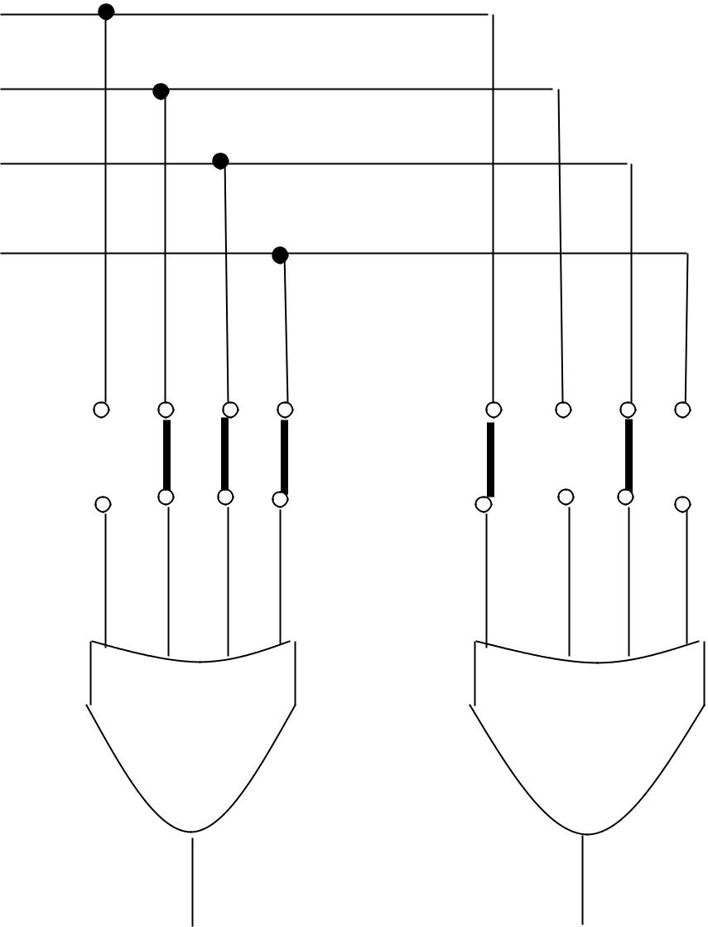
AND-OR gates

F₁ F₂

Combinational Circuit Implementation With a 4 x 2 ROM

Combinational Circuit Implementation With a 4 x 2 ROM

A₀ |  |  | 00 |  |  |  |  |  |  |  | ROM with
A₀ |  |  | 01
 |  | 2 x 4 | 01 |  |  |  |  |  |  |  | AND-OR-INVERTER
 |  | 2 x 4 | 10 |  |  |  |  |  |  |  | AND-OR-INVERTER
 |  | decoder | 10 |  |  |  |  |  |  |  | gates
A₁ |  | decoder | 11 |  |  |  |  |  |  |  | gates
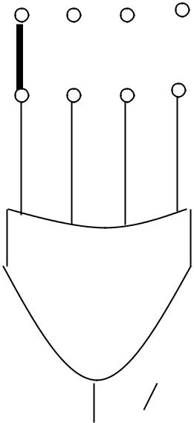
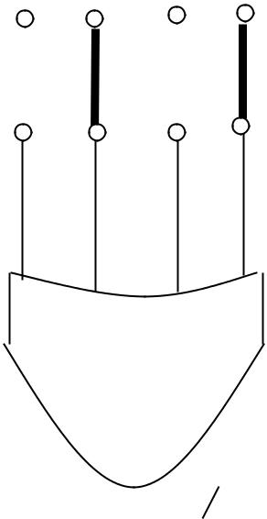

TRUTH TABLE

A₀ | A₁ | F₁ | F₂
0 | 0 | 0 | 1
0 | 1 | 1 | 0
3 | 0 | 1 | 1
4 | 1 | 1 | 0

 F₁ 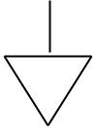 F₂

F₁ F₂

- Types of ROM

–Mask programming (ROM)

–PROM

–EPROM

–EAROM

- Uses

–to implement complex CC from truth tables

–to convert one binary code to another

–to implement arithmetic functions

–to display of characters on CRT

–to design microprogrammed control units
 |  |  | (i) |  |  | TRUTH TABLE
 | Inputs (3) |  |  |  |  |  | Outputs (6) |  |  |  | Decimal
 | A₂ | A₁ | A₀ |  | B₅ | B₄ | B₃ | B₂ | B₁ | B₀
0 | 0 | 0 | 0 |  | 0 | 0 | 0 | 0 | 0 | 0 | 0
1 | 0 | 0 | 1 |  | 0 | 0 | 0 | 0 | 0 | 1 | 1
2 | 0 | 1 | 0 |  | 0 | 0 | 0 | 1 | 0 | 0 | 4
3 | 0 | 1 | 1 |  | 0 | 0 | 1 | 0 | 0 | 1 | 9
4 | 1 | 0 | 0 |  | 0 | 1 | 0 | 0 | 0 | 0 | 16
5 | 1 | 0 | 1 |  | 0 | 1 | 1 | 0 | 0 | 1 | 25
6 | 1 | 1 | 0 |  | 1 | 0 | 0 | 1 | 0 | 0 | 36
7 | 1 | 1 | 1 |  | 1 | 1 | 0 | 0 | 0 | 1 | 49

Example: Design a comb. circuit using a ROM. The circuit accepts a 3-bit number and generates an output binary number equal to the square of the input number.
A |  |  |  | (ii) |  | A |  |  |  |  |  |  |  |  |  | (iii)
 |  | 2 |  |  | A₁ | A |  | 0
 |  |  |  |  | A₁ | A |  | 0 |  |  |  |  | A₂ |  | A₁ | A₀ |  | F₁ | F₂ | F₃ |  | F₄
 |  |  |  |  |  |  |  |  |  |  |  | 0 | 0 |  | 0 | 0 |  | 0 | 0 | 0 |  | 0
 |  |  |  | 8 x 4 |  |  |  |  |  |  |  | 1 | 0 |  | 0 | 1 |  | 0 | 0 | 0 |  | 0
 |  |  |  |  |  |  |  |  |  |  |  | 2 | 0 |  | 1 | 0 |  | 0 | 0 | 0 |  | 1
 |  |  |  | ROM |  |  |  |  |  |  |  | 3 | 0 |  | 1 | 1 |  | 0 | 0 | 1 |  | 0
F₁ |  |  |  | F₂ | F₃ | F₄ |  |  | 0 |  |  | 4 | 1 |  | 0 | 0 |  | 0 | 1 | 0 |  | 0
 |  |  |  |  |  |  |  |  |  |  |  | 5 | 1 |  | 0 | 1 |  | 0 | 1 | 1 |  | 0
B₅ |  |  |  |  |  |  |  |  |  |  |  | 6 | 1 |  | 1 | 0 |  | 1 | 0 | 0 |  | 1
 |  |  |  | B₄ | B₃ | B₂ |  |  | B₁ B₀ |  |  | 7 | 1 |  | 1 | 1 |  | 1 | 1 | 0 |  | 0
 |  |  | BLOCK DIAGRAM |  |  |  |  |  |  |  |  |  |  | ROM TRUTH TABLE

ROM Implementation
Programmable Logic Array (PLA)

- All the bit patterns available in the ROM are not used due to don’t care conditions which results into wastage of equipment

- Size of the ROM required to convert a 12-bit card code to a 6-bit internal alphanumeric code:

4096 x 6



212 input | output | A-Z | = | 26
valid entries = 47 |  | Numbers | = | 10
don’t care conditions = 4049 |  | other char= |  | 11
 |  |  |  | 47

- It is more economical to use PLA (LSI) in such cases to avoid wastage.
Programmable Logic Array (PLA)

- A block diagram of the PLA consists of:

– n inputs

– m outputs

– k product terms

– m sum terms

• Output function:

AND-OR form AND-OR-INVERTOR form

- A typical PLA has : n = 16, m = 8, k = 48 programmed links

 | PLA |  |  | ROM
2n * k + k * m + m |  |  | 2n * m = 216 x 8
1928 |  |  | 524288
1 |  |  | 272

n x k
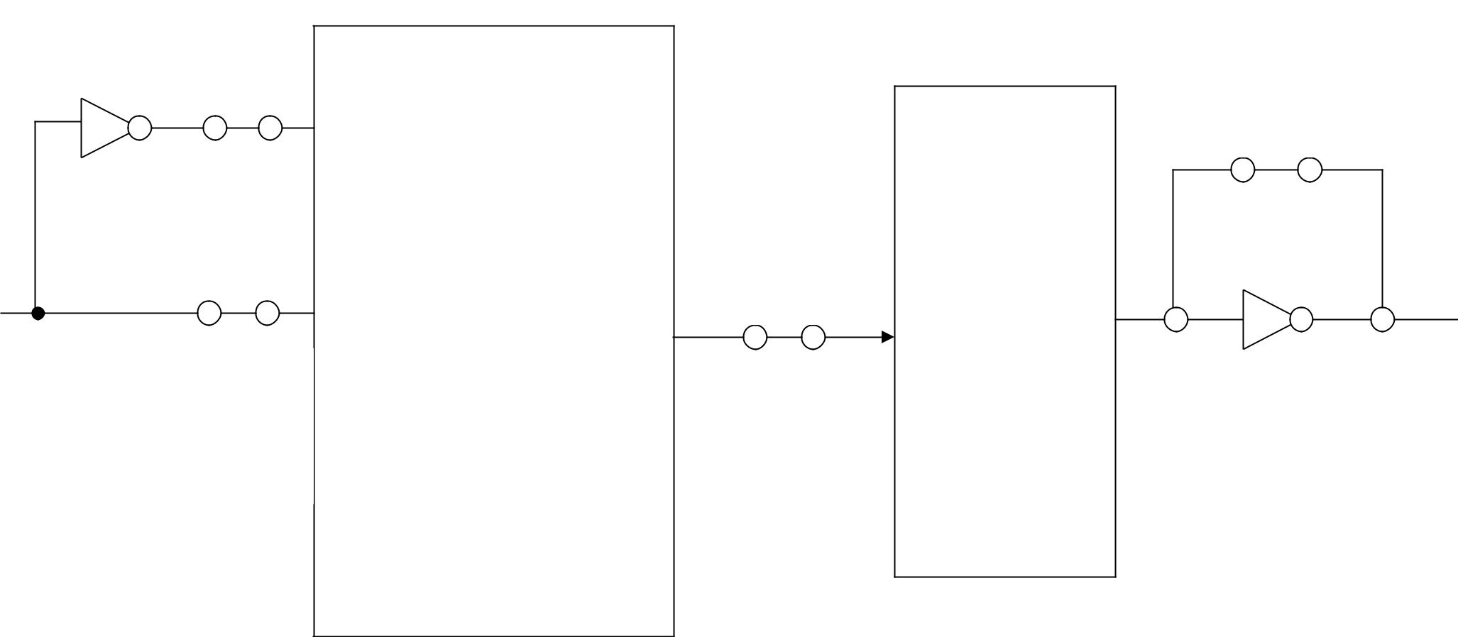
 | Links |  |  |  | m
 | Links |  |  |  | Links
 |  |  |  | m Sum | Links
 |  | K Product | k x m | terms
 |  | terms | Links
Inputs | n x k | (AND gates) |  | (OR | m output
 | Links | (AND gates) |  | gates) | m output

PLA BLOCK DIAGRAM
IMPLEMENTATION OF PLA COMB CIRCUIT

- Mask programmable (PLA)

- Field programmable (FPLA)

- PLA program table is required to program a PLA

- Truth table of the comb. Circuit can be used to simplify the function to get the minimum AND gates (sum of products)
- Paths are specified in its AND – OR or AND – OR - INVERT

pattern by programming PLA

• PLA program table contains:

1st column - lists product terms numerically

2nd column - specifies the required paths between OR gates and AND gates

T is written if the output inverter is to be bypassed

C is written if the output inverter is not to be bypassed

3 Variable is unprimed

0 variable is primed

- Variable is absent
EXAMPLE#1

F1 (A, B,C) = Σ (4,5,7)
F2 (A,B,C) = Σ (3,5,7)
 |  |  |  |  | B |  |  |  |  |  |  |  | B
BC | 00 |  | 01 |  | 11 |  |  | 10 | BC | 00 | 01 |  | 11 |  |  |  |  | 10
A’
A’ |  |  |  |  |  |  |  |  | A’ |  |  |  |  |  | 1
0 |  |  |  |  |  |  |  |  | 0
A |  | 1 |  | 1 |  | 1 |  |  | A |  |  | 1 |  |  | 1
1 |  |  |  |  |  |  |  |  | 1
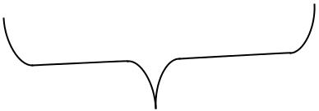
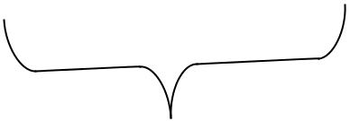
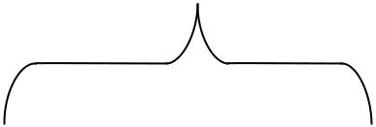
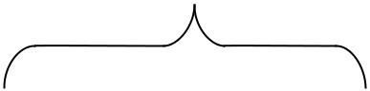

C | C
F₁(A,B,C)=∑(4,5,7) | F₂(A,B,C)=∑(3,5,7)
F₁=AB’+AC | F₂=AC+BC
Map simplification
TRUTH TABLE

A |  | B |  | C |  | F1 |  | F2
0 |  | 0 |  | 0 |  | 0 |  | 0
0 |  | 0 |  | 1 |  | 0 |  | 0
0 |  | 1 |  | 0 |  | 0 |  | 0
0 |  | 1 |  | 1 |  | 0 |  | 1
1 |  | 0 |  | 0 |  | 1 |  | 0
1 |  | 0 |  | 1 |  | 1 |  | 1
1 |  | 1 |  | 0 |  | 0 |  | 0
1 |  | 1 |  | 1 |  | 1 |  | 1
 |  | Product |  | Inputs |  | Outputs
 |  | term | A | B | C | F1 | F2
 | AB’ | 1 | 1 | 0 | - | 1 | -
 | AC | 2 | 1 | - | 1 | 1 | 1
 | BC | 3 | - | 1 | 1 | - | 1
 |  | PLA Program table |  |  |  | T | T | T/C

STEPS REQUIRED IN PLA IMPLEMENTATION

A

1

B

2

C | 3

AB’
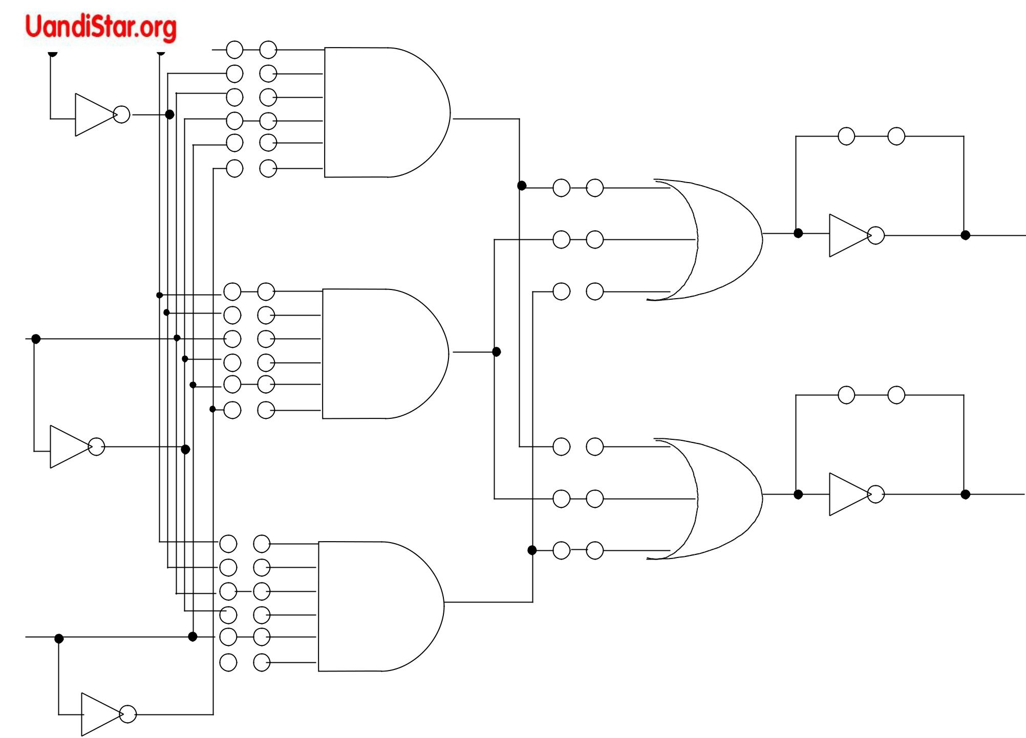

AC

BC

PLA Links = 26

AB’ + AC

F₁

AC + BC

F₂

n = 3

m = 2

K = 3

K * m + m

- (2)

PLA with 3 inputs, 3 product terms, and 2 outputs; it  implements the combinational circuit

EXAMPLE#2

F₁(A,B,C)=∑(3,5,6,7)

F₂(A,B,C)=∑(0,2,4,7)
B
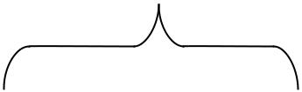
^{BC}00 01 11 10

0 | A
0 | A |  |  |  |  | 1
1
1 | A |  |  | 1 |  | 1 |  | 1



F₁=AC+AB+BC |  |  | C
 | BC |  |  | B
 | BC | 01 | 11 | 10
 | 00 | 01 | 11 | 10
A | 0 | 0 |  | 0
A | 0
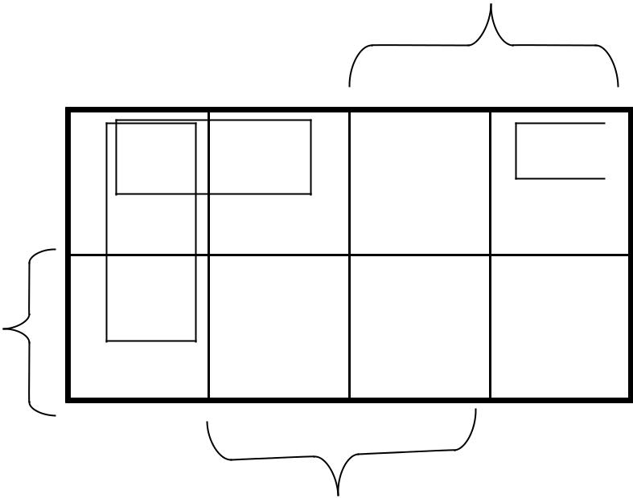

C
F’₁=B’C’+A’C’+A’B’
B
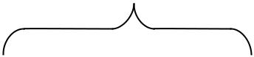
^{BC} 00 01 11 10

0 ^{A} |  |  | 1 |  |  |  |  |  |  |  |  |  |  |  |  | 1
 |  |  | 1
₁A |  |  | 1 |  |  |  |  |  |  |  | 1
F₂=B’C’+A’C’+ABC |  |  |  |  |  |  |  |  |  | C
BC |  |  |  |  |  |  |  |  |  |  |  |  | B
BC | 00 |  |  |  |  | 01 |  |  |  | 11 |  |  | 10
0 ^{A} |  |  |  |  |  |  |  | 0 |  | 0
 |  |  |  |  |  |  | 0
₁A |  |  |  |  |  |  |  |  |  |  |  |  |  |  |  |  | 0


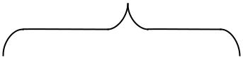


C
F’₂=B’C+A’C+ABC’
PLA Program Table


B’C’

A’C’

A’B’

ABC

Product |  | Inputs |  |  |  | Outputs
term | A | B | C |  |  | F’1 | F2
1 | - | 0 | 0 |  |  | 1 | 1
2 | 0 | - | 0 |  |  | 1 | 1
3 | 0 | 0 | - |  |  | 1 | -
4 | 1 | 1 | 1 |  |  | - | 1
 |  |  |  |  | C |  | T | T/C

 | Examples |  | Condition
F₁(A,B,C)=∑(3,5,6,7) |  |  | Inputs=3
F₂(A,B,C)=∑(0,2,4,7)
 |  |  | Product term=4
 |  | F₁=(B’C’+A’C’+A’B’)’ | Outputs =2
 |  | F₂ =B’C’+A’C’+ABC

HOME ASSIGNMENT

DRAW CIRCUIT FROM THE PLA IMPLEMENTATION TABLE

