LOGIC CIRCUITS

- COMBINATIONAL LOGIC CIRCUIT

- SEQUENTONAL LOGIC CIRCUIT

DESIGN PROCEDURE

- THE PROBLEM IS STATED

- INPUT |& OUTPUT VARIABLES ARE DETERMINED

- INPUT & OUTPUT VARIABLES ARE ASSIGNED LETTER SYMBOLS

- TRUTH TABLE IS DERIVED TO DEFINE THE RELATIONSHIPS B/W INPUTS & OUTPUTS

- THE SIMPLIFIED BOOLEAN FUNCTION FOR EACH OUTPUT IS OBTAINED

- THE LOGIC DIAGRAM IS DRAWN

CONSTRAINTS FOR A PRACITAL DESIGN

- MINIMUM NUMBER OF GATES

- MINIMUM NUMBER OF INPUTS TO A GATE

- MINIMUM PROPAGATION TIME OF THE SIGNAL THROUGH THE CIRCUIT

- MINIMUM NUMBER OF INTERCONNECTIONS

- LIMITATIONS OF THE DRIVING CAPABILITIES OF EACH GATE

n INPUT VARIABLES

COMBINATIONAL LOGIC
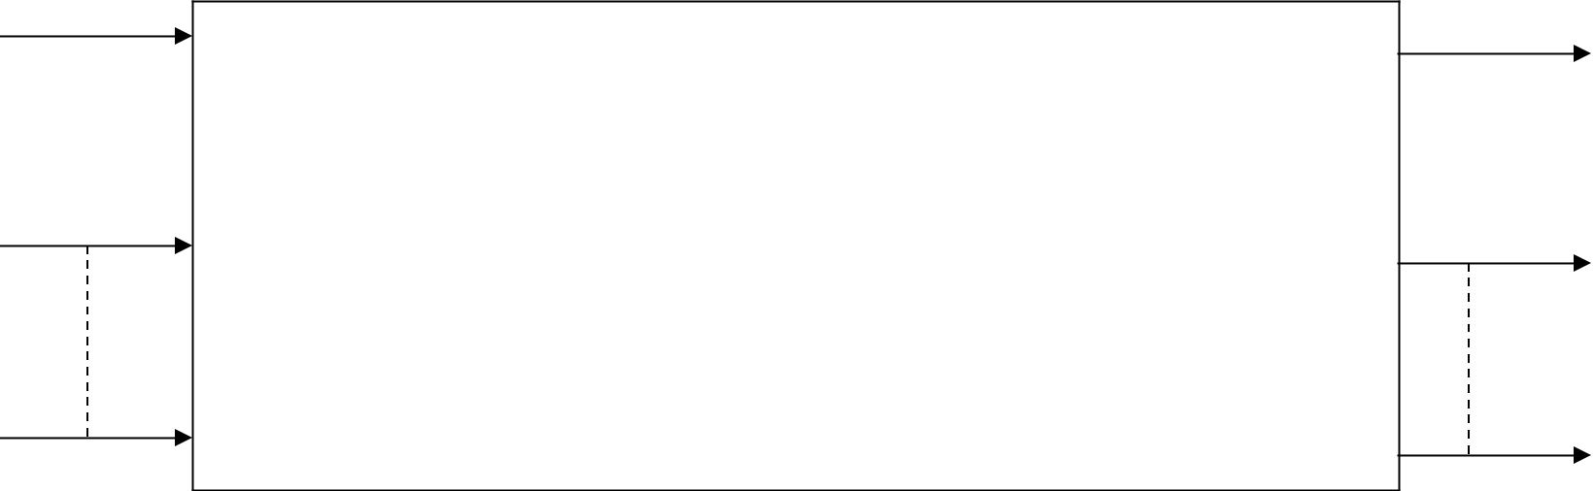

CIRCUIT

- OUTPUT VARIABLES

BLOCK DIAGRAM OF A COMBINATIONAL CIRCUIT

ADDERS

 | HALF ADDERS |  | x | y | C | S
 |  |  | 0 | 0 | 0 | 0
 |  |  | 0 | 1 | 0 | 1
S = x’ y + x y’ |  |  | 1 | 0 | 0 | 1
C = xy |  |  | 1 | 1 | 1 | 0

x
y’ | s
x’ | s
y
x | c
y | c
(a) S = x y’ + x’ y C = x y
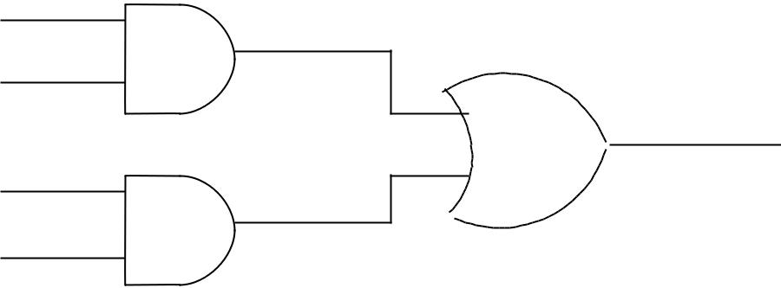
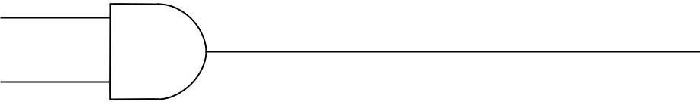

x
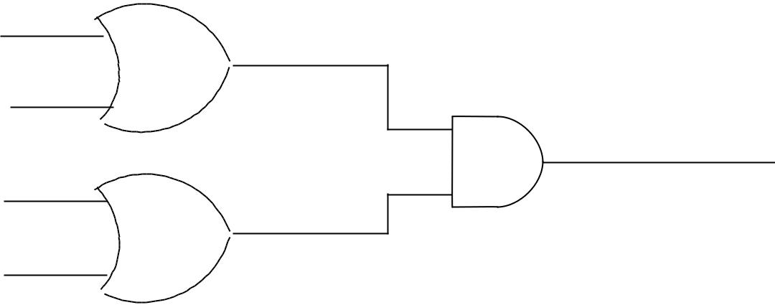

y

x’

y’

x
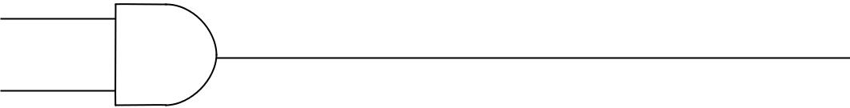
y

s

c

(b) S = (x + y) (x’ + y’) c = x y

x’

y’

x

y

x
y

x’

y’

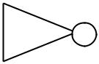 S
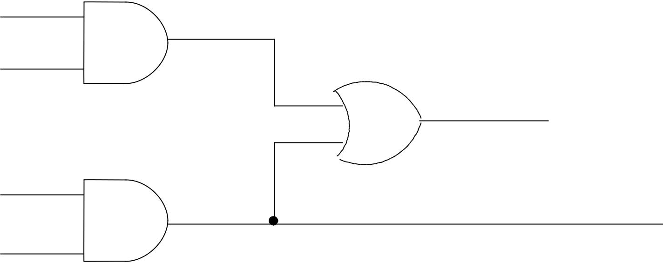

C

(c) S = (c + x’ y’)’ C = x y
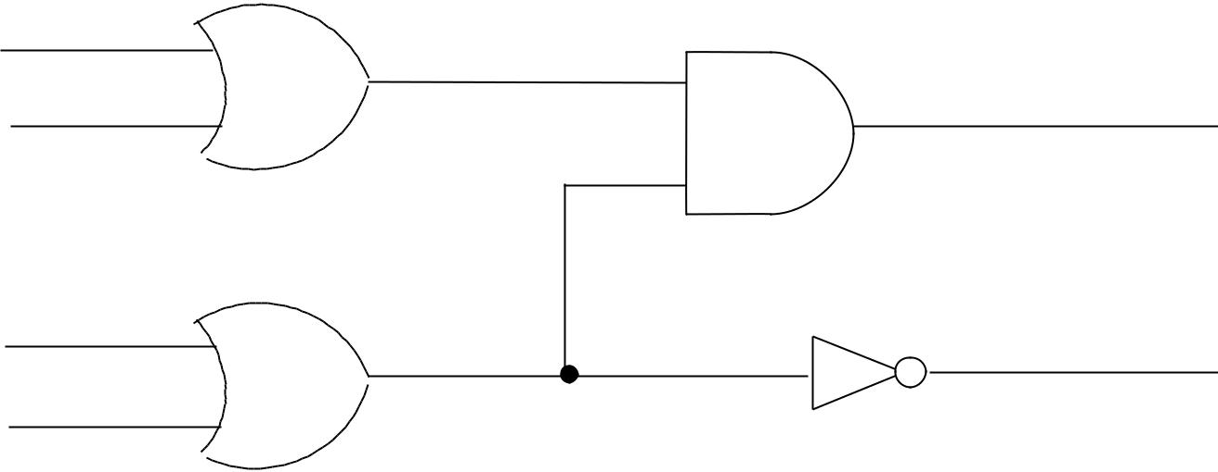

S

C

(d) S = (x + y) . (x’ + y’) C = (x’ + y’)’
X OR
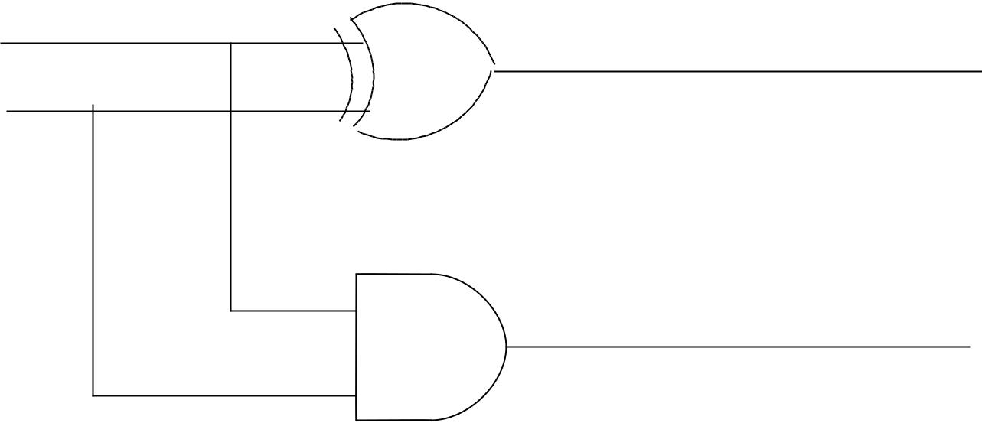

x | s
y | s

c

- S = x Å y

C = x y

VARIOUS IMPLEMENTATIONS OF A HALF ADDER
FULL ADDER

x | y | z | c | s
0 | 0 | 0 | 0 | 0
0 | 0 | 1 | 0 | 1
0 | 1 | 0 | 0 | 1
0 | 1 | 1 | 1 | 0
1 | 0 | 0 | 0 | 1
1 | 0 | 1 | 1 | 0
1 | 1 | 0 | 1 | 0
1 | 1 | 1 | 1 | 1

 |  | yz |  | z
 | x | 00 01 |  | 11 | 10
 | x |  | 1 |  | 1
x | 0 |  | 1 |  | 1
x | 1 | 1 |  | 1
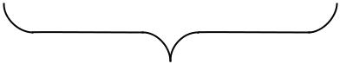
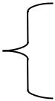
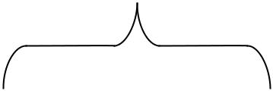

z

S = x’ y’ z + x’ y z’ + x y’ z’ + xyz

 |  | yz |  |  |  |  |  | z
 | x | 00 | 01 |  | 11 |  |  |  |  |  | 10
x | 0 |  |  |  |  |  | 1
x | 1 |  |  | 1 |  |  | 1 |  |  |  | 1
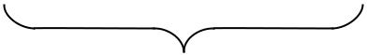
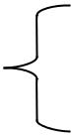
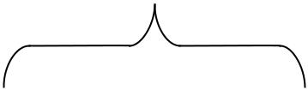

z

C = x y +xz + yz

MAP FOR FULL ADDER

x’
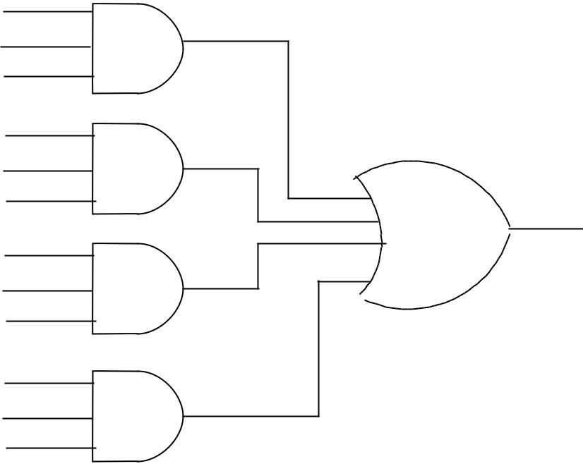
y’

z

x’
y

z’
x
y’
z’
x
y
z

S=x’y’z+x’yz’+xy’z’+xyz

x
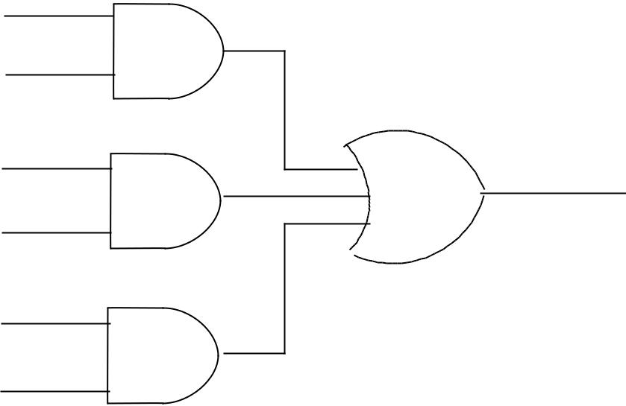
y

x | c
z | c

y

z

C=xy+xz+yz

IMPLEMENTATION OF FULL – ADDER IN SUM OF PRODUCTS

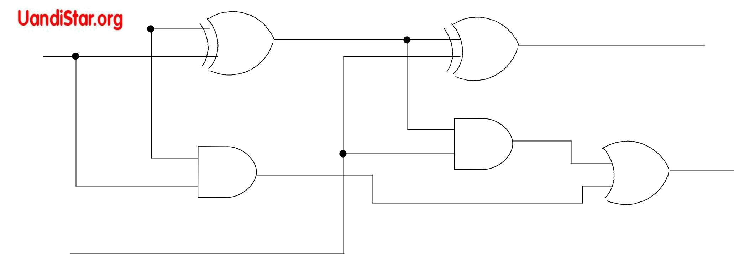
x

y

^{z}IMPELEMENTATION OF A FULL – ADDER WITH TWO HALF – ADDER AND AN OR GATE

- = z Å (x Å y)

  - z’(xÅ y) + z (x Å y)’

  - z’ (x y’ + x’ y) + z (xy + x’y’)

  - z’ (x y’ +x’ y) + z(x y + x’ y’)

  - x y’ z’ + x’ y z’ + x y z + x’ y’ z
- = z(x y’ + x’ y) + x y

  - x y’ z + x’ y z + x y

  - x y’ z + y (x’ z+ x)

  - x y’ z + y [ (x + x’) (x + z)]

  - x y’ z + y (x + z)

  - x y’ z + x y + y z

  - z ( x y’ + y) + x y

  - z[( x + y) ( y + y’)] + x y

  - z (x + y) + x y

  - x z + y z + x y
Half subtractor

X | y | B | D
0 | 0 | 0 | 0
0 | 1 | 1 | 1
1 | 0 | 0 | 1
1 | 1 | 0 | 0

D = x’ y + x y’

B =x’ y

x
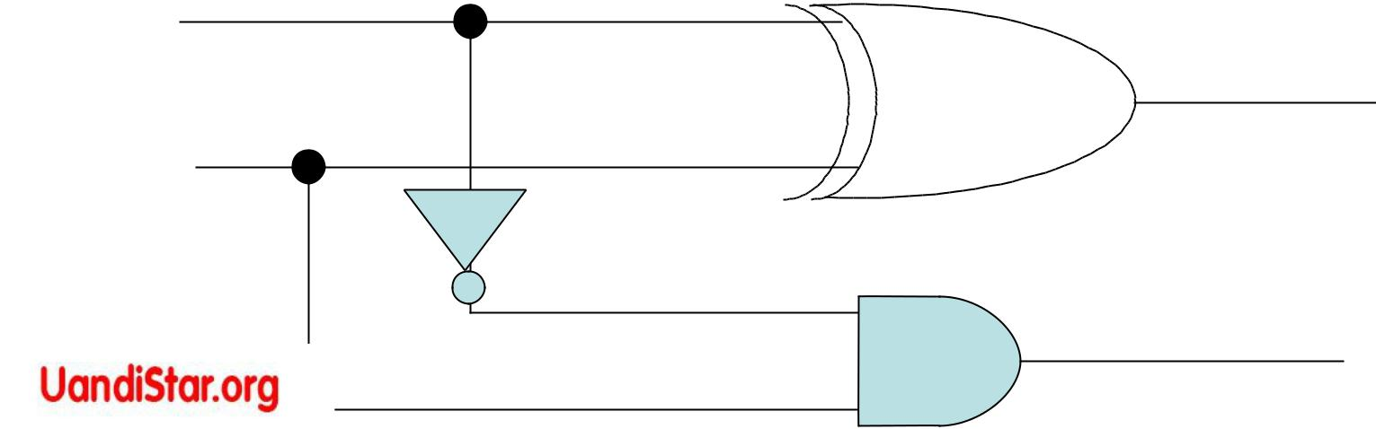

y

D = x - y


D

B
Full subtractor
 | X |  |  | y |  | z |  |  |  |  | B | D
 | 0 |  |  | 0 | 0 |  |  |  |  | 0 |  | 0
 | 0 |  |  | 0 | 1 |  |  |  |  | 2 |  | 1
 | 0 |  |  | 1 | 0 |  |  |  |  | 1 |  | 1
 | 0 |  |  | 1 | 1 |  |  |  |  | 4 |  | 0
 | 1 |  |  | 0 | 0 |  |  |  |  | 0 |  | 1
 | 1 |  |  | 0 | 1 |  |  |  |  | 0 |  | 0
 | 1 |  |  | 1 | 0 |  |  |  |  | 0 |  | 0 |  |  | D = x – y - z
 | 1 |  |  | 1 | 1 |  |  |  |  | 1 |  | 1
 |  |  |  | y z |  |  |  | y
 |  |  |  | y z | 01 |  | 11 | 10
 | x |  |  | 0 0 | 01 |  | 11
 | x |  |  |  | 1 |  |  |  |  |  | 1 | D = x’y’z+x’yz’ +
 | 0 |  |  |  | 1 |  |  |  |  |  | 1
 |  |  |  |  |  |  |  |  |  |  |  |  | xy’z’+xyz
x | 1 |  |  | 1 |  |  | 1
 |  |  |  |  | z

y z ₀ ₀ |  |  |  |  |  |  |  | y
 |  | 01 |  | 11 |  |  |  | 10
x
o |  |  | 1 |  |  | 1 |  |  | 1 |  | B =x’y+x’z+yz
^{x} 1 |  |  |  |  | 1
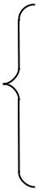
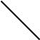

z

MAPS FOR FULL- SUBTRACTOR

D= x’y’z+x’yz’+xy’z’+xyz

B = x’y+x’z+yz
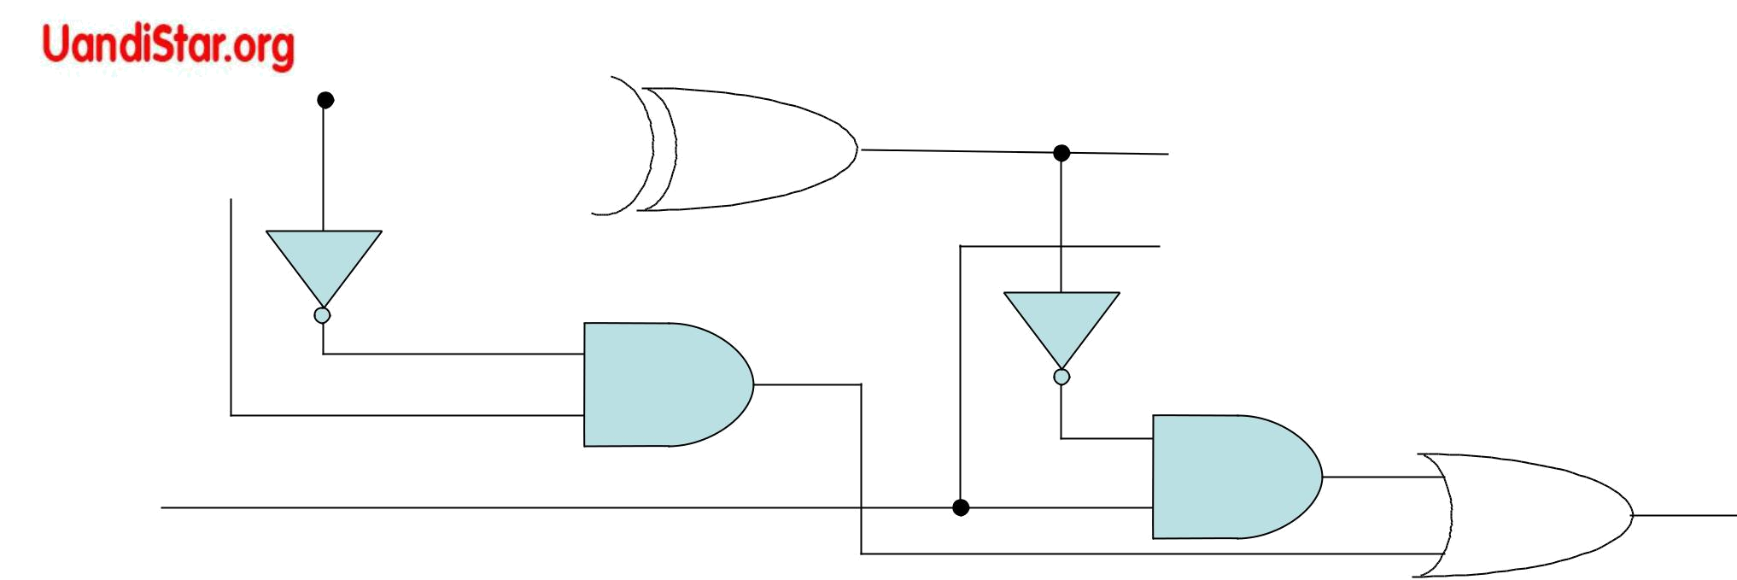
Full subtractor

x

y

D

z | B

D=zÅ(xÅy)
D=z’(xy’+x’y)+z(xy’+x’y)’ | B=x’y+x’y’z+xyz
D=xy’z’+x’yz’+z(xy+x’y’) | = x’(y+y’z)+xyz = x’(y+y’)(y+z)+xyz = x’(y+z)+xyz
D=xy’z’+x’yz’+z(xy+x’y’) | = x’y+x’z+xyz = x’y+z(x’+xy) = x’y+z(x+x’)(x’+y)
D=xy’z’+x’yz’+xyz+x’y’z | =x’y+z(x’+y) = x’y+x’z+yz

B=z(xy’+x’y)’+x’y

B=z(x’y’+xy)+x’y

=x’y’z+xyz+x’y

 |  |  |  |  |  |  | Code conversion
 |  |  |  | Input |  |  |  |  |  | Output
 |  |  |  | BCD |  |  |  |  | Excess-3 code
 |  |  | A | B | C |  | D | w |  | x | y | z
0 | 0 |  |  | 0 | 0 | 0 |  | 0 | 0 |  | 1 | 1
2 | 0 |  |  | 0 | 0 | 1 |  | 0 | 1 |  | 0 | 0
3 | 0 |  |  | 0 | 1 | 0 |  | 0 | 1 |  | 0 | 1
4 | 0 |  |  | 0 | 1 | 1 |  | 0 | 1 |  | 1 | 0
5 | 0 |  |  | 1 | 0 | 0 |  | 0 | 1 |  | 1 | 1
6 | 0 |  |  | 1 | 0 | 1 |  | 1 | 0 |  | 0 | 0
7 | 0 |  |  | 1 | 1 | 0 |  | 1 | 0 |  | 0 | 1
8 | 0 |  |  | 1 | 1 | 1 |  | 1 | 0 |  | 1 | 0
9 | 1 |  |  | 0 | 0 | 0 |  | 1 | 0 |  | 1 | 1
9 | 1 |  |  | 0 | 0 | 1 |  | 1 | 1 |  | 0 | 0
 | Z=D’ |  |  |  |  | x=B’C+B’D+BC’D’ = B’(C+D)+BC’D’
 | Y=CD+C’D’=CD+(C+D)’ |  |  |  |  | W=A+BC+BD = A+B(C+D)
Truth table for code-conversion example

Z=D’

y=CD+C’D’=CD+(C+D)’

X=B’C+B’D+BC’D’=B’(C+D)+BC’D’

=B’(C+D)+B(C+D)’

W=A+BC+BD=A+B(C+D)

AB 00

01
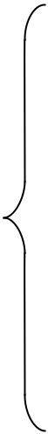

11

A

10

 | CD |  |  |  | C
00 |  |  | 01 | 11 | 10
1 |  |  |  |  |  |  | 1
1 |  |  |  |  |  |  | 1
 | X |  | X | X |  |  | X
1 |  |  |  | X |  |  | X


AB

00
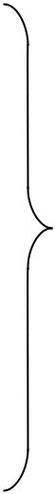

01

B

11

A

10

C
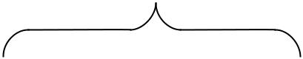

CD
00 01 11 10
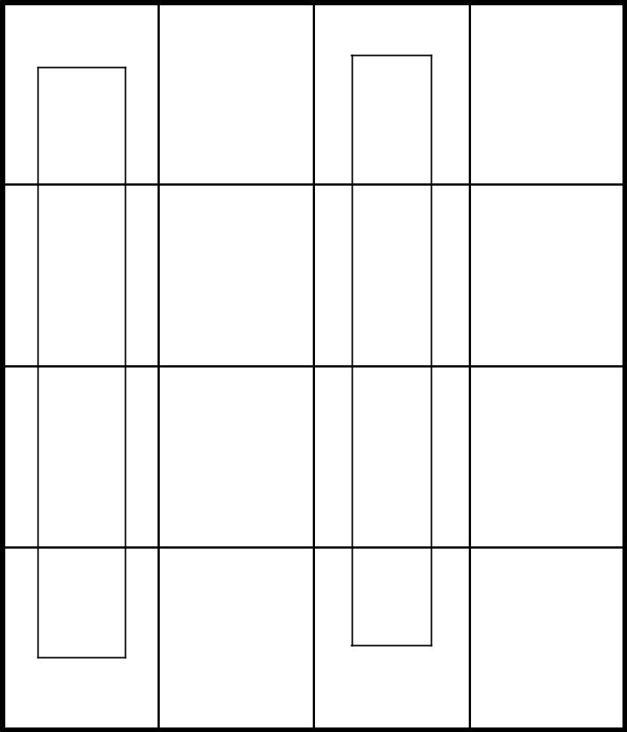

1 | 1
1 | 1
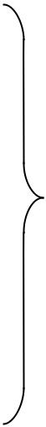

B

X

1
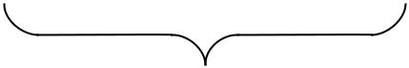

D D
^{Z=D’} Y =CD+C’D’

AB 00

01
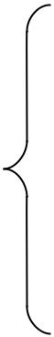

11

A

10

 | CD |  |  |  |  |  |  |  |  |  |  |  |  |  | C
00 |  |  | 01 |  |  |  |  | 11 |  |  |  |  |  |  | 10
 |  |  |  |  | 1 |  |  |  |  | 1 |  |  |  |  |  | 1
 | 1
 | X |  |  |  |  |  | X |  |  |  |  | X |  |  |  | X
 |  |  |  |  |  |  | 1 |  |  |  |  | X |  |  |  | X

AB

00

01

B

11

A

10

C
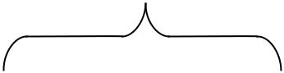

CD
00 01 11 10
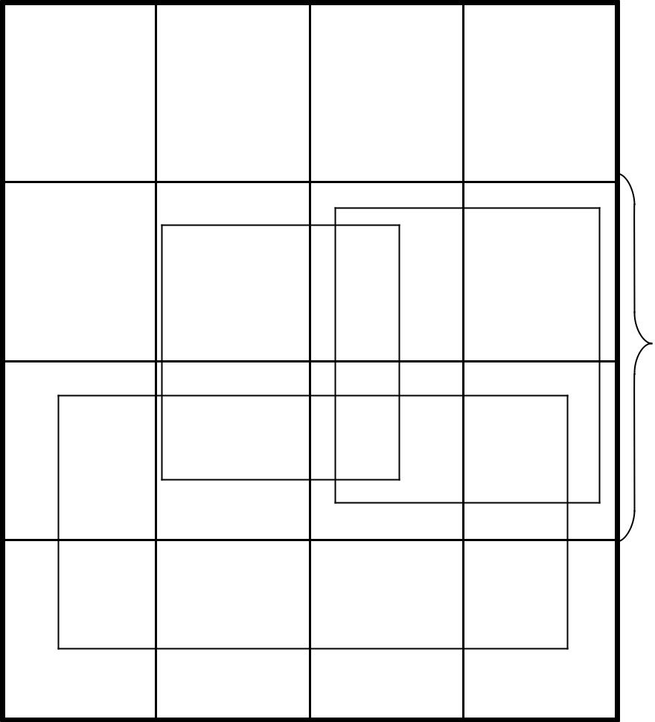

1 1

B

X

1 1

X=B’C+B’D+BC’D’ ^{D} W=A+BC+BD^{D}

MAPS FOR BCD-TO-EXCESS-8 CODE CONVERTOR

C
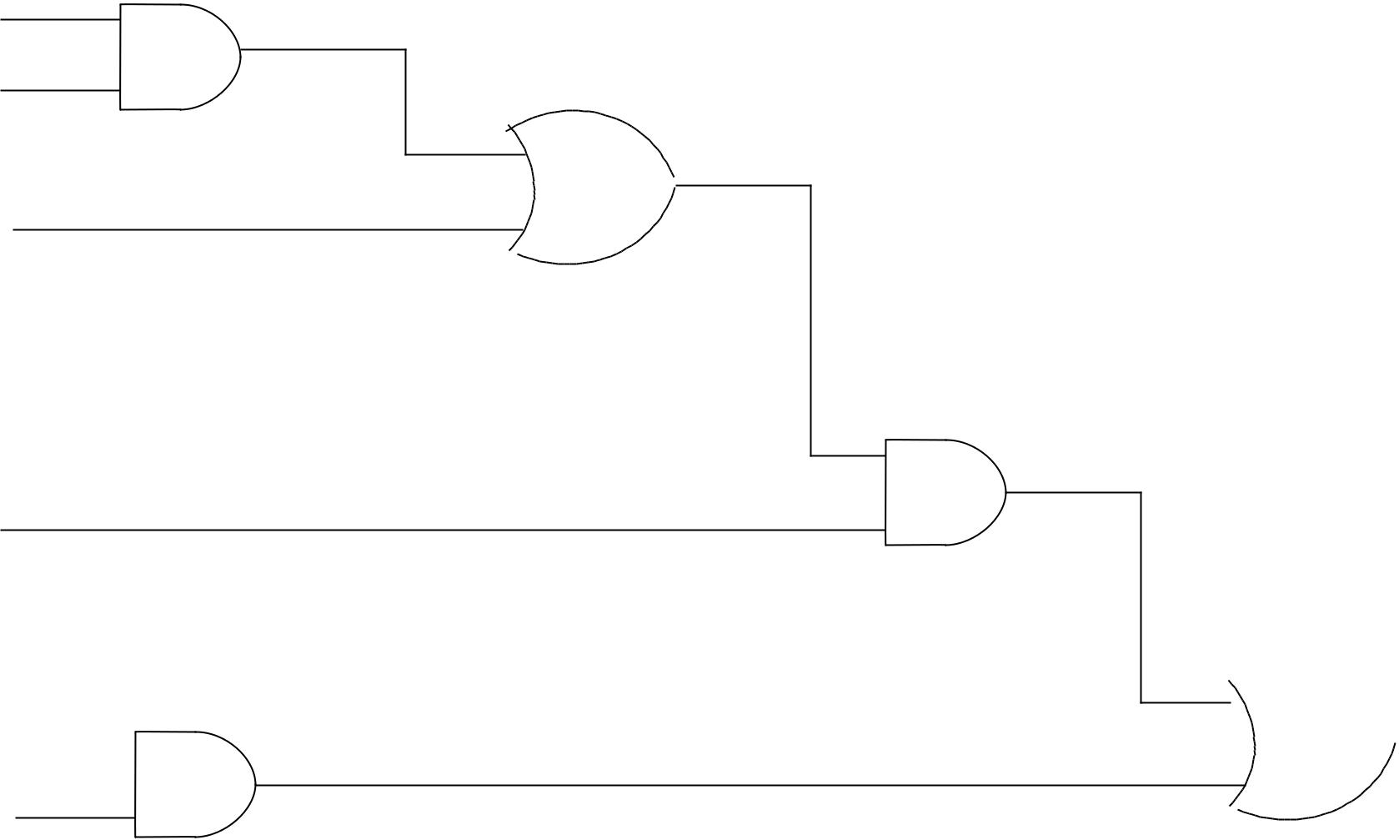

D

B

A

B  F C’

F=A(B+CD)+BC’

(a) AND / OR Implementation

C

D

B

A

B

C’
AND
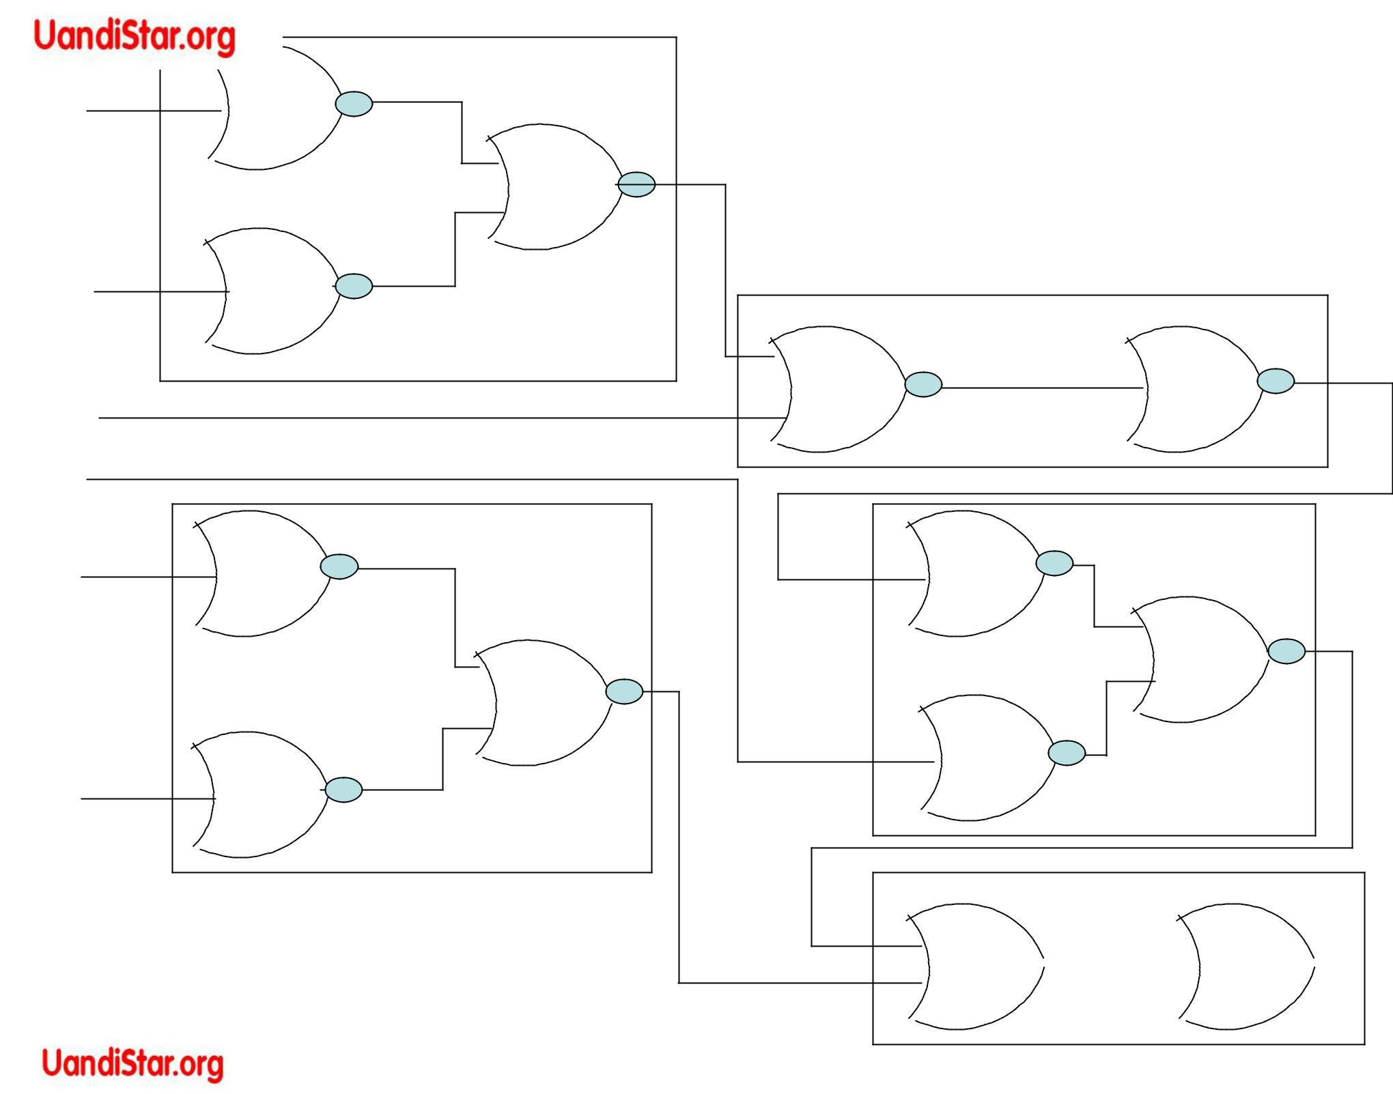

1

OR

3

AND | AND
2 | 4

OR

5 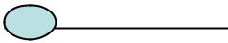 6  F

(b) Substituting Equivalent NOR Functions
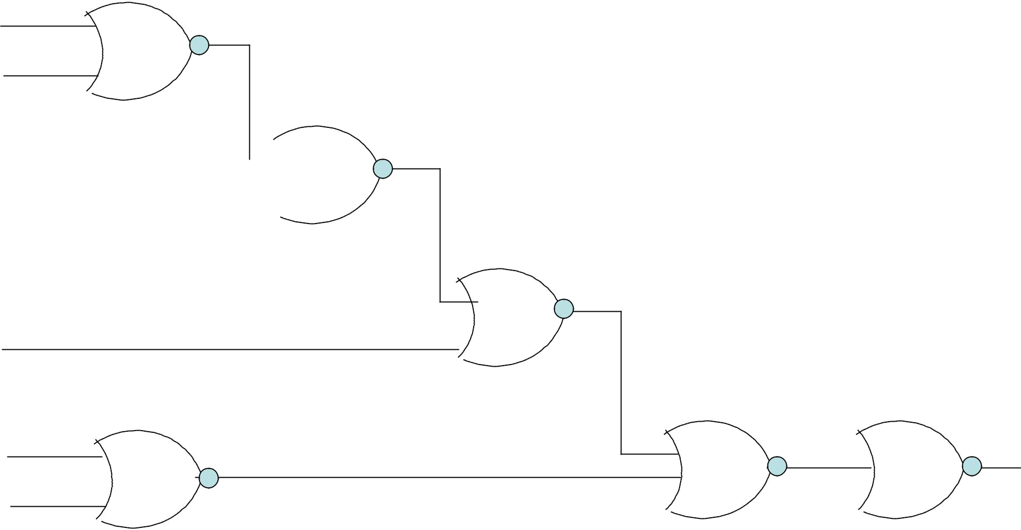
C’ | 1
D’ | 1

_{B} 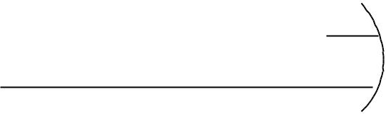 3

4
A’

B’ | 2 | 5 | 6 | F
C |  | (c) NOR implementation

Implementation of F = A (B+CD ) + BC’ with NOR gates (Block Diagram Method)
Analysis Procedure

C’ | T1
C’ | 1
D’ | 1
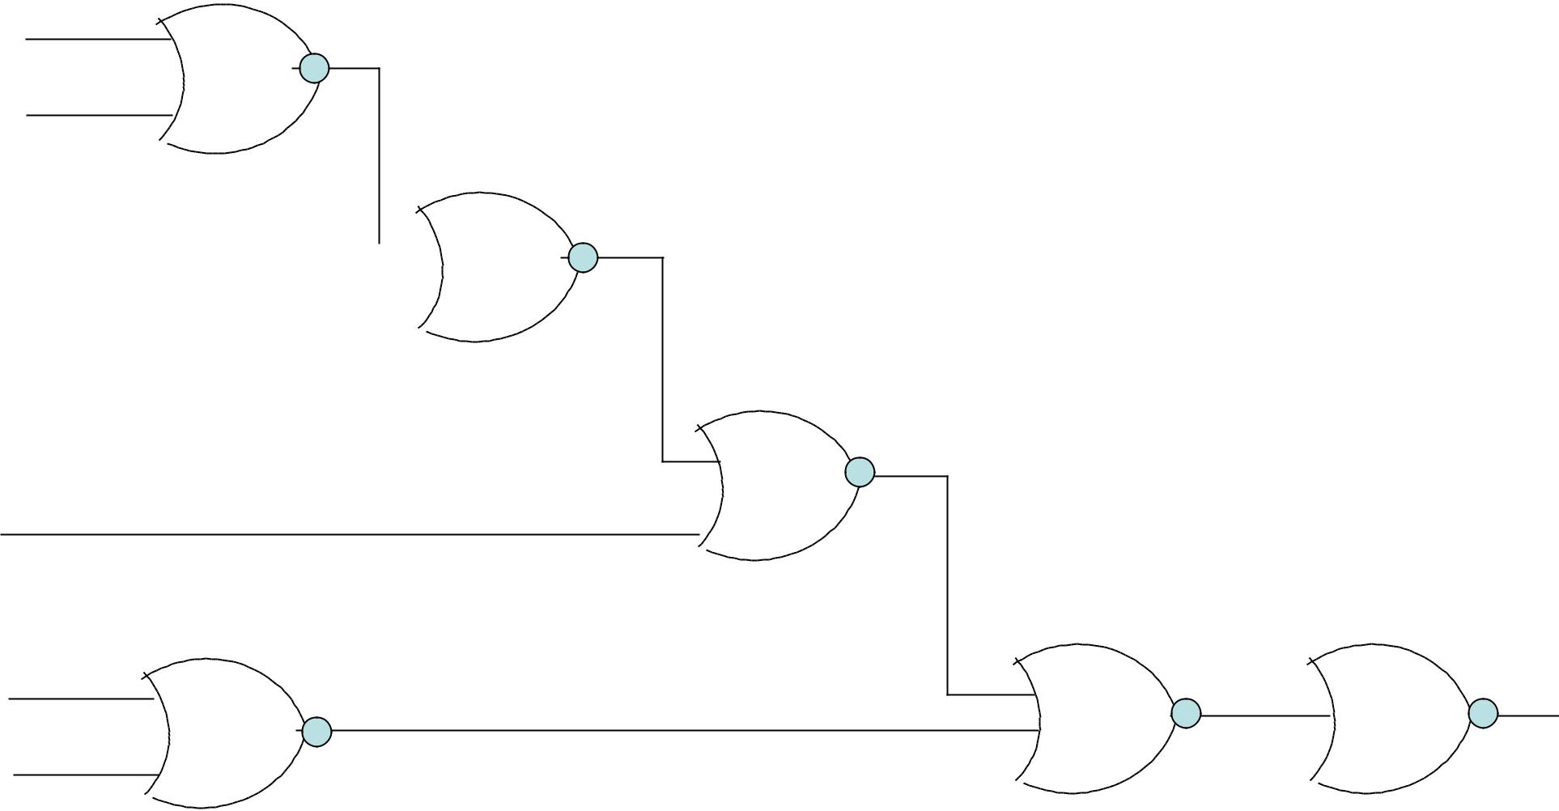

T3
_{B}  3

T4

4
A’

B’ |  | T2 |  | T5 | F
B’ | 2 | T2 | 5 | 6 | F
Method – 1 : Algebraic manipulation

T₁ = (C’ +D’)’ = CD

T₂ = (B’ + C)’ = BC’

T₃ = (B + T₁)’ = (B + CD)’ = B’ (C’ + D’)

T₄ = (A’ + T₃)’ = [A’ + B’ (C’ + D’]’ = A (B + CD) T₅ = (T₄ + T₂ )’ = [A (B + CD) + BC’ ]’

- = (T₅)’ = [{A(B+CD)+BC’}’]’

- = A(B + CD) + BC’
 | Method – 2 |  | Derivation of the truth table
A B C D |  |  |  |  | T₁ | T₂ | T₃ | T₄
0 | 0 | 0 | 0 |  | 0 | 0 | 1 | 0
0 | 0 | 0 | 1 |  | 0 | 0 | 1 | 0
0 | 0 | 1 | 0 |  | 0 | 0 | 1 | 0
0 | 0 | 1 | 1 |  | 1 | 0 | 0 | 0
0 | 1 | 0 | 0 |  | 0 | 1 | 0 | 0
0 | 1 | 0 | 1 |  | 0 | 1 | 0 | 0
0 | 1 | 1 | 0 |  | 0 | 0 | 0 | 0
0 | 1 | 1 | 1 |  | 1 | 0 | 0 | 0
1 | 0 | 0 | 0 |  | 0 | 0 | 1 | 0
1 | 0 | 0 | 1 |  | 0 | 0 | 1 | 0
1 | 0 | 1 | 0 |  | 0 | 0 | 1 | 0
1 | 0 | 1 | 1 |  | 1 | 0 | 0 | 1
1 | 1 | 0 | 0 |  | 0 | 1 | 0 | 1
1 | 1 | 0 | 1 |  | 0 | 1 | 0 | 1
1 | 1 | 1 | 0 |  | 0 | 0 | 0 | 1
1 | 1 | 1 | 1 |  | 1 | 0 | 0 | 1

^{T}₁5

1
1
1
0
0
1
1
1
1
1
0
0
0
0

0

F
0
0
0
0
1
1
0
0
0
0
0
1
1
1
1

1
 Method 3 : Block Diagram Transformation

C’

D’

B

A’

B’

C
_{A} F = (A+B+C)’
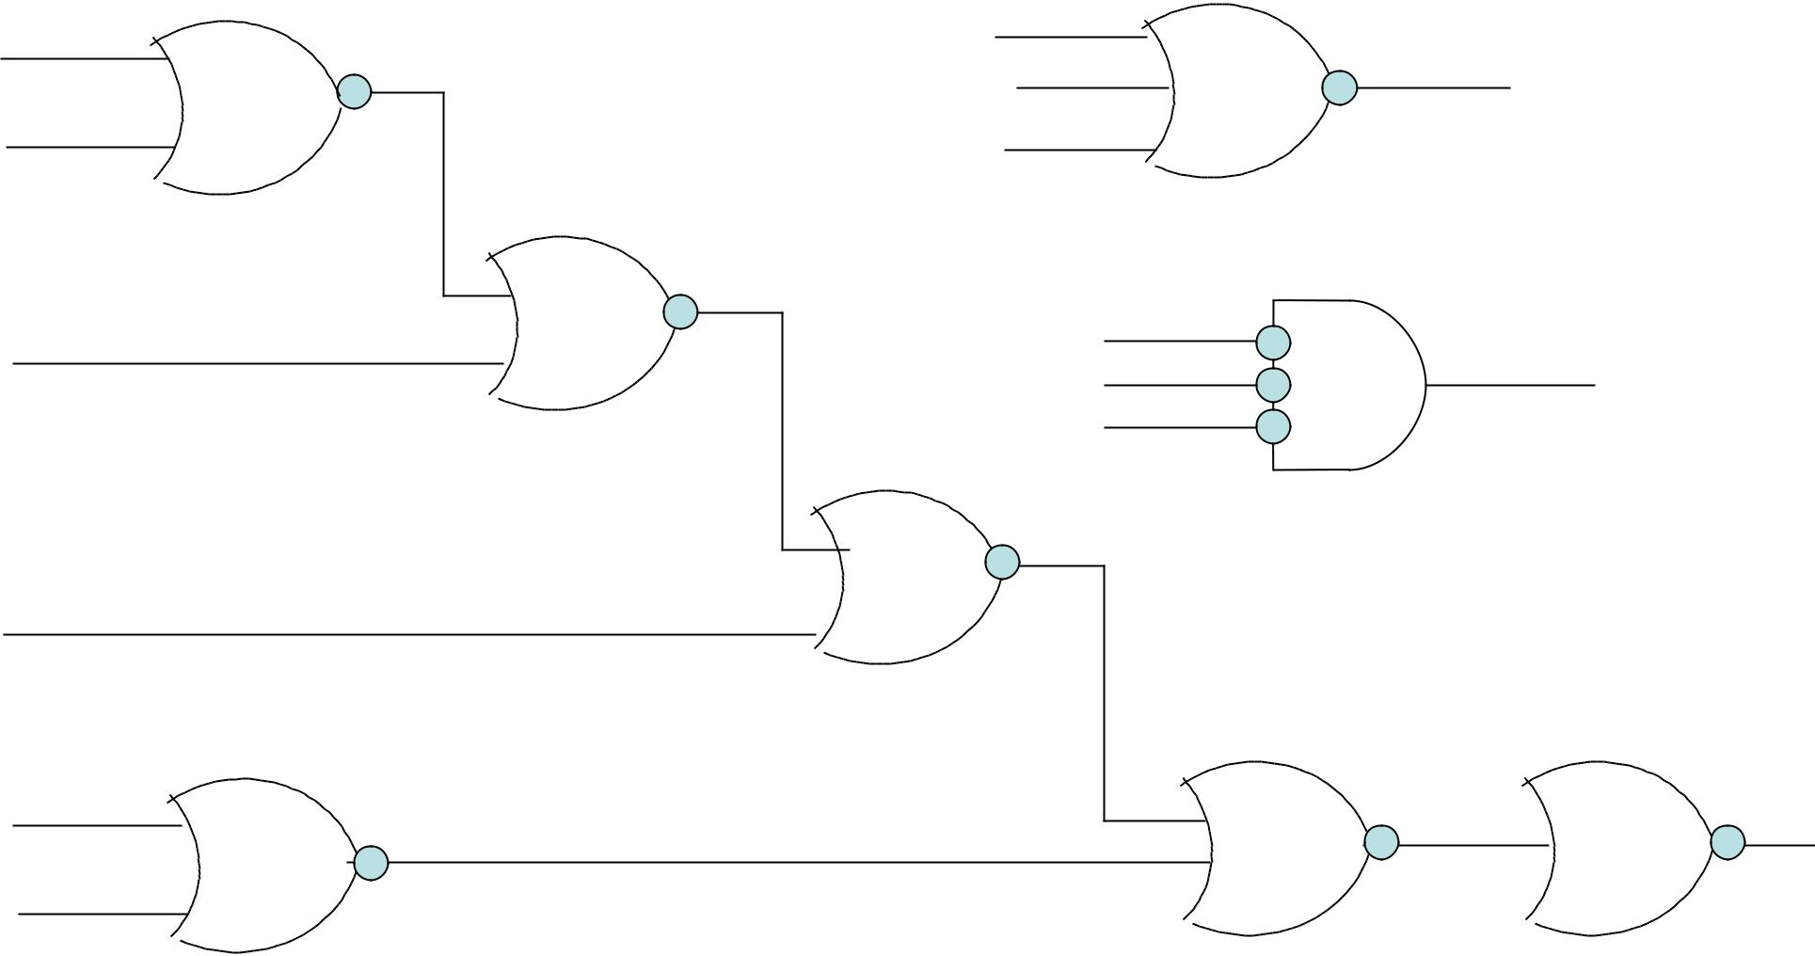

B

C

F = A’+B’+C’=(A+B+C)’
A
B

C

F

  - = (A+B+C) + BC’

- NOR Logic diagram

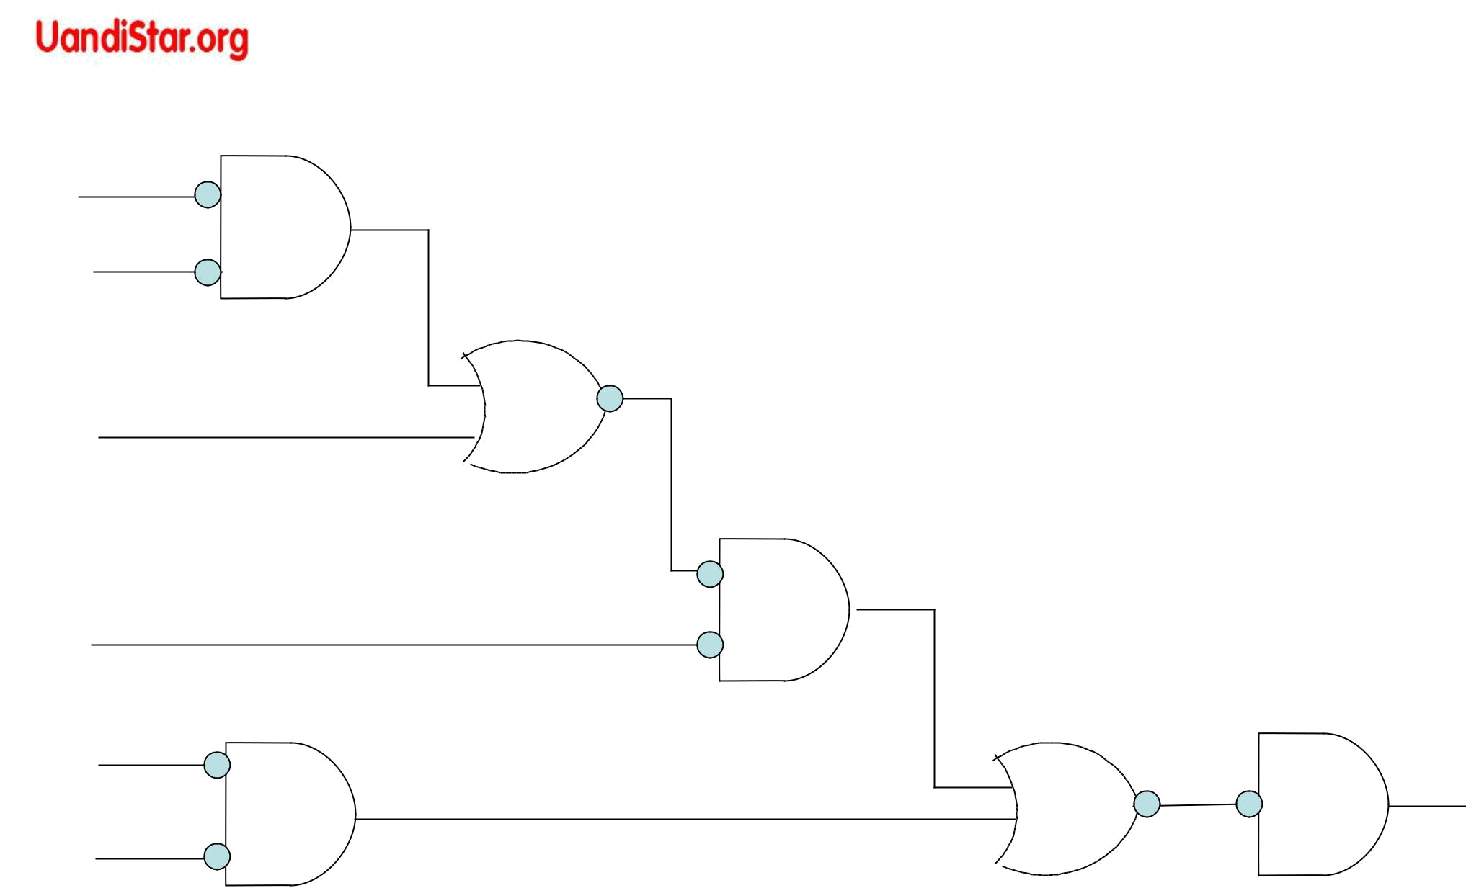
C’

D’

B

A’

B’
F

C

(b) Substitution of invert AND symbols in alternate levels
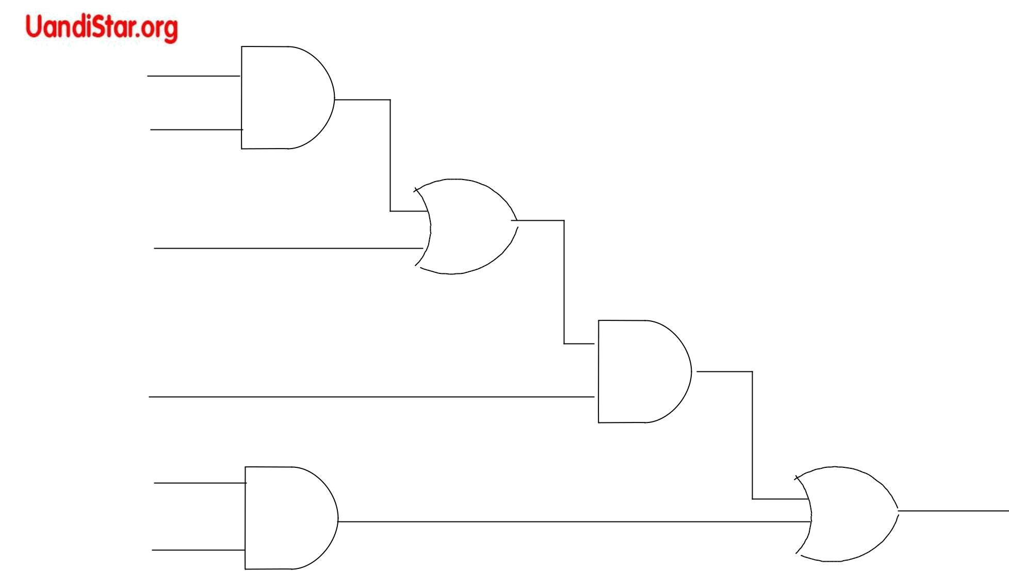
C

D
F = A(B + CD) + BC’

B

A

B

F

C’

(c) AND – OR Logic diagram

Conversion of NOR logic diagram to AND - OR
F = x Å y = x y’ + x’ y |  | F = x y = x y + x’ y’
x | F | x
y |  | y
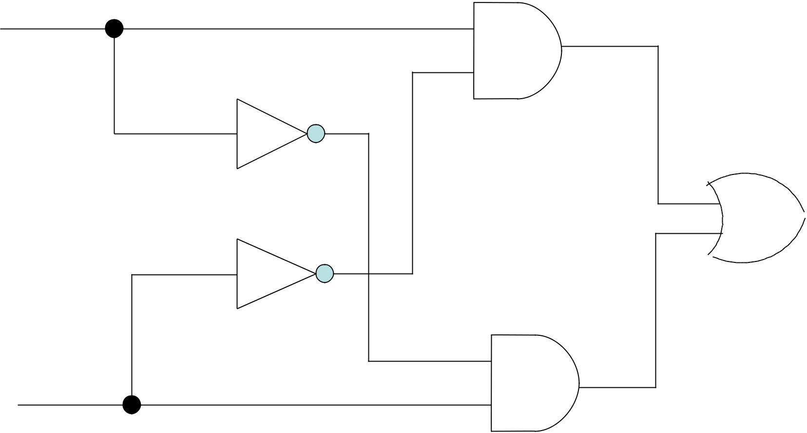
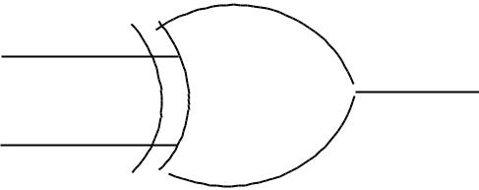
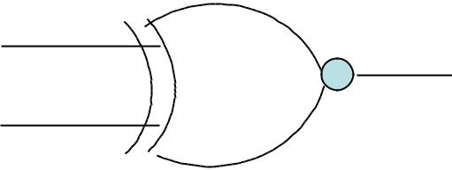


x

X  y

y

(a) With AND – OR – NOT gates (X-OR Implementation)

 | [x ( x’ + y’ )]’ = x’ + x y
x | [ ( x’ + x y)( y’ + x y)]’
 | = x (x’ + y’) + y (x’ + y’) = xy’+x’y
 | x’+y’
 | X | y
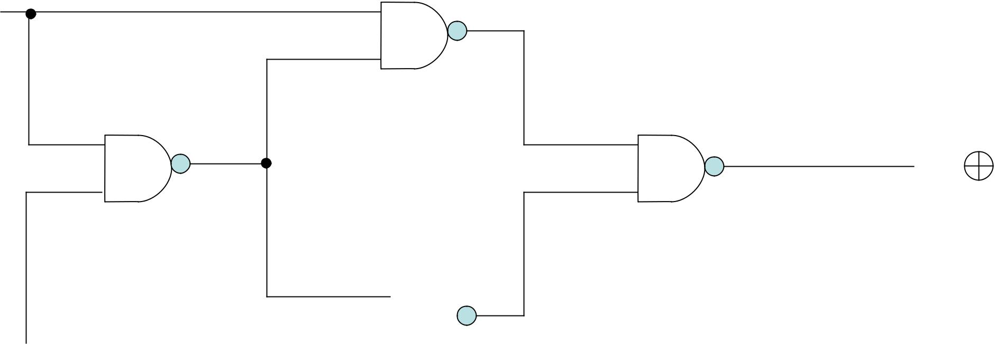

^{y} 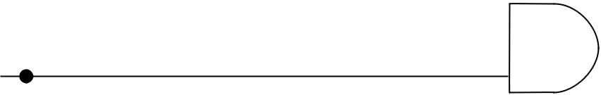 [ y (x’+ y’)]’ = y’ + x y

(b) With NAND gates (X-OR Implementation)
Exclusive – OR implementations

 | CD |  | C |  |  |  |  |  |  | C
 |  |  |  |  |  |  |  | 00 01 |  | 11 10
AB | 00 01 |  | 11 |  | 10 |  | AB
00 |  | 1 |  |  | 1 |  | 00 | 1 |  | 1
 |  |  |  |  |  |  | 01 |  | 1 |  | 1
01 | 1 |  | 1 |  |  | B |  |  |  |  |  | B
 |  |  |  |  |  |  | _{A} 11 | 1 |  | 1
_{A} 11 |  | 1 |  |  | 1
 |  |  |  |  |  |  | 10 |  | 1 |  | 1
10 | 1 |  | 1
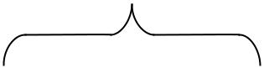
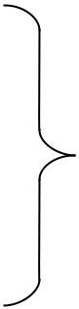
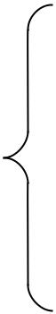
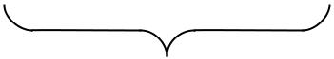
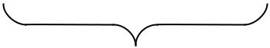

D
(a) F=A Å B Å C Å D

F=S (1,2,4,7,8,11,13,14)

(0’s and 1’s are odd)

D

(b) F=A  B  C D
F=S (0,3,5,6,9,10,12,15)

(0’s and 1’s are even

Map for a four-variable (a) exclusive-OR function and (b) equivalence function

 | BC |  |  |  | B |  | BC |  |  | B
 | 00 |  | 01 | 11 | 10 |  | 00 | 01 | 11 | 10
A ₀ |  | 1 |  |  | 1 | A 0 | 1 |  | 1
 |  |  |  |  |  |  |  | 1 |  | 1
A 1 | 1 |  |  | 1 |  | A 1 |  | 1 |  | 1
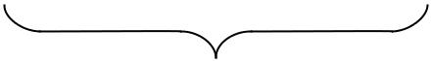
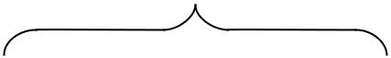
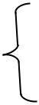

(a) ^{C}

F= A Å B Å C = A B C

(1’s are odd)

For Table (b)

(A Å B Å C)’ = F= A Å B C (A B C ) = A B Å C

Map for three-variable functions

Uses of X OR AND

(iv)Arithmetic operations

(v) Error- detection & error-correction codes

C

F= A Å B C = A B Å C

(1’s are even)

Odd-parity generation

Three-bit |  |  |  | Parity-bit
messages |  |  | Z | Generated
X | Y |  | Z | p
0 | 0 |  | 0 | 1
0 | 0 |  | 1 | 0
0 | 1 |  | 0 | 0
0 | 1 |  | 1 | 1
1 | 0 |  | 0 | 0
1 | 0 |  | 1 | 1
1 | 1 |  | 0 | 1
1 | 1 |  | 1 | 0
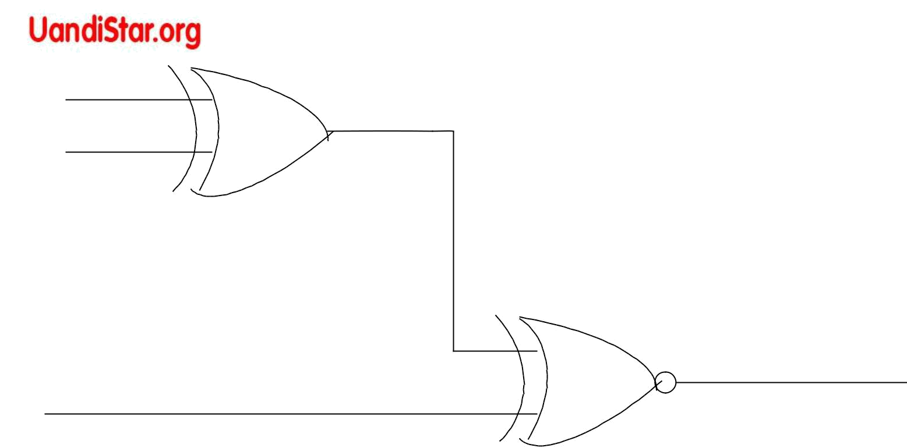
x | Logic diagrams for parity generation and checking
y | Note : Parity checker can also be used as parity
 | generator by Keeping input at 0 and making
 | output as p

z

P

(a) 3-bit add parity generator | P= x Å y z
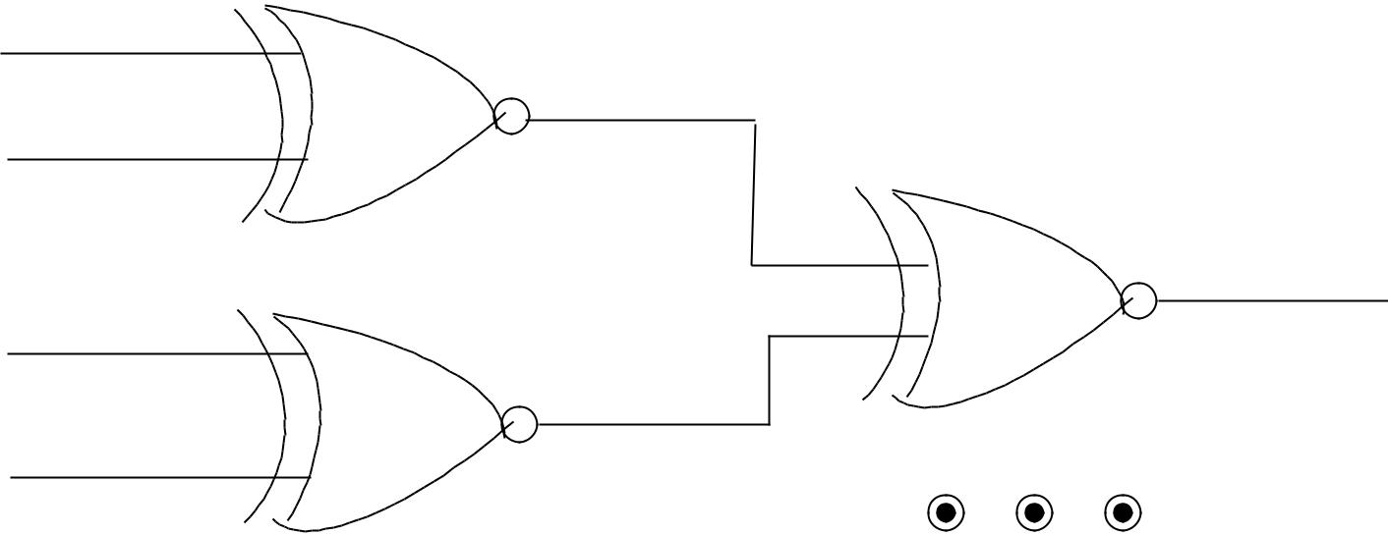

x

y

C

z
P | C= x y z p
 | (a) (b) 4-bit odd parity checker

ODD-PARITY CHECK


Four- bits received

x y z p

Parity-error check

c

0 | 0 | 0 | 0 | 1
0 | 0 | 0 | 1 | 0
0 | 0 | 1 | 0 | 0
0 | 0 | 1 | 1 | 1
0 | 1 | 0 | 0 | 0
0 | 1 | 0 | 1 | 1
0 | 1 | 1 | 0 | 1
0 | 1 | 1 | 1 | 0
1 | 0 | 0 | 0 | 0
1 | 0 | 0 | 1 | 1
1 | 0 | 1 | 0 | 1
1 | 0 | 1 | 1 | 0
1 | 1 | 0 | 0 | 1
1 | 1 | 0 | 1 | 0
1 | 1 | 1 | 0 | 0
1 | 1 | 1 | 1 | 1

