**KKR & KSR INSTITUTE OF TECHNOLOGY & SCIENCES Approved by AICTE, New Delhi | Affiliated to JNTU, Kakinada**

Accredited by NBA & NAAC

NATIONAL WORKSHOP

on

RETOOLING LANGUAGE TEACHING TO THE STUDENTS OF PROFESSIONAL COURSES

1st, 2nd & 3rd November, 2K18

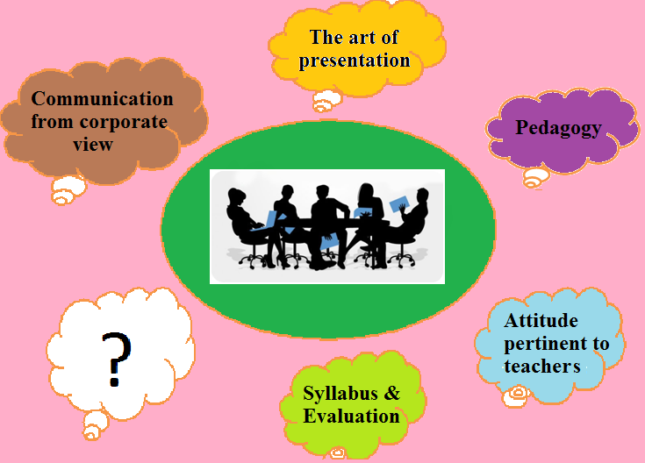

**Organized by**

**The Dept. of Science & Humanities**

**KKR & KSR Institute of Technology & Sciences**

**Vinjanampadu(V), Vatticherukuru(Md), Guntur, A.P - 522017**

**www.kitsguntur.ac.in**

**Mail: kitsengws2k18@gmail.com**

**Ph:-0863-2286666/77**

**About KKR & KSR Institute of Technology & Sciences**

KKR & KSR Institute of Technology & Sciences, a pioneering institute in the capital region of Andhra Pradesh is located amidst serene environment at Vinjanampadu Village of Vatticherukuru Mandal, 5 km away from Guntur. Since its inception in 2008 the institute has been marching ahead with thunderous achievements. From a modest intake of 240 students the institute is now a potential one offering quality education to the students over 3000 with a provision of quality infrastructure.

KITS offers UG programmes in the Departments of CSE, EEE, ECE, Mechanical and Civil Engineering. The institute is accredited by NBA and NAAC and is permanently affiliated to JNTUK.The institute also offers PG programmes in MBA, M.Tech (CSE), M.Tech (VLSI), M.Tech (DECS).

With an emphasis on innovation and by adopting latest technologies to improve life, KITS encourages research, conferences, seminars, workshops, technical fests and hackathons which resulted in 10 start-ups from intellectual brains within the campus. The institute leaves no stone unturned to enable the students and the staff reach their goals. It creates unbounded space for one to grow to one’s fullest potential. Every year about 500 students are being placed in corporate organizations. Besides others there have been 92 placements in Capgemini, 13 in TCS so far during this semester.

**About S & H Department**

The department of Basic Sciences and Humanities in KKR & KSR Institute of Technology and Sciences is synthesized with dedicated team of faculty members, quality infrastructure, fully equipped laboratories and good facilities.

The department is a unique combination of multiple disciplines of thought like Languages, Mathematics, Physics, Chemistry, Environmental Studies, Professional Ethics, Physical Education, Library and Management Studies. It offers necessary training to the students to enhance their communication skills by organizing English language clubs. The department engages in orienting the freshers for a successful college career and imbibes in them the qualities of continuous learning. The members of the department effectively contribute to all the activities belonging to the student clubs, literary and cultural events.

The department also offers training in life skills, verbal reasoning, arithmetic for campus placements etc. The department firmly believes that a good foundation is the life for a huge structure. A well-disciplined career builds up the character. The department works towards realizing this truth.

**Objectives of the Workshop**

Language refines, civilizes, empowers, humanizes…! Human learning begins before birth and continues till death as a consequence of ongoing interactions between person and environment.

Sea changes have swept the education system across the globe. Today, the focus is on learner-centric education. The teacher – student relationship is not that of a boss and a subordinate or that of ‘a respectable guru and an obedient shishya’. The ever cheerful, empathetic and inspiring teacher needs to be a friend, philosopher and guide.

“I cannot teach anybody anything. I can only make them think” – Socrates

As a facilitator of learning, a teacher helps students in acquiring new or modifying existing knowledge, behaviors, skills, values or preferences. Precisely these are the objectives of the workshop. Let us think out of box, share our ideas, experiences and thereby empower ourselves and our students.

**Topics**

1. Attitude Pertinent to Teachers of Professional Courses
2. Pedagogy Related to Language Teaching to Students of Professional Courses
3. Communication from Corporate View
4. The Art of Presentation of Content
5. Syllabus and Evaluation Systems

**RESOURCE PERSONS**

1. Dr.A.S.Rama Krishna

2. Dr. K. Suresh Kumar

3. Dr. G. Chenna Reddy

4. Dr. P. Yamini

5. Dr. Sk. Shabree Sultana

6. Prof. P. Gopichand & Prof. P. Naga Susila

7. Mr. K. Prabhakara Rao

**How does each session proceed?**

Each session proceeds in two time slots

**Slot 1:** Each topic is discussed in groups by the participants. Then, the participants share their opinions, experiences and strategies pertaining to the topic with other groups.

**Slot 2:** The Resource person deals with the topic and then interacts with the participants.

**Registration Form**

Registration Fee : Rs. 300/-

Name of the Participant :

Designation :

Mobile No. :

Email ID :

Name &

Address of the Organization :

Date:

Place:

Signature of Signature of the the Principal Participant

Participants are requested to mail the filled in form to the following

Email ID: **kitsengws2k18@gmail.com**

**Who can attend?**

1. Faculty of professional institutes
2. Aspirants

For registrations and details please contact:

1. Ms. Pavani Gonnuri - +91 8500244671
2. Mr. Y. Ramu - +91 7382731230

**ORGANISING COMMITTEE**

**CHIEF PATRONS**

Sri Koye Subba Rao, Chairman

Sri Koyi Sekhar, Secretary

**PATRON**

Dr. P. Babu, Principal

**CHAIR PERSON**

Prof. M. Basaveswara Rao, +91 9441185032

HOD, Dept. of Science & Humanities

**CONVENORS**

Dr. N. Aravind, Prof. of English,

+91 9490187628

Mr. M. Nageswara Rao, Asst. Prof. of English,

+91 9885427024

**MEMBERS**

Ms. Pavani Gonnuri

Mr. Ramu Yarlagadda

Mr. V. Srinivasa Rao

Mrs. A. Sirisha

Mrs. N. Ram Devi

Mr. N. Suresh

Mrs. I. Vidya Rekha