JULY Volume-1 2024



TechnoPhilia



Editors: Advisor:

Prof. R.Ramesh,CSE. Dr. Ch. Aruna Professor,CSE

Dr. P. G. K.Sirisha, Assoc.Prof. CSE Dr.R.V.Kishore Kumar,CSE

Mrs. Ch. Durga Bhavani, Assist Prof, CSE Dr. A. Suneetha, CSE

Mr.B.S. Narayana Reddy,CSE

**Contents**

|  |  |
| --- | --- |
| **Items** | **Page no** |
| **About the Department** | **2** |
| **Vision of the Department** | **2** |
| **Mission of the Department** | **2** |
| **College Activities** | **3** |
| **Department Events** | **9** |
| **Student Achievements** | **16** |
| **Placement Details** | **16** |

**Student coordinators:**

N. Naga Pavan (21JRA05C0)

P. Praveen Kumar (21JR1A05C2)

K. Satya Sai (21JR1A0562)

T. Rohith ( 22JR5A0516)

Department of Computer Science and Engineering

July Volume-1 2024

Page2

KKR & KSR Institute of Technology and Sciences

Vinjanampadu, Vatticherukuru Mandal, Guntur, Andhra Pradesh – 522017 Email:[hodcse@kitsguntur.ac.in](mailto:hodcse@kitsguntur.ac.in)

About the Department

The KKR & KSR Institute of Technology and Sciences was established Computer Science and Engineering stream in the year of 2008. The Department of Computer Science and Engineering educates knowledge of computer and its engineering. Almost all fields are computerized to have an ease of handling the problems of designing, manufacturing, maintenance, servicing, researching, marketing and accounting. The B.Tech computer engineering program includes computer operations on different languages, data generation, collection and utilization of information. The Department is implementing OBE based education.

|  |  |
| --- | --- |
| Vision | Mission |
| To become a reputed center in computer Science and systems engineering for quality, competency and social responsibility | 1. Providing a strong theoretical and practical education in a congenial environment. 2. Providing additional skills and training to meet the current needs of the industry. 3. Inculcating ethical values to meet the challenges of life with courage and confidence. |

Department of Computer Science and Engineering

*College Achievements*

**Department of CSE Students participated in A 3-Days Tech Camp on "Google Android Developer" from 01.07.2024 to 03.07.2024 conducted by Eduskills**[**@KITS**](https://www.instagram.com/KITS/)

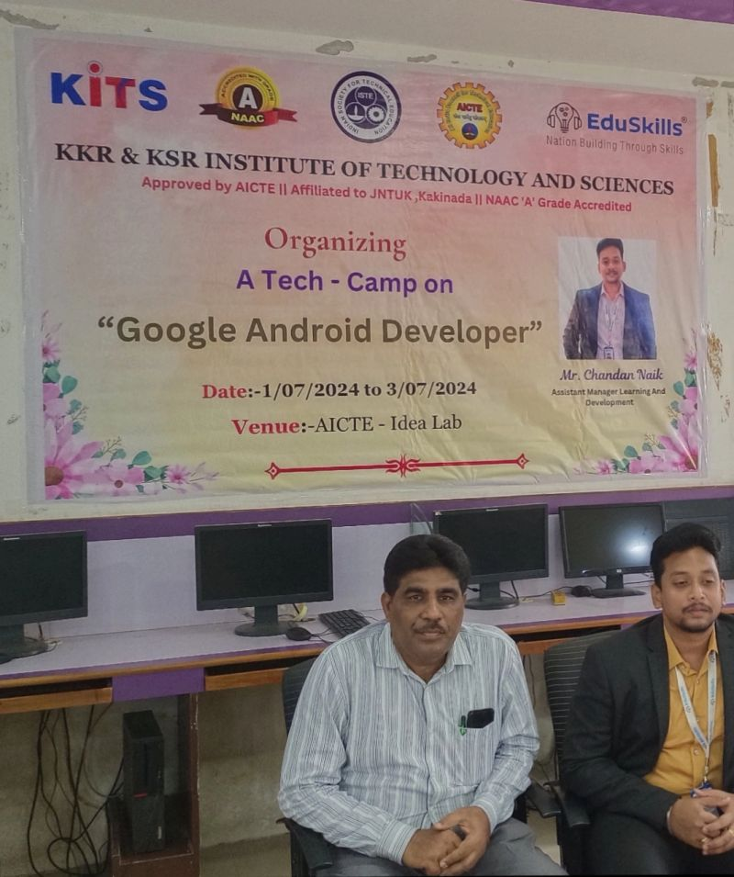

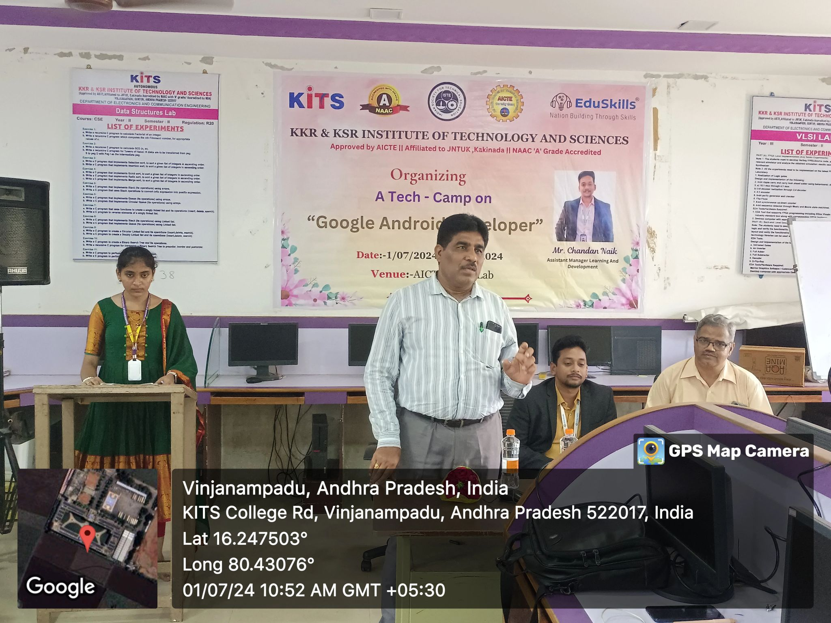

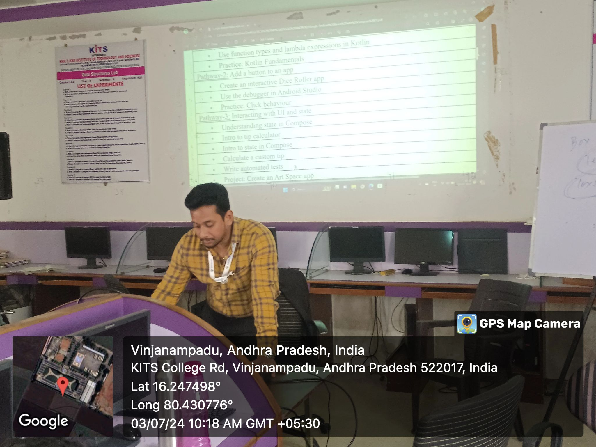

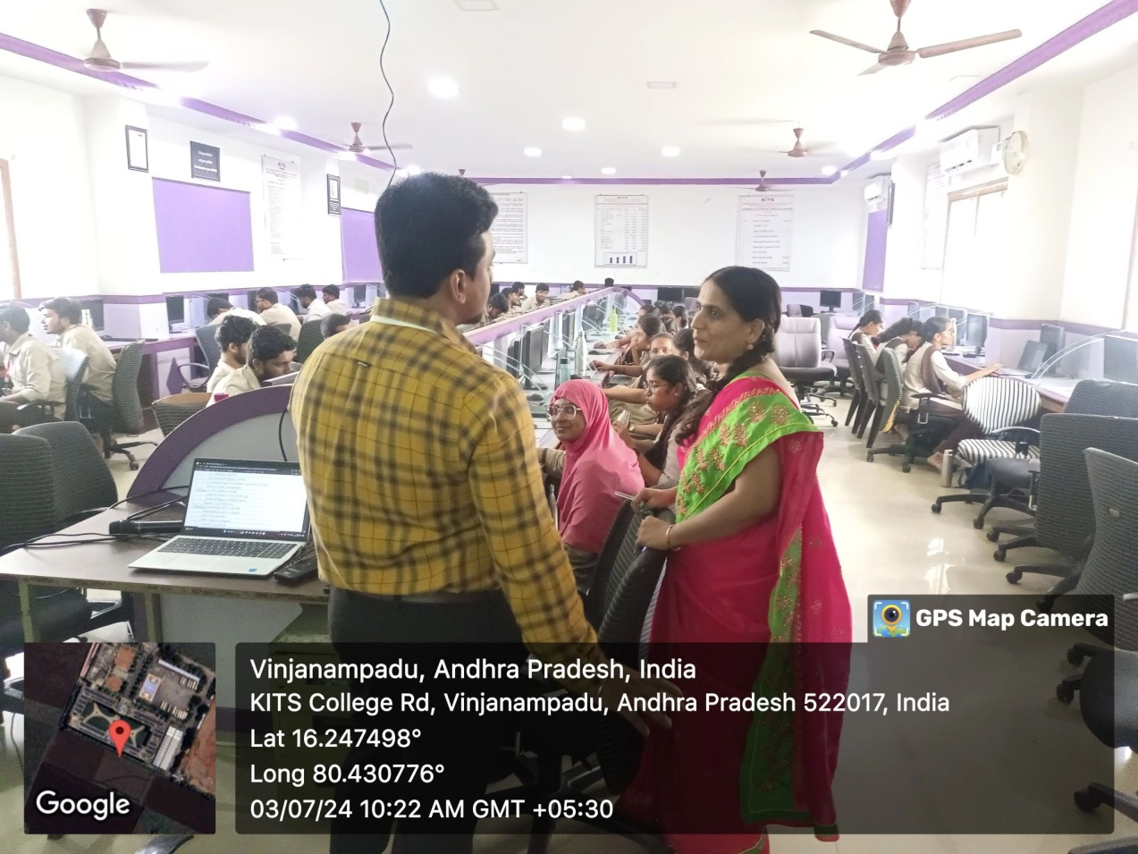

**Social Media Links:**

<https://www.facebook.com/share/p/AZpaLmD4zMA7wd9H/?mibextid=qi2Omg>

<https://www.instagram.com/p/C-FtX_eBNeO/?igsh=ZjRsamR6cDJ3M3Rt>

<https://www.linkedin.com/posts/kitsguntur-cse-ab4330264_computersocietyofindia-kitsguntur-computerscienceengineering-activity-7224413129919676416-x5XE?utm_source=share&utm_medium=member_android>

**Department of CSE Students got the prizes in a Movie promotion of "Alanati Ramachandrudu" on 23.07.2024**[**@KITS**](https://www.instagram.com/KITS/)

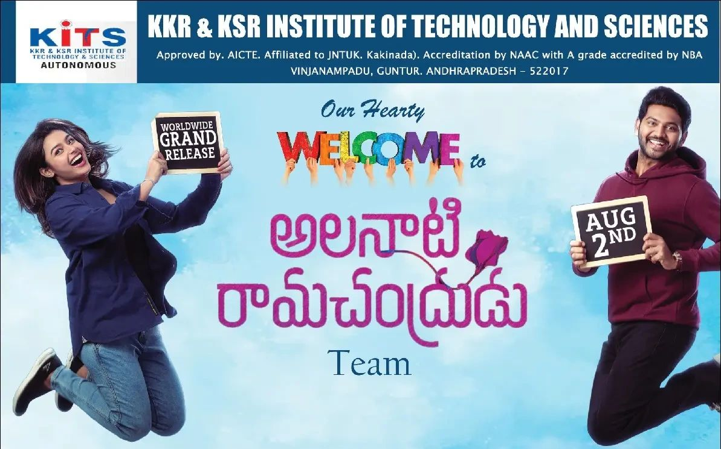

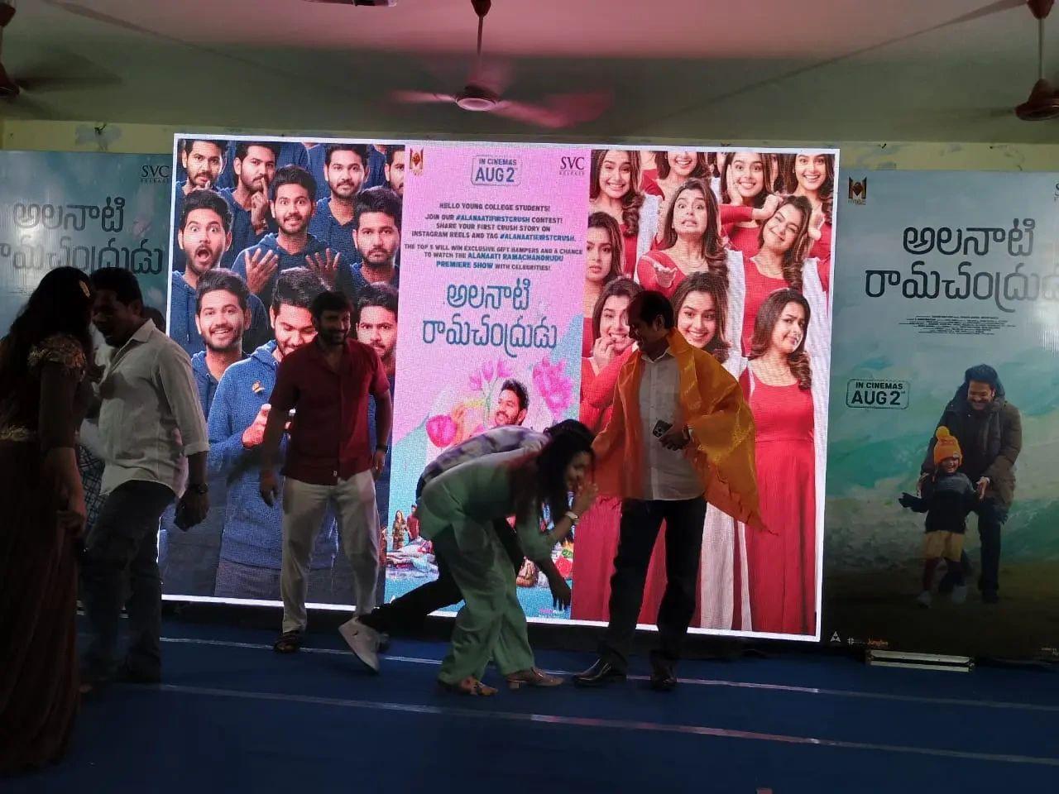

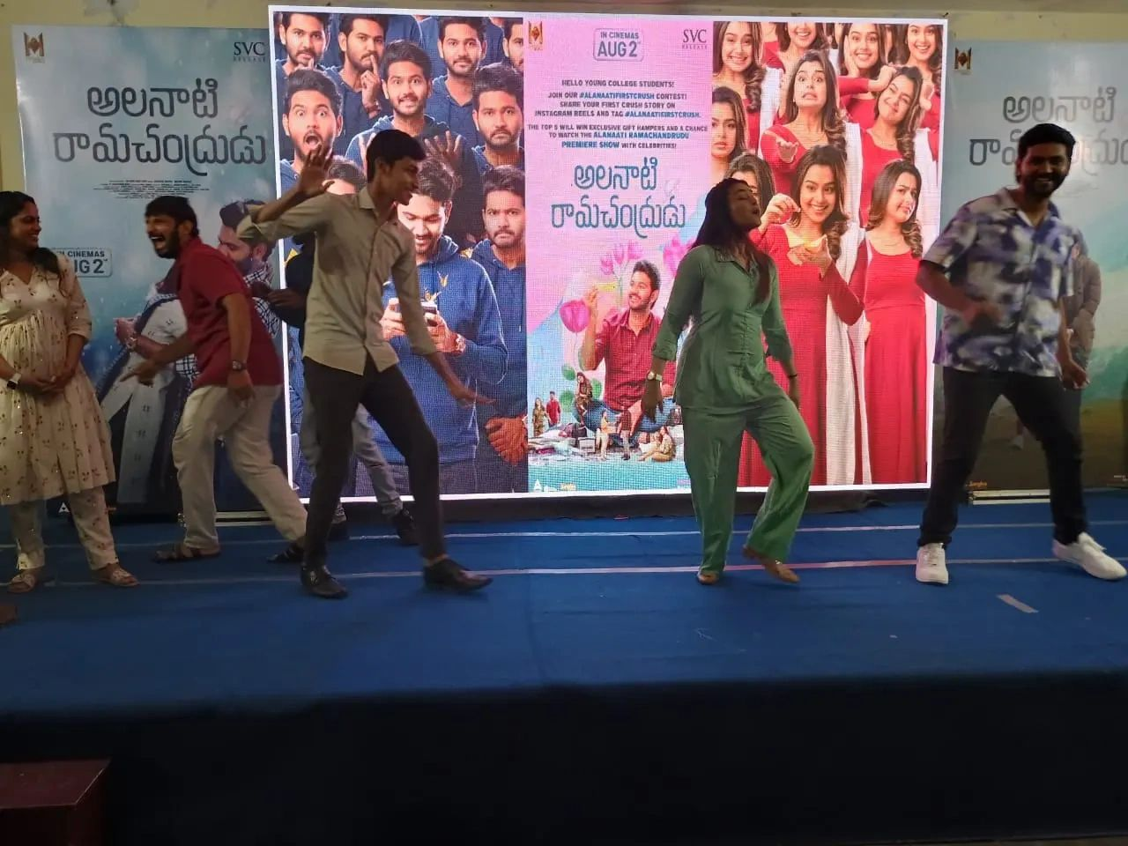

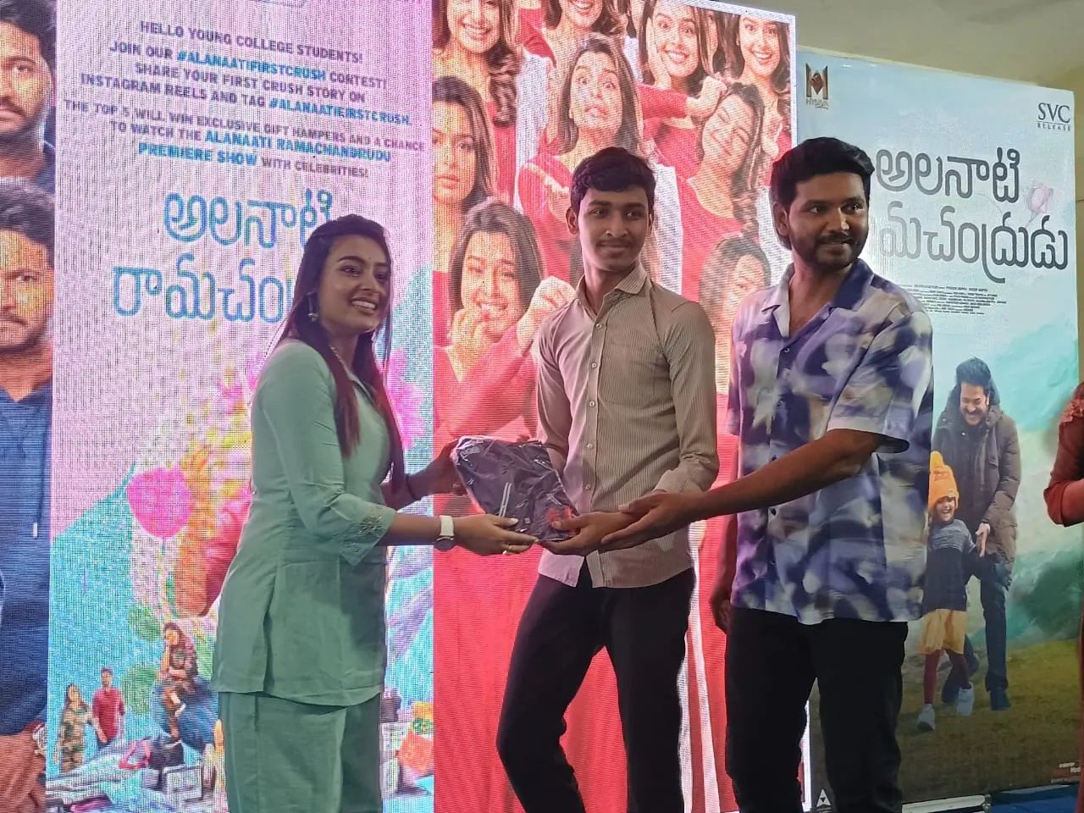

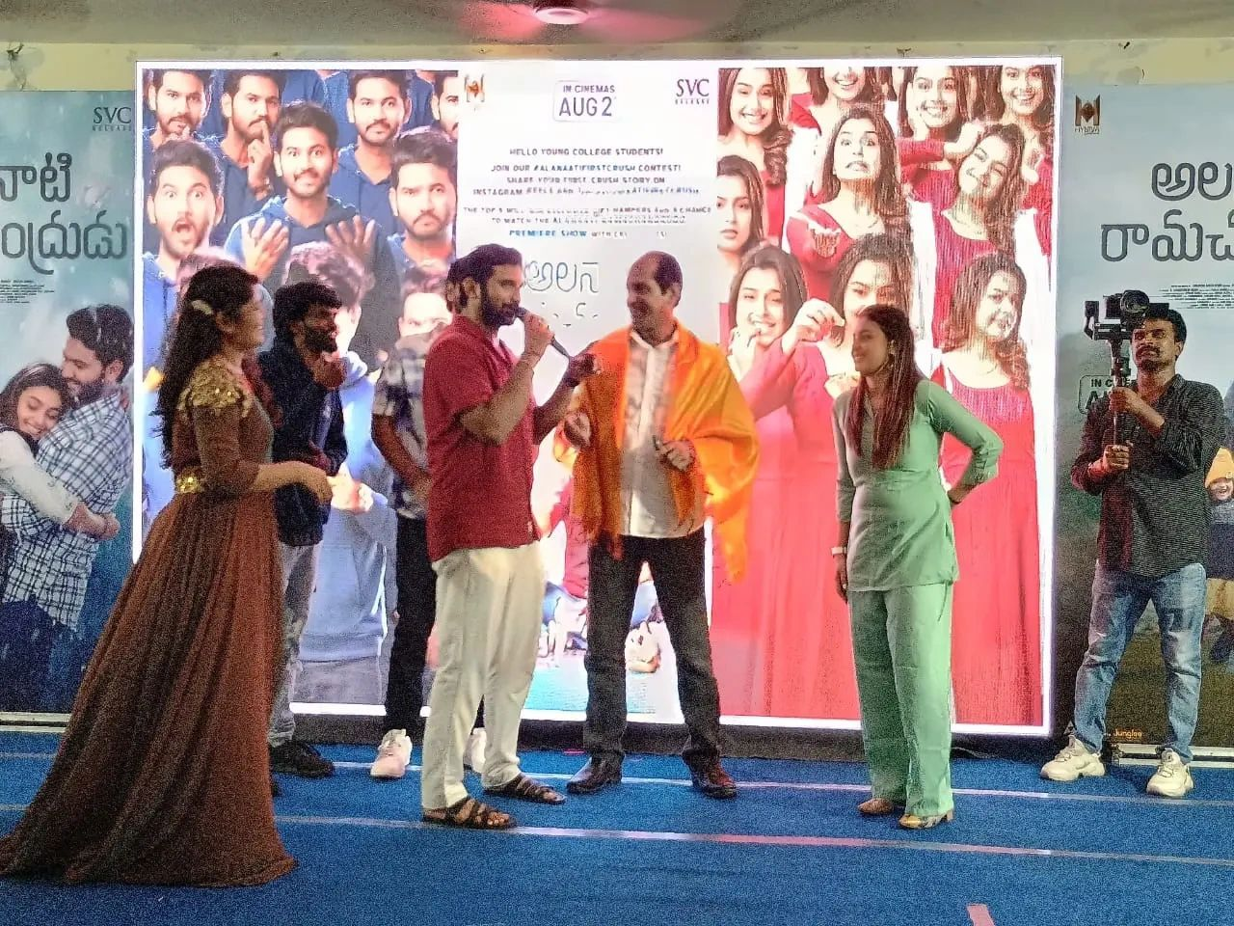

**Social Media Links:**

<https://www.facebook.com/share/p/rJpDdjMv3f6vJ6Z8/?mibextid=oFDknk>

<https://www.instagram.com/p/C-FyGWtB8xI/?igsh=Y2w4MjhvZjZpdHh0>

<https://www.linkedin.com/posts/kitsguntur-cse-ab4330264_alanatiramachandrudu-computersocietyofindia-activity-7224420354952155137-B8if?utm_source=share&utm_medium=member_android>

**Department of CSE organised 3-Days Motivational session on “Life Skills, Leadership skills, Entrepreneurship skills, Attitude and Behaviour”**

**on 26th, 27th and 29th July 2024**

**1. Objective of the Event:**

Department of CSE organised 3-Days Motivational session on “Life Skills, Leadership skills, Entrepreneurship skills, Attitude and Behaviour” by Mr. Syed Rafi, Motivational Speaker from Delhi on 26th, 27th and 29th July 2024 at KITS, Guntur. The presenter himself is a source of motivation to students gave encouraging examples from his own life and inspired students. He discussed about various perspective of life to change the mind set towards the goals like respect yourself, celebrate the small achievement, have some gratitude etc.. He discussed the important of goals in life which brings optimism into life and such constructive changes can make once life brighter and successful.

**2. Name of the Resource Persons:**

Mr. Syed Rafi, Motivational Speaker from Delhi.

**3. Participants:** II year, III year and Final year Students were participated fromthe Department of CSE.

1. **Social Media Links:**

<https://www.facebook.com/share/p/n5bud5xn7CnFfdmS/?mibextid=oFDknk>

<https://www.linkedin.com/posts/kitsguntur-cse-ab4330264_computersocietyofindia-kitsguntur-computerscienceengineering-activity-7222574371859546113-ud0Y?utm_source=share&utm_medium=member_android>

<https://www.instagram.com/p/C94mFHThBbr/?igsh=MTd3ZHU3N2g5dzQyag>==

1. **Date & Venue of the Event:**

The event is organized in Offline mode in KKR & KSR Institute of Technology and Sciences, Vinjanampadu, Guntur, Andhra Pradesh in Old seminar hall Idea Lab from 10.00 AM to 5:00 PM. From 26th July to 29th July2024.

1. **No. of Participants: 210**
2. **Banners:**

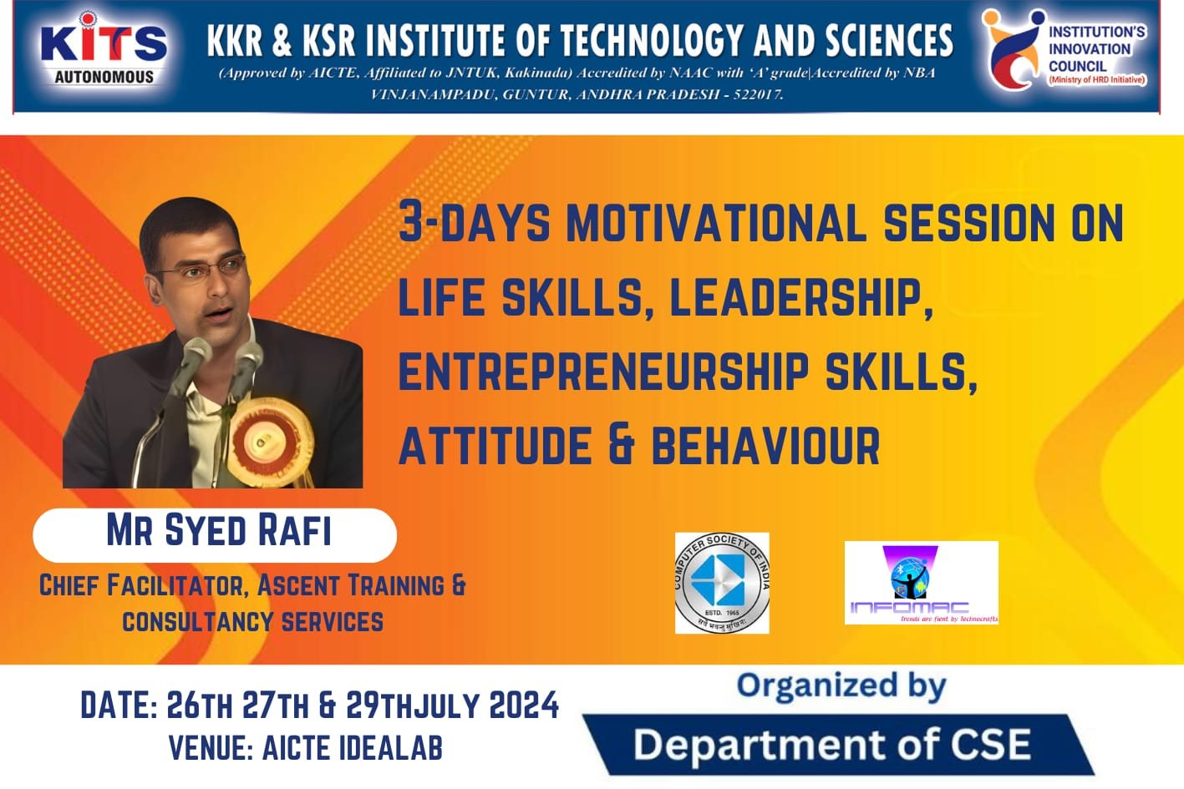

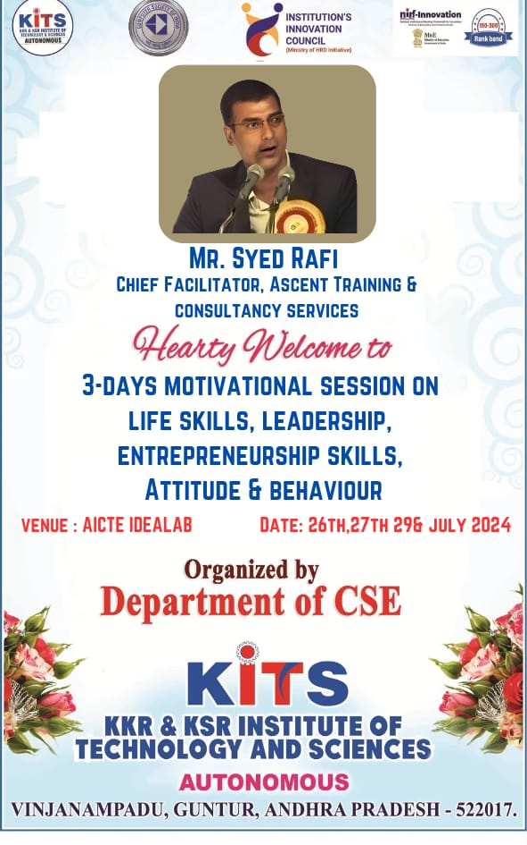

## Event Photographs:

## E:\1aCSI 2024-2025\july\finalyear\WhatsApp Image 2024-07-26 at 4.45.58 PM.jpeg

## 

## E:\1aCSI 2024-2025\july\finalyear\WhatsApp Image 2024-07-26 at 4.42.18 PM.jpeg

## E:\1aCSI 2024-2025\july\finalyear\WhatsApp Image 2024-07-27 at 3.41.14 PM.jpeg

## E:\1aCSI 2024-2025\july\finalyear\WhatsApp Image 2024-07-27 at 3.41.15 PM.jpeg

## E:\1aCSI 2024-2025\july\finalyear\WhatsApp Image 2024-07-29 at 7.53.51 PM.jpeg

## E:\1aCSI 2024-2025\july\finalyear\WhatsApp Image 2024-07-29 at 7.53.52 PM.jpeg

## E:\1aCSI 2024-2025\july\finalyear\WhatsApp Image 2024-07-29 at 7.53.49 PM.jpeg

## E:\1aCSI 2024-2025\july\finalyear\WhatsApp Image 2024-07-29 at 7.53.48 PM.jpeg

## News Paper Clippings:

## 

## E:\1aCSI 2024-2025\july\finalyear\WhatsApp Image 2024-07-29 at 7.52.01 PM.jpeg

.

***STUDENT ACHIEVEMENTS***

**Campus Placement Details for the Month of June, 2024**

Our 2020-24 batch students got placed in several companies in this Academic year. The table gives the summary of campus placements conducted up-to June, 2024.

|  |  |  |
| --- | --- | --- |
| **S. No** | **Name of Company** | **No of students Selected** |
| **1** | **Accenture(HD)** | **12** |
| **2** | **AvyaIT** | **1** |
| **3** | **Codegnan** | **7** |
| **4** | **Deloitte** | **2** |
| **5** | **GeekMinds** | **1** |
| **6** | **GoDigit** | **2** |
| **7** | **Kodenest** | **20** |
| **8** | **Miracle** | **9** |
| **9** | **Norwin** | **3** |
| **10** | **Pilog** | **1** |
| **11** | **Pivox** | **4** |
| **12** | **Savantis** | **17** |
| **13** | **Snovasys** | **3** |
| **14** | **TapAcademy** | **4** |
| **Total Placements** | | **86\*** |

\***Still Counting**

**\*\*\*\*\*\*\*\*\*\*\*\*\*\*\*\*Congratulations to all selected candidates\*\*\*\*\*\*\*\*\*\*\*\*\*\*\***