**KKR&KSR Institute of Technology and Sciences**

**Vinjanampadu, Guntur, Andhra Pradesh-522017**

Approved by AICTE, New Delhi and Permanent Affiliation from JNTUK, Kakinada

Accredited with “A” Grade by NAAC & NBA Accreditation Status for 5 UG (CSE, ECE, EEE, ME, Civil )

**DEPARTMENT OF MASTER OF BUSINESS ADMINISTRATION**

**National level five day online Faculty Development Program**

**On**

**“Innovative Business Strategies for Post Covid-19 Pandemic”.**

( From 8th to 12th june, 2020)

**About the Program/Event**:

National level five day online Faculty Development Program(FDP) was organized by our MBA department, during 8th to 12th june, 2020 on the topic "Innovative Business Strategies for Post Covid-19 Pandemic. The resource persons were invited from the top premier institutions of the country, viz., IIM-Shillong, NIT Jalandhar, Central University of Hyderabad, SRM University, Chennai and Siva Sivani Institute of Management Hyderabad. Participants have attended the online sessions across the country. The program has witnessed the overwhelm response from the participants. Registrations have comes from nearly twenty states of the country.

**Objective of the Event: FDP**

The objective of the FDP Program is that due to the Covid-19, Corona virus there has been

lockdown in almost all sectors worldwide. There has been sudden fall down in the

Manufacturing sector, Retail sector, Health care, Pharma, Airways, Tourism, Film industry,

Banking and Education sector, etc. As a result of this the Indian economy and GDP also

reduce to surprising figures. The attitudes of both manufactures and customers have changed

tremendously. A vacuum has been occupied in the entire business environment in the global.

keeping these issues the above said title was decided to the program. The primary objective

of the FDP was to suggest suitable and innovative business strategies so that to cope up from

this pandemic environment.

* **Details of Resource Persons** :
  + Dr.Pradeep Kumar Dadabada, Assistant professor, IIM shillong.
  + Dr.A.Chandra Mohan, Professor of Management Studies SRM University, Chennai.
  + Dr.Sonia Chawala, Associate Professor, Department of Science & Humanities NIT, Jalandhar.
  + Dr,ChetanSrivastava, Associate Professor, School of Management Studies, CentralUniversity of Hyderabad.
  + Dr.Kunal Gaurav, aera Chair person and Consultancy Siva Sivani Institute of Management, Hyderabad
* **Venue of the program**: Goto Meeting App , KKR and KSR Institute of Technology,

Guntur, Andhra Pradesh.

* **Total no. of participants**: 157(142+10+5)
* **Banner and poster of the Event:**

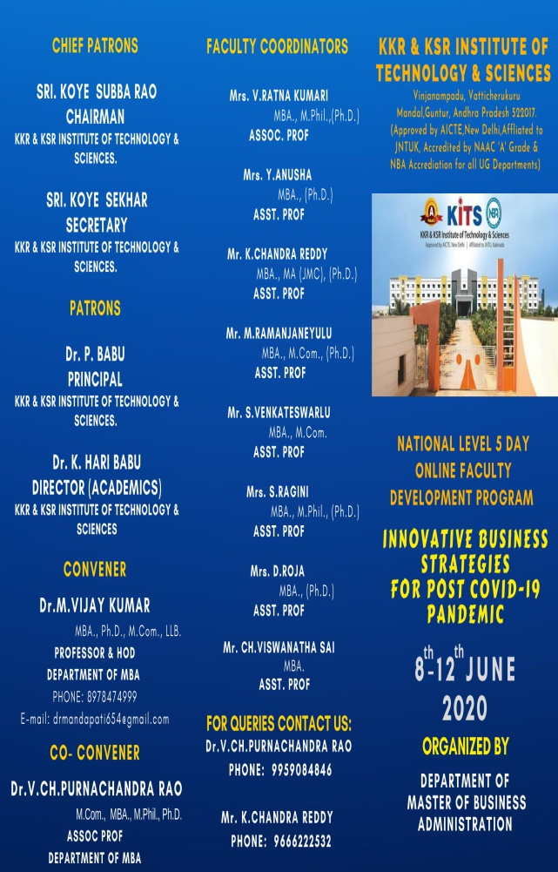 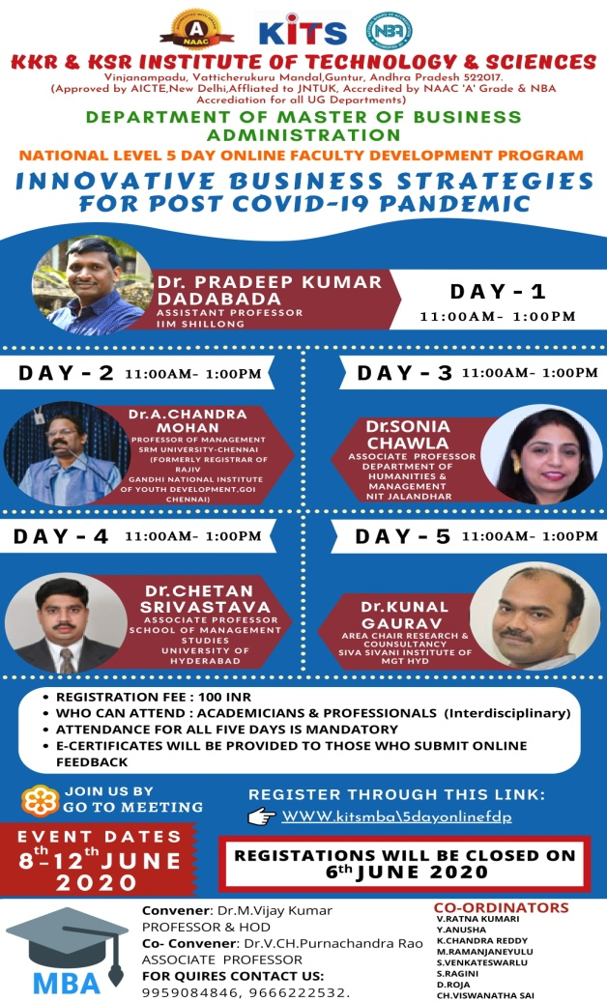

Resource persons were invited from various parts of the country and from various prestigious management institutions they have well given different innovative strategies which can be applicabe both industry and post Covid-19.

* **FDP Day-1:**

On 8th june Dr.Pradeep Kumar Dadabada, Assistant professor, IIM shillong has given a lecture on "Financial Time series Predictions in times of Covid-19".

Event photographs:

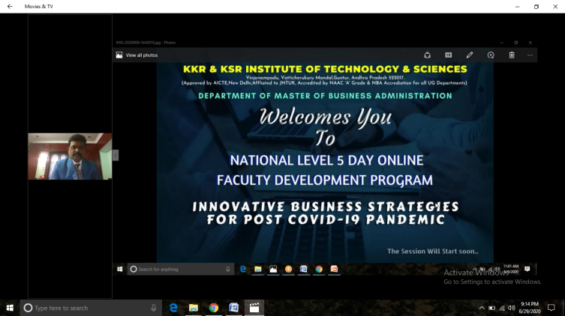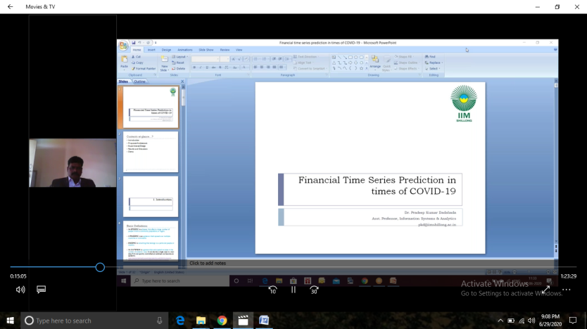

**Day-2:**

On 9th June Dr.A. Chandra Mohamn ,Professor of Management Studies SRM University, Chennai has given lecture on "Innovative business strategies and skills".

Event photographs:

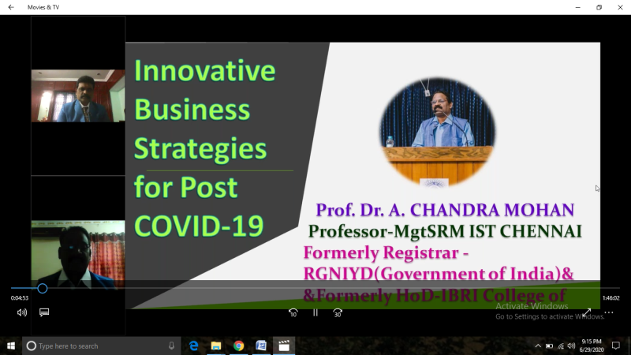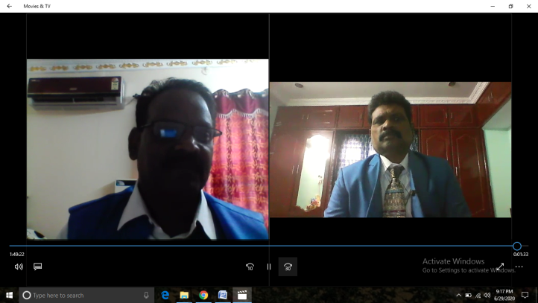

**Day-3**

**On** 10th june Dr.Sonia Chawala, Associate Professor, Department of Science & Humanities, NIT, Jalandhar has given the webinar on "Mitigation Strategies for Post Covid-19 Challenges for Higher Education Institures in India".

Event photographs:

**Day-4**

On 11th june DChetanSrivastava, Associate Professor, School of Management Studies,

Central University of Hyderabad , has discussed on the topic "Revisiting Marketing in Post Covid-19 Environmnet" .

Event photographs:

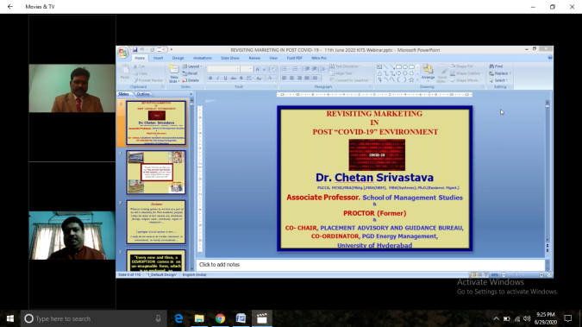

**Day-5:**

On 12th june 2020 the session was taken by Dr.Kunal Gaurav, aera Chair person and

Consultancy Siva Sivani Institute of Management Hyderabad on the topic "Post covid-19

Teaching Strategies of Management Teachers".

Event Photographs:

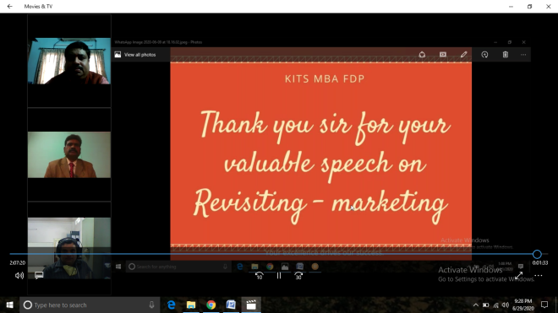

* **Registration details: participants**: 157(142+10+5)

Event Photographs:

* **Feed back on the Program:**
* The most commonly encountered impediment to participation in FDPs is teachers' beliefs that teaching skills and expertise were sufficient for excellent teaching.
* Our FDP program produce promising outcomes in the learning and innovative business strategies have proven effective in developing faculty skills and educational leadership.
* Indeed, today, faculty development constitutes a strategic lever for institutional excellence and quality, and essentially important means for advancing forward institutional readiness to bring in the desired change in response to the ever growing complex demands facing universities and colleges.
* One of The participant (Geeta, Assistant Professor, Universal College, Lalru, Punjab) reported increased confidence in their teaching, leadership and entrepreneurial skills in recognizing their substantial areas. The participants also reported improved attitudes toward students and increased innovative business strategies about industry-institutional requirements.
* The participant (Dr.P.Subba Rao, Professor, Godavari Institute of Engineering and Technology) reported that **the** very purpose of FDP is identifying: "What are the effects of faculty development interventions on the knowledge, attitudes and skills of teachers in management education, and on the institutions in which they work?"Is completed.
* All of the reports of the participants focused on teaching improvement and the interventions included Time series Predictions, business strategies and skills, Revisiting Marketing strategies, Teaching Strategies of Management Teachers.
* Overall satisfaction with faculty development programs was high. Participants consistently found programs acceptable, useful and relevant to their objectives.
* Participants reported increased knowledge of educational principles and gains in teaching skills. Where formal tests of knowledge were used, significant gains were shown. Changes in teaching behavior were consistently reported by participants and were also detected by students.
* However, reported changes included greater educational involvement and establishment of collegiate networks. Key features of effective faculty development contributing to effectiveness included the use of experiential learning, provision of feedback, effective peer and colleague relationships, well-designed interventions following principles of teaching and learning, and the use of a diversity of educational methods within single interventions.
* Faculty development program (FDP) has been considered as a stand-alone educational pedagogy in fostering knowledge and professional skills of faculty.