
KKR&KSR Institute of Technology and Sciences
Vinjanampadu, Guntur, Andhra Pradesh-522017
Approved by AICTE, New Delhi and Permanent Affiliation from JNTUK, Kakinada
Accredited with “A” Grade by NAAC & NBA Accreditation Status for 5 UG (CSE, ECE, EEE, ME, Civil ) Programs

"Enhancement of Employability Skills for Management Graduates in the Perspective of Covid-19 Pandemic”

- About the Program/Event:
National level Webinar was organized by our MBA department, on 8th July, 2020 on the topic "Enhancement of Employability Skills for Management Graduates in the Perspective of Covid-19 Pandemic”. The resource person Dr. Yarlagadda Srinivasulu, Professor, Pondicherry Central University. Around 700 members participated in this event; Participants have attended the online sessions across the country. The program has witnessed the overwhelm response from the participants. Registrations have comes from nearly twenty states of the country.

- Objective of the Event: FDP
The objective of the webinar is to have an opportunity to explore the concept of “learning and training anywhere, anytime”, an idea central to the concept of lifelong learning. This in turn requires examination of a range of issues such as how technical, and effectively we prepare or to support new ways of working in the face of disruptors like a pandemic, and how quickly we can organize digital education and training and mobilize teachers and trainers to maintain services to learners. This E-discussion seeks to glean insights into innovative practices in education and training, particularly those that are embracing technology to promote skills development. The E-discussion will also allow us to consider the new challenges emerging in the current context as we move to online forms of learning and skills development, including how we ensure that no one is excluded from new forms of learning and training. This emphasizes us in filling the gaps and upgrading our self to the corporate style of learning and inculcating the behavior concepts.

- Details of External Participants (If any):Yes
- Details of Resource Persons :
Dr. Yarlagadda Srinivasulu, Professor, Pondicherry Central University

- Venue of the Event: Goto Webinar App , KKR and KSR Institute of Technology, Guntur, AP
- Date & Time of the Event: 08-07-2020 , (11.00AM to 12.00 PM)
- No of participants: 642
- Promotion of the Event on the Social Media Website: (Link and Screenshot)

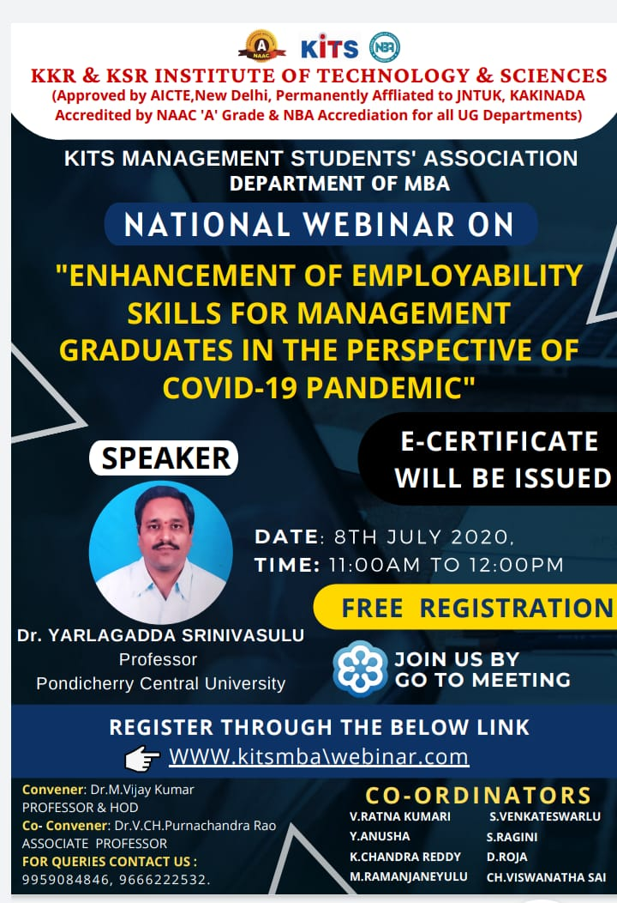
https://attendee.gotowebinar.com/register/379062539305236238 Webinar ID: 818-917-211
- Event Photographs from different angles covering all the students, Banner and speaker .

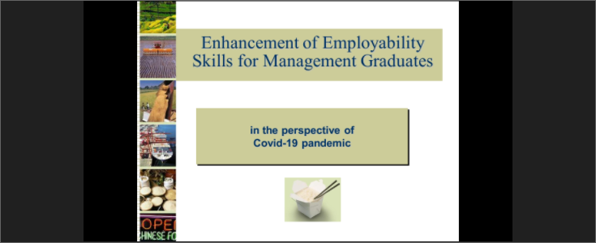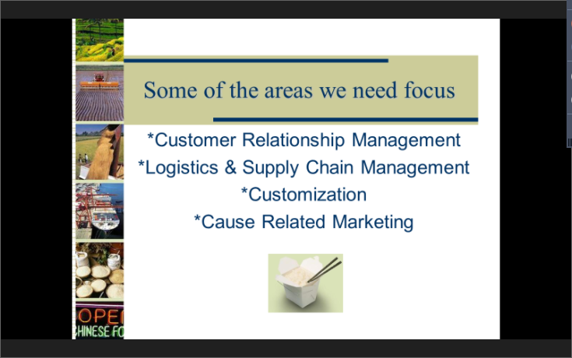

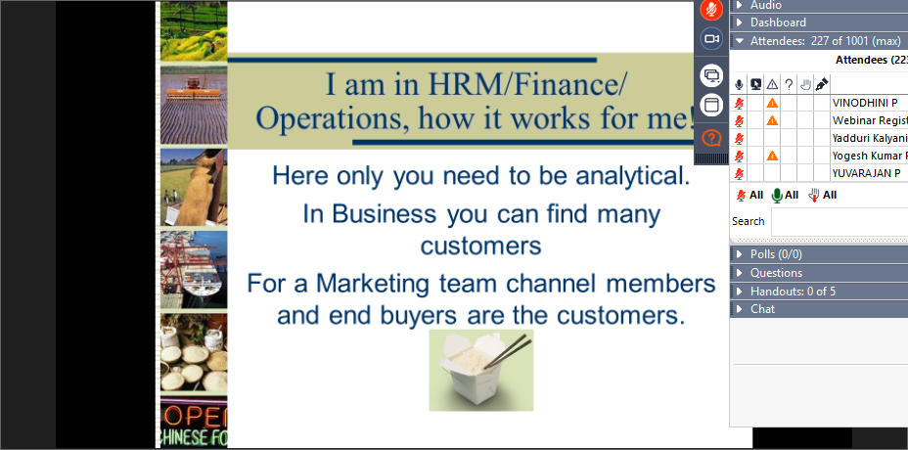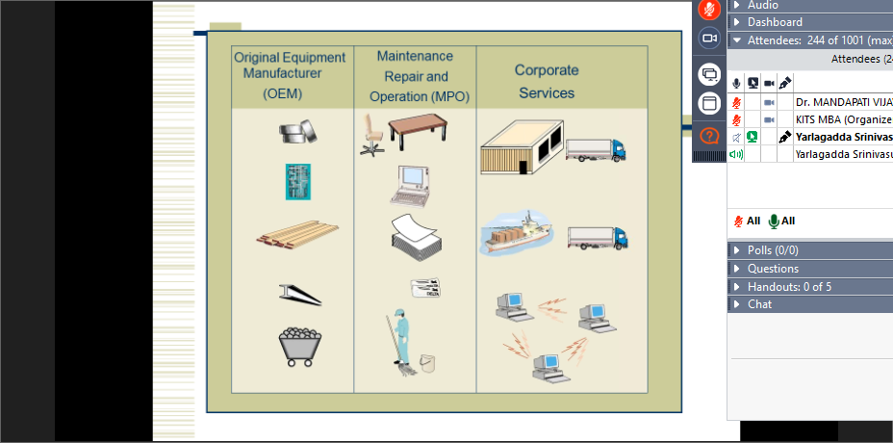

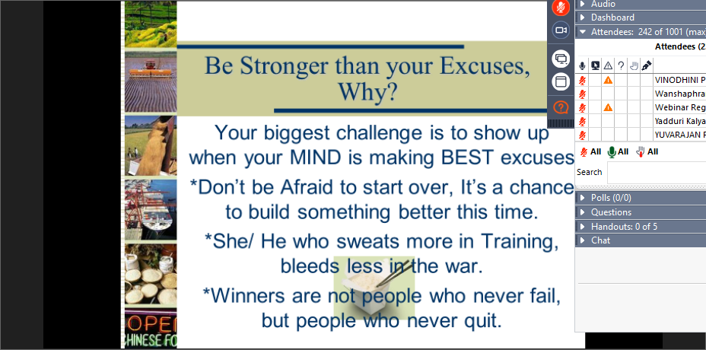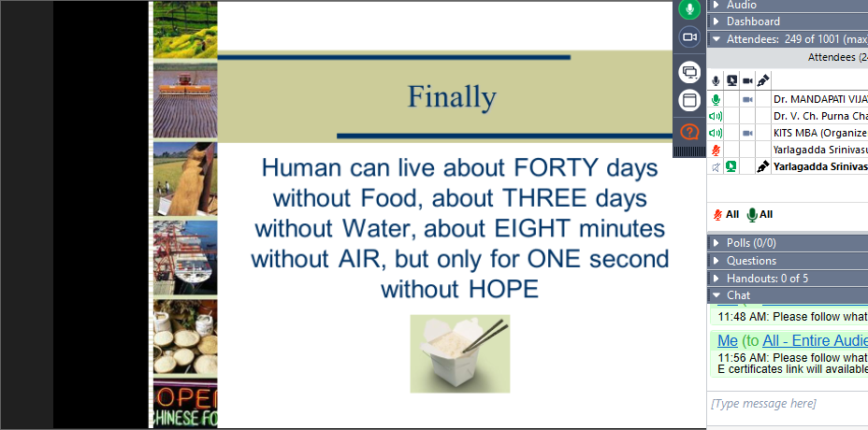
- 1- 2 minutes video of the event:
https://transcripts.gotomeeting.com/#/s/3034b21892724578ad02496537daf03e457698c86c09e86be876b4a3a7cb64f9
- Expenditure Amount ( If any) : Rs: 5,000
- Remarks: Nil
- Experiences and Output of the Session :
The resourse person Dr. Yarlagadda Srinivasulu, Professor, Pondicherry Central University tried to reach the students, parents and faculty with the live examples. How to face this pandemic and how to develop the moral. He specified that this pandemic is like a speed breaker we need to understand the up’s and down’s which come in our may. He said that reaching the Goal is itself the main aim of everyone’s life so do work hard and hard to achieve it in whatever the situation it might be.

Feed back on the Program/Event:
- The participants are the students, parents, faculty etc..
- Participants were very happy and understood how to enhance and enrich our self
- The finally slide itself explained clearly what exactly is required for a human being that is “HOPE”.
