
Inputs

Outputs
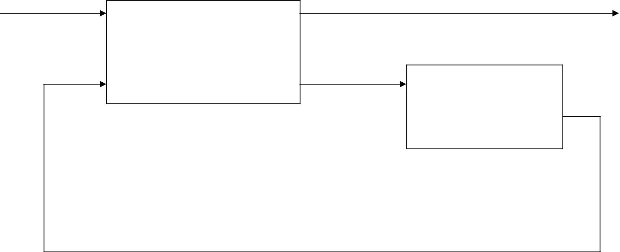
Combinational
Circuit _{Memory}

elements

Block diagram of a Sequential Logic Circuit


1 | R (reset) | 1 | Q
0 |  | 1 | Q
0 |  |  | (a) Logic Diagram
1 |  | 2 | Q’
0 | S (set) | 2 | Q’
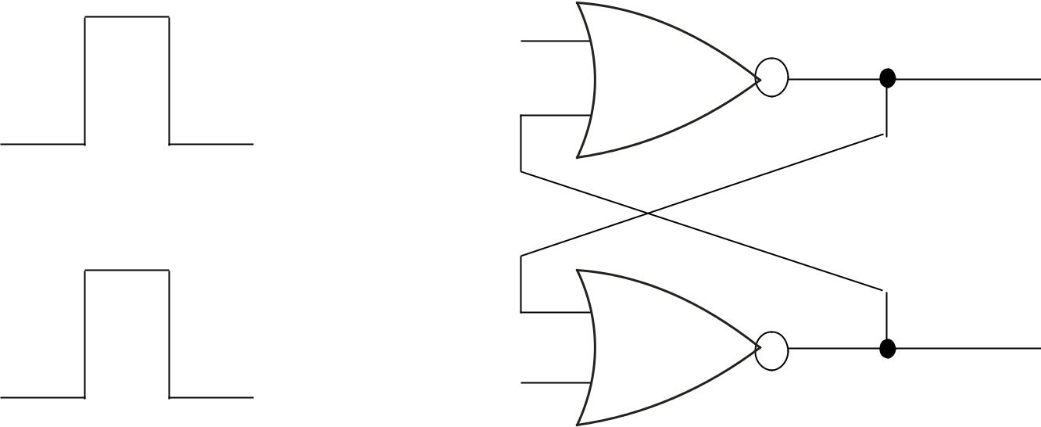

S | R | Q | Q’
1 | 0 | 1 | 0
0 | 0 | 1 | 0 | (after S=1, R=0)
0 | 1 | 0 | 1
0 | 0 | 0 | 1 | (after S=0, R=1)
1 | 1 | 0 | 0

(b) Truth Table

Basic flip-flop circuit with NOR gates

(Asynchronous Sequential Circuits)

1 |  |  |  | S (set)
1 |  |  |  |  |  |  | 1
0
1
1 |  |  |  | R (reset) |  |  | 2
0
 | S |  | R | Q | Q’
1 |  | 0 |  | 0 | 1
1 |  | 1 |  | 0 | 1 | (after S=1, R=0)
0 |  | 1 |  | 1 | 0
1 |  | 1 |  | 1 | 0 | (after S=0, R=1)
0 |  | 0 |  | 1 | 1
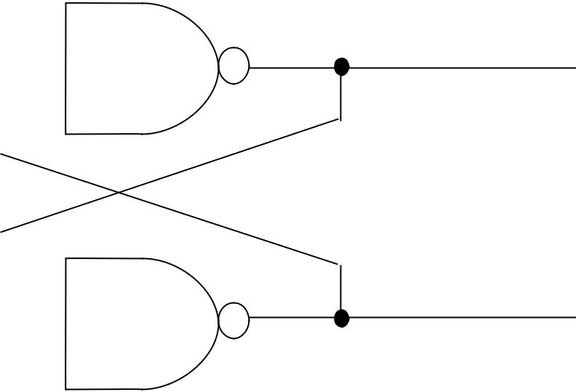

Q

(a) Logic Diagram

Q’

(b) Truth Table

Basic flip-flop circuit with NAND gates (Asynchronous Sequential Circuits)

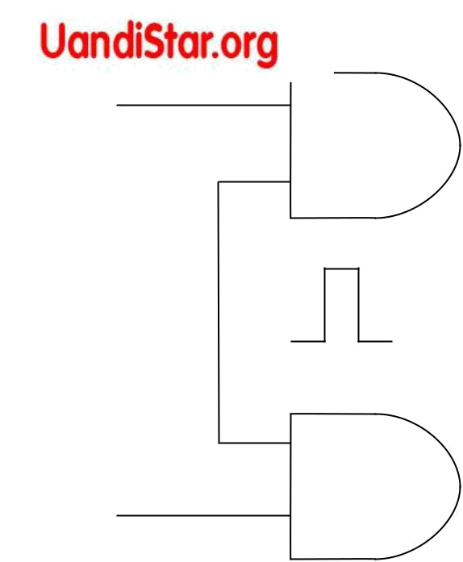

R
1

CP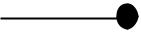
_{S} 1

1 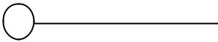 Q
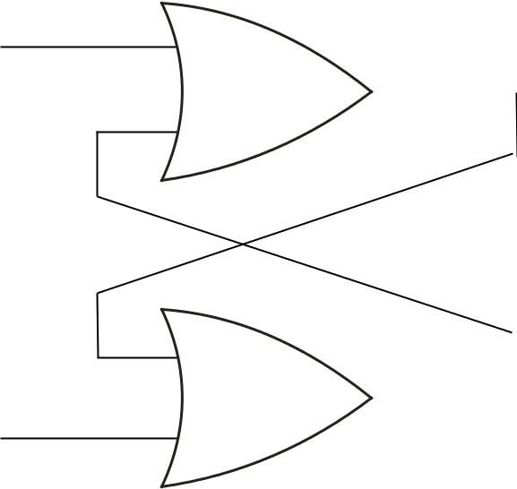

2 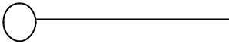 Q’

Q | S | R | Q(t+1)
0 | 0 | 0 | 0
0 | 0 | 1 | 0
0 | 1 | 0 | 1
0 | 1 | 1 | Indeterminate
1 | 0 | 0 | 1
1 | 0 | 1 | 0
1 | 1 | 0 | 1
1 | 1 | 1 | indeterminate

(a) Logic diagram |  |  |  |  |  |  |  |  |  |  | (c) Characteristic table
 |  |  |  |  |  |  |  | SR |  |  |  |  |  | S
 |  |  |  |  |  |  | Q | 00 |  | 01 | 11 |  |  | 10
 | Q’ |  |  |  | Q |  | Q |  |  |  |  |  | X |  | 1
 |  |  |  |  |  |  | 0 |  |  |  |  |  | X
 |  |  |  |  |  |  | 0 |  |  |  |  |  | X
 |  |  |  |  |  |  |  | 1 |  |  |  |  | X
 | R |  |  |  | S |  | 1 | 1 |  |  |  |  | X |  |  | 1
 |  |  |  |  |  |  |  |  |  |  | R |  |  | Q(t+1) = S+R’Q
 |  | CP
 |  | CP |  |  |  |  |  |  |  |  |  |  |  | SR = 0
 | (b) Graphical Symbol
 |  |  |  |  |  |  |  |  |  |  | (d) Characteristic equation
 |  |  |  |  | Clocked RS flip-flop
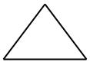
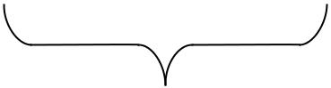
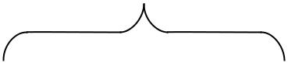

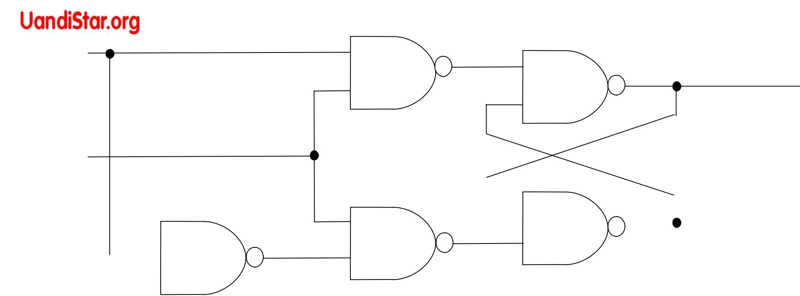  D | S
 | 3 | 1 | Q

CP

 |  |  |  |  |  |  |  |  |  |  |  |  |  |  |  |  |  |  |  |  |  |  |  | Q’
 |  |  | 5 |  |  |  | R |  | 4 |  |  | 2
 |  |  |  |  |  |  | (a) Logic diagram |  |  |  |  | with NAND gates _{D 0} |  |  |  |  |  |  |  | 1
 |  |  |  |  |  |  |  |  |  | Q | D | Q(t+1) |  |  |  | Q
Q’ |  |  |  |  | Q
 |  |  |  |  |  |  |  |  | 0 |  | 0 | 0 |  |  |  | 0 |  |  |  |  |  | 1
 |  |  |  |  |  |  |  |  | 0 |  | 1 | 1
 |  |  |  |  | D |  |  |  |  |  | 1 | 1 |  |  |  | 1 |  |  |  |  |  | 1
 |  |  |  |  |  |  |  |  | 1 |  | 0 | 0 |  |  |  |  |  |  |  |  |  | 1
 |  |  |  |  |  |  |  |  | 1 |  | 1 | 1
 |  | CP |  |  |  |  |  |  |  |  | 1 | 1 |  |  |  |  |  |  |  | Q(t+1) = D
 |  |  |  |  |  |  |  |  | (c) Characteristic table |  |  |  |  |  |  |  | (d) Characteristic equation
(b) Graphical Symbol

Clocked D flip-flop
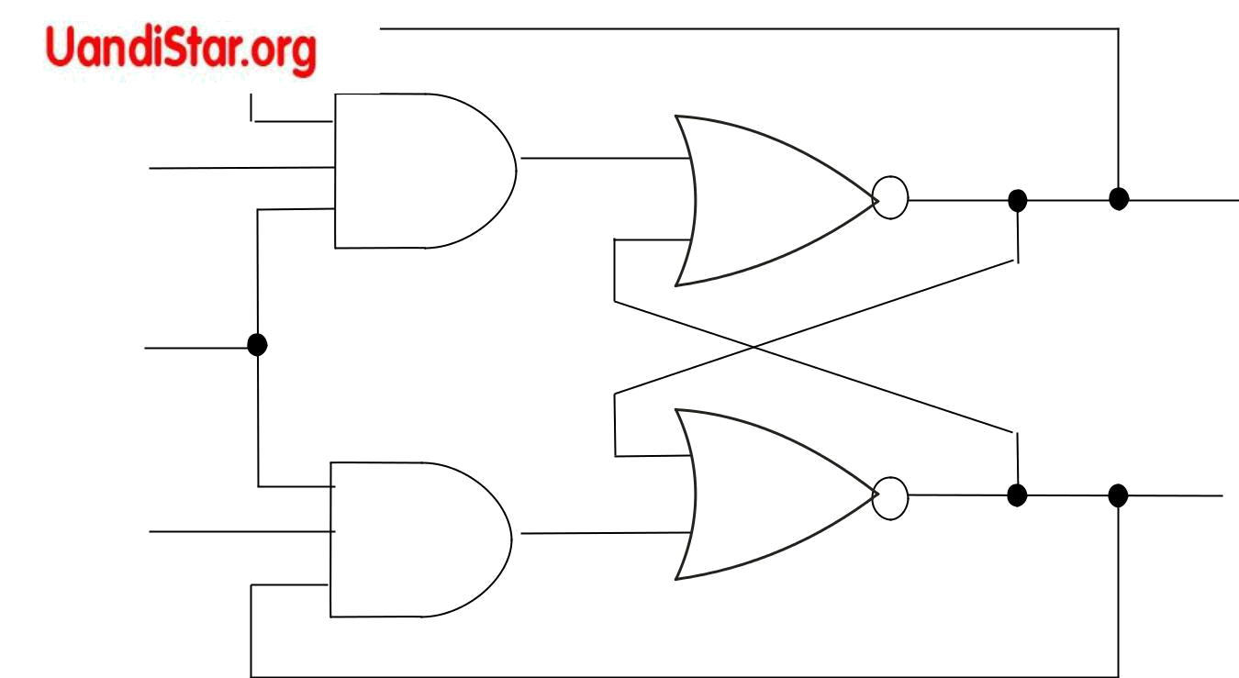
K | Q | Clocked JK
CP |  | flip-flop
J | Q’

 |  |  | (a) Logic diagram |  |  |  | J | K |  | Q(t+1)
 |  |  |  |  | 0 |  | 0 | 0 |  | 0
Q’ |  |  | Q
 |  |  |  |  | 0 |  | 0 | 1 |  | 0
 |  |  |  |  | 0 |  | 1 | 0 |  | 1
K |  |  | J |  | 0 |  | 1 | 1 |  | 1
 |  |  |  |  | 1 |  | 0 | 0 |  | 1
 |  |  |  |  | 1 |  | 0 | 1 |  | 0
 |  |  |  |  | 1 |  | 1 | 0 |  | 1
 |  | CP
 |  |  |  |  | 1 |  | 1 | 1 |  | 0
(b) Graphical Symbol |  |  |  |  |  |  | 1 | 1 |  | 0
 |  |  |  |  | (c) Characteristic table
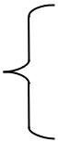

 | JK |  |  |  |  | J
Q | 00 |  | 01 | 11 |  | 10
0 |  |  |  |  | 1 |  | 1
1
1 | 1 |  |  |  |  |  |  | 1
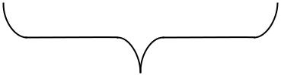
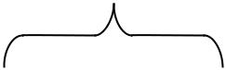

K
Q(t+1) = JQ’+K’Q

(d) Characteristic equation

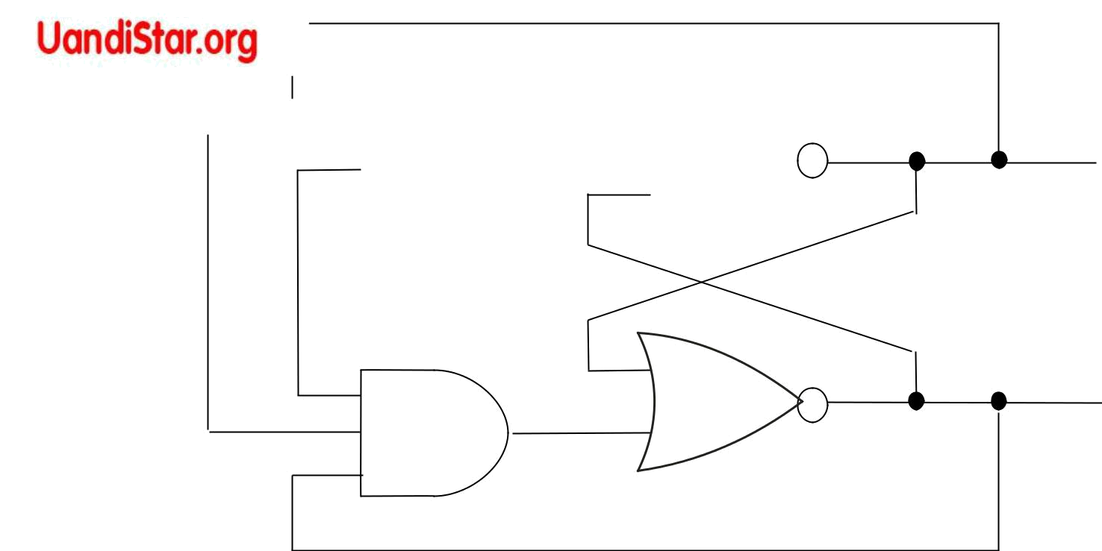
T 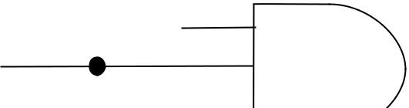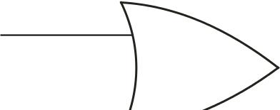 CP 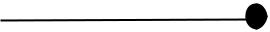

(a) Logic diagram

 |  |  |  |  | Q | T |  | Q(t+1)
Q’ |  | Q
 |  |  |  | 0 |  | 0 |  | 0
 |  | T |  | 0 |  | 1 |  | 1
 |  |  |  | 1 |  | 0 |  | 1
 |  |  |  | 1 |  | 1 |  | 0
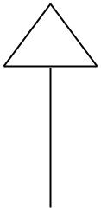

CP | (c) Characteristic table
(b) Graphical Symbol | (c) Characteristic table

- Clocked T flip-flop

Q’

Q | T | 0 | 1
Q |  |  | 1
0 |  |  | 1
1 |  | 1
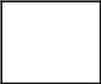

Q(t+1) = TQ’+T’Q

(d) Characteristic equation

1

0
Positive Pulse Negative Pulse
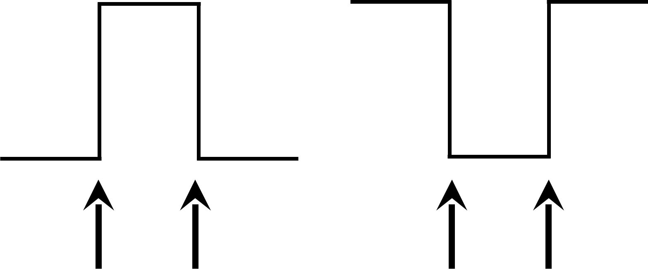

Positive- Negative- Negative- Positive-

edge edge edge edge

Definition of clock pulse transition

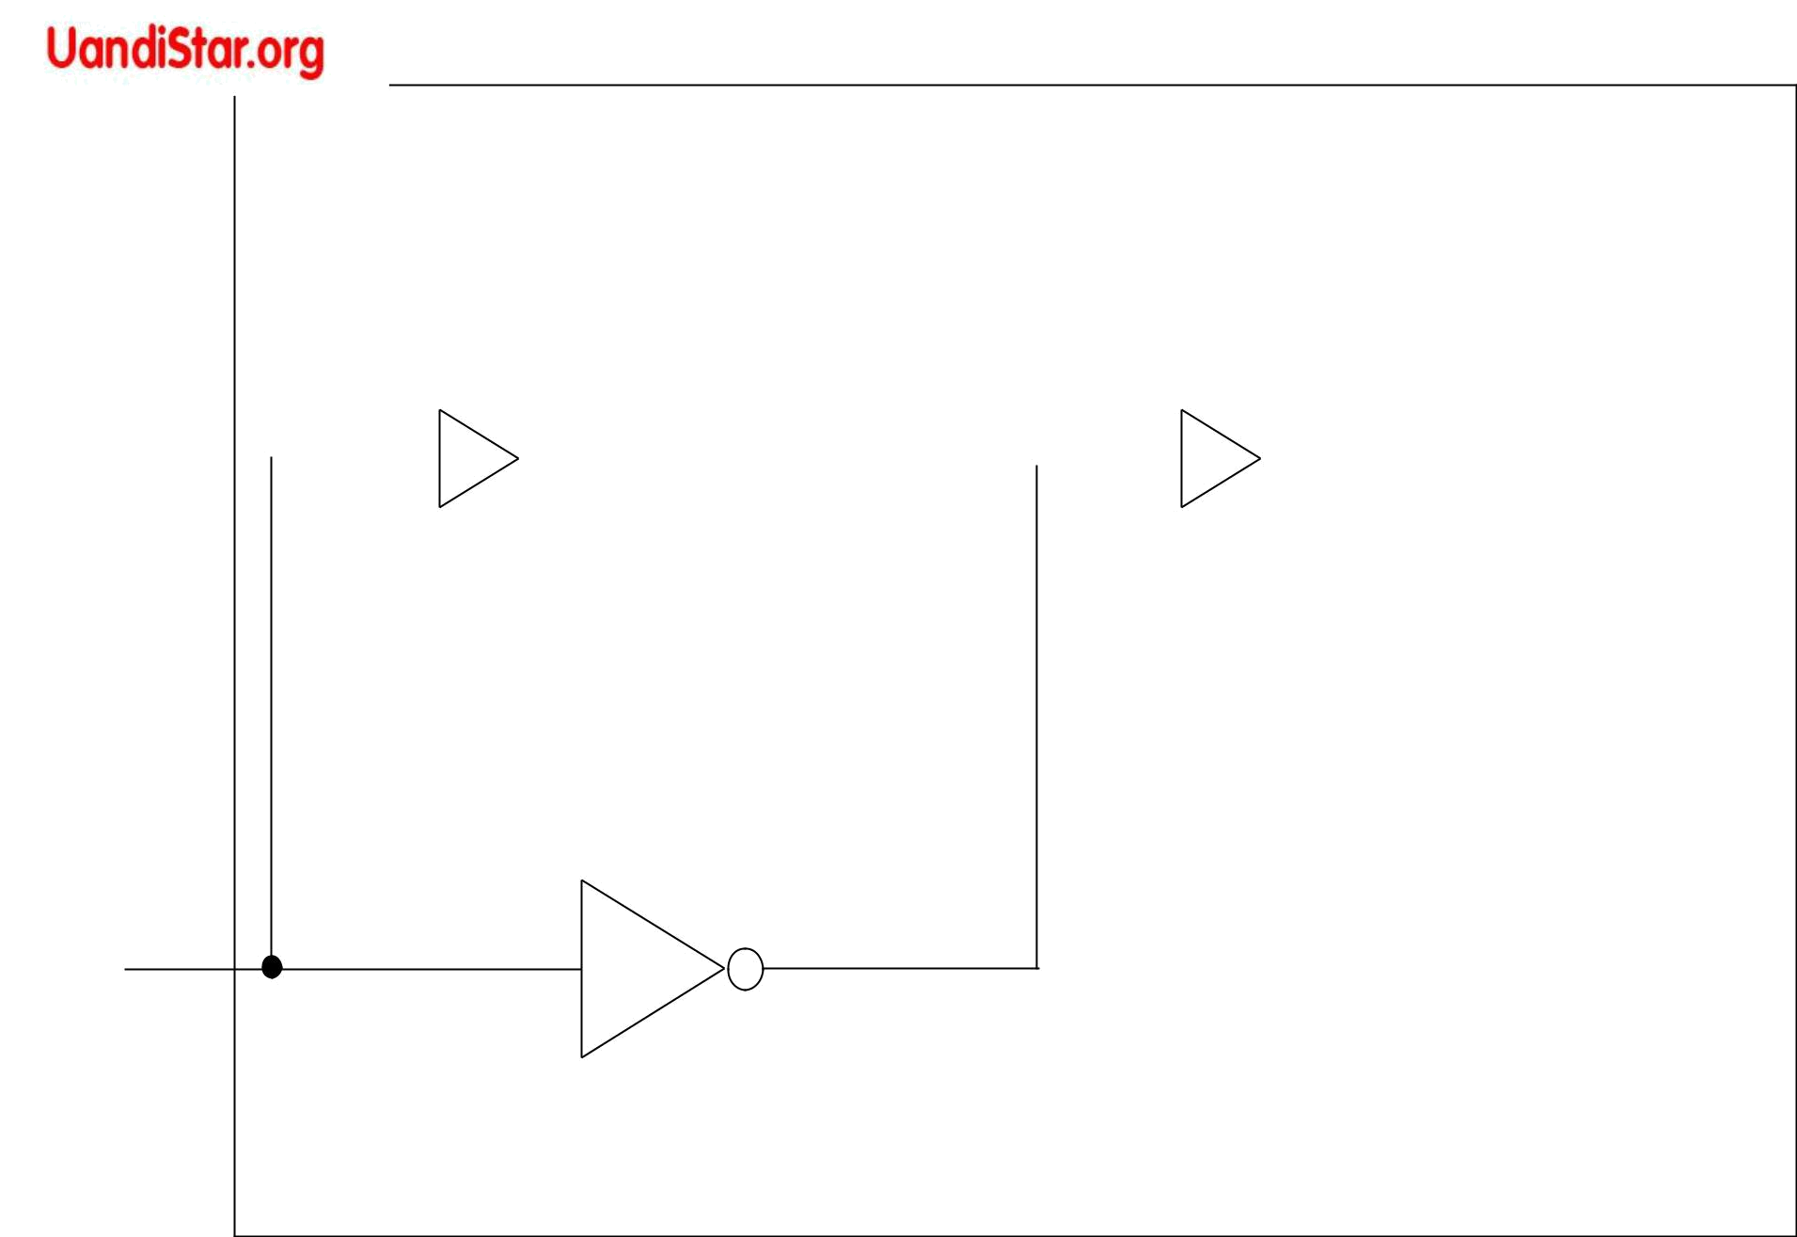  S |  |  |  |  |  | Y |  |  |  |  |  |  |  | Q
 |  |  |  | S |  |  |  |  | S |  |  |  |  | Q
 |  |  |  | Master |  |  |  |  |  | Slave
R |  |  |  | Master |  | Y’ |  |  |  | Slave |  |  |  | Q’
R |  |  |  | R |  |  |  |  | R |  |  |  |  | Q’

CP

MASTER-SLAVE FLIP-FLOP

Logic diagram of master-slave flip-flop

CP

S

S=1, R=0 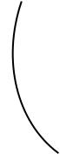 _{S=0, R=1}



Y


Q

Timing relationships in a master-slave flip-flop

J 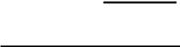

1
3
Y
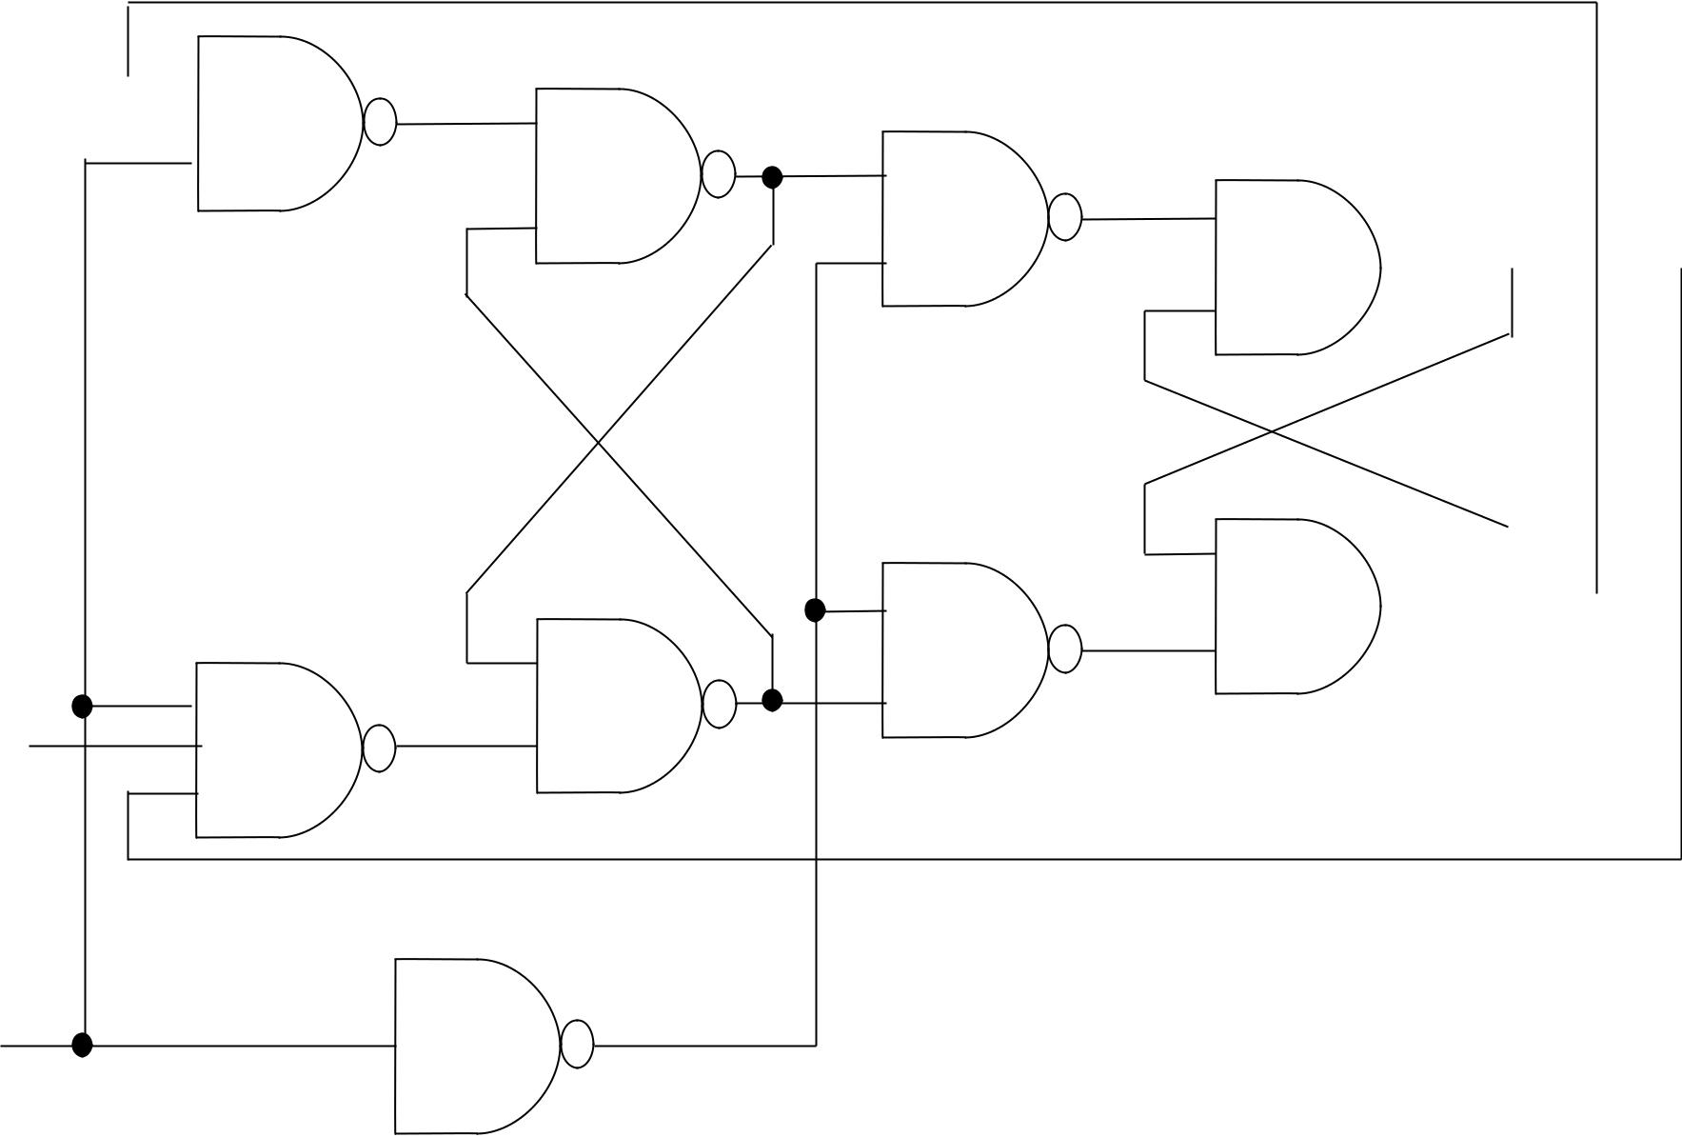

5

6

7

8

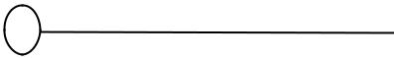 Q

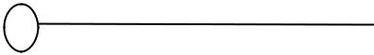 Q’

K

CP

2
4

Y’

9

Clocked master-slave JK flip-flop

CP

D

1

2

3

4

S
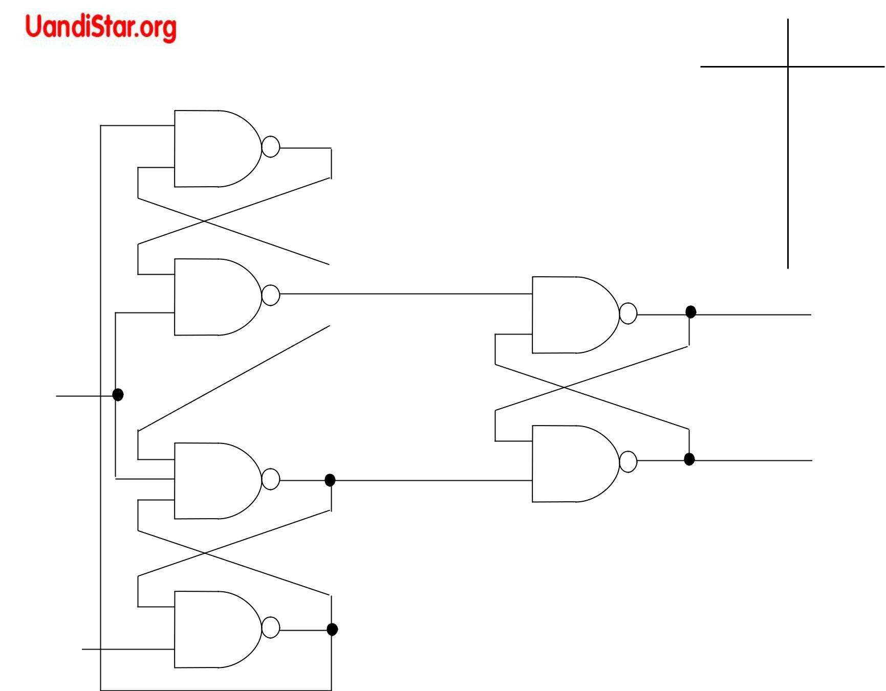

R
R Q Q’

1 0 0 1

1 1 0 1 (NC)

0 1 1 0

1 1 1 0 (NC)

0 | 0 | 1 | 1
5 |  |  | Q

6 | Q’

- S=R=1 for steady state values

- When S=1 & R=0 : Q=0

- When S=0 & R=1 : Q=1

D-type positive-edge-triggered flip-flop

CP=0

D=0

1
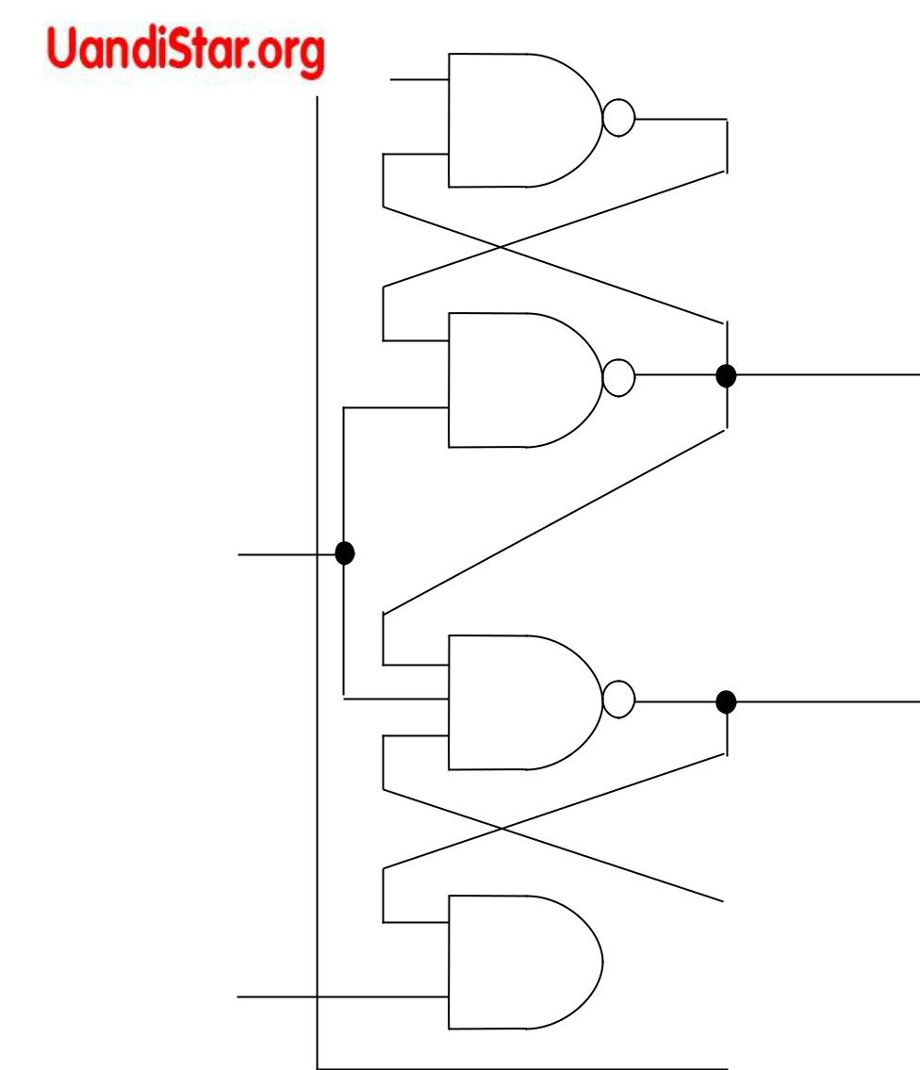

2

3

4

0

- S

CP=0

1 R

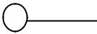 1 D=1

1

2

3

4
1
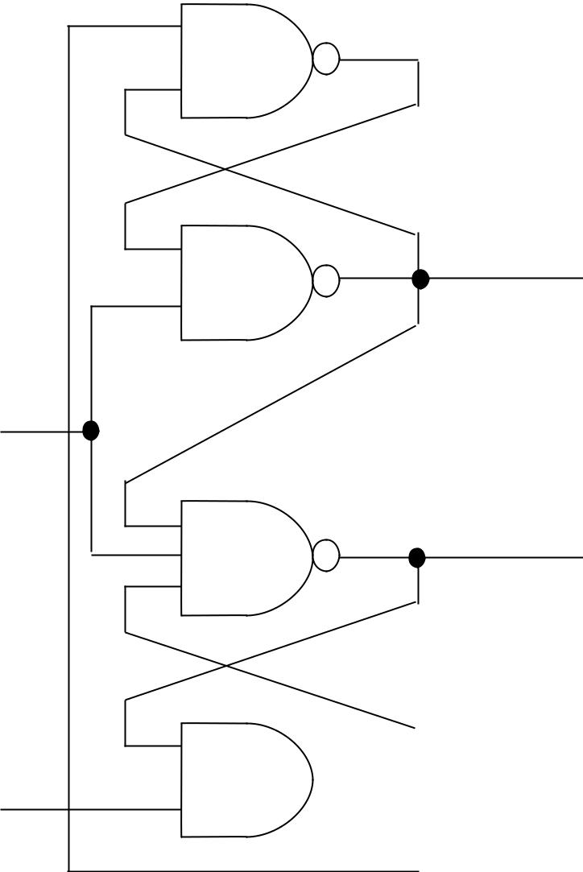

- S

1 R

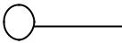0

No Change at the outputs of the flip flop whether D = 0 or 1

So Q = 0 & Q’ = 1

(a) With CP = 0

Operation of the D-type edge-triggered flip-flop

CP=1

D=0

1 | 0 | 1 | 1
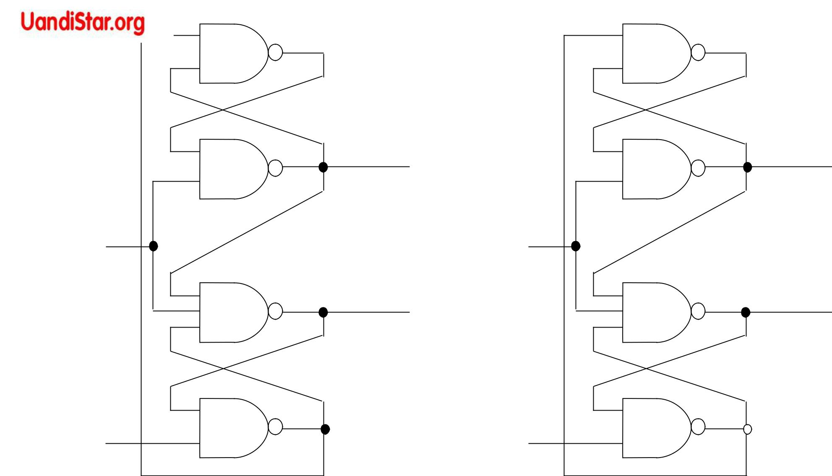

2 | 1 | S | 2 | 0 | S

CP=1

3 | 0 | R | 3 | 1 | R

4 | 1 | D=1 | 4 | 0
So Q = 0 & Q’ = 1 |  |  | So Q = 1 & Q’ = 0

(b) With CP = 1

Operation of the D-type edge-triggered flip-flop

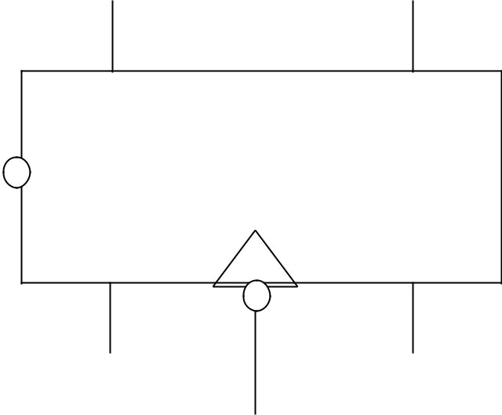

Clear | Q’ | Q
 | K | J

CP
Direct Inputs

Asynchronous
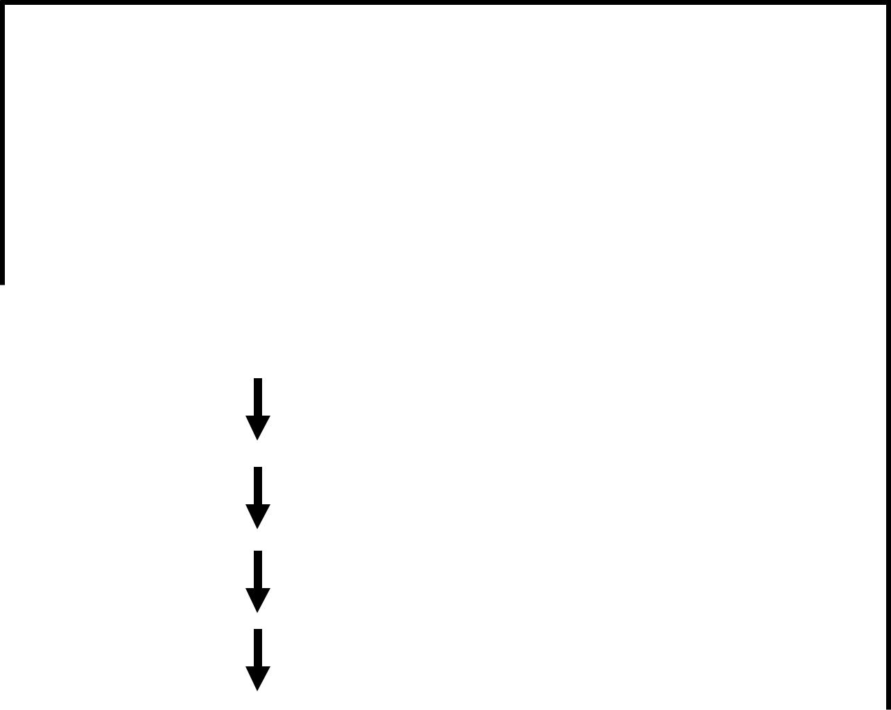

Function Table

 | Inputs |  |  |  | Outputs
Clear | Clock |  | J | K | Q | Q’
0 | x |  | x | x | 0 | 1
1 |  |  | 0 | 0 | No Change
1 |  |  | 0 | 1 | 0 | 1
1 |  |  | 1 | 0 | 1 | 0
1 |  |  | 1 | 1 | Toggle

JK flip-flop with direct clear

x’
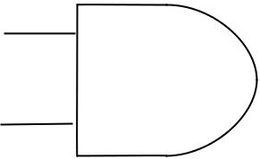

A

x
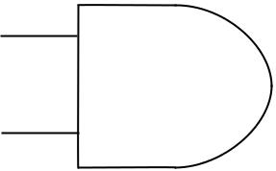

A’

x
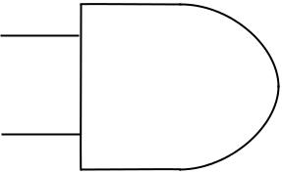

B’

x’
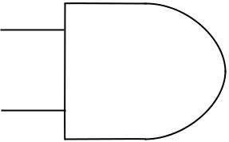

B
x
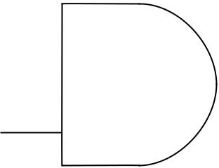
A 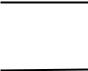 ^{y B’}

CP
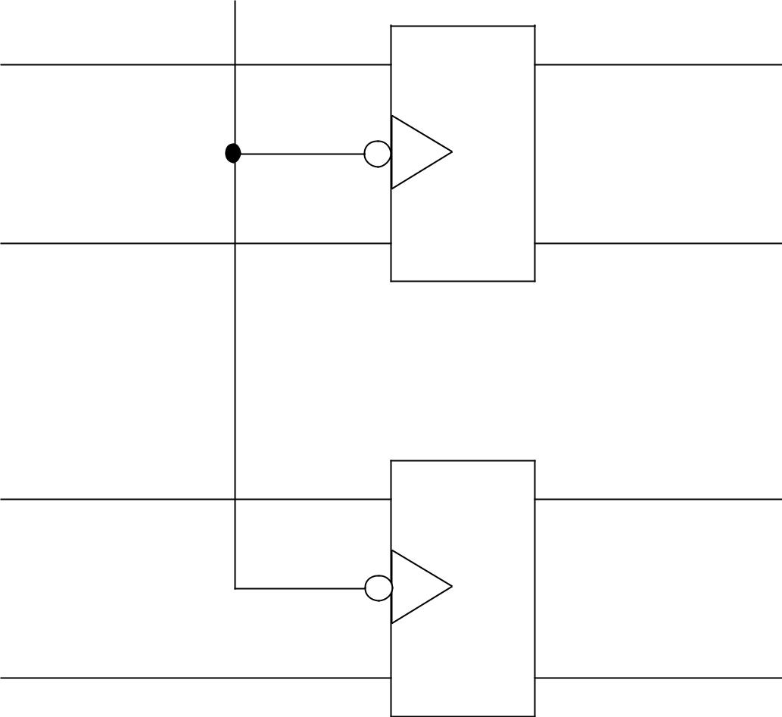

R Q’

S Q

R Q’

S Q

Input = x (External)

Output = y

Clocked RS flip-flop

B’

B

A’

A

Example of clocked sequential circuit

(Analysis)

State table for circuit

 | Next State |  | Output
Present State | x=0 | x=1 | x=0 | x=1
AB | AB | AB | y | y
00 | 00 | 01 | 0 | 0
01 | 11 | 01 | 0 | 0
10 | 10 | 00 | 0 | 1
11 | 10 | 11 | 0 | 0
0/0
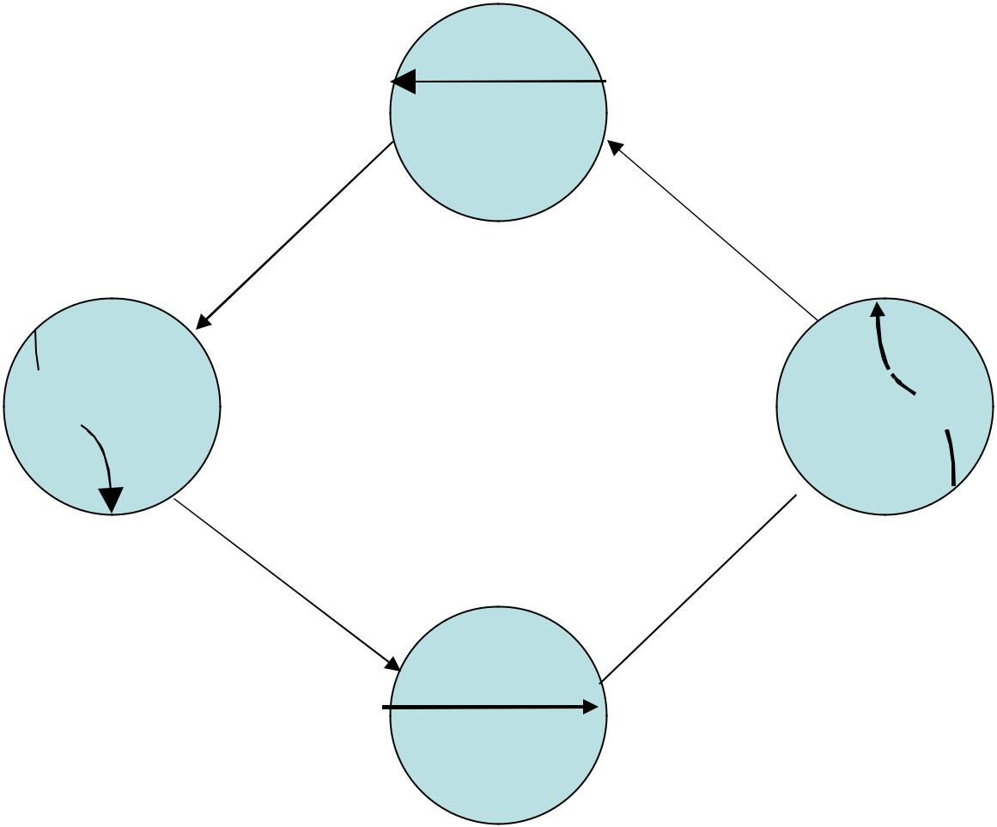

00
1/1

1/0 1/0 0/0

01 10

0/0
0/0

11

1/0

State diagram for the circuit

 |  | Bx |  |  | B
 | A | 00 | 01 | 11 | 10
 | A |  |  |  | 1
 | 0 |  |  |  | 1
A | 1 | 1 |  | 1 | 1
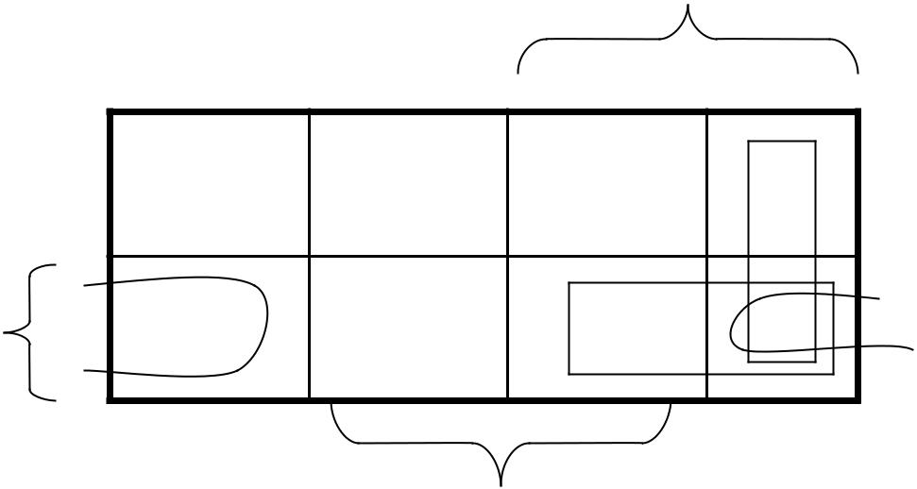

x

A(t+1) = Bx’+(B+x’)A

- A(t+1) = Bx’ + (B’x)’ A A(t+1) = S+ R’A
Q(t+1) = S+ R’Q

SR=0

 | Bx |  |  |  |  | B
A | 00 | 01 |  | 11 | 10
0 |  | 1 |  | 1 |  | 1
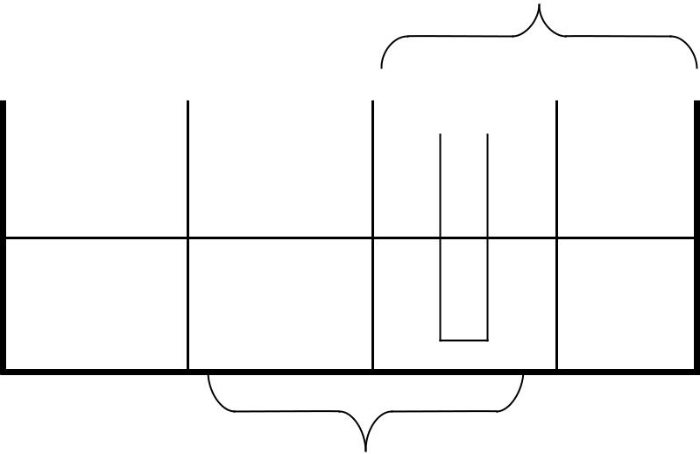

A¹ 1

x

B(t+1) = A’x+(A’+x)B

- B(t+1) = A’x + (Ax’)’ B B(t+1) = S+ R’B

State equations for flip-flops A and B

Analysis of clocked sequential circuit

SA = B x’ RA = B’x

SB = A’x

RB = Ax’ y =

AB’x

x’

A

x

A’

x

B’

x’

B

x |  | y |  |  | Input = x (External)
A
B’ |  |  |  |  | Output = y
CP |  |  |  |  | Clocked RS flip-flop
 |  |  |  |  |  | B’
 |  | R Q’ |  |  |  | B’
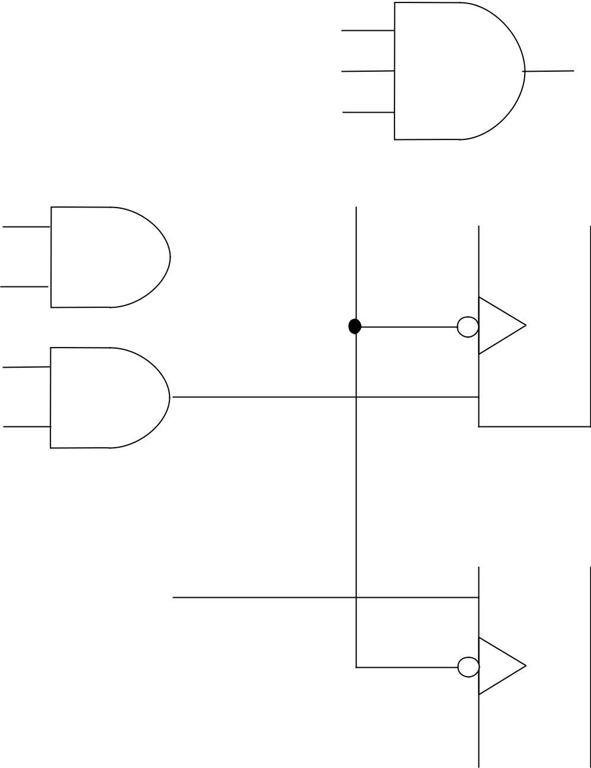

S Q |  | B

 |  |  | A’
R Q’ |  |  | A’

 |  | S Q |  |  | A
Clocked sequential circuit

B

C’

x

B’

C

x’

B | CP
y
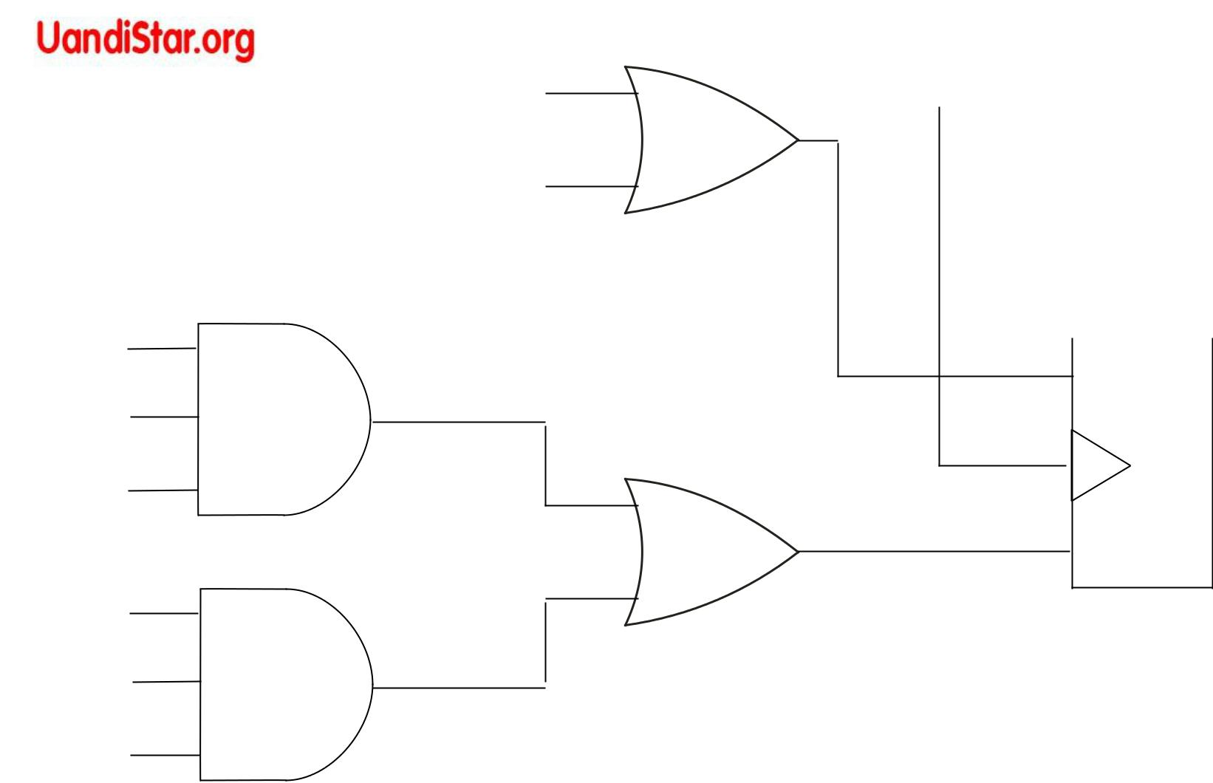

 |  |  | A’
K Q’ |  |  | A’

J Q |  | A

JA = BC’x + B’Cx’ and KA = B+y

Implementation of the flip-flop input functions

The problem of state-reduction is to find ways of reducing the number of states in a sequential circuit without altering the input-

output relationships. | 0/0

g

0/0

0/0

1/1

 |  |  |  |  |  | minimizes the cost of
 |  |  |  |  |  | circuit by reducing flip-
 |  | 0/0 |  |  |  | flops & gates.
a |  | 0/0 |  |  |  | Consider the input
1/0 |  |  |  |  |  | sequence 01010110100
 |  | 0/0 |  |  |  | starting from present state a.
b |  | 0/0 | c |  |  | We are interested only in
1/0 |  |  |  |  |  | output sequences caused by
 |  | 1/0 |  | 0/0 |  | input sequences..
d |  |  |  |  |  | e
1/1 |  |  |  | State diagram
f |  | 1/1
1/1
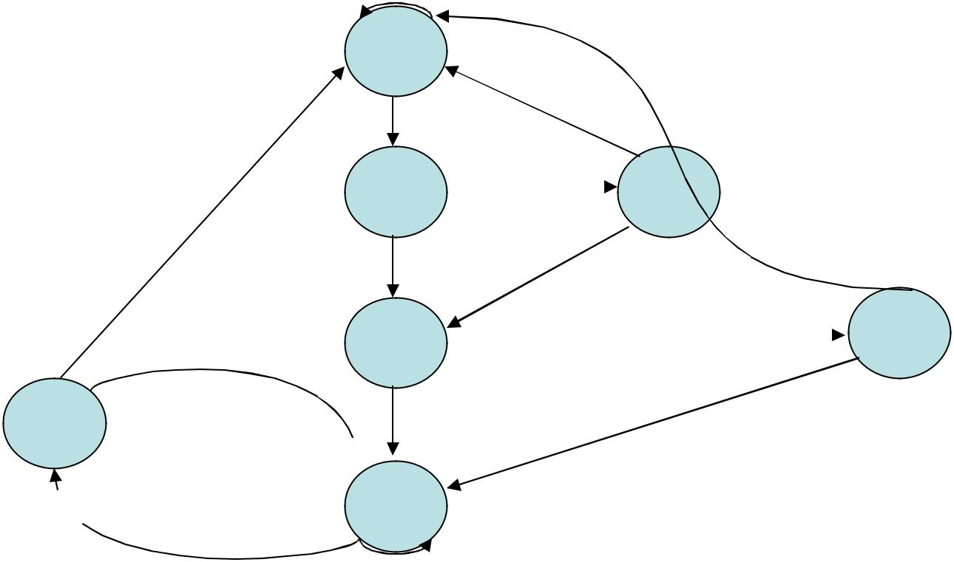

Present State | a | a | b | c | d | e | f | f | g | f | g | a
Input Value | 0 | 1 | 0 | 1 | 0 | 1 | 1 | 0 | 1 | 0 | 0
Output Value | 0 | 0 | 0 | 0 | 0 | 1 | 1 | 0 | 1 | 0 | 0

State Table

 | Next State |  |  | Output
Present State | x=0 | x=1 |  | x=0 | x=1
a | a | b |  | 0 | 0
b | c | d |  | 0 | 0
c | a | d |  | 0 | 0
d | e | f |  | 0 | 1
e | a | f |  | 0 | 1
f | g | f |  | 0 | 1
g | a | f |  | 0 | 1
Reducing the State Table

 | Next State |  |  |  | Output
Present State | x=0 | x=1 |  | x=0 | x=1
a | a | b |  | 0 | 0
b | c | d |  | 0 | 0
c | a | d |  | 0 | 0
d | e | f | d | 0 | 1
e | a | f | d | 0 | 1
f | g e | f |  | 0 | 1
g | a | f |  | 0 | 1
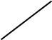
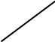

State | a | a | b | c | d | e | d | d | e | d | e | a
Input | 0 | 1 | 0 | 1 | 0 | 1 | 1 | 0 | 1 | 0 | 0
Output | 0 | 0 | 0 | 0 | 0 | 1 | 1 | 0 | 1 | 0 | 0
Reduced State Table

 | Next State |  |  | Output
Present State | x=0 | x=1 |  | x=0 | x=1
a | a | b |  | 0 | 0
b | c | d |  | 0 | 0
c | a | d |  | 0 | 0
d | e | d |  | 0 | 1
e | a | d |  | 0 | 1

0/0

101 | 1/1
e | 1/1

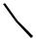0/0
0/0
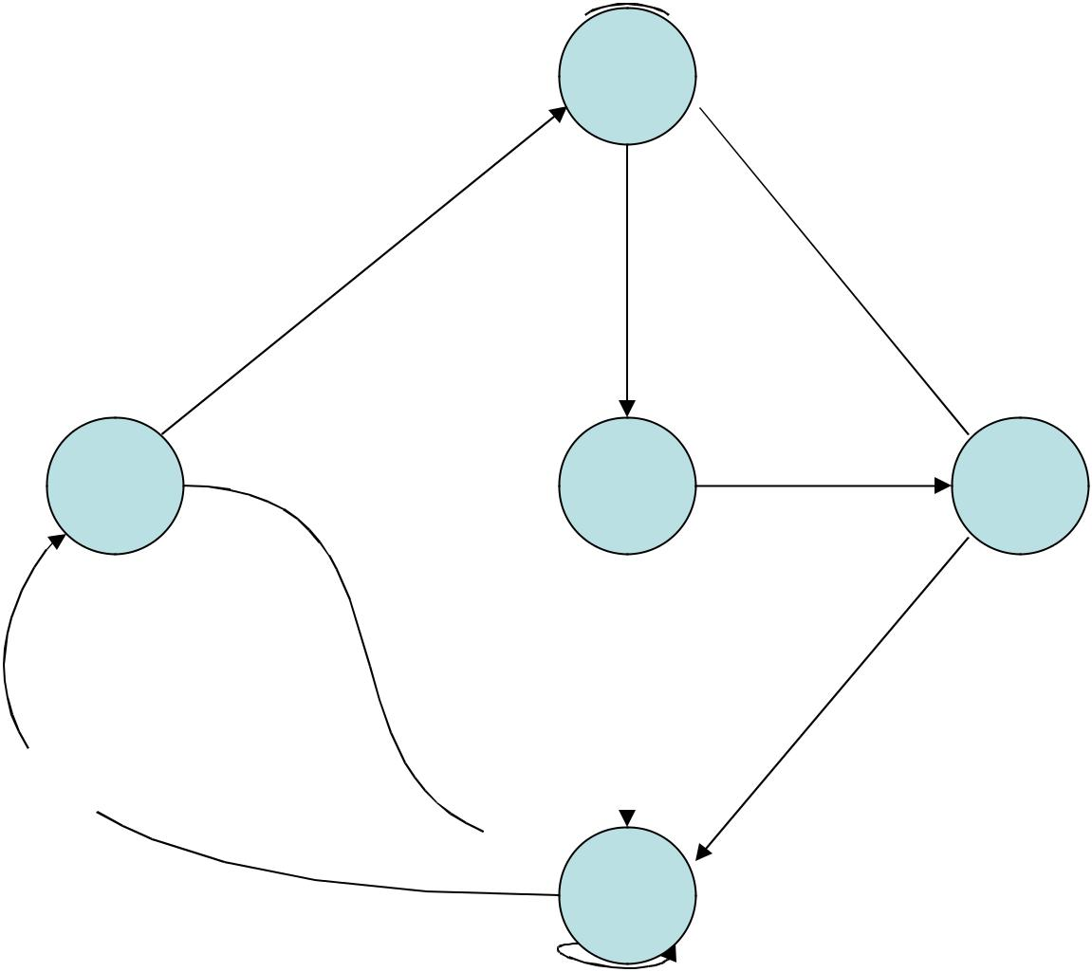

001

a
0/0

1/0

- 0/0

b
1/0 _{1/0}

011

c

m flip-flops can represent up to 2m distinct states (i.e. if m=3, 8 states => 000-111)

For five states, 3 flip-flops are required.

Fewer states do not guarantee a saving in the number of flip-flops or number of gates.

100

d

1/1

Reduced State diagram

Three possible binary state assignments

State | Assignment 1 | Assignment2 | Assignment3
a | 001 | 000 | 000
b | 010 | 010 | 100
c | 011 | 011 | 010
d | 100 | 101 | 101
e | 101 | 111 | 011

Reduced State Table with binary assignment 1
Present State | Next State |  |  | Output
Present State | x=0 | x=1 |  | x=0 | x=1
001 | 001 | 010 | 0 |  | 0
010 | 011 | 100 | 0 |  | 0
011 | 001 | 100 | 0 |  | 0
100 | 101 | 100 | 0 |  | 1
101 | 001 | 100 | 0 |  | 1

Flip-flop characteristic tables
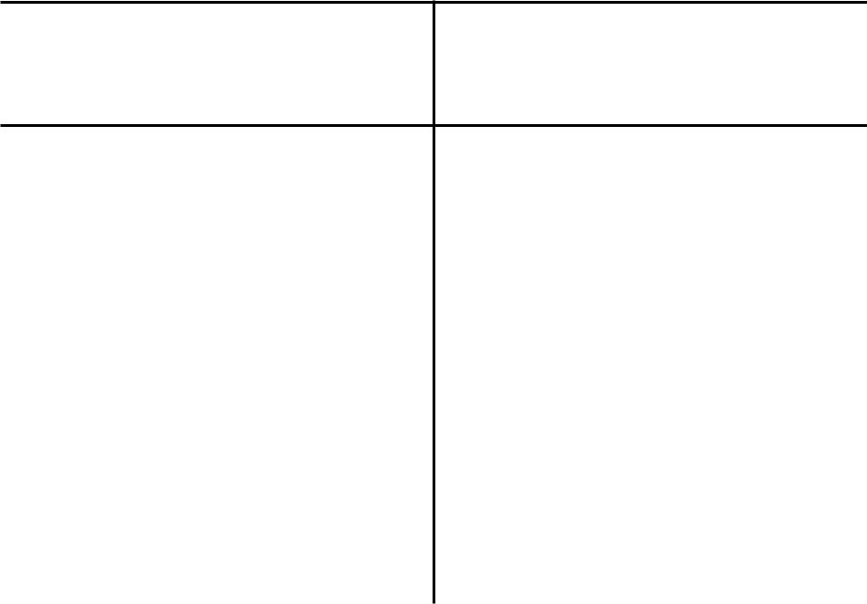

S | R |  | Q(t+1)
0 | 0 |  | Q(t) NC
0 | 1 |  | 0
1 | 0 |  | 1
1 | 1 |  | ?
 | (a) RS

D |  | Q(t+1)
0 |  | 0
1 |  | 1
 | (c) D

J K Q(t+1)

- 0Q(t) NC

0 | 1 | 0
1 | 0 | 1
1 | 1 | Q’(t)
 | (b) JK

T | Q(t+1)
0 | Q(t) NC
1 | Q’(t)
 | (d) T

Flip-flop excitation tables

Q(t) | Q(t+1) | S | R
0 | 0 | 0 | X
0 | 1 | 1 | 0
1 | 0 | 0 | 1
1 | 1 | X | 0

Q(t) | Q(t+1) | J | K
0 | 0 | 0 | X
0 | 1 | 1 | X
1 | 0 | X | 1
1 | 1 | X | 0

(a) RS

Q(t) | Q(t+1) | D
0 | 0 | 0
0 | 1 | 1
1 | 0 | 0
1 | 1 | 1

(b) JK
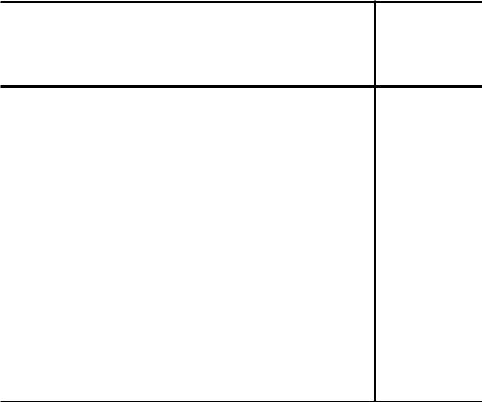

Q(t) Q(t+1) T

0 0 0

0 1 1

1 0 1

1 1 0

_{(c) D} (d) T

Design Procedure for Sequential Logic Circuits

- The word description of the circuits behavior is stated. This may be accompanied by a state diagram, a timing diagram, or other pertinent information.

- From the given information about the circuit, obtain the state table.

- The number of states may be reduced by state reduction methods if the sequential circuit can be characterized by input-output relationships independent of the number of states.

- Assign binary values to each state if the state table obtained in step 2 or 3 contains letter symbols.

- Determine the number of flip-flops needed and assign a letter symbol to each.

- Choose the type of flip-flop to be used.

- From the state table, derive the circuit excitation and output tables.

- Using the K-Map or any other simplification method, derive the circuit output functions and the flip-flop input functions.

- Draw the logic diagram.

Design the clocked sequential circuit using JK flip-flops from the given state diagram.

0
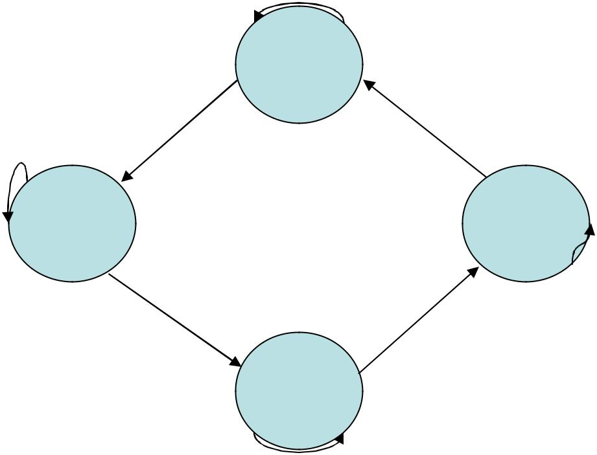

00 1

 |  |  | 1 |  |  | 0
 | 1 |  | 01 |  | 11
 |  |  | 0 |  | 1
 | State diagram |  | 0 |  | 10
 |  | State Table |  |  | 0
 |  |  | Next State |  | Output
 | Present State |  | x=0 |  | x=1
A | B |  | A | B | A | B
0 | 0 |  | 0 | 0 | 0 | 1
0 | 1 |  | 1 | 0 | 0 | 1
1 | 0 |  | 1 | 0 | 1 | 1
1 | 1 |  | 1 | 1 | 0 | 0

 |  |  |  |  |  |  |  | Q(t) | Q(t+1) | J | K
 |  |  |  |  |  |  | 0 |  | 0 | 0 | X
 |  |  |  |  |  |  | 0 |  | 1 | 1 | X
 |  |  | Excitation table |  |  |  | 1 |  | 0 | X | 1
 |  |  |  |  |  |  | 1 |  | 1 | X | 0
Inputs of Combinational |  |  |  |  | Outputs of Combinational circuit
 | Circuit |  | Next state
Present state |  | Input |  |  |  | Flip-flop inputs
A | B | x | A | B | JA |  | KA |  | JB | KB
0 | 0 | 0 | 0 | 0 | 0 |  | X |  | 0 | X
0 | 0 | 1 | 0 | 1 | 0 |  | X |  | 1 | X
0 | 1 | 0 | 1 | 0 | 1 |  | X |  | X | 1
0 | 1 | 1 | 0 | 1 | 0 |  | X |  | X | 0
1 | 0 | 0 | 1 | 0 | X |  | 0 |  | 0 | X
1 | 0 | 1 | 1 | 1 | X |  | 0 |  | 1 | X
1 | 1 | 0 | 1 | 1 | X |  | 0 |  | X | 0
1 | 1 | 1 | 0 | 0 | X |  | 1 |  | X | 1

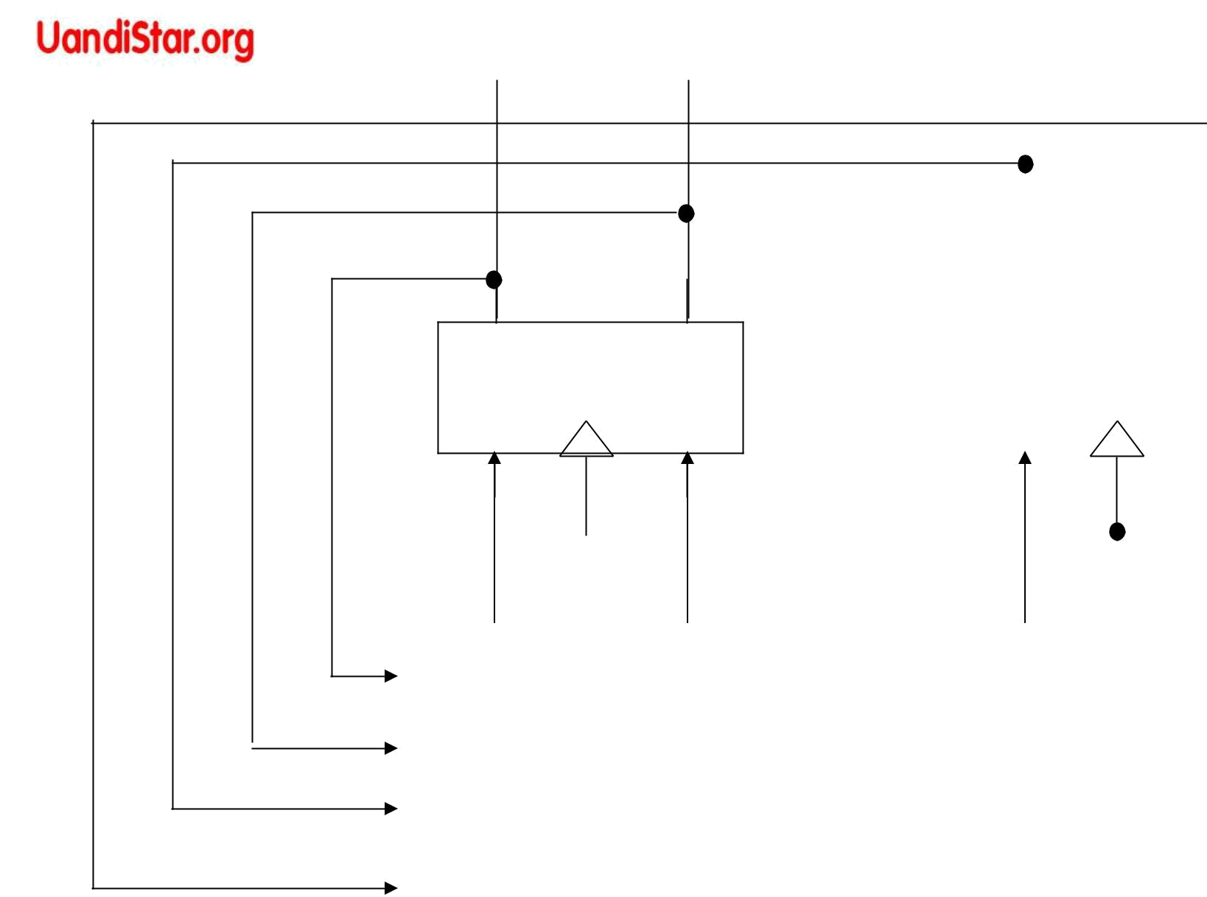

A’ | A
Q’ | Q
K | J

 | B’ | B
Q’ |  | Q
K |  | J

 |  |  |  |  |  | CP
KA |  | JA | KB | JB
A’ |  |  |  |  |  |  | External
A |  | Combinational Circuit |  |  |  |  | outputs
B’ |  |  |  |  |  |  | (none)
B |  |  | x

External Inputs

Block diagram of sequential circuit

A

0

A ¹

A

0

1

 | Bx |  |  |  |  | B |  |  |  |  |  | Bx |  |  |  |  | B
00 |  | 01 |  | 11 |  | 10 |  |  |  | A | 00 |  | 01 |  | 11 |  | 10
 |  |  |  |  |  |  |  | 1 |  | A |  | X |  | X |  | X |  | X
 |  |  |  |  |  |  |  | 1 |  | 0 |  | X |  | X |  | X |  | X
 | X |  | X |  | X |  |  | X |  | 1 |  |  |  |  |  | 1
 |  |  |  |  | x |  |  |  |  |  |  |  | KA = Bx
 |  | JA = Bx’
 | Bx |  |  |  |  | B |  |  |  |  |  | Bx |  |  |  |  | B
00 |  | 01 |  | 11 |  | 10 |  |  |  | A | 00 |  | 01 |  | 11 |  | 10
 |  |  | 1 |  | X |  |  | X |  | A |  | X |  | X |  |  |  | 1
 |  |  | 1 |  | X |  |  |  |  | 0 |  | X |  | X |  |  |  | 1
 |  |  | 1 |  | X |  |  | X |  |  |  | X
 |  |  | 1 |  | X |  |  |  |  | 1 |  | X |  | X | 1
 |  | JB = x |  |  |  |  |  |  |  |  | KB = A . X = Ax + A’x’
 |  |  |  | Maps for combinational circuit
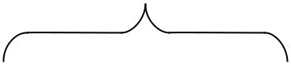
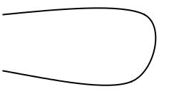
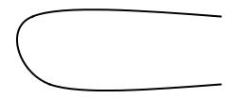

A
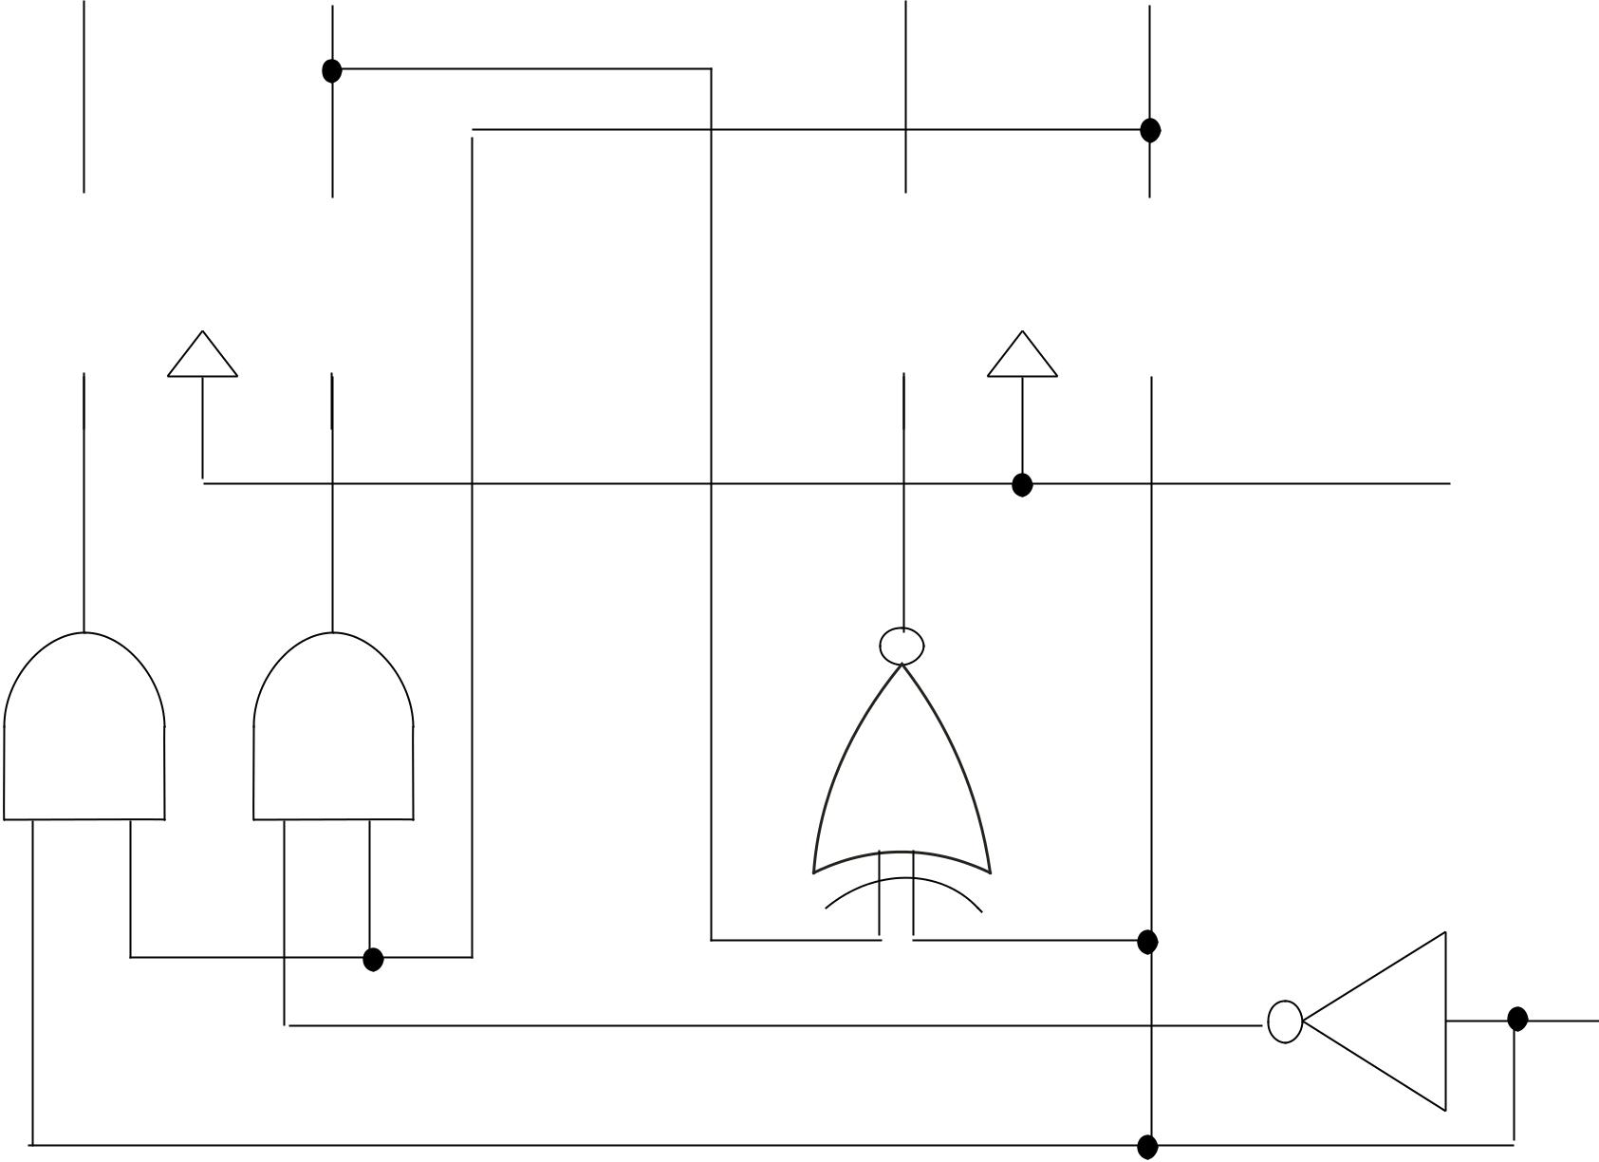

B

Q’ |  | Q |  | Q’ | Q
K |  | J |  | K | J

JA = Bx’

KA = Bx

JB = x
KB = A x

CP

x

Logic diagram of Sequential Logic Circuit

- Design a sequential circuit using state table with assignment 1 employing RS flip-flops.

Excitation table

Present state |  |  | Input | Next State |  |  |  |  |  |  | Flip-flop Inputs |  |  |  |  | Output
A | B | C | x | A | B | C |  |  |  | SA RA SB RB SC RC |  |  |  |  |  | y
0 | 0 | 1 | 0 | 0 | 0 | 1 |  |  |  | 0 | X | 0 | X | X | 0 | 0
0 | 0 | 1 | 1 | 0 | 1 | 0 |  |  |  | 0 | X | 1 | 0 | 0 | 1 | 0
0 | 1 | 0 | 0 | 0 | 1 | 1 |  |  |  | 0 | X | X | 0 | 1 | 0 | 0
0 | 1 | 0 | 1 | 1 | 0 | 0 |  |  |  | 1 | 0 | 0 | 1 | 0 | X | 0
0 | 1 | 1 | 0 | 0 | 0 | 1 |  |  |  | 0 | X | 0 | 1 | X | 0 | 0
0 | 1 | 1 | 1 | 1 | 0 | 0 |  |  |  | 1 | 0 | 0 | 1 | 0 | 1 | 0
1 | 0 | 0 | 0 | 1 | 0 | 1 |  |  |  | X | 0 | 0 | X | 1 | 0 | 0
1 | 0 | 0 | 1 | 1 | 0 | 0 |  |  |  | X | 0 | 0 | X | 0 | X | 1
1 | 0 | 1 | 0 | 0 | 0 | 1 |  |  |  | 0 | 1 | 0 | X | X | 0 | 0
1 | 0 | 1 | 1 | 1 | 0 | 0 |  |  |  | X | 0 | 0 | X | 0 | 1 | 1
 |  |  |  | Q(t) |  | Q(t+1) |  | S |  |  |  | R
 |  |  |  | 0 |  | 0 |  | 0 |  |  |  | X
 |  |  |  | 0 |  | 1 |  | 1 |  |  |  | 0
 |  |  |  | 1 |  | 0 |  | 0 |  |  |  | 1
 |  |  |  | 1 |  | 1 |  | X |  |  |  | 0
 | Cx |  |  |  |  |  |  |  |  |  |  |  |  | C |  |  |  |  |  | Cx |  |  |  |  |  |  |  |  |  |  |  |  |  | Cx
 | AB | 00 |  |  | 01 |  |  |  |  | 11 |  |  |  |  | 10 |  |  |  | AB | 00 |  |  | 01 |  |  | 11 |  | 10 |  |  |  |  |  | AB | 00 |  |  |  | 01 |  |  |  |  | 11 |  | 10
 | 00 |  | x |  |  |  | x |  |  |  |  |  |  |  |  |  |  | 00 |  |  | x |  |  | x |  |  | x |  |  |  |  |  |  | 00 |  | x |  |  |  | x |  |  |  | 1
 | 00 |  |  |  |  |  |  |  |  |  |  |  |  |  |  |  |  |  |  |  |  |  |  |  |  |  | x |  |  | x |  |  |  |  |  |  |  |  |  |  |  |  |  | 1
 |  |  |  |  |  |  |  |  |  |  |  |  |  |  |  |  |  |  |  |  |  |  |  |  |  |  |  |  |  |  |  |  |  | 01
 | 01 |  |  |  |  |  |  |  |  |  |  |  |  |  |  |  |  | 01 |  |  | x |  |  |  |  |  |  |  |  | x |  |  |  | 01 |  | x
 | 01 |  |  |  |  |  | 1 |  |  | 1
A | 11 |  | x |  |  |  | x |  |  | x |  |  |  |  | x |  |  | 11 |  |  | x |  |  | x |  |  | x |  |  | x |  |  |  | 11 |  | x |  |  |  | x |  |  |  | x |  |  | x
A |  |  |  |  |  |  |  |  |  |  |  |  |  |  |  |  |  |  |  |  |  |  |  |  |  |  |  |  |  |  |  |  |  | 10
A | 10 |  | x |  |  |  | x |  |  | x |  |  |  |  |  |  |  | 10 |  |  |  |  |  |  |  |  |  |  |  | 1 |  |  |  | 10
 |  |  | SA=Bx |  |  |  |  |  |  |  |  |  |  |  |  |  |  |  |  |  |  |  |  | RA=Cx’ |  |  |  |  |  |  |  |  |  |  |  |  |  |  |  | SB=A’B’x
 | Cx |  |  |  |  |  |  |  |  |  |  |  |  |  |  |  |  |  |  |  |  |  |  | Cx |  |  |  |  |  |  |  |  |  |  | Cx
AB | 00 | 01 |  |  | 11 |  |  |  |  | 10 |  | AB |  |  | 00 |  |  | 01 | 11 | 10 |  | AB |  | 00 |  | 01 |  |  | 11 |  |  |  |  | ₁₀AB 00 01 |  |  |  |  |  |  |  |  |  | 11 |  | 10
00 | x |  | x |  |  |  |  |  |  | x |  |  |  |  | x |  | x |  |  |  | x |  |  | x |  |  | x |  | 1 |  |  |  |  |  |  |  |  | x |  |  |  | x
01
01 |  |  | 1 |  |  | 1 |  |  |  | 1 |  |  |  |  | 1 |  |  |  |  |  | x |  |  |  |  |  | x |  | 1
11 | x |  | x |  |  | x |  |  | x |  |  |  |  |  | x |  | x |  | x |  | x |  |  | x |  |  | x |  | x |  |  |  | x |  |  |  |  | x |  |  |  |  |  |  |  |  | x
11 | x |  | x |  |  |  |  |  |  |  |  |  |  |  | x |  |  |  | x |  | x |  |  |  |  |  |  |  |  |  |  |  |  |  |  |  |  |  |  |  |  | x |  | x |  |  | x
10 | x |  | x |  |  | x |  |  | x |  |  |  |  |  | 1 |  |  |  |  |  | x |  |  |  |  |  | x |  | 1 |  |  |  |  |  |  |  |  |  |  |  |  | 1 |  | 1
 |  | RB=BC+Bx |  |  |  |  |  |  |  |  |  |  |  |  |  |  |  | SC=x’ |  |  |  |  |  |  |  |  | RC=x |  |  |  |  |  |  |  |  |  |  |  |  | y=Ax
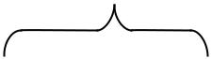
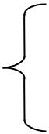

Maps for simplifying the sequential circuit

Logic diagram
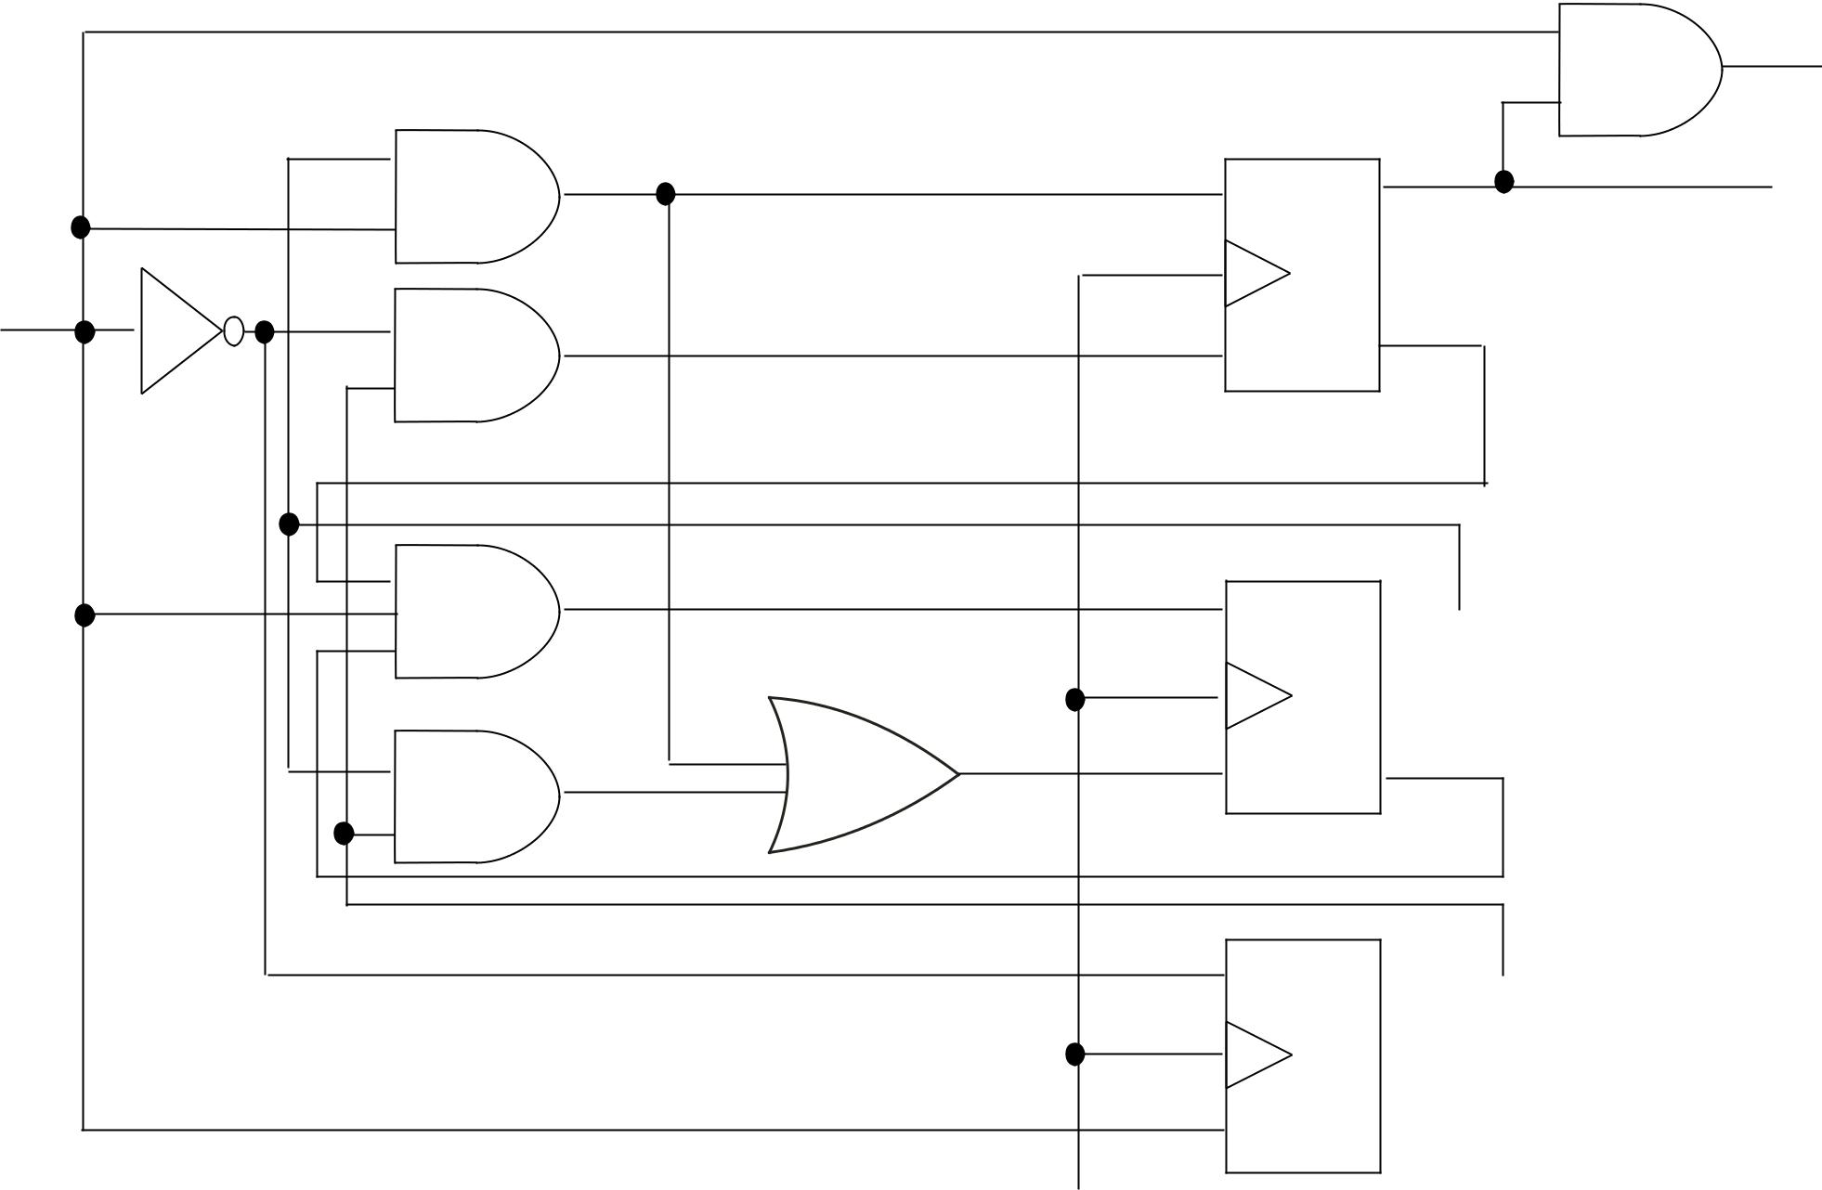

y

 | S | Q | A
x | R | Q’ | A’

S Q ^{B}

R Q’ B’

S Q ^{C}

R Q’

CP

SA = Bx, RA = Cx’, SB = A’B’x, RB = BC + Bx, SC = x’, RC =x & y = Ax
Example: Analyse the sequential circuit and determine the effect of unused states.

Unused states |  |  |  |  | 0/0 |  | 0/0
000 | A | B |  |  | 001 |  | 0/0
000 | 0 | 0 |  | 0/0 |  |  |  |  | 000
 | 0 | 0 |  | 0/0 |  | 1/0
110 | 1 | 1 |  |  | 0/0 |  |  |  | 1/0
 | 1 | 1 |  |  | 0/0 |  |  |  | 1/0
111 | 1 | 1 |  | 1/1 |  | 0/0
 | 1 | 1 | 101 | 1/1 | 011 | 0/0 |  | 010
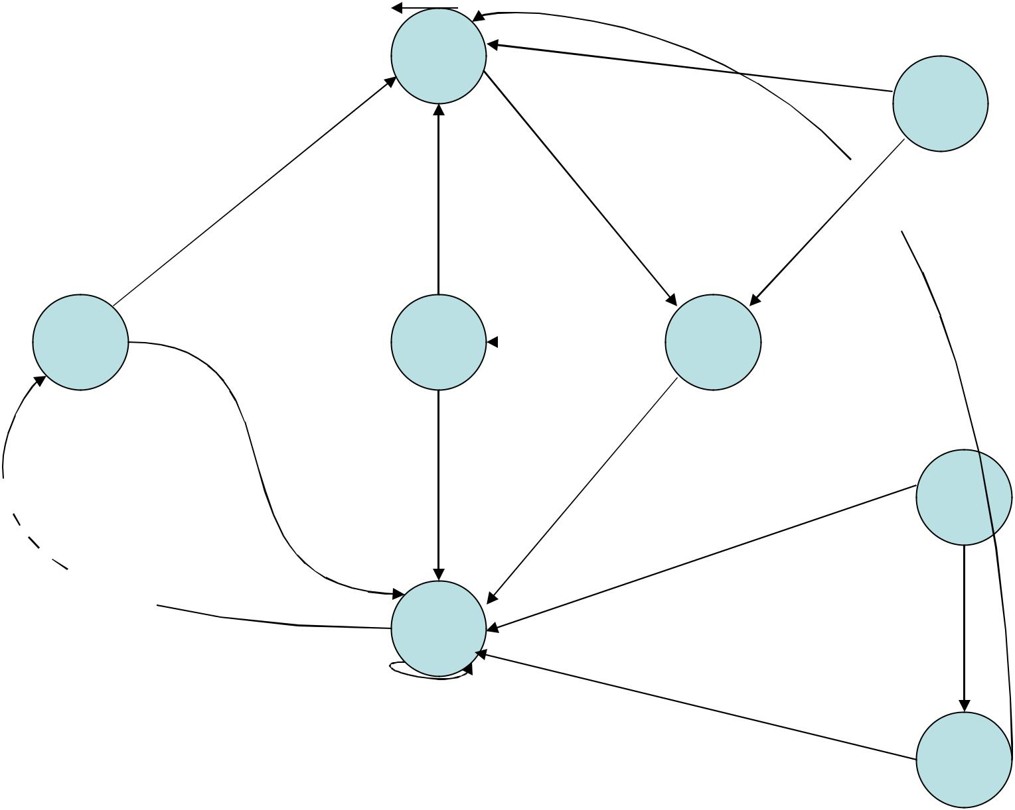

The circuit is self-starting and 0/0 self-correcting 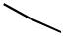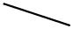 since it

eventually goes

to a valid state

from which it

continues to

operate as
required.

1/0 | 1/0 | 110

100 |  | 1/1 | 0/0
 | 1/1 | 1/1 | 111

State diagram of the circuit

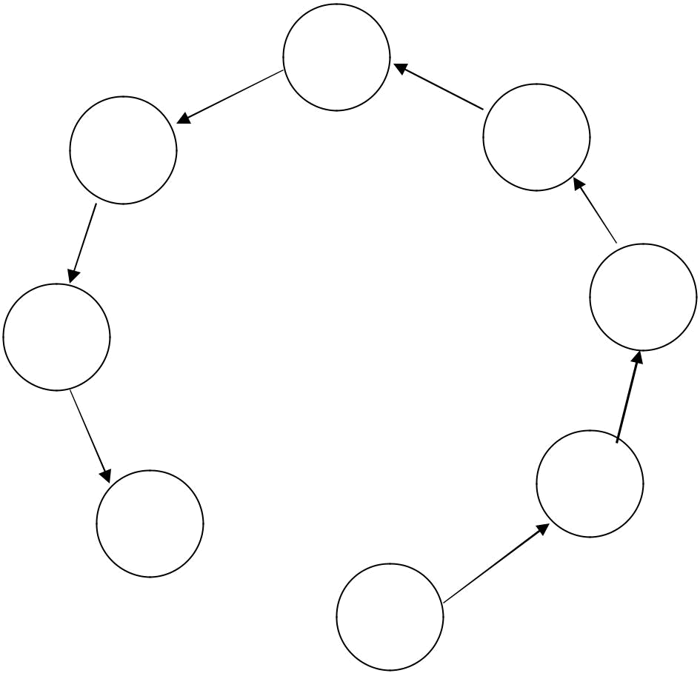

000

001 | 111

010

110

011

101

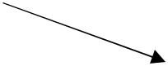 100

State diagram of a 3 bit binary counter

Excitation table for a 3-bit binary counter

A₂ A₂
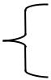

 | Count sequence |  |  |  |  |  |  |  |  | Flip-flop inputs
 | A₂ | A₁ |  |  |  | A₀ |  |  | TA₂ |  |  | TA₁ |  |  |  | TA₀
0 |  | 0 | 0 |  |  |  |  |  | 0 |  |  |  | 0 |  |  | 1
 |  | 0 |  |  |  |  |  |  |  |  |  |  | 0 |  |  | 1 |  |  |  |  |  |  |  | Q(t) |  | Q(t+1) |  |  | T
0 |  | 0 | 1 |  |  |  |  |  | 0 |  |  |  | 1 |  |  | 1
 |  | 0 |  |  |  |  |  |  |  |  |  |  | 1 |  |  | 1 |  |  |  |  |  | 0 |  |  |  |  | 0 |  | 0
0 |  | 1 | 0 |  |  |  |  |  | 0 |  |  |  | 0 |  |  | 1 |  |  |  |  |  | 0 |  |  |  |  | 1 |  | 1
0 |  | 1 | 1 |  |  |  |  |  | 1 |  |  |  | 1 |  |  | 1 |  |  |  |  |  | 1 |  |  |  |  | 0 |  | 1
1 |  | 0 | 0 |  |  |  |  |  | 0 |  |  |  | 0 |  |  | 1 |  |  |  |  |  | 1 |  |  |  |  | 1 |  | 0
1 |  | 0 | 1 |  |  |  |  |  | 0 |  |  |  | 1 |  |  | 1
1 |  | 1 | 0 |  |  |  |  |  | 0 |  |  |  | 0 |  |  | 1
1 |  | 1 | 1 |  |  |  |  |  | 1 |  |  |  | 1 |  |  | 1
A₁A₀ |  |  |  |  | A₁ |  |  |  | A₁A₀ |  |  |  |  |  |  |  |  |  | A A
 |  |  |  |  |  |  |  |  |  |  |  |  |  |  |  |  |  |  |  |  |  | 0
 | 00 | 01 | 11 |  |  | 10 |  |  |  | 00 | 01 |  | 11 |  |  | 10 |  |  |  | 1
0 |  |  |  |  |  |  |  | A₂ | 0 | 00 |  |  |  |  |  | 10 |  | A₂ |  |  |  | 00 |  |  |  | 01 | 11 | 10
0 |  |  |  | 1 |  |  |  |  | 0 |  |  | 1 | 1 |  |  |  |  |  |  | 0 |  |  | 1 |  |  | 1 | 1 | 1
1 |  |  |  | 1 |  |  |  |  | 1 |  |  | 1 | 1 |  |  |  |  |  |  | 1 |  |  | 1 |  |  | 1 | 1 | 1
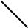
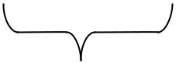
A₀ | TA₁ = A₀ | TA₀ = 1
A₀ | Maps for a 3-bit binary counter
TA₂ = A₁A₀ | Maps for a 3-bit binary counter

Logic diagram 0f a 3-bit binary counter

A₂ |  |  |  |  | A₁ |  |  | A₀
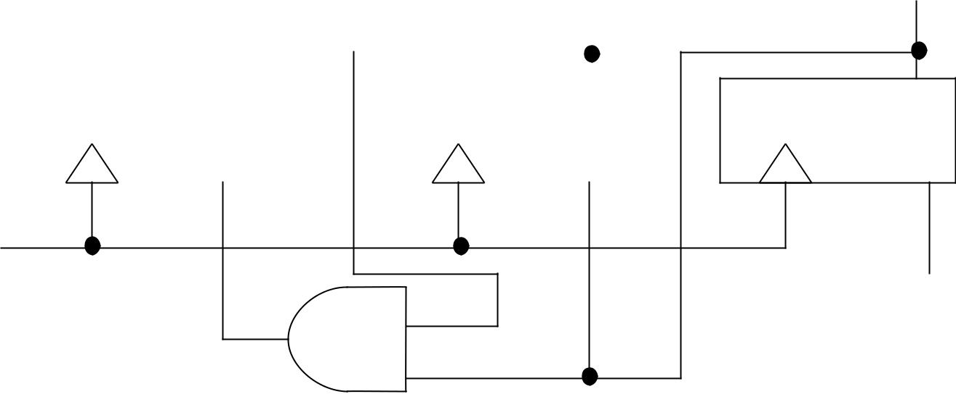

CP

1

TA₂ = A₁A₀

TA₁ = A₀

TA₀ = 1
- Design a counter that counts a repeated sequence as shown below using JK flip-flop

Counting Sequence : 0, 1, 2, 4, 5 and 6

 |  |  |  |  |  |  |  |  |  | Don’t care
 |  |  |  |  |  |  |  |  |  | 011
 |  |  |  |  |  |  |  |  |  | 111
Count sequence |  |  |  |  | Flip-flop inputs |  |  |  |  | 111
A | B | C | JA | KA | JB | KB | JC | KC
0 | 0 | 0 | 0 | X | 0 | X | 1 | X
0 | 0 | 1 | 0 | X | 1 | X | X | 1
0 | 1 | 0 | 1 | X | X | 1 | 0 | X
5 | 0 | 0 | X | 0 | 0 | X | 1 | X
1 | 0 | 1 | X | 0 | 1 | X | X | 1
7 | 1 | 0 | X | 1 | X | 1 | 0 | X

Excitation table

Q(t) Q(t+1) J K

0 0 0 X

0 1 1 X

1 0 X 1

1 1 X 0

 |  | BC |  |  |  |  |  |  |  |  | Don’t care: 011 & 111
 |  | BC | 01 |  |  | 11 |  | 10
A | 00 |  |  |  |  |  |  |  |  |  |  |  | A
A |  |  |  |  |  |  | x |  |  | 1 |  |  | A
0 |  |  |  |  |  |  | x |  |  | 1 |  |  | 0
1 |  | x |  | x |  |  | x |  |  | x |  |  | 1
 |  |  |  |  |  |  |  | JA = B
 |  | BC | 01 |  |  | 11 |  | 10
A | 00 |  |  |  |  |  |  |  |  |  |  |  | A
A |  |  |  | 1 |  |  | x |  |  | x |  |  | A
0 |  |  |  | 1 |  |  | x |  |  | x |  |  | 0
1 |  |  |  | 1 |  |  | x |  |  | x |  |  | 1
 |  |  |  |  |  |  |  | JB = C
 |  | BC | 01 |  |  | 11 |  | 10
A | 00 |  |  |  |  |  |  |  |  |  |  |  | A
A |  | 1 |  | x |  |  | x |  |  |  |  |  | A
0 |  | 1 |  | x |  |  | x |  |  |  |  |  | 0
1 |  | 1 |  | x |  |  | x |  |  |  |  |  | 1
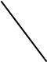

JC = B’

BC | 01 | 11 |  | 10
00 | 01
x | x
x | x |  | x |  | x
 |  |  | x |  | 1
 |  |  |  | KA = B
BC | 01 | 11 |  | 10
00 | 01
x | x |  | x |  | 1
x | x |  | x |  | 1
 |  |  |  | KB = 1
BC | 01 | 11 |  | 10
00 | 01
x | 1 |  | x |  | x
x | 1 |  | x |  | x
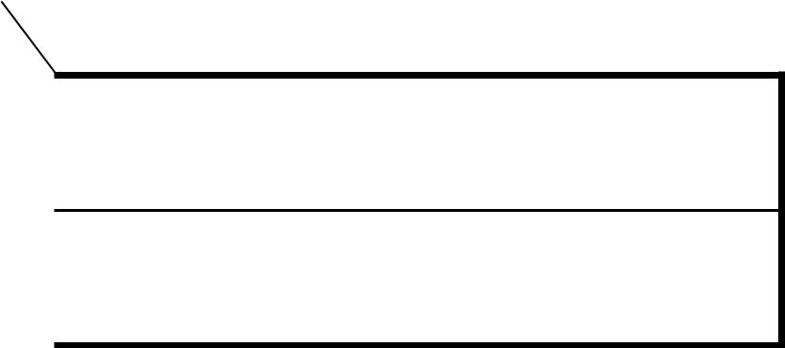
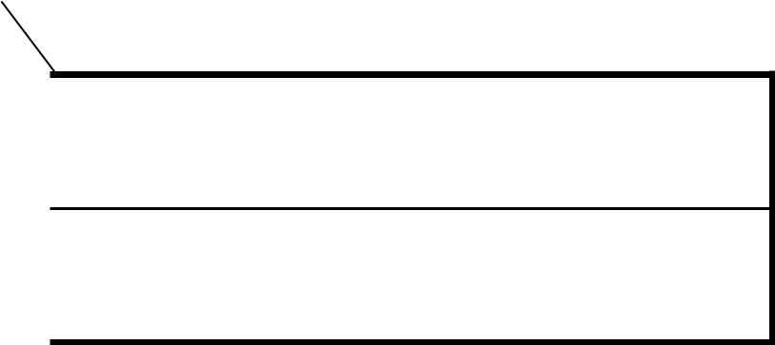

KC = 1
A B C
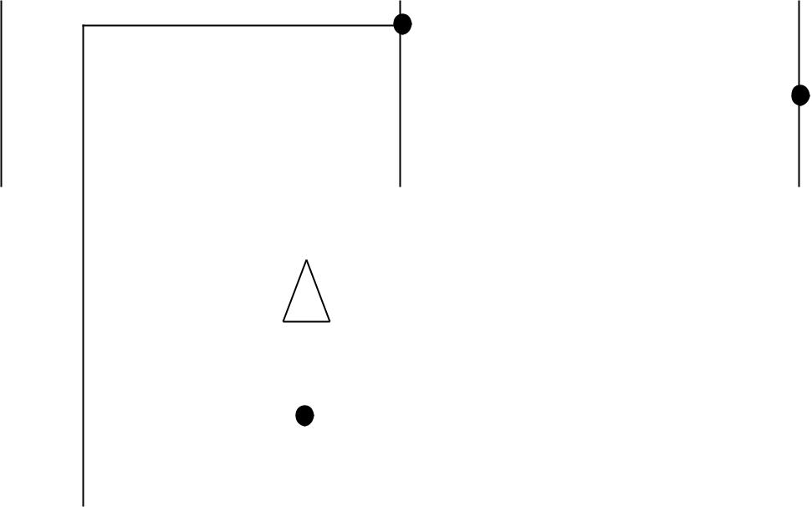

B’
 |  | Q’ |  | Q |  |  |  |  | Q’ |  |  | Q |  |  |  |  | Q’ |  |  | Q |  | (a) Logic Diagram
 |  | K |  | J |  |  |  |  | K |  |  |  | J |  |  |  | K |  |  |  | J | of Counter
Count
Pulses
 |  |  |  |  |  |  |  |  |  |  |  |  |  |  |  |  |  |  | 1 |  |  | Using K-maps
 |  |  |  |  |  |  |  |  |  |  |  |  |  |  |  |  |  |  |  |  |  | JA = B
 |  |  |  |  |  | 000 |  |  |  |  |  |  |  |  |  |  | 111 |  |  |  |  | KA = B
 |  |  |  |  |  |  |  |  |  |  |  |  |  |  |  |  |  |  |  |  |  | JB = C
 |  |  |  |  |  |  |  |  |  |  |  |  |  |  |  |  |  |  |  |  |  | KB = 1
 |  |  |  | 001 |  |  |  |  |  |  |  | 110 |  |  |  |  |  |  |  |  |  | JC = B’
Unused states |  |  |  |  |  |  |  |  |  |  |  |  |  |  |  |  |  |  |  |  |  | KC = 1
011
111 |  |  |  | 010 |  |  |  |  |  |  |  | 101 |  |  |  |  |  |  |  |  |  | (b) Logic Diagram
 |  |  |  |  |  |  |  |  |  |  |  |  |  |  |  |  |  |  |  |  |  | of Counter
 |  |  |  |  |  | 100 |  |  |  |  |  |  |  |  |  |  | 011 |  |  |  |  | Counter is self-starting
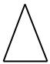
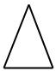
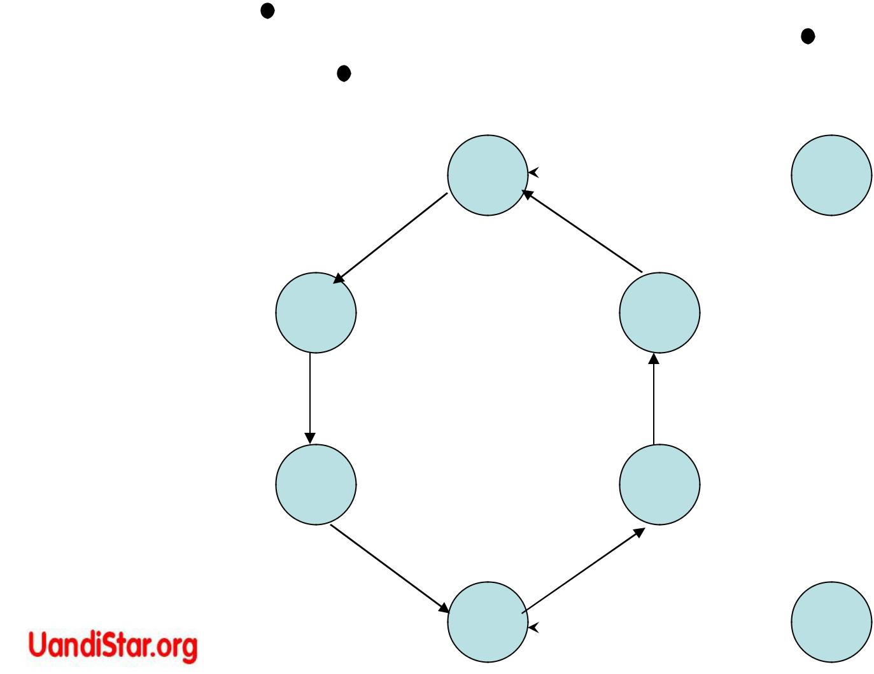
Design with State Equation

With D Flip Flops Characteristic equation

Q(t+1) = D

Example # 1: State equations from the given table are:

A(t+1) = DA(A,B,x) = ∑ (2,4,5,6)

B(t+1) = DB(A,B,x) = ∑ (1,3,5,6)

DA = AB’ + Bx’

DB = A’x + B’x +ABx’

Present |  | Input | Next
State |  |  | State
A | B | x | A | B
0 | 0 | 0 | 0 | 0
0 | 0 | 1 | 0 | 1
0 | 1 | 0 | 1 | 0
0 | 1 | 1 | 0 | 1
1 | 0 | 0 | 1 | 0
1 | 0 | 1 | 1 | 1
1 | 1 | 0 | 1 | 1
1 | 1 | 1 | 0 | 0

 |  | Bx
A₀ | 00 |  | 01 |  | 11 | 10 |  |  | A₀
A₀ |  |  |  |  |  |  | 1 |  | A₀
 |  |  |  |  |  |  | 1
1 |  | 1 | 1 |  |  |  | 1 |  | 1

DA = AB’ + Bx’

Bx
00 | 01 |  |  |  | 11 |  | 10
 |  |  | 1 |  | 1
 |  | 1
 |  |  |  |  |  |  |  | 1
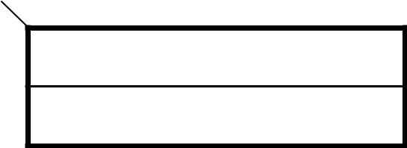

DB = A’x + B’x +ABx’

Q Qt D
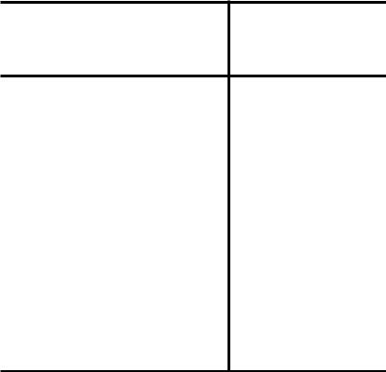

0 0 0

0 1 1

1 0 0

1 1 1

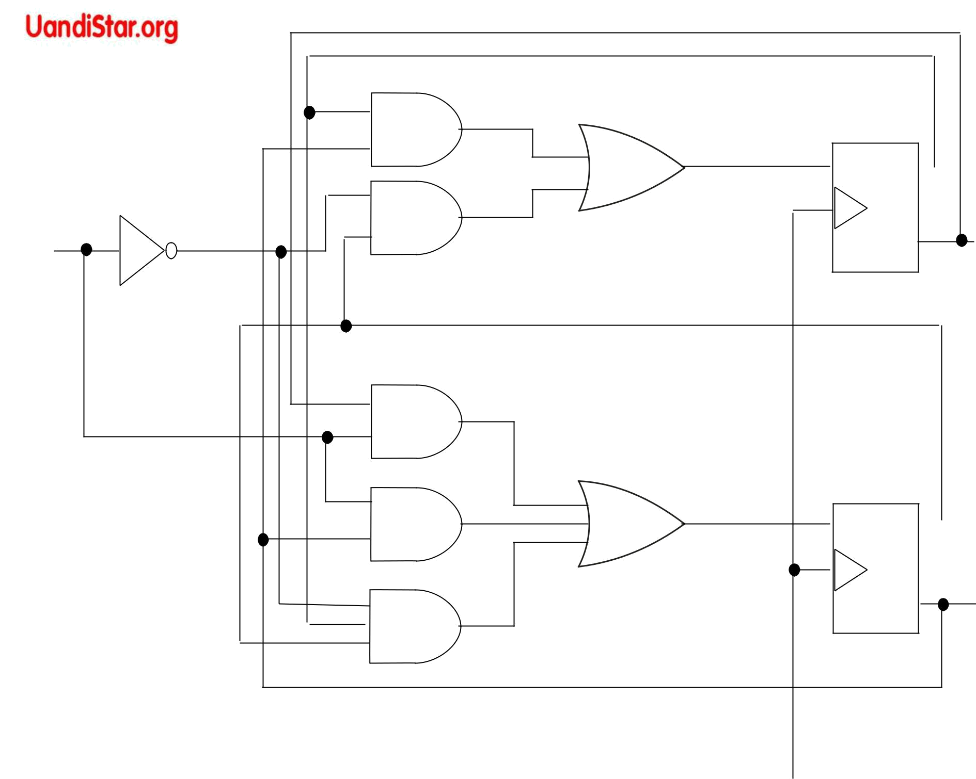

D Q 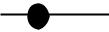 A

x | A’

D Q 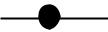 B

B’

DA = AB’ + Bx’ | _{CP} Logic diagram
DB = A’x + B’x +ABx’ | _{CP} Logic diagram
Example # 2 : Design a sequential Circuit as per given conditions using D flip flops:-

A(t+1) = C + D |  | _{C} Q D | _{B} Q D | _{A} Q D
B(t+1) = A | _{D} Q D | _{C} Q D | _{B} Q D | _{A} Q D
C(t+1) = B
D(t+1) = C
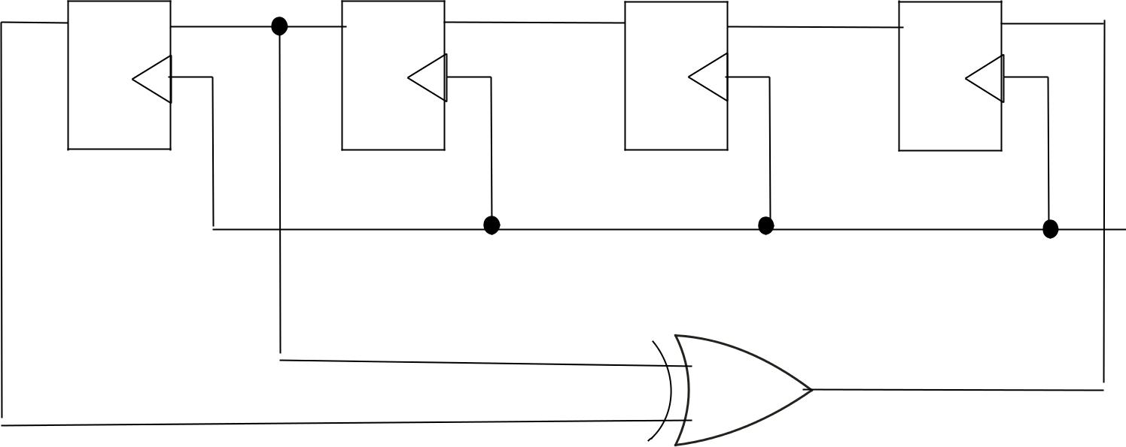

So
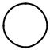

CP

DA = C + D

DB = A

DC = B

DD = C

Example # 3:- Design a Sequential Circuit with JK flip-flops to satisfy

the given equations:-

State Equations [Characteristic equation of JK flip-flops = Q(t+1) = (J) Q’ + (k’) Q ]
A(t+1) = A’B’CD + A’B’C + ACD + AC’D’ B(t+1) = A’C + CD’ + A’BC’ C(t+1) = B

D(t+1) = D’

Algebraic manipulations for matching characteristic equation of JK flip-flops:

A(t+1) = (B’CD + B’C) A’ + (CD + C’D’)A = (J)A’ + (K’) A

J = B’CD + B’C = B’C ------------(i)

(K’) = (CD +C’D’)’ = CD’ + C’D------(ii)

B(t+1) = (A’C +CD’) + (A’C’)B

B(t+1) = (A’C + CD’)(B’+B) + (A’C’)B

- (A’C + CD’) B’ + (A’C + CD’ + A’C’) B

- (J)B’ + (K’) B

J = A’C + CD’ -------------(iii)

(K’) = (A’C + CD’ + A’C’)’ = AC’ + AD ---------- (iv)
C(t+1) = B = B(C’ + C) = BC’ + BC

= (J) C’ + (K’) C

J = B ----------(v)

(K’) = B’ -------(vi)

- (J) D’ + (K’) D J = K’ = 1

J = 1----------(vii)

(K)’ = (O)’ = (K)’ = 1-----------(viii)

JA = B’C ----------(i) KA = CD’ + C’D-----------(ii)

JB = A’C + CD’ --------(iii) KB = AC’ + AD -------(iv)

JC = B ---------(v) KC = B’ ----------(vi)

JD = 1 ----------(vii) KD = 1 ------------(viii)

